Security Architecture
  - AWS services
  - Scott Overton

Introduction
This document is an overview of AWS services and helping winlocal achieve there coal of going from self-hosting to going fully off cloud, this document will go through step by step of resources used and also showing the cost effective ways of saving win local money. As I said I’m showing the resources used I will also be showing a architecture diagram and also taking about 2 additional services and then AWS sustainability.

Table of Contents
Introduction 1
Task 1 3
Task 2 4
Network design 4
Bastion host 4
Amazon Machine image 5
Single-AZ amazon RDS deployment 5
Auto Scaling Configuration 5
Security implantation 6
Static Backup Website 7
TASK 3 -SNS / CloudWatch 7
SNS 7
CloudWatch 8
Task 4 8
Auto Scaling — Eliminating Waste 9
Right Sizing with t2.micro 9
Eliminating On-Premises Infrastructure 9
Future Sustainability 9
Conclusion for winlocals 10

Task 1
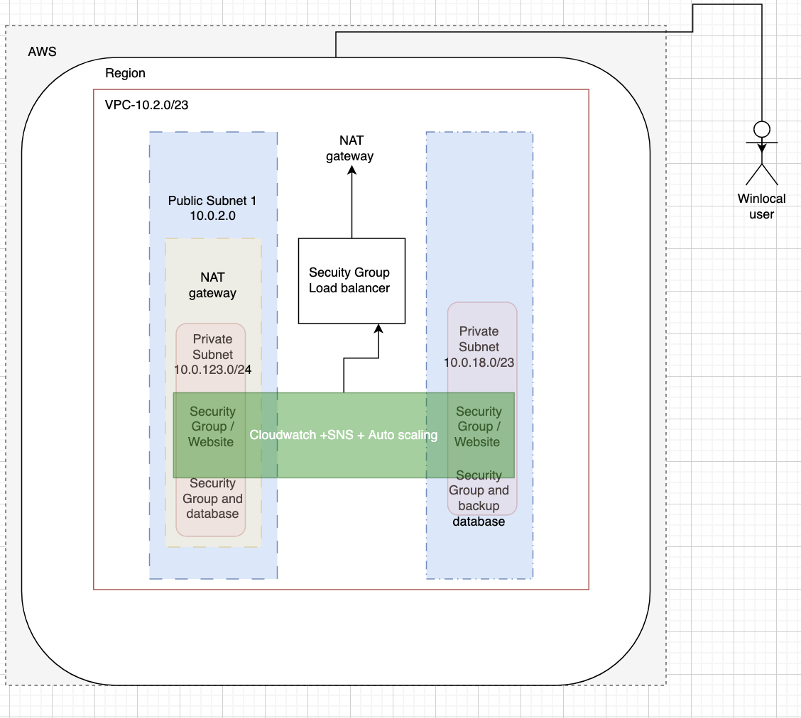

Task 2
I will now be taking about the setup of the AWS services.

Network design
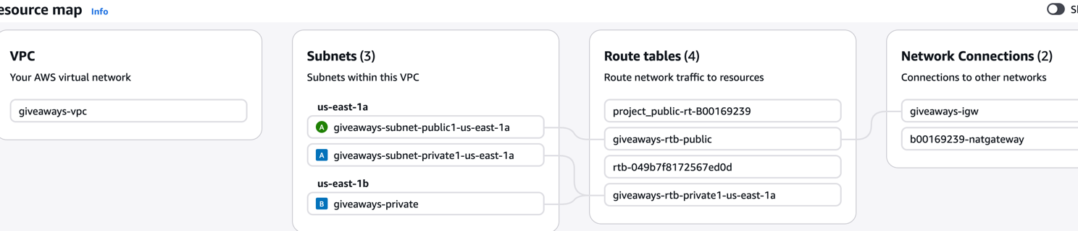
Easily able to set up a vpc in aws and it automatically will makes a private and public subnet and this is Important as I will be using it to connect to the data base, However I need to create a Nat gateway which is needed for the ec2 to connect to. I create another subnet as private for the load balancer which will be explained later on.

Bastion host
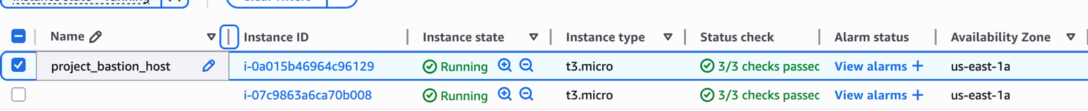
A bastion host is a dedicated EC2 instance placed in a public subnet that acts as a secure gateway for administrators to access private EC2 instances. It is the only entry point into the private network via SSH. This is needed for Winlocal as there are mulit level private network, The Bastion host is needed if they didn’t have it they wouldn’t be able to ssh into Data bases and other private resources to allow updates and service them.
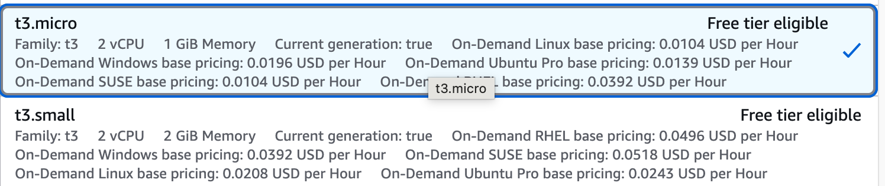
I want to show for instance types is that fact you can use free versions. This is a cost cutting measurement is a good way in the fact people only might need to ssh into a console and apply updates for security reasons.

Amazon Machine image
An Amazon Machine Image (AMI) is a snapshot of a configured EC2 instance. It captures the operating system, installed software, configuration files, and application code at a specific point in time. New EC2 instances can be launched instantly from this image, identical to the original. This is important for winlocal in how it allows for auto scaling such as that if server spikes in traffic the ASG uses the Ami to get the pre-configured websites’ also allows for consistency as in each time its created it is identical to the original which saves time in configuration issues.

Single-AZ amazon RDS deployment
Its deployed in a single availability zone meaning that if the availability zone goes down then the website is unavailable and there is no standby instances and it’s a single point of failure in the architecture. A way to improve this would be mulit availability zone deployment. If the primary database it will automatically spin up standby database.

Auto Scaling Configuration
I created an auto scaler and ill show it in use but I want to explain why it’s important for winlocal, When winlocal run giveaways the traffic will spike and the way win local deal with it is by having Somone there to update the network to add more servers. This isn’t cost effective and slow. With awes we are able to set certain cpu limits such as 60% and that once it reaches that I will spin up another server. This is automatic and can be changed anytime and so no human intervention. When traffic dies down It terminates the new ec2 spun up. This is perfect for win locals as they are only paying for what they use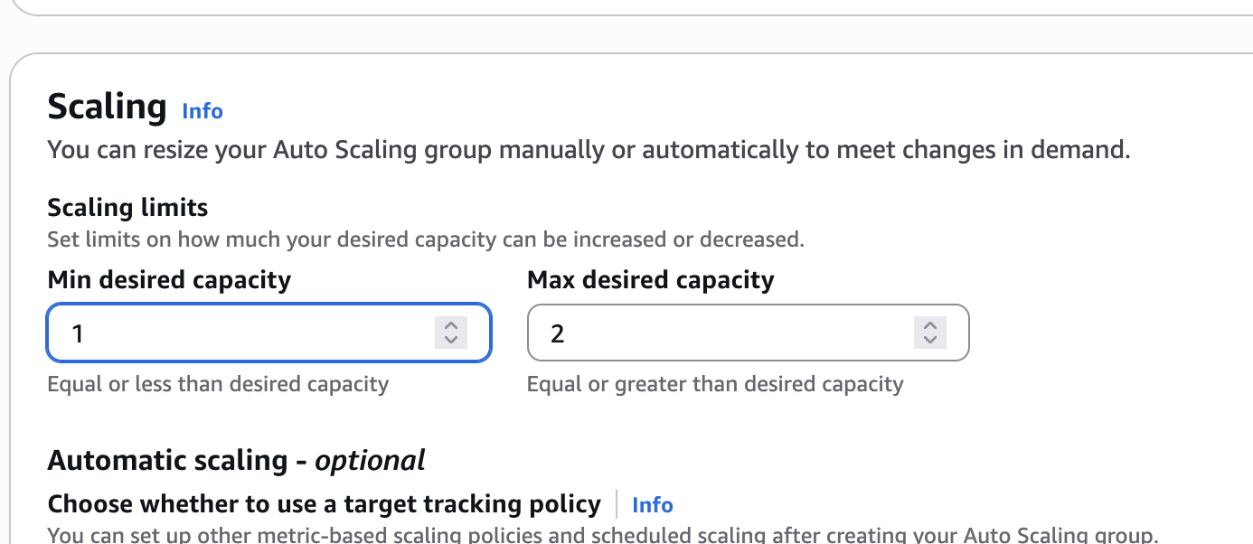
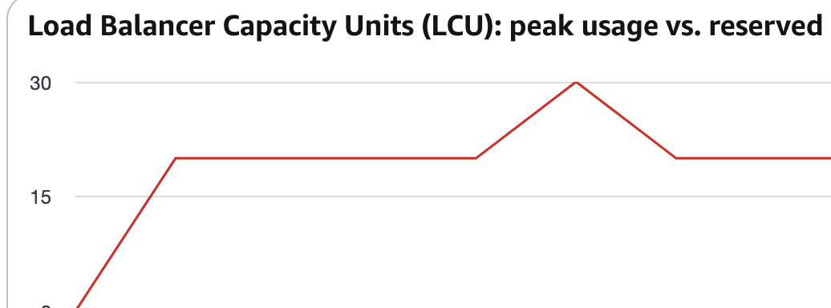
You can see it spiking here as I connect 2 tabs to the ec2 website. Its good in how I can see it going down as the traffic leaves. As I said before this this is perfect for winlocal as they are only paying for new ec2 instances when it spins one up and not paying for one when it’s not in use.

Security implantation
Basic security will be public and private subnets. As before the vpc set up a public and private subnet, simply the public subnet allows connection to the internet and it allows traffic for it. The private subnet will only be for internal networks such as databases and how the bastion host connects to other private servers. I am going to use security groups as they are basically firewalls with allowing certain groups to connect to servers. They follow the principle of least privilege. This is perfect for winlocal as they had there ransomware attack which allowed a hacker to move around the website for free. Security groups stop this as if it happened again as each network is isolated and so stopping them in their tracks.

Static Backup Website
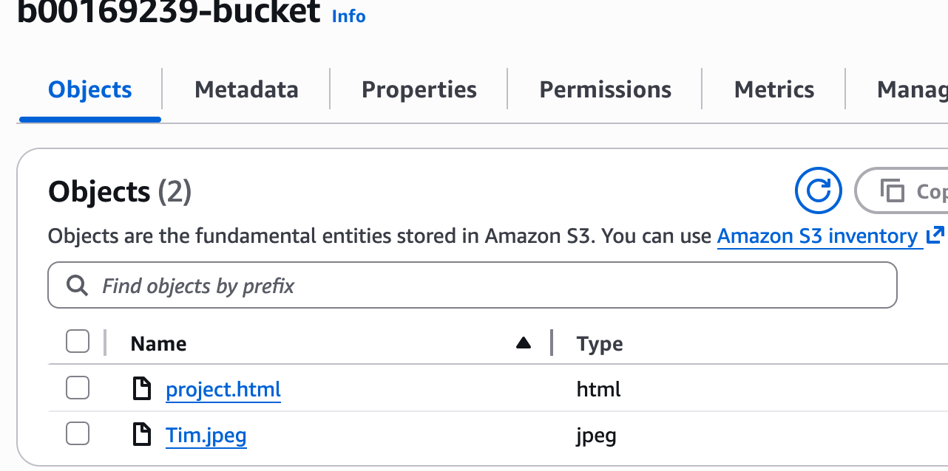
The static backup website is a simple HTML page hosted on Amazon S3 that displays a "competition unavailable” message to users. It requires no servers, no database, and no compute resources to run. Because it is hosted on S3, it is extremely reliable and will remain. Available even if the entire EC2 infrastructure goes down. This is a reason why a backup would be used.

TASK 3 -SNS / CloudWatch

SNS
A competition campaign launches and traffic spikes. The Auto Scaling Group launches a second EC2 instance. The technical team immediately receives an email saying a new instance has launched — they know the system is working and can monitor the situation in real time.
n WinLocals previous setup, the ransomware attack went undetected for ten weeks because there was no alerting system in place. Nobody was notified when suspicious activity was occurring.
SNS fixes this by sending instant email notifications when:
- A new EC2 instance launches (Auto Scaling scaled out)
- An EC2 instance terminates (Auto Scaling scaled in)
- An instance fails to launch
- Any other infrastructure event occurs

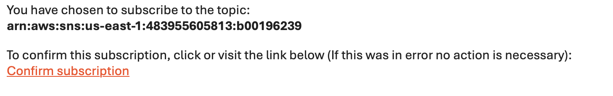
You can see the email sent from amazon to me. Because I sorted this out I am able to receive emails from aws in examples mentioned above.

CloudWatch
What it is: Amazon CloudWatch is a monitoring service that watches over your AWS infrastructure in real time and alerts the WinLocal technical team when something needs attention.
What it monitors for WinLocal:
- EC2 CPU usage during competition campaigns
- Whether Auto Scaling is triggering correctly
- Overall infrastructure health

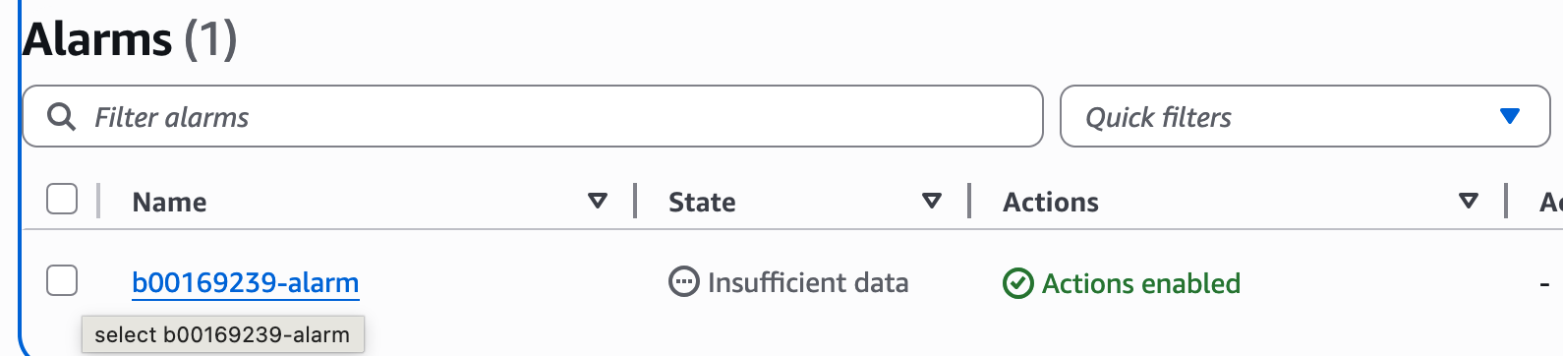
CloudWatch acts as an automated watchman over WinLocal's infrastructure, ensuring that performance issues and unusual activity are detected and flagged immediately rather than going unnoticed for weeks like the previous security breach.

Task 4
The Sustainability pillar of the AWS Well-Architected Framework focuses on minimising the environmental impact of cloud infrastructure by reducing energy consumption, maximising resource utilisation, and eliminating waste.
How the PoC has been Optimised for Sustainability

Auto Scaling — Eliminating Waste
The most significant sustainability optimisation in the PoC is the use of Auto Scaling. In WinLocal's previous on-premises setup, servers ran at full capacity 24/7 regardless of actual demand. This meant energy was constantly being consumed even during periods of low or no traffic.
The Auto Scaling Group configured in the PoC ensures Only 1 instance runs during normal low traffic periods, A second instance only launches when CPU exceeds 60% Instances are automatically terminated when demand drops No compute resources are running unnecessarily This directly reduces energy consumption by ensuring servers are only active when needed.

Right Sizing with t2.micro
The PoC uses t2.micro instances which are small, efficient instances suited to WinLocal's current workload. Using oversized instances would waste energy and cost money unnecessarily. By matching instance size to actual workload requirements WinLocal avoids over-provisioning which is a core sustainability principle.

Eliminating On-Premises Infrastructure
By migrating from their on-premises data centre to AWS, WinLocal eliminates the need for Physical servers running 24/7 On-premises cooling systems Dedicated power supplies Physical storage devices such as their NAS .AWS data centres are significantly more energy efficient than traditional on-premises data centres, operating with a much lower Power Usage Effectiveness (PUE) rating.

Future Sustainability
Implement S3 Lifecycle Policies As WinLocal grows and stores more data, they should implement S3 Lifecycle Policies to automatically move older, infrequently accessed data to cheaper and more energy efficient storage tiers such as S3 Standard-IA (Infrequent Access) S3 Glacier for long term archival This reduces the amount of active storage infrastructure needed.
Choose Sustainable Regions As WinLocal expands, they should consider deploying workloads in AWS regions powered by higher percentages of renewable energy. AWS has committed to powering operations with 100% renewable energy and some regions are already at or near this target.

Conclusion for winlocals
This project involved designing and implementing a cloud-based infrastructure solution for WinLocal Giveaways to address the critical issues identified in their current on-premises environment. The proposed AWS architecture and Proof of Concept demonstrates that cloud technology is well suited to support WinLocal's rapid growth and increasing demand. Overall this PoC provides WinLocal Giveaways with a solid foundation and the confidence that AWS cloud technology can reliably, securely, and efficiently support the future of their platform.

References
https://docs.aws.amazon.com/wellarchitected/latest/sustainability-pillar/sustainability-pillar.html
https://docs.aws.amazon.com/vpc/latest/userguide/what-is-amazon-vpc.html
AWS – academy

