**Color Pallettle and Fonts**

The color palette I’ll be using is blues and grays because those are Luiz’s favorite colors.

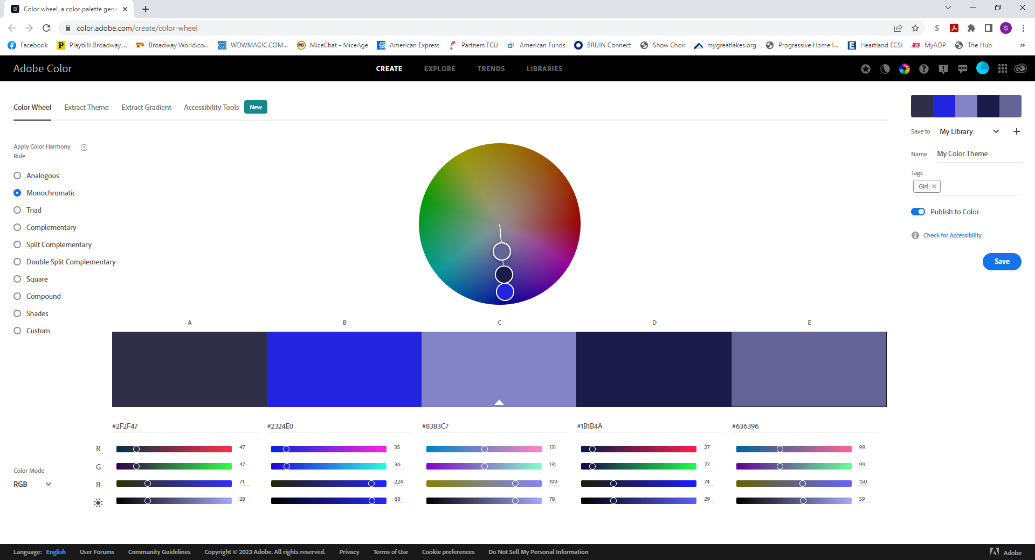

I’ll being using the font ‘Bangers’ for my headings and ‘Gudea’ for my paragraphs.

**HTML Heading Links**

<link rel="preconnect" href="https://fonts.googleapis.com">

<link rel="preconnect" href="https://fonts.gstatic.com" crossorigin>

<link href="https://fonts.googleapis.com/css2?family=Bangers&family=Gudea:ital,wght@0,400;0,700;1,400&display=swap" rel="stylesheet">

**CSS rules to specify families**

font-family: 'Bangers', cursive;

font-family: 'Gudea', sans-serif;

**Webpage Layout**

* Landing Page
  + Picture of Luiz (image)
  + Title of name
  + Short description of website
  + Links to other pages
* About Page
  + Luiz Bio
  + Picture of Luiz (image)
* Career Page
  + Teacher
  + Royal Caribbean
    - Shore Excursion (image)
    - Next Cruise Sales (image)
  + Walt Disney World
* Hobbies Page
  + Traveling
  + Movies

**Interview Questions:**

Where and when were you born?

* Recife, Brazil
* October 16,1982

Parents names and Occupation?

* Antonio Soares – pharmaceutical sales
* Maria Soares – Stay at home mother but was a teacher before that.

Education

* Bachelor’s degree in tourism and hospitality from Faculdade Integrada do Recife.
* Master’s degree in tourism and hospitality management from Universidade do Vale do Itajai.

Past jobs

* Professor for two years at Universidade do Alto Vale do Itajai
  + Taught classes on tourism and travel agents.
* Royal Caribbean Cruise Line
  + Assistant Shore Excursion Manager
  + Loyalty and Cruise Sales Associate
  + Cruise Sales Associate – Loyalty branched off into a different department.
  + Cruise Sales Manager

Current Job

* Walt Disney World for past 5 years
  + Disney Reservation Center – Booking Disney vacations.
  + Group Reservation Specialist – booking Disney vacations for teams coming to compete at Disney.
  + Inventory Specialist – assigning rooms.

When did you move to the US?

* June 2017

What are your favorite colors?

* Blue, black, and gray

What are your hobbies?

* Go to the movies.
* Travel

Why do you like to travel?

* To explore the world
* See different cultures.
* East different food

What are your favorite movies?

* Sound of Music
* Titanic
* Alien Franchise

Favorite place to travel.

* Europe – Italy, Greece, England, Turkey
* Cruises

**Bio**

Luiz Soares was born October 16, 1982, in Recife Brazil the capital city of the Brazilian state Pernambuco. He was born to a middle class family of his father Antonio Soares, mother Maria Soares and sister, Terciana Soares Rayes, eight years his senior. His father was in pharmaceutical sales and was the breadwinner of the family as his mother was a stay at home mom. Both his parents instilled in Luiz the importance of hard work and good education. Luiz got his bachelor’s degree in Tourism and Hospitality from the Faculdade Integrada do Recife in 2005 and started on his master’s degree shortly after that in Tourism and Hospitality Management from the Universidade do Vale do Itajai. He finished his masters in 2009 which led him to his first post college job of teaching at Universidade do Alto Vale do Itajai where he taught courses on tourism for two years.

After teaching Luiz decided that he wanted to travel the world, so he joined Royal Caribbean Cruise Line as their Shore Excursion Assistant Manager. Luiz explored the world with Royal Caribbean for eight years moving from the shore excursion team to the Next Cruise sales team as the Loyalty and Cruise Sales Associate and then moving up to Cruise Sales Manager. While working for Royal Caribbean, Luiz met his husband and they decided to move to Orlando, Florida to start their life together on land.

Luiz currently works at Walt Disney World as an Inventory Specialist, where he assigns rooms to Walt Disney World Guests to maximize revenue. Luiz hasn’t forgotten about his love for traveling as his husband and him continue to travel the world every chance they get. Since moving back to a life on land he loves to got to movies, try new restaurants, and explore central Florida.

**Picture Ideas**

