Building a Production-Style Backend API with Async Workers
A practical FastAPI, Redis, PostgreSQL, and Docker Compose project for reliable background job processing.

Why This Project Exists
Modern AI and data applications rarely fit into a simple request-response pattern. Fast work, like validation and status checks, should not be blocked by slow work like document processing, embeddings, model calls, or report generation.
The 02-backend-api-worker project demonstrates a production-style backend pattern: accept work quickly, store durable job state, queue long-running work, process it asynchronously, and let clients poll for results.

System at a Glance
- FastAPI API service validates requests, creates jobs, enqueues work, and exposes status endpoints.
- Redis queue stores job IDs and decouples the API from background processing.
- Worker service consumes queued jobs, executes handlers, and writes results.
- PostgreSQL stores job status, payloads, results, errors, and timestamps.
- Docker Compose creates a repeatable local environment with health checks.
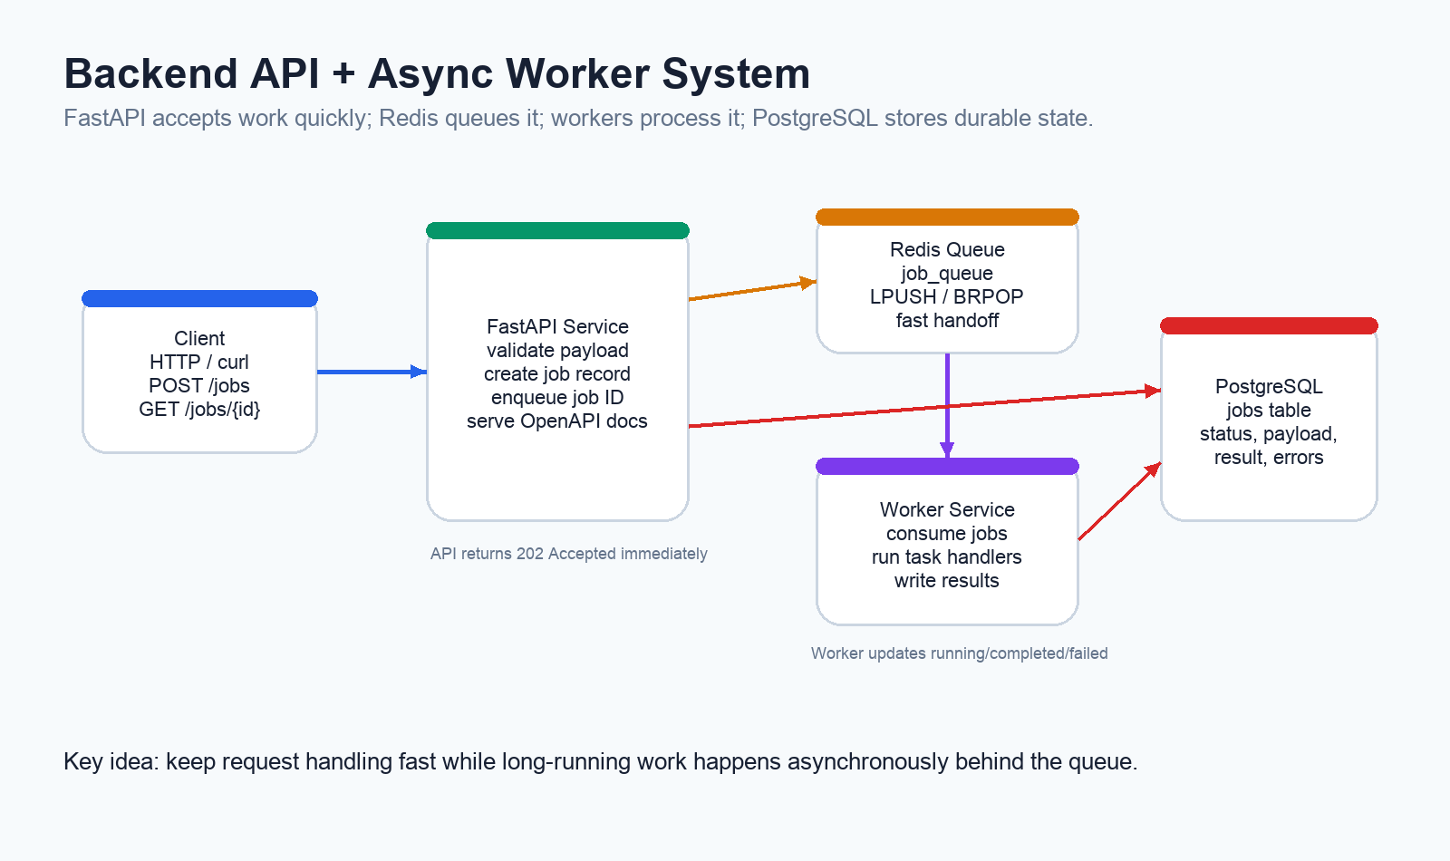
Figure 1. High-level architecture for the FastAPI, Redis, worker, and PostgreSQL system.

How Jobs Flow Through the System
A client submits a job with POST /jobs. The API validates the payload, inserts a PostgreSQL record, pushes the job ID to Redis, and returns 202 Accepted. The worker later consumes that job ID, marks the job running, executes the task, and persists the result or error.
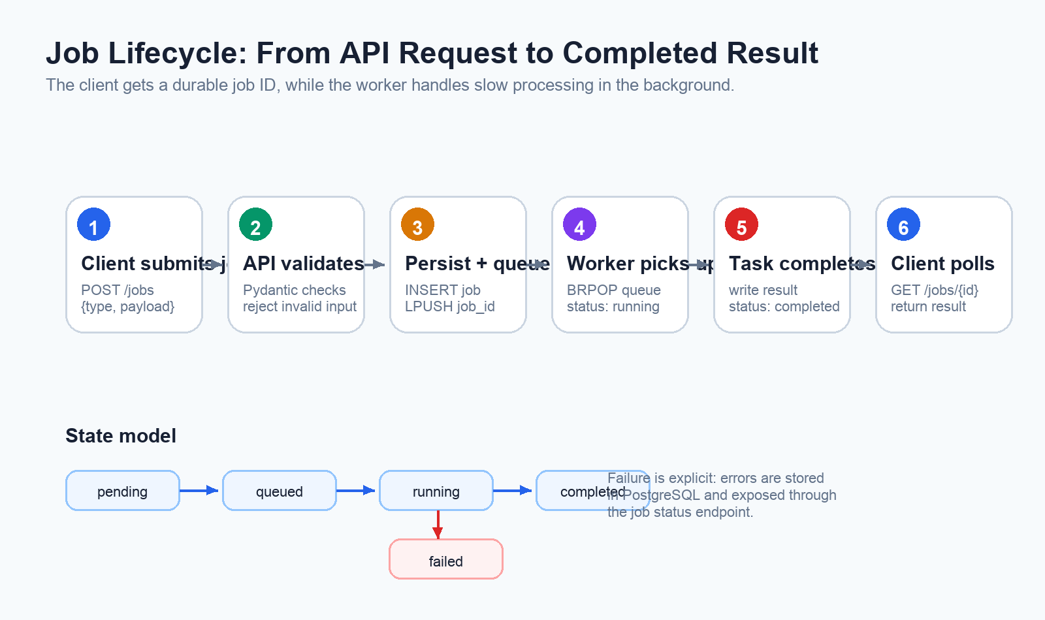
Figure 2. Job lifecycle from submission to completion or failure.

API Surface
Endpoint | Purpose
GET /health | Verify PostgreSQL and Redis connectivity.
POST /jobs | Create and queue a background job.
GET /jobs/{job_id} | Poll job status and retrieve results.
GET /jobs | List recent jobs.
/docs and /redoc | Explore generated OpenAPI documentation.

Supported Job Types
Job Type | Purpose | Output
word_count | Count words and characters. | word_count, character_count
reverse_text | Reverse a string. | original, reversed
slow_task | Simulate long-running work. | message, slept_seconds

Design Decisions
Redis and PostgreSQL serve different roles. Redis is the fast handoff mechanism; PostgreSQL is the durable source of truth. The queue carries a job ID, while the database stores the complete lifecycle.
Separating the API and worker allows each service to scale independently, isolates failures, and mirrors production systems where long-running work should not block request handling.

Reliability Practices
- Explicit job states: pending, queued, running, completed, and failed.
- Payload validation before work enters the queue.
- Durable job records in PostgreSQL.
- Health checks for core dependencies.
- Structured JSON logging with service and job metadata.
- Containerized local development with Docker Compose.

Why This Matters for AI Infrastructure
Async job processing is a foundation for AI platform work. The same pattern can power document ingestion, embedding jobs, vector indexing, batch inference, evaluation runs, and long-running workflow steps.
Before scaling RAG systems, model serving, observability, or Kubernetes deployments, it helps to understand this backend pattern: fast API acceptance, durable state, reliable queueing, background execution, and transparent status reporting.

Final Takeaway
The 02-backend-api-worker project is a compact but realistic backend architecture. It turns slow work into trackable background jobs and creates a foundation for more advanced AI infrastructure systems.

