Audit: NIST CSF 2.0 Gap Assessment
Version:

NIST CSF v2.0 — Journey
Profile(s) :

14/10/2026

Auditors:



Summary

Assessment scope:

Description:
-

Observations:

Number of requirements: 106
3 | 0 | 8 | 0 | 95
Compliant | Partially compliant | Non-compliant | Not applicable | Not assessed

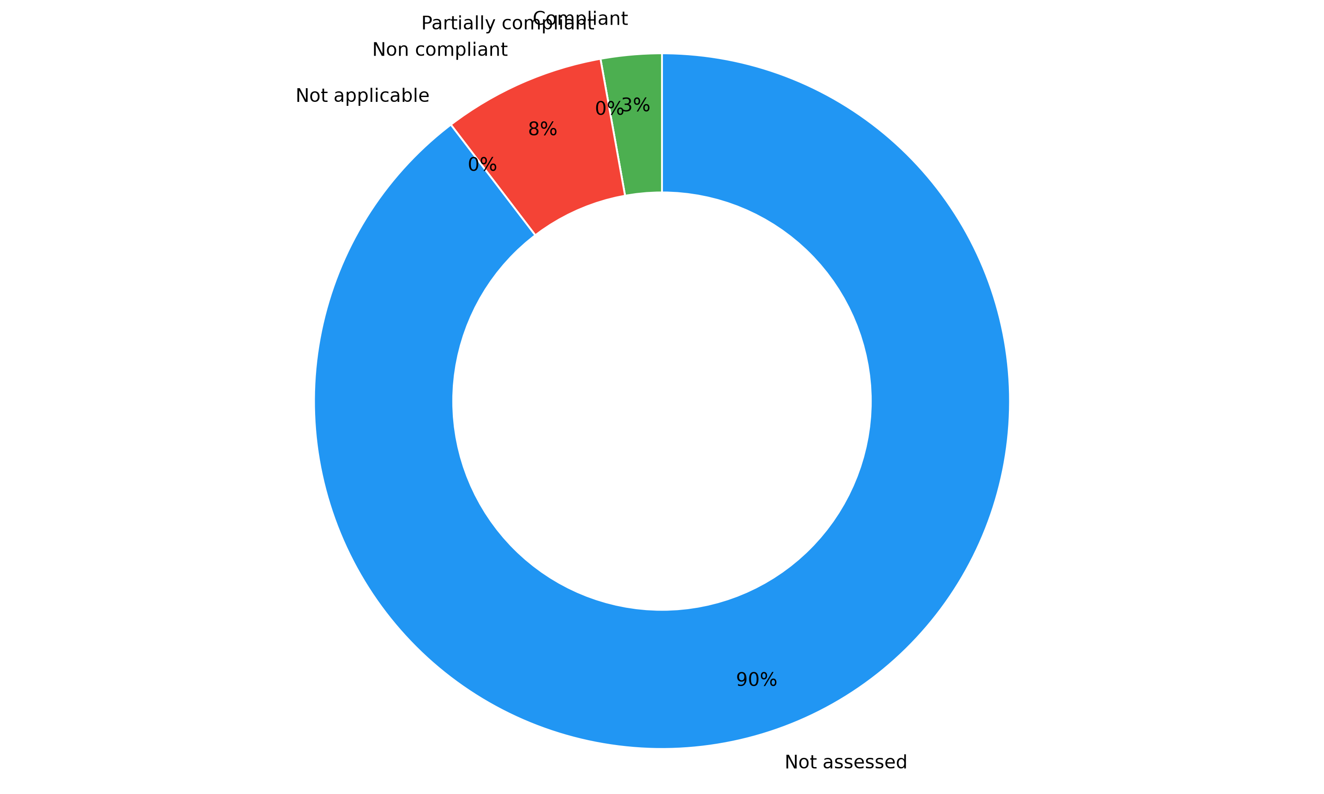

<Comments>


Audited scopes

Overview
The percentage indicates the completion of each section based on the items marked as compliant or non-applicable.

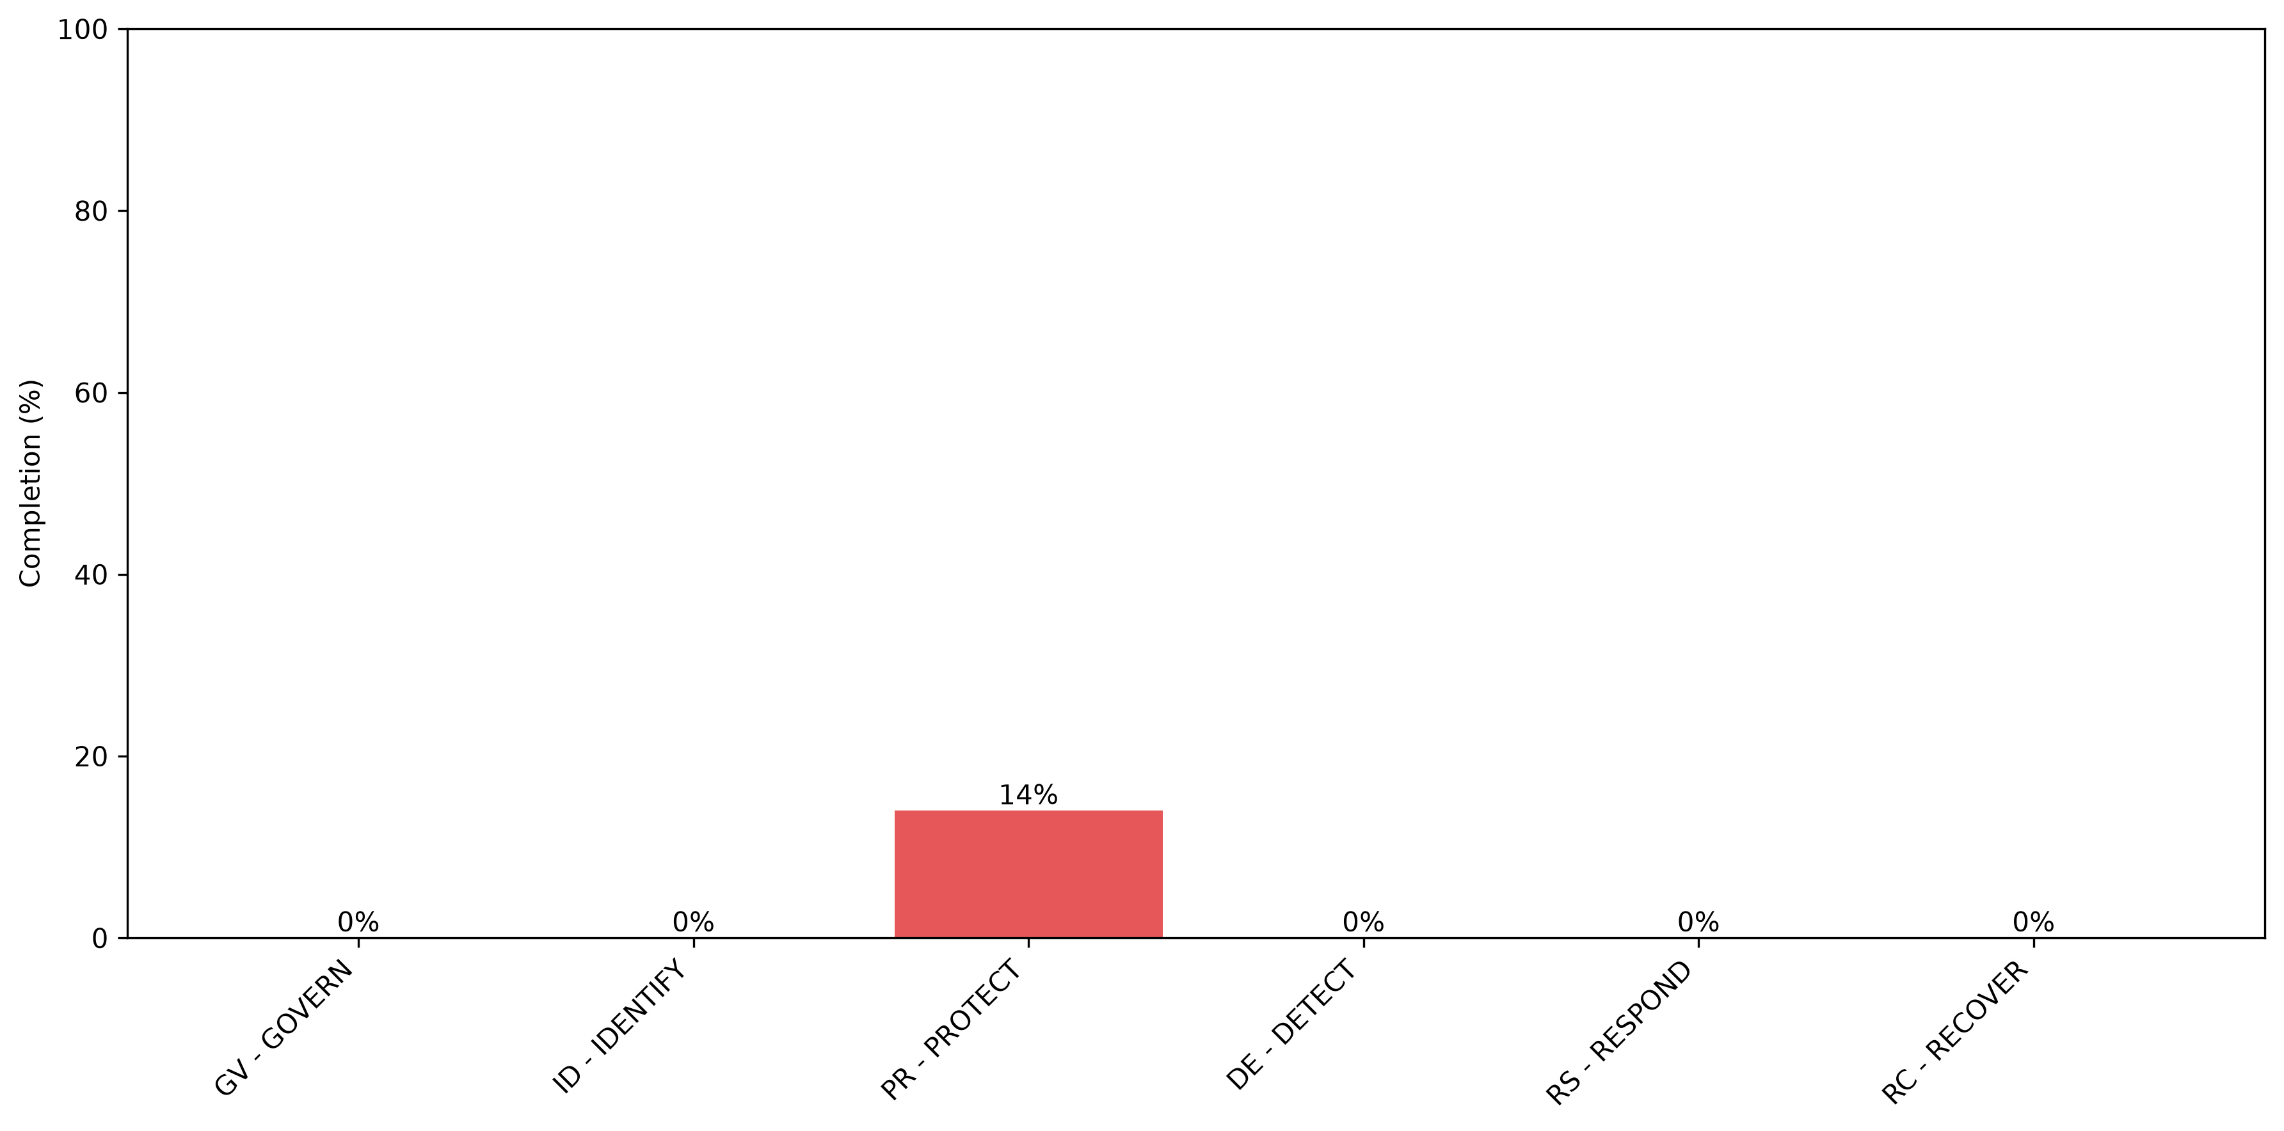
<comments>

Additionally, the following chart illustrates the maturity assessed by the auditor in each section:
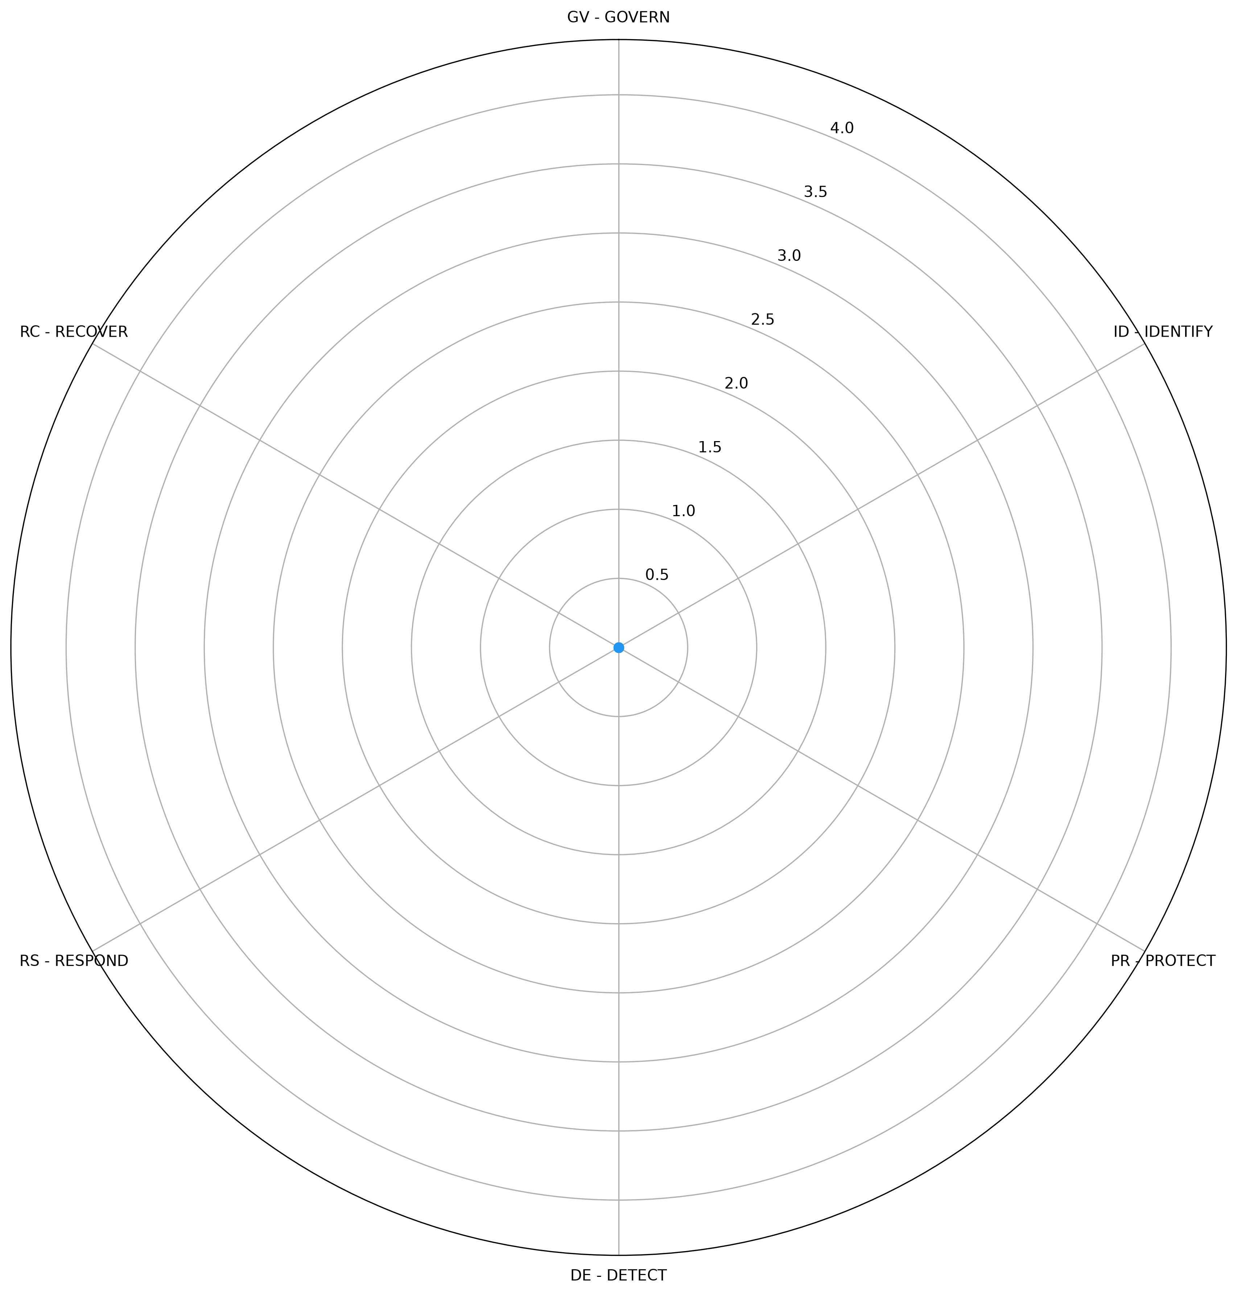

Auditor notes

Category | Drifts identified | Comments
GV - GOVERN | 31 | <comments>
ID - IDENTIFY | 21 | <comments>
PR - PROTECT | 19 | <comments>
DE - DETECT | 11 | <comments>
RS - RESPOND | 13 | <comments>
RC - RECOVER | 8 | <comments>

Security controls

Overview
Identified security controls: 0

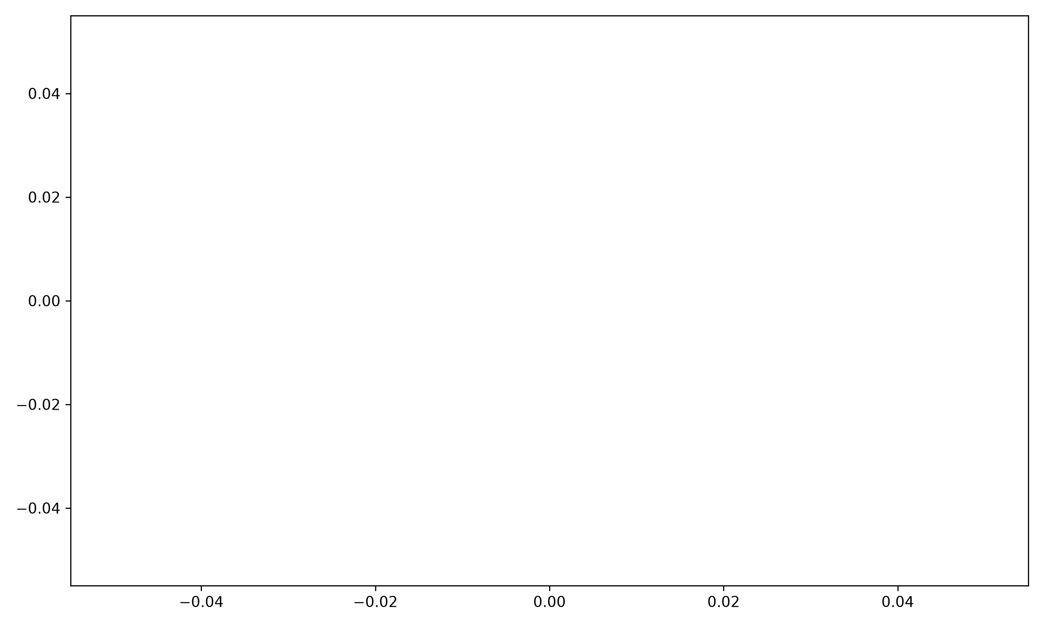
<comments>

Main priorities (P1)
The table below lists the security controls that have not been implemented yet and prioritized by the auditor:

Control | Description | Category | Status | Requirements covered

Auditor observations
<comments>


Full action plan
Control | Description | Priority | Category | Status | ETA | Requirements covered

Appendix

- Details of the requirements and attached evidences
- The remediation plan (controls list)
- Auditor background and approach

