Define System Paramaters: 1
Create Open Loop Model 1
Observability & Controllability Matricies 2
LQR Controller 2
Create Closed Loop Model 3
Simulate 4
% Scott Barnes
% The George Washington University
% MAE 6246: Electromechanical Control Systems
% Final Project: Inverted Pendulum
clc; clear; close all;

Define System Paramaters:
m = 3; % Pendulum Mass
g = 9.81; % Gravity
M = 10; % Cart Mass
l = 1.5; % Pendulum Length
F1 = 0.001; % Magnitude of Plant White Noise
F2 = 0.001; % Magnitude of Measurement White Noise

Create Open Loop Model
[A, B, C, D] = create_ol_sys(m, M, l, g)
A =
Columns 1 through 3
0 0 1
0 0 0
0 -2.943 0
0 28.34 0
Column 4
0
1
0
0
B =
0
0
0.1
0.0666666666666667
C =
1 0 0 0
0 1 0 0
0 0 1 0
0 0 0 1
D =
0
0
0
0

Observability & Controllability Matricies
c = is_controllable(A, B);
o = is_observable(A, C);
System is controllable
System is observable

LQR Controller
G = optimal_lqr(A, B, C, D);
Q =
1 0 0 0
0 1 0 0
0 0 1 0
0 0 0 1
G =
Columns 1 through 3
-10.0000000000218 1115.15662768293 -17.4538030176603
Column 4
207.861602890946
The optimal control law was found to be:
Columns 1 through 3
-10.0000000000218 1115.15662768293 -17.4538030176603
Column 4
207.861602890946

Create Closed Loop Model
Noiseless Model
Ac = A-B*G;
clSys = ss(Ac, B, C, D)
% Noisy Model
clSysN = op2cl_noise(Ac, B, C, D, F1, F2);
clSys =
A =
x1 x2 x3 x4
x1 0 0 1 0
x2 0 0 0 1
x3 1 -114.5 1.745 -20.79
x4 0.6667 -46 1.164 -13.86
B =
u1
x1 0
x2 0
x3 0.1
x4 0.06667
C =
x1 x2 x3 x4
y1 1 0 0 0
y2 0 1 0 0
y3 0 0 1 0
y4 0 0 0 1
D =
u1
y1 0
y2 0
y3 0
y4 0
Continuous-time state-space model.

Simulate
% Set Initial Conditions
y_0 = -1.9; % Initial Position
dy_0 = 0; % Intial Velocity
theta_0 = pi; % Initial Angle
dtheta_0 = 0; % Initial Angular Velocity
% Select Simulation Parameters
tf = 5+abs(5*cos(theta_0))+M/m % Termination Time
dt = 0.1; % Change in Time (Decreasing dt increases processing time)
% dt = tf/750; % Change in Time (750 Data Points)
live = 't'; % Set Real Time Simulation to 't' (true) or 'f' (false).
% Note: real time simulation is computationally demanding
% Run Simulation
[y, t, x] = sim_inv_pend(tf, dt, F1, F2, y_0, dy_0, theta_0, dtheta_0, clSysN, live, l, G, B);
tf =
13.3333333333333
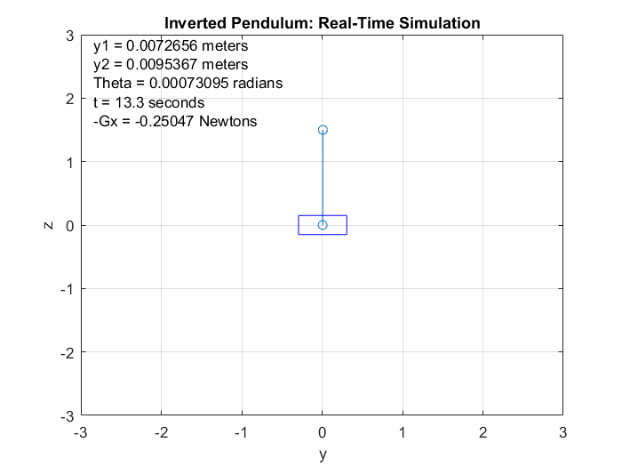
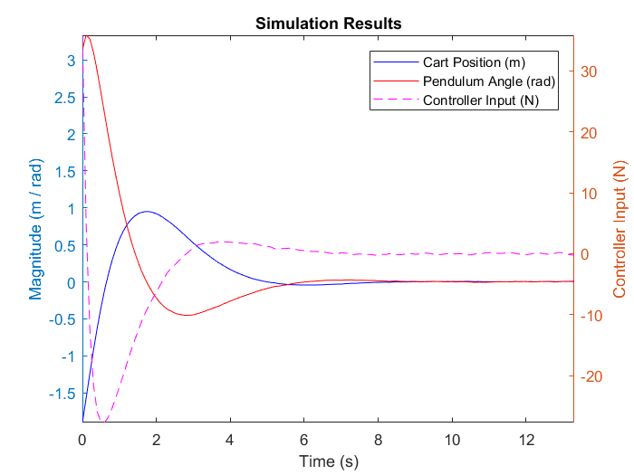
Published with MATLAB® R2017a

