Please make site banner blue and lime green ☺

MN Grant info links:

Literacy Plan Requirements: <http://education.state.mn.us/MDE/dse/prof/dev/>   
Reading Proficiency Resource: http://education.state.mn.us/MDE/dse/prof/

MN Striving Readers Grant Page: <http://education.state.mn.us/mde/dse/grants/>

Designed to improve the language and literacy of Minnesota’s students, the **$21 million Striving Readers Comprehensive Literacy Grant** by the U.S. Department of Education is an incredible opportunity to help struggling readers. Voyager Sopris Learning® is working with more than 75 districts in Minnesota, and we are proud to be your educational partner.

The links below will help you learn more about the grant, suggested solutions, and additional resources you may find helpful.

Resources

LETRS-Proven Professional Development

LL- Two Years Growth

PRJ- ESSA Compliant

PP- Award Winning

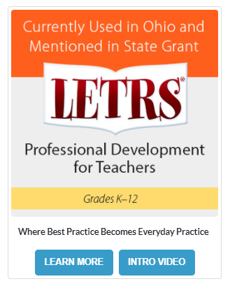

## LANGUAGE!® Live

Research Base: <http://www.voyagersopris.com/info/language-live/downloads/L!L-ResBase.pdf>

Knox County Schools Case Study: <http://www.voyagersopris.com/docs/default-source/literacy/language-live/knox_co_case_study_2017.pdf?sfvrsn=b0279807_2>

Newport News Public Schools Case Study: <http://www.voyagersopris.com/docs/librariesprovider7/literacy-solutions/language-live/closing-learning-gap-newport-news-public-schools-case-study-full-report.pdf>

Walnut High School Case Study: <http://www.voyagersopris.com/docs/default-source/literacy/language-live/case-study--los-angeles-county-language!-live-success-story.pdf?sfvrsn=c718f2e5_4>

2015–2016 Results: <http://www.voyagersopris.com/info/language-live/downloads/LL-Data-2016.pdf>

Video: <https://www.youtube.com/watch?v=b7aKSj42R7o> (Educators Talk About LANGUAGE! Live)

