A Reverse Mad Libs Game

Natural Language Processing

Scott Bing

BSSD 6000 System Software Design

Jonathan Lee

August 31, 2020

**Abstract**

Typically a game of Mad Libs involves the system asking the user to fill in a list of arbitrary words that represent a different part of speech, nouns, verbs adjectives, adverbs, prepositions, etc. The system substitutes these words using the appropriate parts of speech designation into a story. The story is then shown to the user. Everyone has a laugh when the completed story is read out loud.

What if you gave the game to a computer and asked it to not only substitute the correct parts of speech for each missing word but also to come up with a suitable word that matched the context of the story. So when the final story was read, fro the most part it would make sense. This represents the theme of this project. Given an arbitrary story with a series of missing words, the Reverse Mad Libs application uses the principles of Natural Language Processing to fill in each missing word with the ‘best’ candidate word.

**Introduction**

The main section (body) of your manuscript will begin on page 1 (page i and page ii come before). Begin with an introduction. Note that your last name and the page number is in a header, at the upper right corner. There is no page number on the title page. Use double-spacing.

Use a standard font (New York, Times) and use 12 point size. Begin with the “context” of objects you are writing about. You will use raised Arabic numerals to cite your sources in footnotes[1] at the bottom of the page. Your word processor will insert these footnotes and format them for you: tool ribbon -> references -> “insert footnote.”[2]

Use the symbol “ibid.”[3] in your footnotes when you are referring to the same source as the previous citation, and add the page number if different.

When using pictures identify them underneath the image, use single-spacing, number your images.

A solid, thorough handbook such as the Chicago Manual of Style Online[4] tool. Shorter versions are incomplete and while you may choose any handbook to your liking, when in doubt, consult a full edition in the library or online. In the reference room the call number is Ref Z253 .U69 2010.

**What is Natural Language Processing**

Natural Langage processing (NLP) an attempt to meld human language with computer language. It surrounds us today. From this point on in this discussion for the sake of brevity, NLP will refer to Natural Language Processing. When you use the auto-completed facility on a phone or computer application, you are using NLP. When you converse with a non-human voice on the phone, you are using NLP. It is not a new concept. It was actually thought about long before the inception of the modern day computer. As far back a sthe Fifteenth century

Each source should be discussed in a separate paragraph.

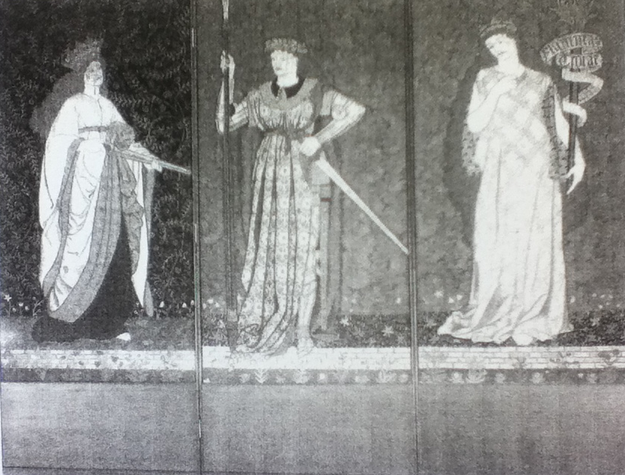

Including tables/figures/images:

* Position figures after the paragraph in which they’re described.
* Cite the source of the figure information with a “source line” at the bottom of the figure.
* Cite a source as you would for parenthetical citation, minus the parentheses, and include full information in an entry on your Works Cited page.
* Acknowledge reproduced or adapted sources appropriately (i.e., data adapted from; map by . . . ).
* Every figure should have a number and a caption flush left on the line below the figure.
* Number figures separately in the order you mention them in the text.
* In the text, identify figures by number (“in figure 3”) rather than by location (“below”).

Figure 1 Heroines, “Three-fold screen with embroidered panels depicting heroines. Designed by William Morris, c. 1860. Worked by Elizabeth (Bessie) Burden, completed 1888… Woolen ground embroidered with wools and silks…Each panel: 171.5 x 73.6 cm. From the Castle Howard Collection…The figures in the screen have been identified as Lucretia (with a sword), Hyppolyte (sword and lance) and Helen” (of Troy). In “Textiles” chapter of *William Morris,* written and edited by Linda Parry published by Philip Wilson Publishers in association with the Victoria and Albert Museum, London in 1996 [plate M.7].

**Conclusion (this is bold)**

This is your final conclusion in one or more paragraphs. What do you honestly think about your topic? What have you learned?

**Bibliography (this is bold) (start on a new page)**

*A bibliography includes items you may have read or looked at, but did not quote in your paper.*

*(select this text box to delete it)*

BOOK WITH ONE AUTHOR

McGhee, Robert. *The Last Imaginary Place: A Human History of the Arctic World*. Oxford: Oxford University Press, 2005.

*A second work by the same author: use em dash: insert -> symbol -> more symbols -> the 3rd dash is em dash.*

*(select this text box to delete it)*

——. *Beluga hunters: an archaeological reconstruction of the history and culture of the Mackenzie Delta Kittegaryumiut*. [St. John's]: Institute of Social and Economic Research, Memorial University of Newfoundland, 1974.

BOOK WITH TWO OR MORE AUTHORS

Williams, Philip F. and Yenna Wu. *The Great Wall of Confinement: The Chinese Prison Camp Through Contemporary Fiction and Reportage.* Berkeley: University of California Press, 2004.

WORK WITH AUTHOR’S NAME IN THE TITLE

Darwin, Charles. *Charles Darwin’s Letters: A Selection, 1825-1859.* Edited by RFrederick Burkhardt. Cambridge: Cambridge University Press, 1996.

*“works cited” is a list of the works you actually made reference to in your footnotes in the body or any images.*

*(select this text box to delete it)*

**Works Cited (this is bold) (start on a new page)**

EDITED WORK WITHOUT AN AUTHOR

Salih, M. Mohamed Salih, ed. *African Parliament: Between Governments and Governance.* New York: Palgrave Macmillan, 2005.

TRANSLATED WORK

Bingying, Xie. *A Woman Soldier’s Own Story*. Translated by Barry Brissman and Lily Chia Brissman. New York: Columbia University Press, 2001.

MULTIVOLUME WORK

Kinder, Hermann and Werner Hilgemann. *The Penguin Atlas of World History.* Vol. 1, *From Prehistory to the Eve of the French Revolution*. Rev. ed. New York: Penguin Books, 2004.

CHAPTER IN AN EDITED WORK(ANTHOLOGY)

Hamilton, Bernard. “The Impact of the Crusades of Western Geographical Knowledge.” In *Eastward Bound: Travel and Travellers, 1050-1550*, edited by Rosamund Allen. Manchester: Manchester University Press, 2004.

EDITION OTHER THAN THE FIRST

Chafe, William H. *The Unfinished Journey: America since World War II*, 5th ed. New York: Oxford University Press, 2002.

WORK IN A SERIES

Flehinger, Brett. *The 1912 Election and the Power of Progressivism: A Brief History with Documents*. Bedford Series in History and Culture. Boston: Bedford/St. Martin’s, 2003.

ARTICLE IN A JOURNAL PAGINATED BY VOLUME

Lucero, Lisa. “The Collapse of the Classic Maya: A Case for the Role of Water Control.” *American Anthropologist* 104 (2002): 814-6.

ARTICLE IN A JOURNAL PAGINATED BY ISSUE

Wynn, Rhoda. “Saints and Sinners: Women and the Practice of Medicine throughout the Ages.” *Journal of the American Medical Association* 283, no. 5 (2000): 668.

ARTICLE IN A POPULAR MAGAZINE

Thomas, Evan. “The Day That Changed America.” *Newsweek Special Double Issue*, December 2001-January 2002, 45-46.

NEWSPAPER ARTICLE

Harris, Hamil. R. and Darryl Fears. “Thousands Pay Respects to King.” *Washington Post*, February 5, 2006, sec. A, Maryland edition.

BOOK REVIEW

Cooper, Ilene. Review of *Nat Turner’s Slave Rebellion in American History*, by Judith Edwards. *Booklist* 96 (2000): 1093.

SOUND RECORDING

Holst, Gustav. *The Planets*. Royal Philharmonic Orchestra. Andre Previn. Telarc compact disc 80133.

FILM, VIDEOCASSETTE, OR DVD

*The Civil War*. Produced and directed by Ken Burns. 11 hours. PBS Video, 1990. 9 videocassettes.

##### *REFERENCE WORKS*

*Well-known reference works, such as encyclopedias, are generally included in footnotes/endnotes but not in the bibliography. Check with your instructor to see if he/she would like you to include them in your bibliography, in which case you would follow one of the examples for a book.*

*(select this text box to delete it)*

WHOLE WEBSITE WITH A KNOWN AUTHOR

Knox, E. L. Skip. “The Crusades.” http://crusades.boisestate.edu.

WHOLE WEBSITE WITHOUT A KNOWN AUTHOR

The Ohio State Department of History. “The Scopes Trial.” http://history.osu.edu/Projects/Clash/Scopes/scopes-page1.htm.

SELECTION FROM A WEBSITE

Linder, Douglas. “An Account of Events in Salem.” *Famous Trials*. www.law.umkc.edu/faculty/projects/ftrials/salem/sal_acct.htm.

ONLINE BOOK

Mather, Cotton. *Memorable Providences, Relating to Witchcrafts and Possessions*. Boston: 1689. At Douglas Linder. *Famous Trials*. www.law.umkc.edu/faculty/projects/ftrials/salem/asa_math.htm.

ARTICLE IN AN ONLINE JOURNAL

Friedman, Shamma. “A Good Story Deserves Retelling--The Unfolding of the Akiva Legend.” *Jewish Studies: An Internet Journal* 3 (2004):55-93. www.biu.ac.il/JS/JSIJ/3-2004/Friedman.pdf.

ARTICLE ACCESSED THROUGH AN ELECTRONIC DATABASE

Toplin, Robert Brent. “The Filmmaker as Historian.” *American Historical Review* 93 (1988): 1210-27. *JSTOR*.www.jstor.org.

ONLINE NEWSPAPER ARTICLE

Linzer, Dafna. “Strong Leads and Dead Ends in Nuclear Case Against Iran.” *WashingtonPost.com*. February 8, 2006. www.washingtonpost.com/wp-dyn/content/article/2006/02/07/AR206020702126.html (accessed February 9, 2006).

Sue Slivan, MLIS

Broome Community College

Chicago Manual of Style paper template

ART 113 / C. Adour (click this box to delete it)

1. These footnotes indicate citations – direct quotes, paraphrases, and indirect references – as well as allow you the chance to add information of your own that might not be a direct part of your manuscript but is still of interest.
2. FORMAT IF YOU ARE INCLUDING A BIBLIOGRAPHY/WORKS CITED: Last Name, page number.
3. Ibid, page number.
4. Chicago Manual of Style Online. 2012. “Chicago-Style Citation Quick Guide.” Accessed September 19. <http://www.chicagomanualofstyle.org/tools_citationguide.html>