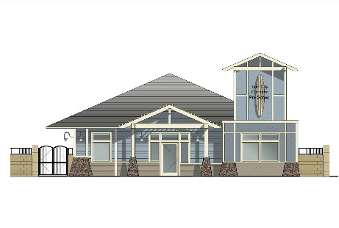

**Surf City Christian**

**Child Development Preschool**

5452 Heil Avenue, Huntington Beach, CA 92649

Phone: (714) 846-0316

[office@surfcitychristian.com](mailto:office@surfcitychristian.com)

www.surfcitychristian.com

**New Family Application 2025-2026**

Date: ___________ Requested Start Date: __________

Child’s Name: ___________________________ Male/Female Date of Birth: __________

Child’s Address:__________________________________________________________

Mother/Guardian Name: _______________ Father /Guardian Name*: ____________*____

Home Address: _____________________ Home Address: _______________________

City: _________________ Zip: ________ City: _________________ Zip: __________

Home Phone: ( ) __ - ______ Home Phone: ( ) - ______________

Cell Phone: ( ) - Cell Phone: ( ) -_______________

Email Address: _____________________ Email Address: _______________________

Employer: _ Employer: ___________________________

Is your child potty trained: Yes No Allergies: ________________________________

What is the expected year your child will start kindergarten? (*Circle One*) 2026 2027 2028

Please list any other childcare facilities your child has attended _________________________

_____________________________________________________________________

Is there any special information you would like us to know about your child?

_____________________________________________________________________

**REQUESTED PROGRAM & DAYS OF ATTENDANCE**

**Circle Program and day option**

**Full Day:**  2 Days 3 Days 5 Days

T/Th M/W/F Monday – Friday

**Half Day:** 2 Days 3 Days 5 Days

T/Th M/W/F Monday – Friday

**Program Request: Star Fish Sea Turtles Surfers/ Sailors**

**2-3 years 3-4 years 4-5 years**

**Notes: ____________________________________________________________________________________________________________**

**PLEASE REMEMBER THIS IS ONLY A REQUEST. WE WILL DO OUR BEST TO ACCOMMODATE EACH FAMILY. THANK YOU, S.C.C.**

**$350.00 NON-REFUNDABLE REGISTRATION FEE DUE UPON PLACEMENT**

**OFFICE USE ONLY**

**Paid Reg. Fee_____________#________ Start Date ____________**

**Program Files—Room/Days offered: ___________________________________**

**On waitlist in Computer: ___________________________________________**