Scott Cacal

6.21.2024

CSD 310

Assignment 4.2

MySQL Install

The following images are of my, MySQL installation.

Bellow is an image of my initial database connection:

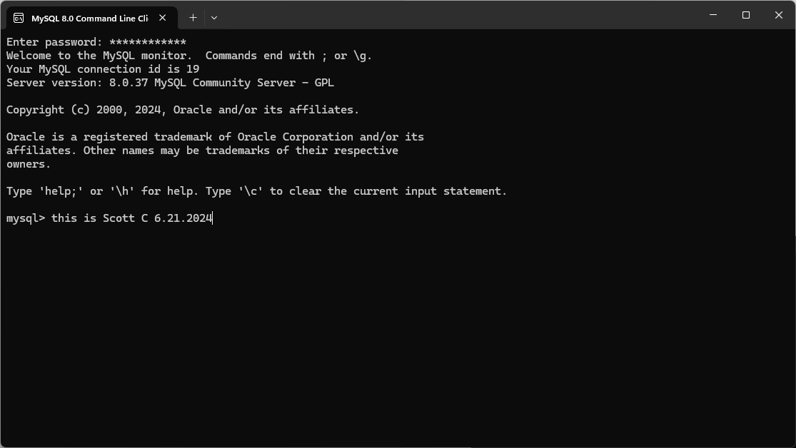

*Initial Database Connection*

Below is an image of my first database creation of a database named, “movies”.

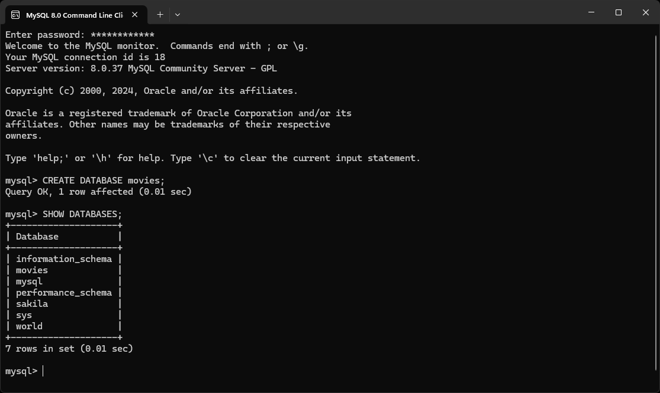

*Show Database*