Scott Cacal

6.21.2024

CSD 310

Assignment 5.3

Movies!

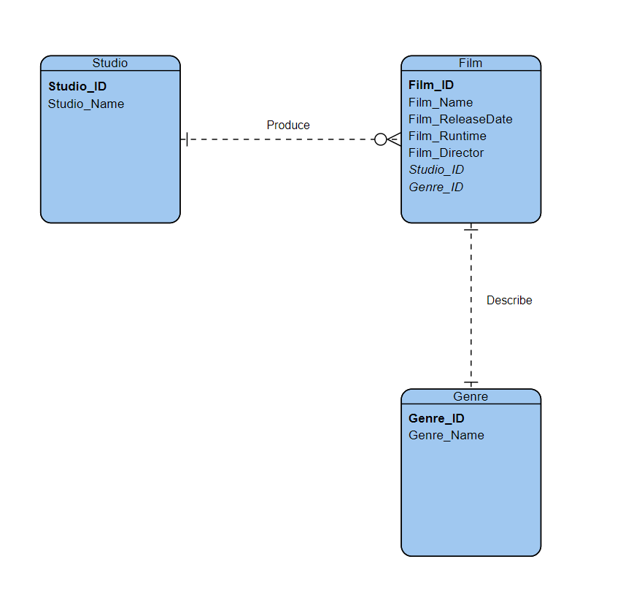Below is the ERD using Visual Paradigm with business rules provided in Module 5.3

*ERD of Movie Database*