Scott Cacal

6.23.2024

CSD 310

Assignment 5.2

MySQL Functions

Below are three functions I have experimented with.

CURRENT_TIMESTAMP()

This function may be used for several points of information. If it’s for a database of users it may provide details of account creation or times of account access which can be used as service support to the user.

*CURRENT_TIMESTAMP() FUNCTION*

TIMEDIFF()

The Timediff() function may be useful for ecommerce purpose. I believe the simplest way to percieve is shipping times. An order is placed and a company has fluctutating lead times be we can provide shipping time to the customer and seller based on that information. In the example below the seller knows they could currently meet a 5 day lead time outputting a hh.mm.ss (hour:min:sec) timestamp for the beginning of a countdown.

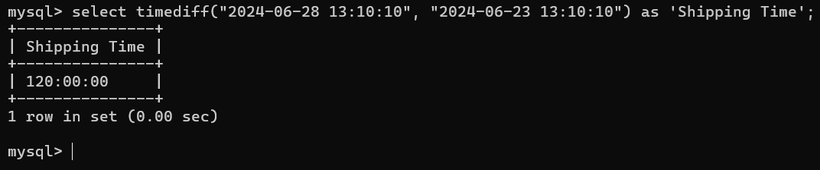

*TIMEDIFF() FUNCTION*

MAX()

I like to relate this function to gaming. A function like this may be useful to quickly evaluate the single highest score of a growing table of values (where values are cyclical and changing).

Further assumptions: From what I’ve been exposed to from past experiences and what I now know as Non-Relational databases, there is a structure to tables (weight tables specifcally) and the structure of the outliers (min and max) are pretty obvious. But for Relational databases, maybe those outliers are completely in the beginning or at the end of a table, so a function like this may be needed.

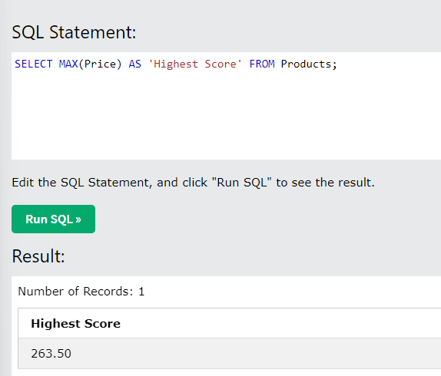

*MAX() FUNCTION*

Note that for this function example I used the sandbox in W3Schools, in order to use this function I needed a table. The table used in the sandbox references a table called “Products”, for the sake of this example I gave the column header name ‘High Score’.