Scott Cacal

6.29.2024

CSD 310

Assignment 6.2

Movies: Setup

Below are images acquired during the Movies Database setup with the provided SQL script and creation of a Python script.

Running the SQL script

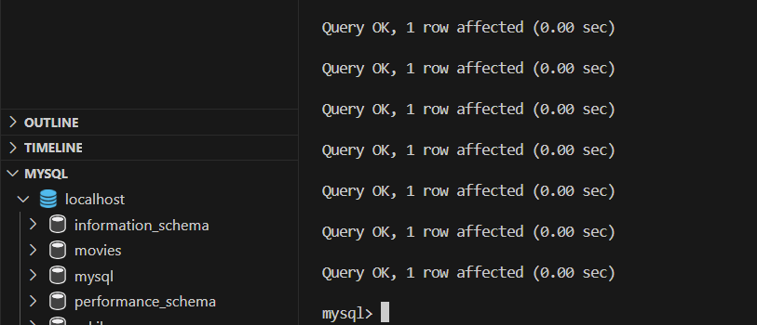

*SQL Script*

Showing a list of database tables

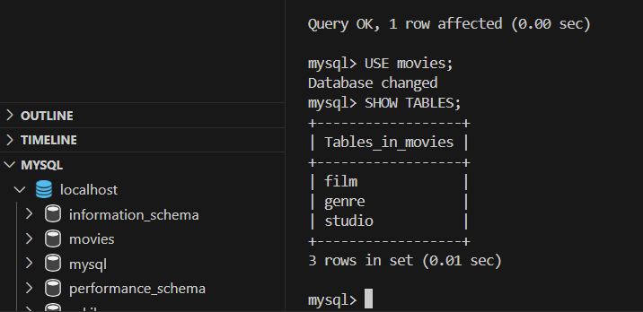

*SHOW TABLES*

Screen shot of running the Python script

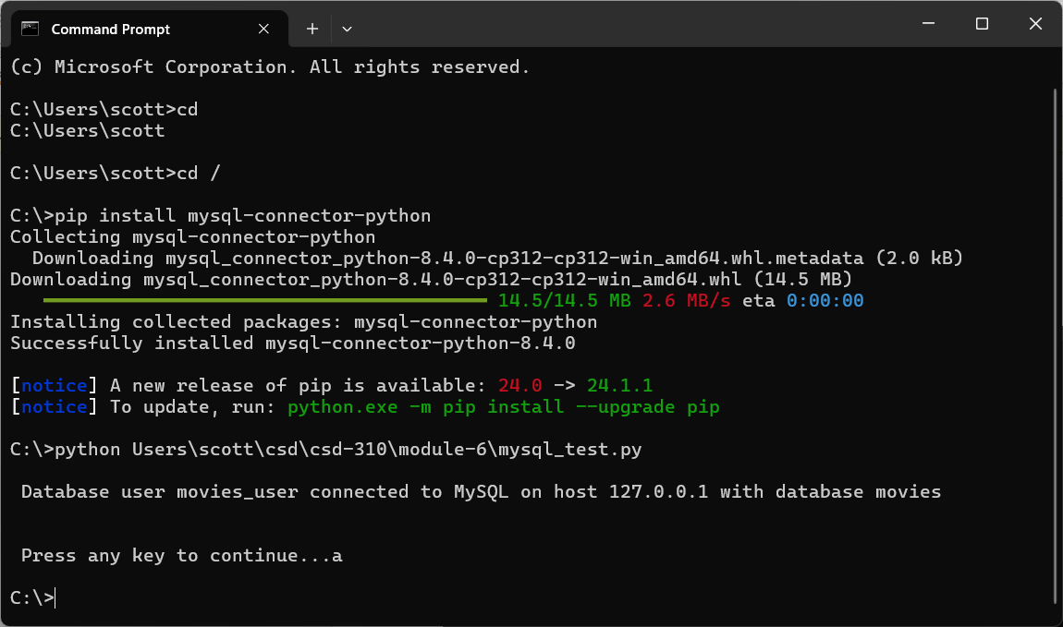

*Python Script*