Scott Cacal

8.17.2024

CSD 340

Assignment 1.3

Building a Web Page Exercise, Part 1

GitHub Link

<https://github.com/scottcacal/csd-340>

Please see the following pages for Assignment 1.3 Screen Shots

*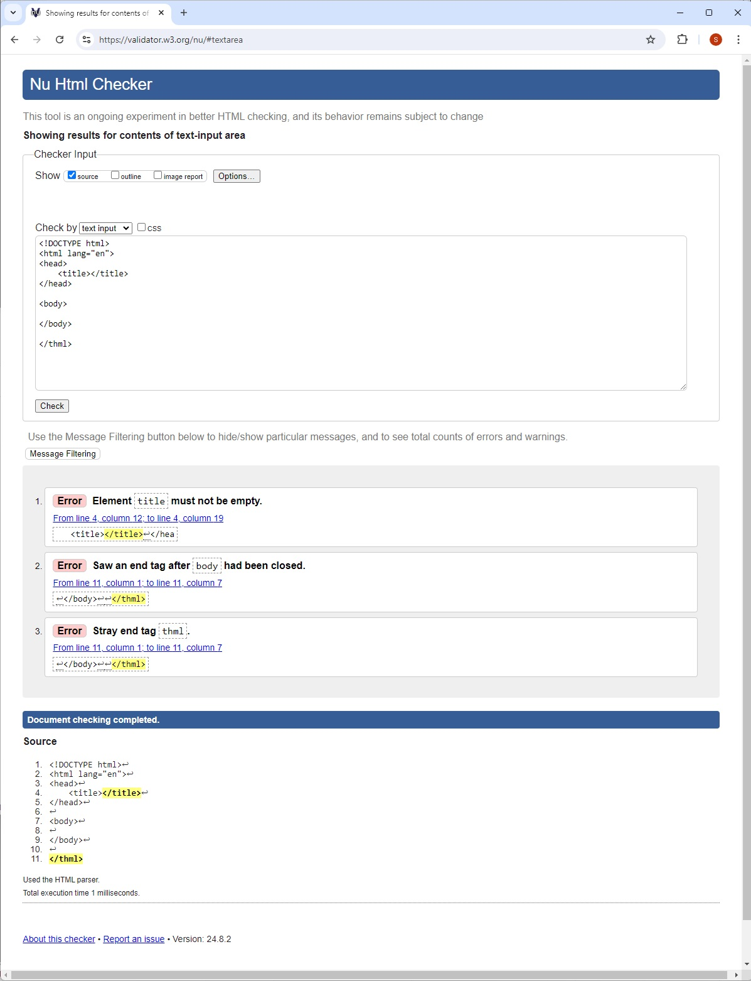*

*Starter Code with Errors*

*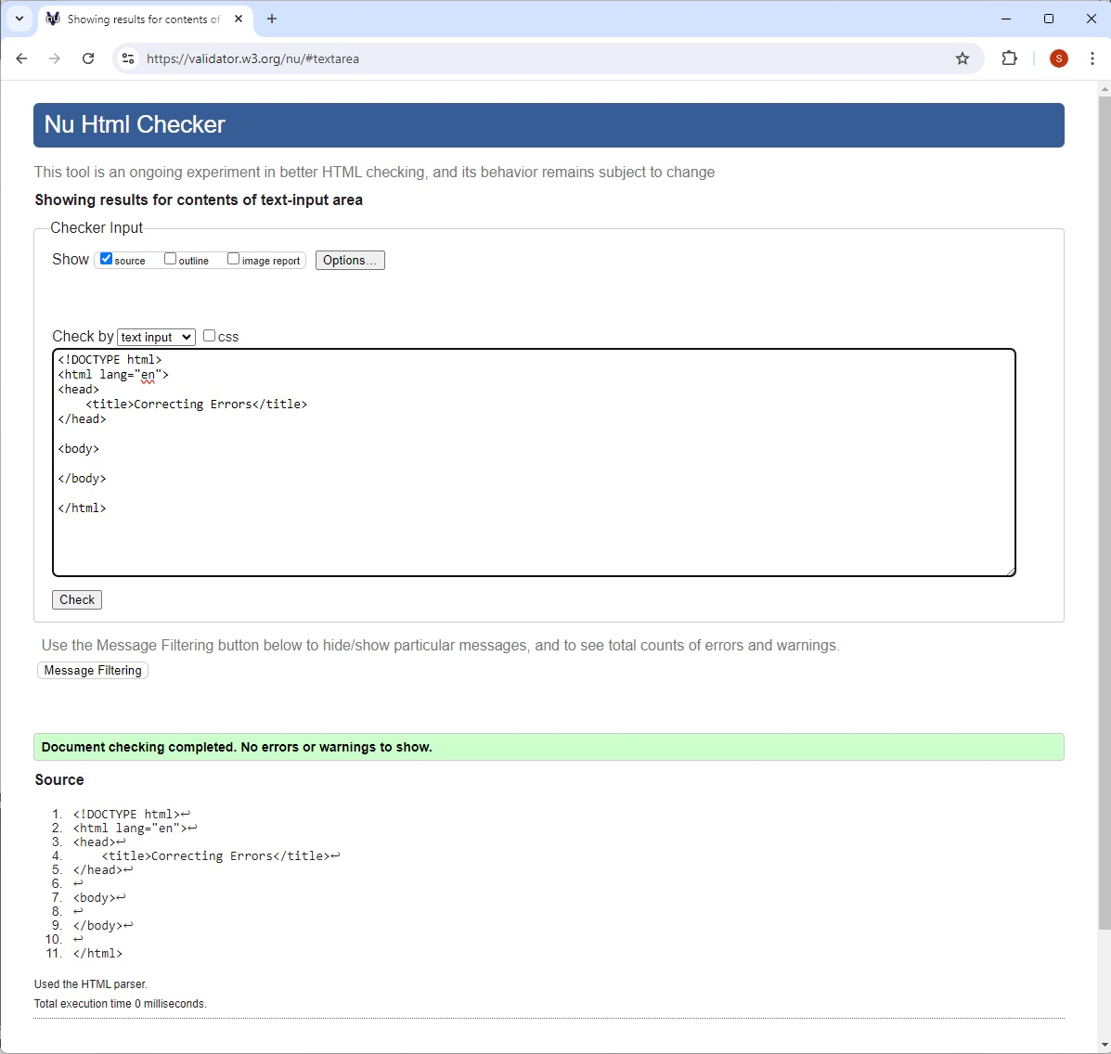*

*Starter Code Corrected*

*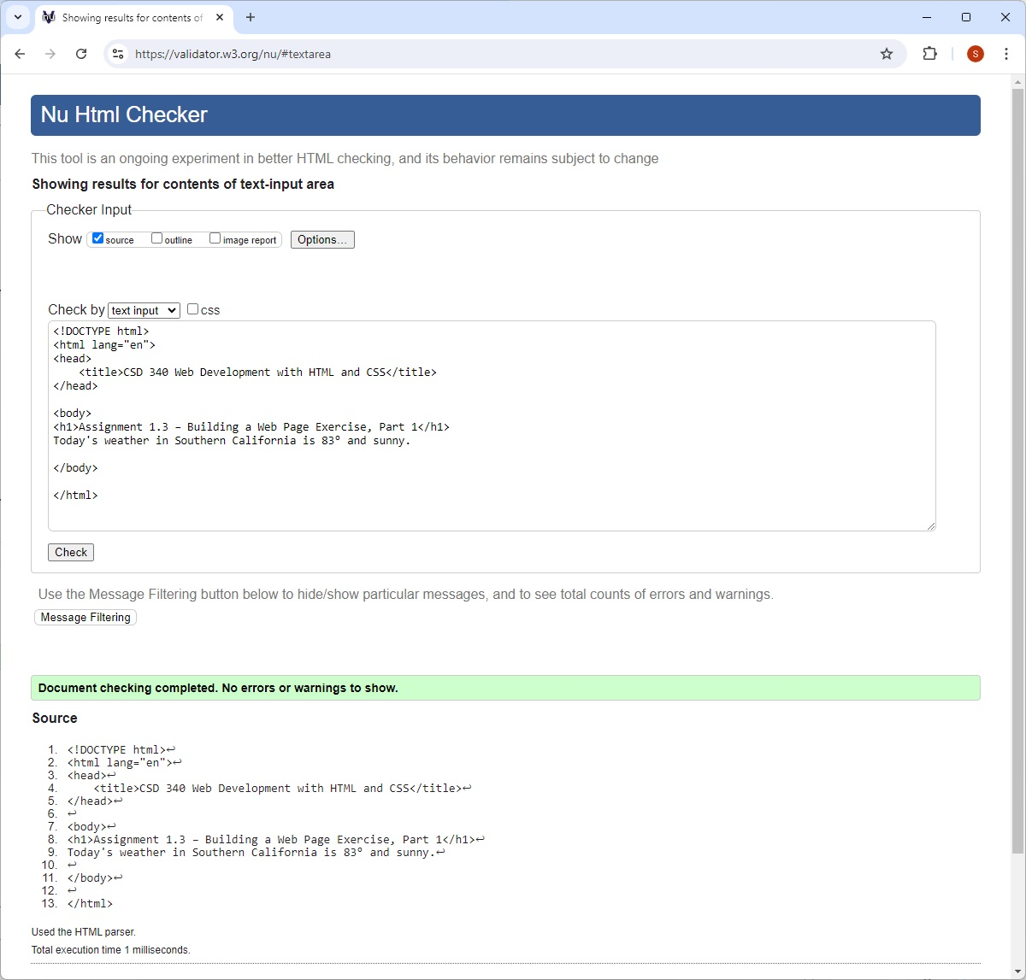*

*Validating Modified Starter Code with Updates*

*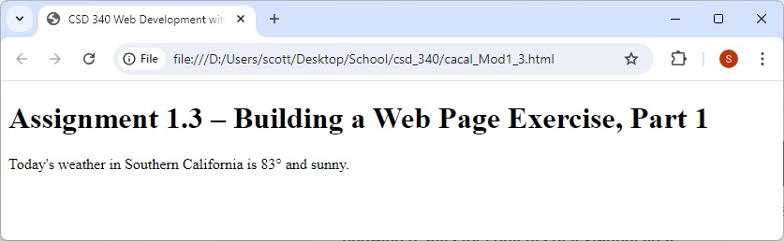*

*HTML File Open*