Scott Cacal

8.24.2024

CSD 340

Assignment 3.2

GitHub Pages

GitHub Link

<https://github.com/scottcacal/csd-340>

GitHub Landing Page

<https://scottcacal.github.io/csd-340/>

Please see the following pages for Assignment 3.2 Screen Shots

*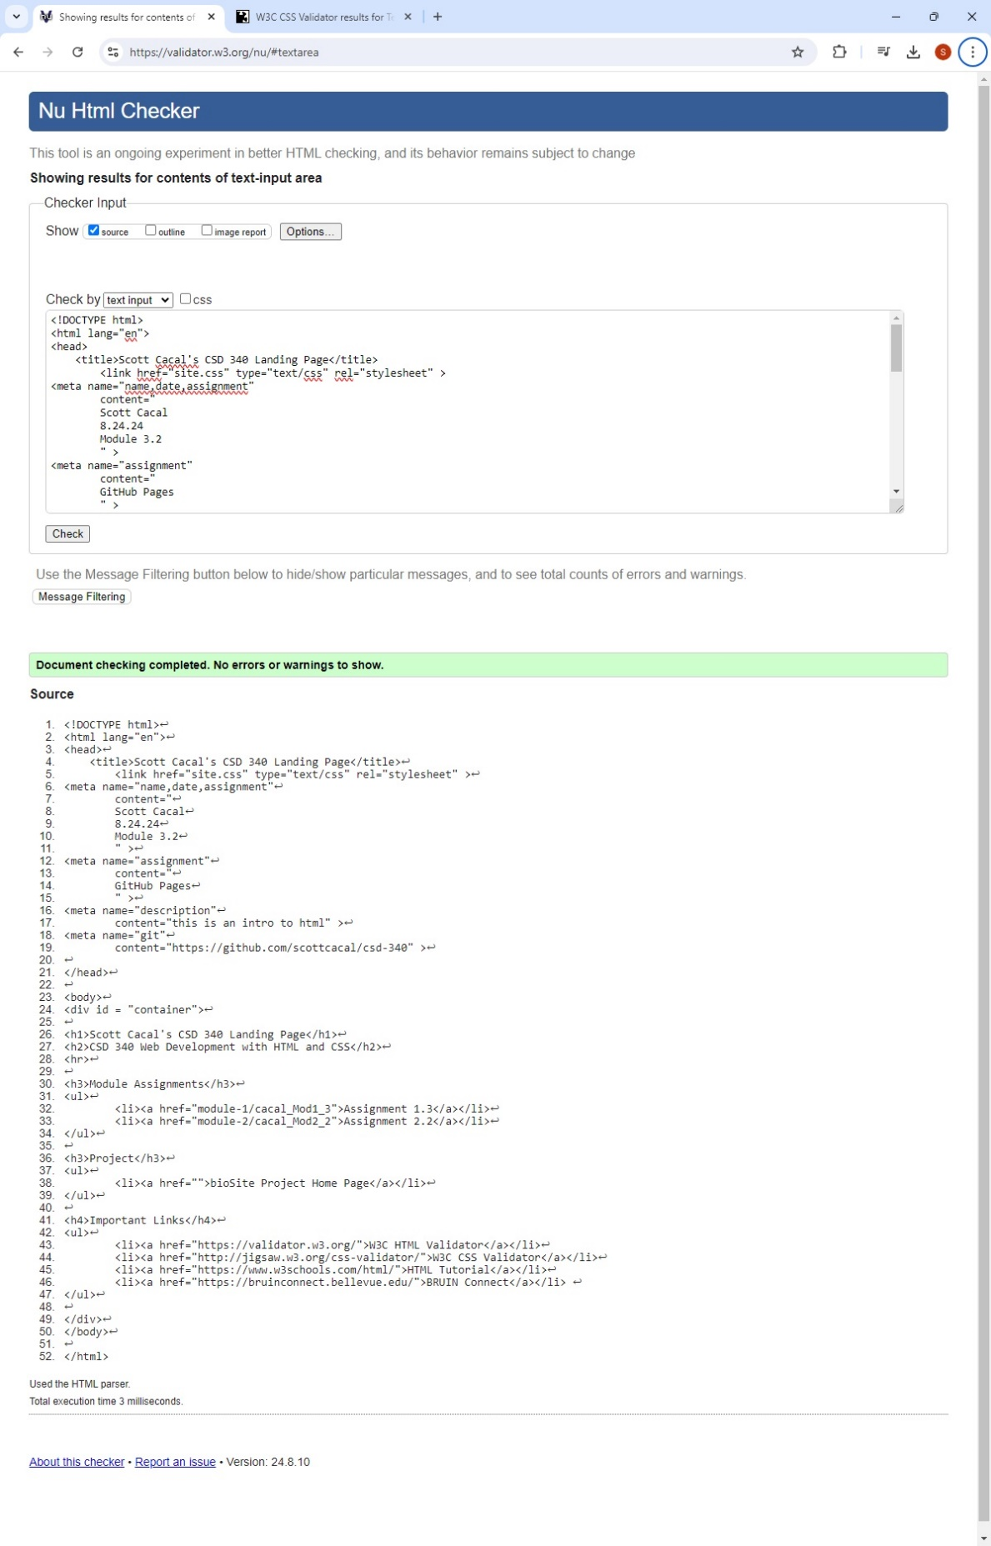*

*HTML Validation*

*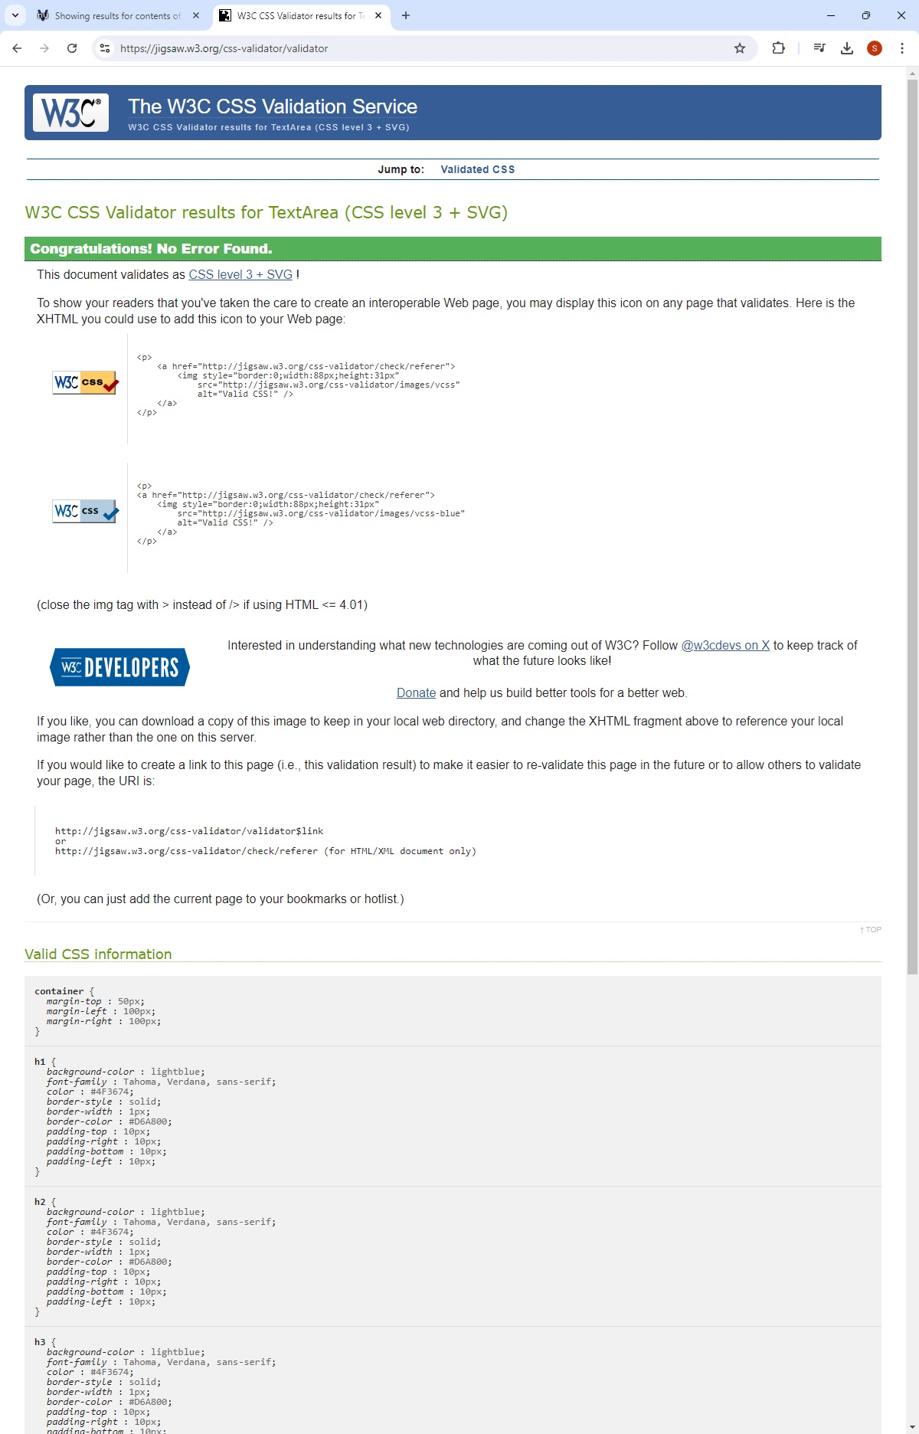*

*CSS Validation*