Scott Cacal

3.2.2025

CSD 380

Assignment 10.2

Shared Code Repository – Git Exercise

GitLab Link (Repo): <https://github.com/david-amos/GitLab>

GitHub User Name: scottcacal

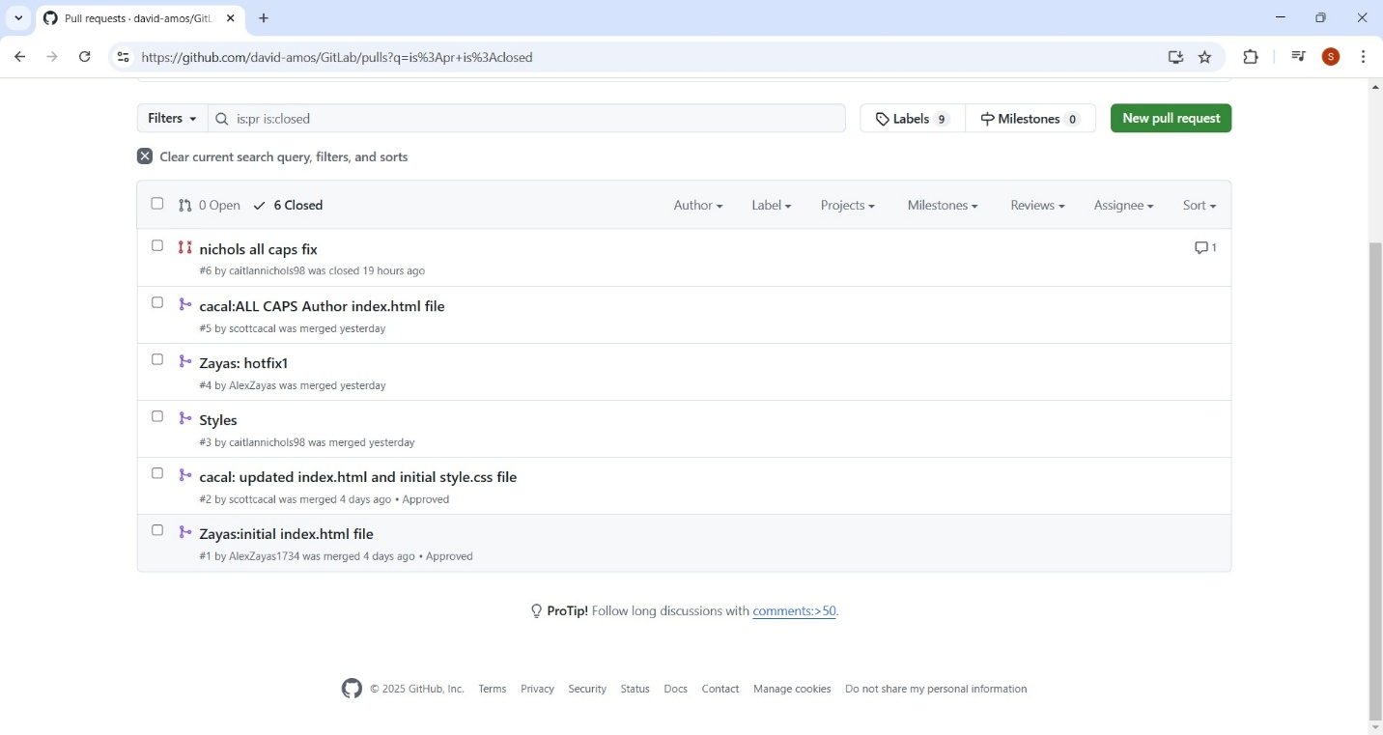

*Pull Request - Closed*