Scott Campbell

CAS 180 SEO – 17688

January 14, 2014

Module 1 Assignment

1. Which is your favorite search engine? Why?
   1. I like to use Google. I prefer Google to other browsers because I like the minimalistic layout, which translates to faster load times, as well as the format of the search results. Also I have a Google account and use Google Chrome.

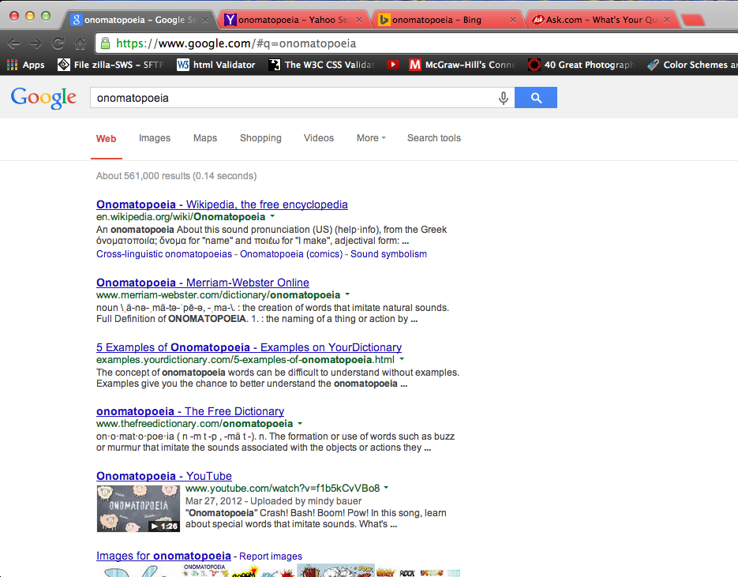

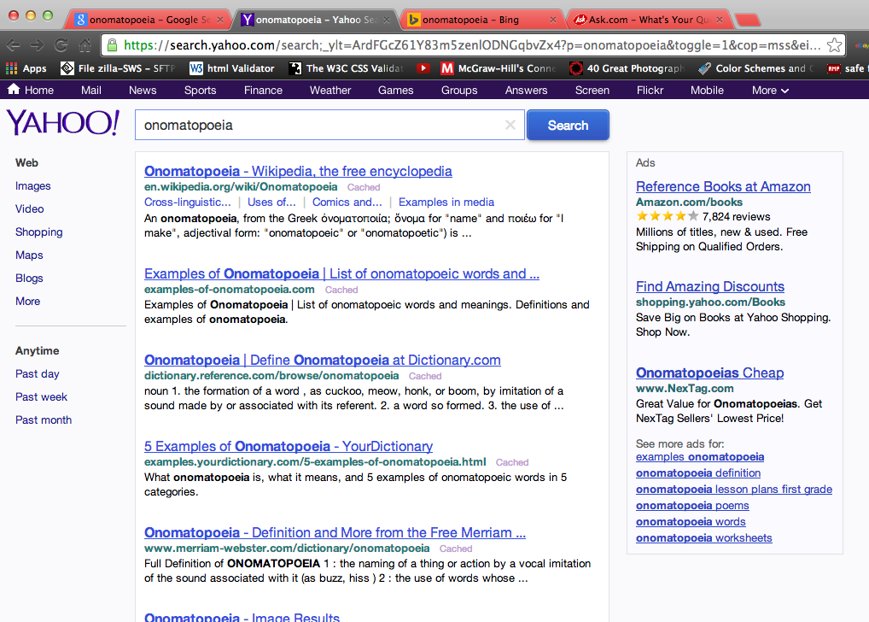

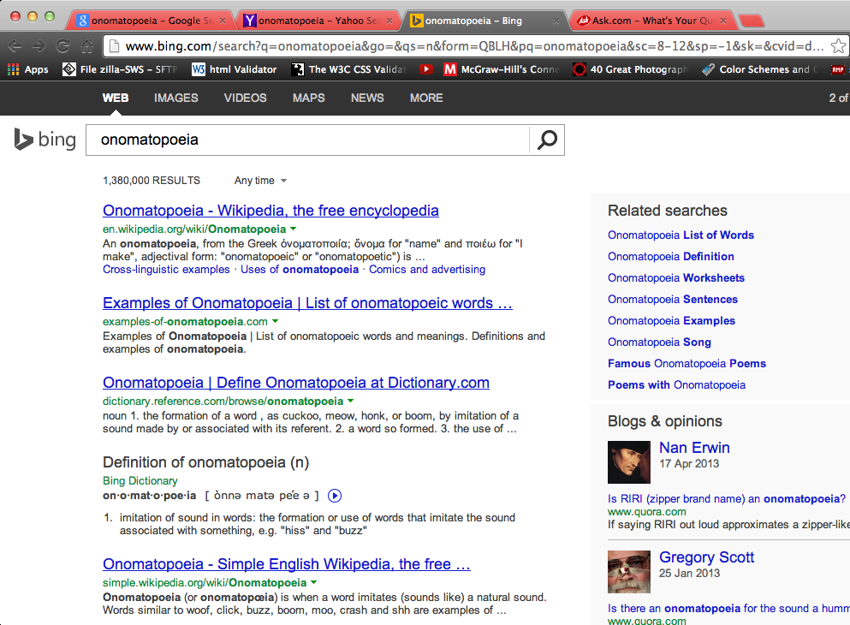

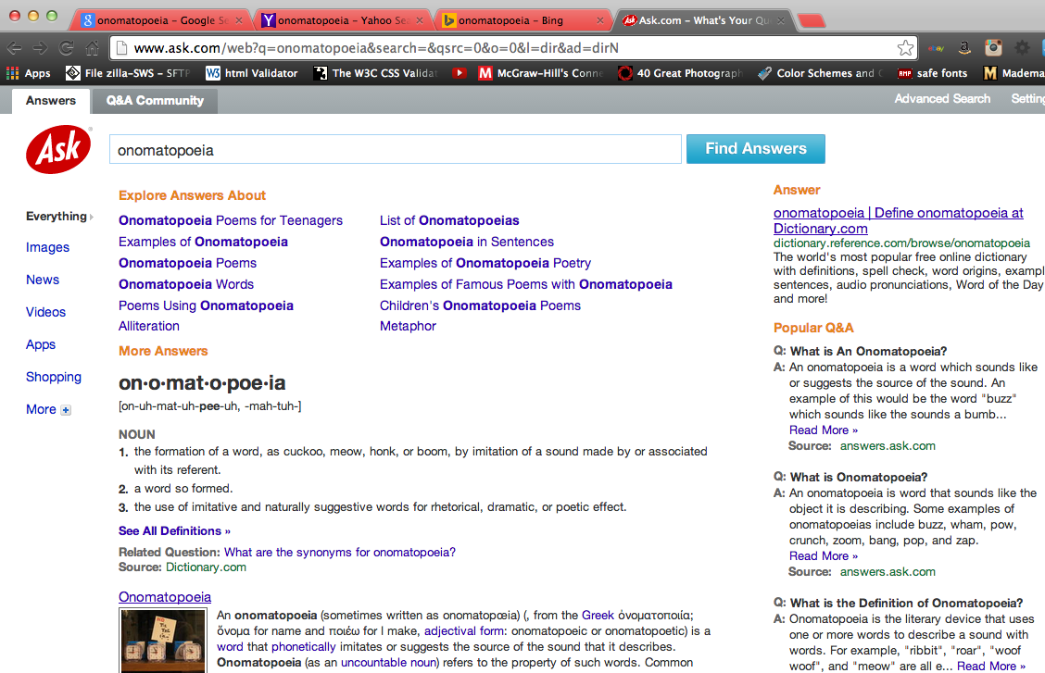

1. Why do you think different results came up?
   1. I think different results came up because different search engines have different ranks for certain websites. Also they have different layouts, which gives them all a unique look and feel.
2. 