CSC 311: Computer Organization and Software Interface
Lab 5 - Due: October 23, 2017

In this lab assignment you will write a Base-64 decoder in MIPS assembly language.

The Multipurpose Internet Mail Extensions (MIME)
In the early days of the ARPANET (the precursor to the Internet), email consisted of only text messages written in English and expressed in ASCII. Nowadays, on the worldwide Internet, this approach is no longer adequate – people want to send arbitrary (possibly binary) data, such as programs, Word documents or music or messages in languages without alphabets (e.g. Chinese and Japanese) or with accents (e.g. French and German). The document RFC 2045 describes MIME, a mechanism for sending files as attachments to an email message. These attachments need to be encoded (wrapped) into text before transmission, and decoded back to their original form by the recipient. One of these encoding methods is called Base 64.
Base 64 encodes three bytes (24 bits) of the input file/data at a time by splitting them into four 6-bit blocks. These blocks are then written as four ‘safe’ ASCII characters, each of which has 64 (2⁶) possible values. The following illustrates how 6 (2 blocks of 3 bytes) bytes of data are encoded. Thus input it’s is encoded as KGl0J3Mp
Input data | ( |  | i |  | t |  | ' | S | )
Bits | 00101000 |  | 01101001 |  | 01110100 |  | 00100111 | 01110011 | 00101001
6 bits at a time | 001010 | 000110 | 100101 | 110100 |  | 001001 | 110111 | 001100 | 101001
Alphabet lookup | 10 | 6 | 37 | 52 |  | 9 | 55 | 12 | 41
Encoded text | K | G | l | 0 |  | J | 3 | M | p

Note that the 6 bits 001010 is 10 in decimal and the number 10 corresponds to the text (or encoding) ‘K’ as can be seen in the Base 64 table that follows.

Base 64 uses the following alphabet:
Encoding | Value | Encoding | Value | Encoding | Value | Encoding | Value
A | 0 | Q | 16 | g | 32 | w | 48
B | 1 | R | 17 | h | 33 | x | 49
C | 2 | S | 18 | i | 34 | y | 50
D | 3 | T | 19 | j | 35 | z | 51
E | 4 | U | 20 | k | 36 | 0 | 52
F | 5 | V | 21 | l | 37 | 1 | 53
G | 6 | W | 22 | m | 38 | 2 | 54
H | 7 | X | 23 | n | 39 | 3 | 55
I | 8 | Y | 24 | o | 40 | 4 | 56
J | 9 | Z | 25 | p | 41 | 5 | 57
K | 10 | a | 26 | q | 42 | 6 | 58
L | 11 | b | 27 | r | 43 | 7 | 59
M | 12 | c | 28 | s | 44 | 8 | 60
N | 13 | d | 29 | t | 45 | 9 | 61
O | 14 | e | 30 | u | 46 | + | 62
P | 15 | f | 31 | v | 47 | / | 63

A Base 64 Encoder is a program that reads up to a line of data (maximum of 80 bytes) from the user and encodes this input in Base 64 using the process explained above and stores or sends the encoded data instead of the original plain ASCII data.

Base 64 Decoder
You will write a MIPS assembly language program that acts as Base 64 Decoder. The decoding process simply performs the encoding steps in reverse. The following diagram illustrates the decoding process.
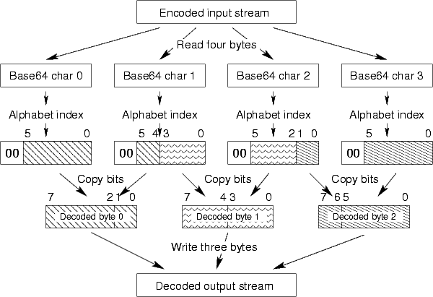
For example, the Base64 encoded string KGl0J3Mp (the third character is the letter l, not a number) would be decoded like this:
Encoded text | K | G |  | l |  | 0 | J | 3 |  | M |  | p
Alphabet lookup | 10 | 6 |  | 37 |  | 52 | 9 | 55 |  | 12 |  | 41
In binary | 001010 | 000110 |  | 100101 |  | 110100 | 001001 | 110111 |  | 001100 |  | 101001
Grouped into bytes | 00101000 |  | 01101001 |  | 01110100 |  | 00100111 |  | 01110011 |  | 00101001
Written as ASCII | ( |  | i |  | t |  | ' |  | s |  | )

- Note the read-four bytes, write-three bytes behavior, which repeats twice in the above example.
Write a program that reads up to a line of Base 64 encoded data (maximum of 80 bytes) from the user and decodes this input as explained above and stores the decoded data in memory.
- Note that your program should in some way be able to hold/store the Base 64 alphabet so that it can access it to do an alphabet lookup. For example when the user types in ‘K’ as the encoded text, your program should recognize it as 10 because K occurs in the 10th position in the alphabet (remember that the alphabet starts from index 0 to 63).
- Note that when you read a byte from the encoded input, since this is a character in Base 64 only 6 bits i.e., bits 0-5 matter, the most significant 2 bits are always 0 (since 0 to 63 can be encoded using 6 bits).
- The arrows and the patterns in the above figure explain how the encoded bits are grouped to get the final decoded output.
Your program should give the following output.
“The Base 64 encoded input data was: …”
“The decoded ASCII output is: …”
Now add a loop to your program so that it keeps asking the user to enter the encoded data as long as the first character the user enters is not a newline character. Note that this is not a problem because newline is not a character in the Base 64 alphabet.
Obviously your program will not work correctly if the user enters encoded data that is not a multiple of 4 bytes right! Assume that the user always enters input that is a multiple of 4 bytes.
Make sure your code is clean, modular and well commented explaining the use of registers and clearly explaining your logic. Make sure your code is modular i.e. instead of writing one big chunk of code; break your code into different appropriately defined functions.

Submit the log file and the .s file.

