**Analysis of Kickstarter Campaigns**

**By Scott McMahan**

Kickstarter is a wildly popular crowd fundraising platform. It went online on April 28, 2009, and has since raised several billion dollars for creative and technological projects around the world.

Founded by Perry Chen, Charles Adler, and Yancey Strickler, the company allows filmmakers, musicians, artists, and designers to have complete control of a fundraising campaign while also maintaining creative control.

Tens of thousands of projects have been successfully funded via the project campaign platform. Notably, people that make pledges to campaigns that fail to meet their funding goals are refunded the money.

A vast range of projects successfully used the website as a financial launchpad. The given data related to about 4,114 campaigns.

Project campaign categories from the data through 2017 included creative endeavors ranging from theater, music, and film and video production to games, technology, and journalism.

The goal fundraising amount sought in the campaigns ranged from a single dollar to $10 million to build a time machine to travel to the distant future (to experience a time that would be like a popular video game), but ended up raising no money.

The highest monetary amount sought in an ultimately successful campaign in the data was $400,000. Yet this campaign, from CestAR to develop and to begin mass production of an augmented reality device that could add realistic 3D projections onto live images of the surroundings, managed to raise $1052110.87.

Total pledges for the campaigns ranged from nothing to well over two million dollars.

Even the successful campaign with the highest total number of pledges, a project to develop and begin production of a 3D printing pen, only sought to raise $30,000. Yet, the campaign managed to gain pledges totaling $2344134.67. This project also had the highest number of backers, 26,457.

A project seeking funding to develop a wireless duo stereo sound system had the funding goal of merely $1 but raised $22,603, reaching 2260300% of the funding goal. This project was an outlier in terms of the percentage of the funding goal pledged.

**Project Categories and Subcategories**

Theater projects were the most common category with 1393 total campaigns. Of those, 839 were successful, 493 failed, 37 were canceled, and 24 were live as of approximately March 2017. Of the successful theater projects, 694 were plays, 85 were classified as spaces, and 60 were musicals.

Music campaigns were the second most common fundraising project types, 700 total. Some 540 were successful, 120 failed, 20 were canceled, and 20 were live. Rock was by far the most common with 260 successful projects. Indie rock and metal were not included in the rock category.

Funding campaigns for film and video projects were the third most common, with a total of 520, including 300 successful, 180 failed, and 40 canceled. Of the successful film project campaigns, 180 were for documentaries.

**Kickstarter Campaigns by Category and Subcategory**

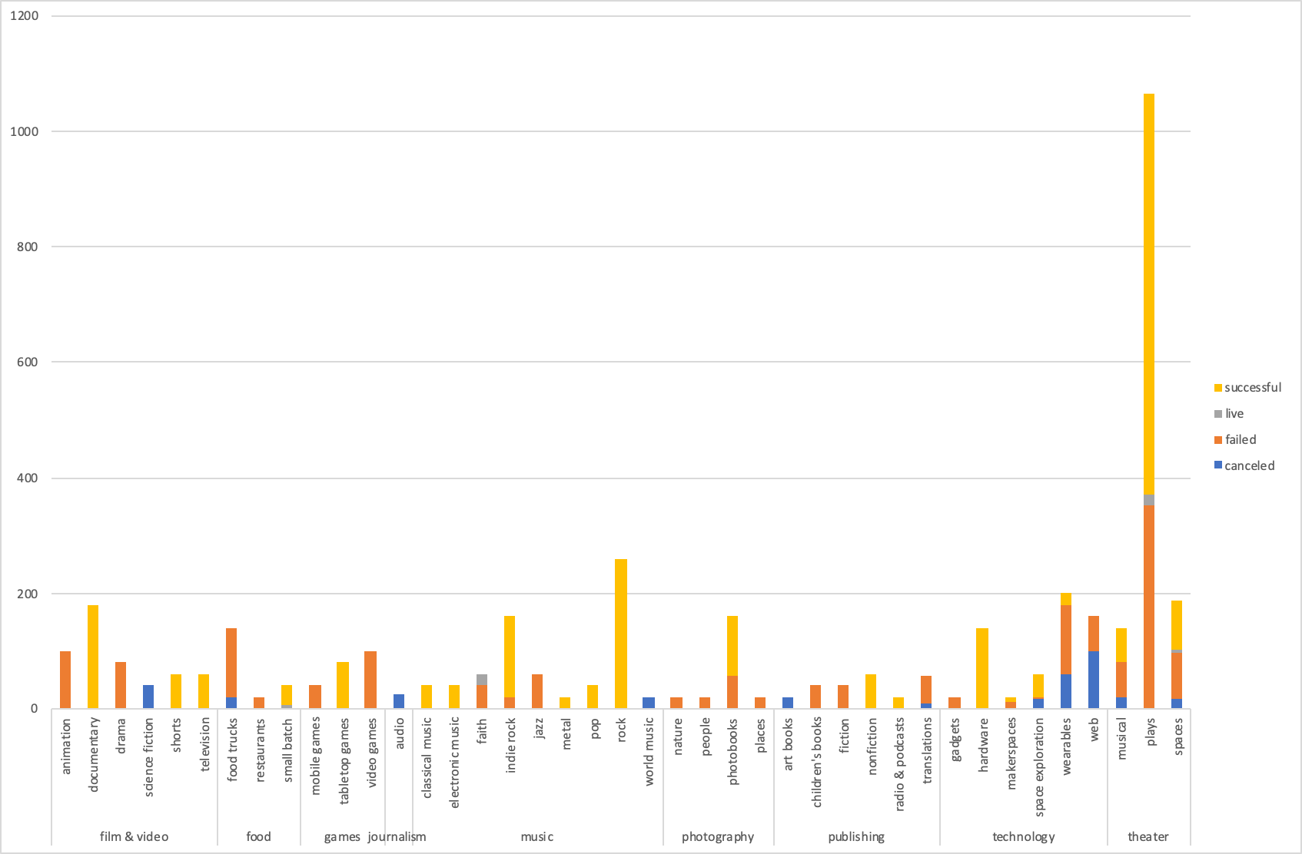

**Comparing Kickstarter Campaign Timing by Month**

A time series analysis of the campaigns outcomes does not appear to show any clear seasonality in the campaign outcomes. However, several of the categories including music, technology, food, and games, appear to show their highest peak in the number of successful campaigns in ending in March.

The most successful campaigns in total funding had at least one thing in common. They were seeking only small to modest amounts compared to what they eventually obtained from backers.

Journalism projects were by far the least successful type with all 24 of the projects canceled.

**Timing of Kickstarter Campaigns by Month**

(Including Food, Games, Music, and Technology, Music, for April 2009 to May 2017)

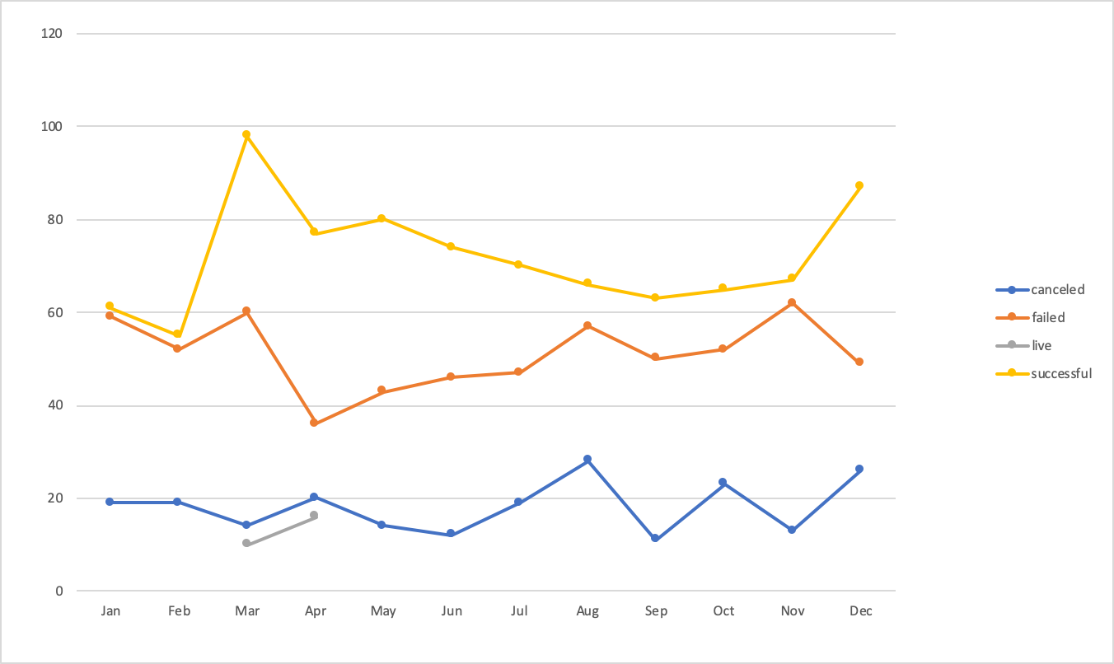

**Percentage of Goal of Successful Campaigns**

The percentage of the goal amount pledged for successful projects varied tremendously from 100% to 2260300%. One campaign outlier (previously mentioned) earned 22,603 times as much as its meager $1 goal. Another outlier, for a horror role playing game earned 9,302.5 times as much as its $1 goal (930250%).

A third outlier had a goal of $10 but raised $30,383.32 for 303833.2% of the goal. Of the 2194 successful campaigns, excluding the outliers, the average was 164% of the goal.

The vast majority, 3038 of the 4114 funding campaigns, originated in the United States.

**U.S. Kickstarter Campaigns By Category**

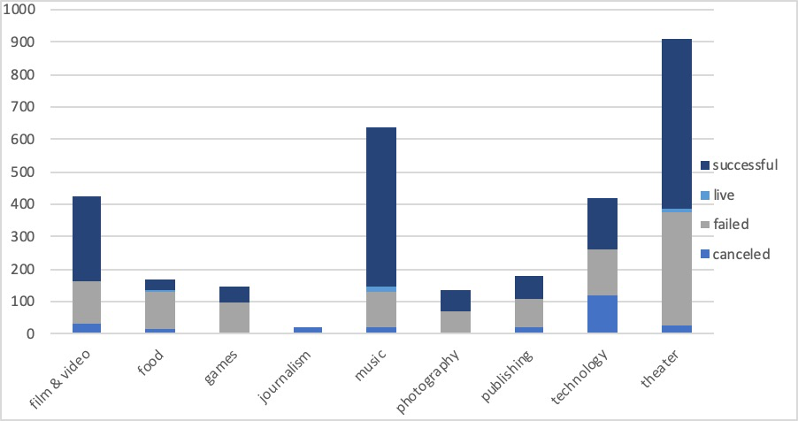

A significant number of campaigns also began in Europe (including Great Britain), 828. Of these 604 originated in the UK (GB). Austria (AT) had 6, Belgium (BE) 2, Switzerland (CH) 6, Germany (DE) 53, Denmark (DK) 14, Spain (ES) 21, France (FR) 27, Ireland (IE) 15, Italy (IT) 29, Luxembourg (LU) 2, Netherlands (NL) 21, Norway (NO) 7, and Sweden (SE) 21.

**European Kickstarter Campaigns Including UK**

(April 2009 – May 2017)

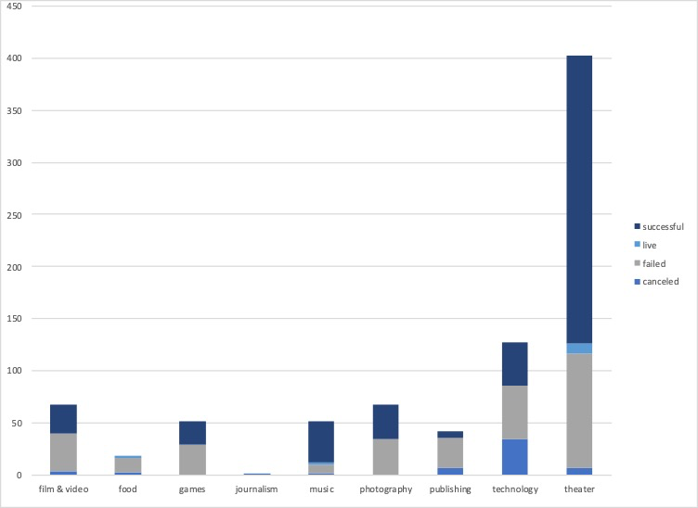

Some also originated in Canada (CA) 146, Mexico (MX) 12, as well as Australia (AU) 74, and New Zealand (NZ).

Several campaigns originated in Asia with three from Hong Kong (HK) and one from Singapore (SG). However, no campaigns originated in Africa, India, and the Middle East and such currencies were excluded as the currency types used.

**Limitations of the Data Set**

While the data does provide the country of origin, it does not offer the country of origin of pledges. Ages, demographics (ethnicities), and genders, of the individual or individuals setting up the campaigns, were also not disclosed.

Links to the campaign launch pages were not included. So, the text and presentations and videos of what makes the most successful campaign launch pages cannot be analyzed.

The data also does not reveal whether a single individual, a group or an already established business or company started the campaigns.

Another potentially interesting aspect of how much each campaign raised might also examine the total amount of funding raised (in equivalent US dollars at the time of each pledge, compared to the average per capita income of people within the country of origin.

Other, potentially useful graphs derived from the data could include,

a graph of the percentage of successful campaign goals pledged by country of origin. Another graph could show the percentage of successful campaign goals pledged by campaign category and subcategory.

An additional graph could be used to visualize the total funding of successful campaigns based on the category and subcategory of the campaigns.

However, to enable an apples to apples comparison, data about exchange rates of the given currency would also be needed. Therefore, graphs looking at total funding obtained in US dollars would not be possible with the given data, because the exchange rates at the date and time of each pledge were not included.