PatentForge
Architecture & Design Document
Full-Lifecycle Patent Analysis Platform
Version 0.1.0-draft | March 30, 2026 | Pre-development

1. Vision
PatentForge is an open-source, full-lifecycle patent platform that takes an inventor from "I have an idea" to "here's a draft patent application with prior art citations, compliance checks, and a filing strategy" — then tracks the patent through prosecution. It is the only open-source tool that covers the entire patent lifecycle in one platform.

2. System Architecture

2.1 Federated Service Model
PatentForge uses a federated architecture: a central backend orchestrates independent specialized services that each own one capability. Services communicate over HTTP/JSON and can be developed, deployed, scaled, and replaced independently.
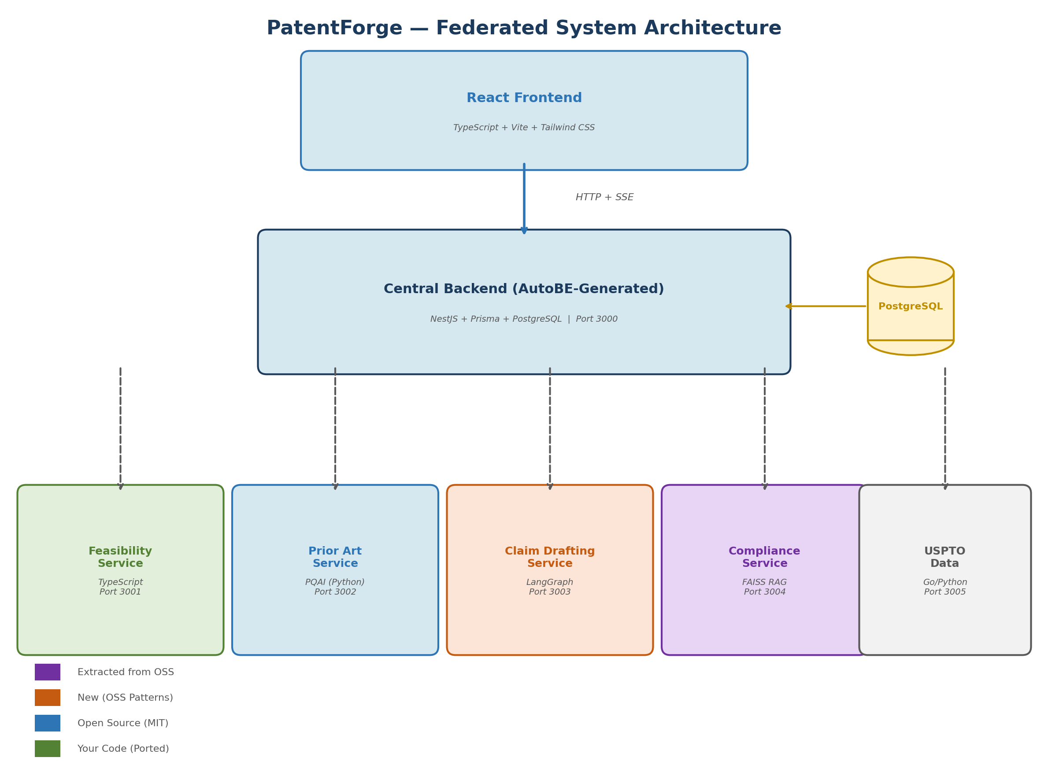

2.2 Central Backend (AutoBE-Generated)
The central backend is generated by AutoBE from a natural language requirements specification. It provides:
Project State Machine: INTAKE → FEASIBILITY → PRIOR_ART → DRAFTING → COMPLIANCE → APPLICATION → FILED. Downstream stages are marked STALE when upstream stages are re-run.
Service Adapters: Manually written TypeScript adapters that call each specialized service (feasibility, prior art, drafting, compliance, USPTO) via HTTP.
Unified Event Bus: SSE endpoint that streams events from all services to the frontend in a common envelope format.
Document Versioning: Every artifact is versioned per project. Re-running a stage creates a new version without deleting history.
Technology Stack: NestJS (TypeScript), Prisma ORM + PostgreSQL, SSE streaming, generated by AutoBE with 100% compilation guarantee.

2.3 Database Schema
The database uses Prisma ORM with PostgreSQL (production) or SQLite (development). The schema is designed around the patent lifecycle stages:
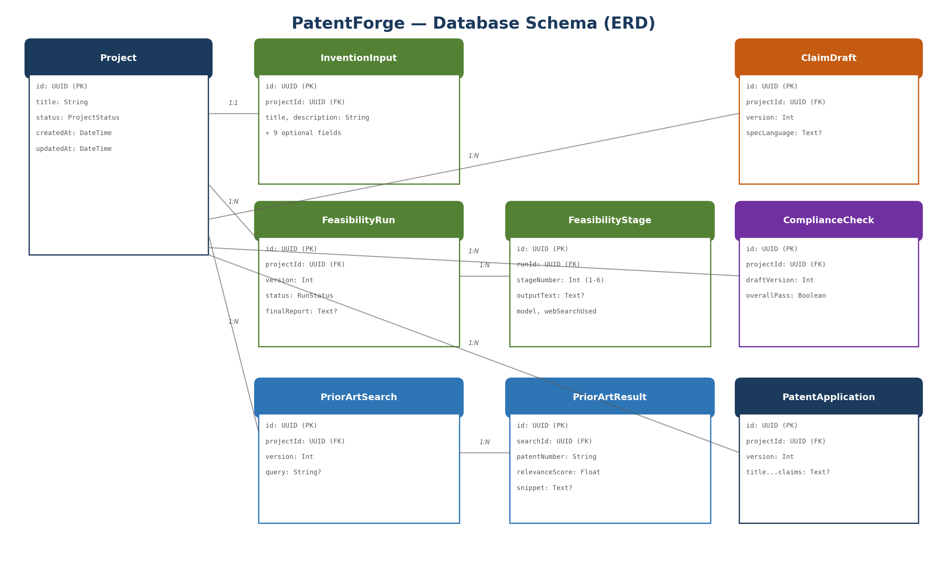

3. Service Specifications

3.1 Feasibility Service
Source: Ported from scottconverse/patent-analyzer-app (C#/.NET 8 → TypeScript)
Runs a 6-stage sequential AI analysis pipeline that evaluates whether an invention is patentable and provides a filing strategy.
# | Stage Name | Web Search | Purpose
1 | Technical Intake & Restatement | No | Restates invention in precise technical/legal terms
2 | Prior Art Research | Yes (20) | LLM-powered prior art search via web
3 | Patentability Analysis | Yes (5) | 101 eligibility, 102 novelty, 103 obviousness, 112 enablement
4 | Deep Dive Analysis | Yes (10) | Specialized analysis of AI/ML and 3D printing elements
5 | IP Strategy & Recommendations | No | Filing strategy, cost estimates, claim directions, timeline
6 | Comprehensive Report | No | Assembles all findings into professional report
Each stage receives all previous stage outputs as context. The service streams tokens to the caller via SSE for real-time display. Rate limit retry with escalating delays (60s/90s/120s). Supports cancellation at any point.

3.2 Prior Art Service
Source: PQAI (MIT) by Georgia IP Alliance + AT&T — ML-powered semantic patent search trained on historical patent examiner decisions.
9-stage pipeline: query preprocessing → CPC index selection → SentenceTransformer vectorization → relevance feedback → FAISS vector search → post-retrieval filtering → MatchPyramid reranking → snippet extraction → result assembly.
Integration options: PQAI public API (zero setup, free) or self-hosted (6 Docker containers, full control). Covers US patents via USPTO bulk data.

3.3 Claim Drafting Service
Source: Architecture patterns from AutoPatent (MIT, 188 stars) and M-Cube (MIT, 117 stars).
Multi-agent system: Planner (builds claim tree via PGTree) → Writer (drafts claim language per node) → Examiner (reviews for quality and gaps) → revision loop. Claims are informed by prior art results and feasibility analysis.

3.4 Compliance Service
Source: Extracted from Claude-Patent-Creator (MIT, 51 stars) — hybrid RAG over MPEP/USC/CFR.
Check | Statute | What It Catches
Written Description | 35 USC 112(a) | Specification doesn't support the claims
Enablement | 35 USC 112(a) | Specification doesn't teach how to make/use
Definiteness | 35 USC 112(b) | Ambiguous claim language, missing antecedent basis
Formalities | MPEP 608 | Format, numbering, dependency chain errors
Abstract Eligibility | 35 USC 101 | Alice/Mayo framework abstract idea test
Uses BM25 keyword search + FAISS dense vector search over the legal corpus, merged and reranked. LLM evaluates claims against retrieved passages and returns structured pass/fail/warn results with MPEP citations.

3.5 USPTO Data Service
Source: USPTO-CLI (MIT, Go, 50+ endpoints) + pyUSPTO (MIT, Python, 9 APIs including Office Action retrieval).
Provides patent bibliographic data, family trees, prosecution timelines, PTAB proceedings, and full-text search. Wraps the USPTO Open Data Portal (38 API endpoints, free, rate-limited).

4. User Journey & UX Design
The user journey follows the patent lifecycle through 7 stages, from invention disclosure to USPTO filing and prosecution tracking:
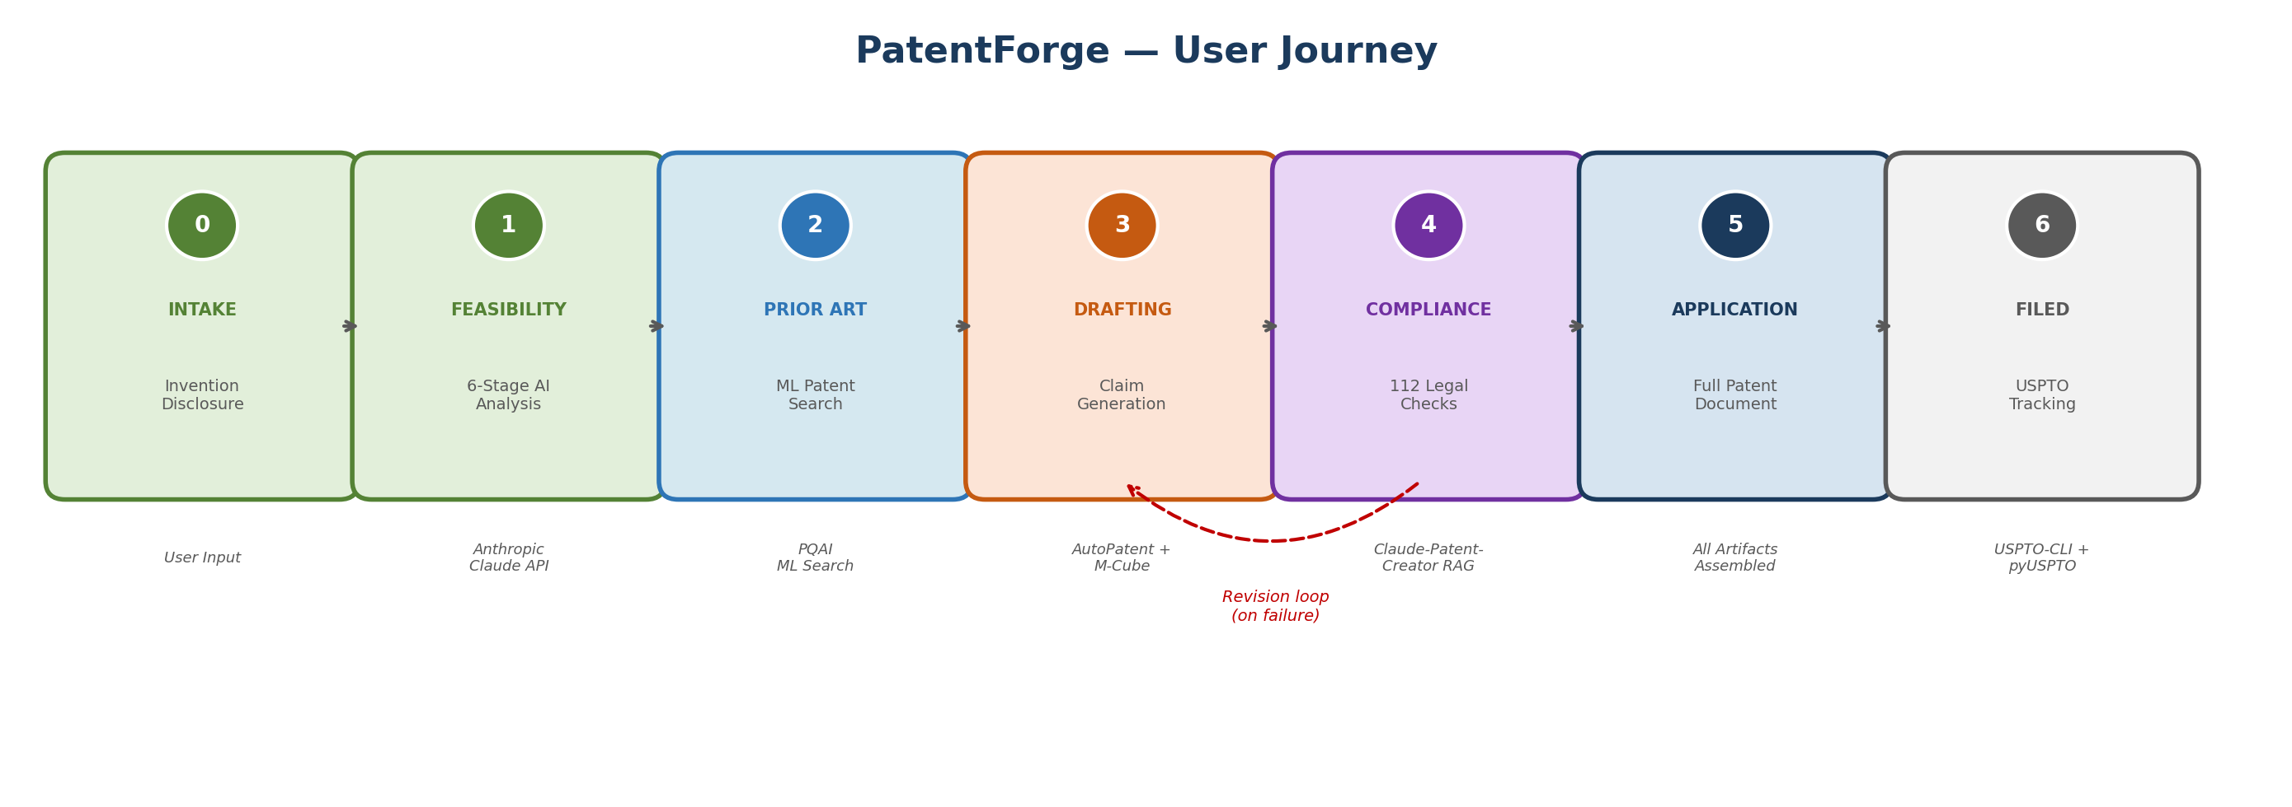

4.1 Cross-Stage Data Flow
Each stage feeds forward into the next. The central backend manages routing and data assembly:
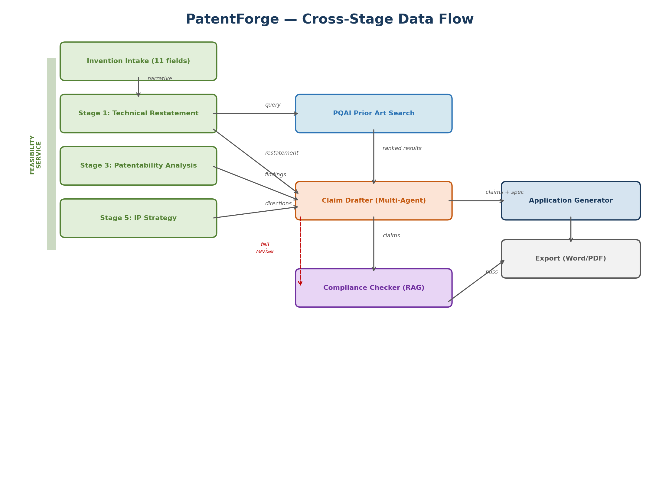
When compliance checks fail, the system routes issues back to the claim drafter for targeted revision (red dashed arrow), then re-runs only the affected compliance checks.

5. Deployment
All services are containerized and orchestrated via Docker Compose. A single "docker compose up" command starts the entire platform.
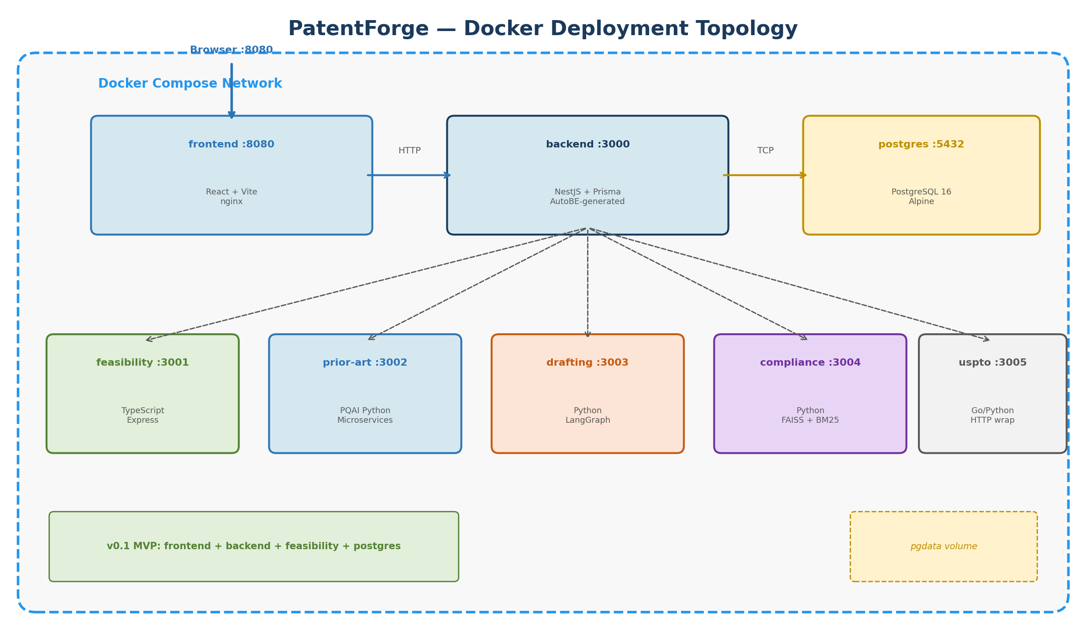
v0.1 MVP requires only 4 containers: frontend, backend, feasibility, and postgres. Additional services are added one at a time as they are built.

6. Technology Sources & Licenses
All source components are MIT-licensed (commercially safe) or public government APIs:
Component | Source | License | Stars | Status
Central Backend | AutoBE (wrtnio/autobe) | MIT | — | Active
Feasibility Pipeline | patent-analyzer-app (private) | Proprietary | — | Active
Prior Art ML Search | pqaidevteam/pqai | MIT | 115 | Active
Claim Drafting | AutoPatent + M-Cube | MIT | 188 / 117 | Active
Compliance RAG | Claude-Patent-Creator | MIT | 51 | Active
USPTO Data (Go) | smcronin/uspto-cli | MIT | 31 | Active
USPTO Data (Python) | DunlapCoddingPC/pyUSPTO | MIT | 2 | Active
Patent Image Search | TIBHannover/iPatent | MIT | 2 | Early
Bulk Data Sync | patent-dev/bulk-file-loader | MIT | — | Active
USPTO APIs | USPTO Open Data Portal | Public | — | Active

7. Release Phases
The platform ships incrementally. Each phase is independently useful:
Phase | Services | What Ships | User Gets
v0.1 | Backend + Feasibility + Frontend | Web patent feasibility analyzer | Cross-platform WPF replacement
v0.2 | + Prior Art Service (PQAI API) | ML prior art search | Structured search alongside LLM
v0.3 | + USPTO Data Service | Patent data enrichment | Real patent lookups, prosecution
v0.4 | + Claim Drafting Service | AI claim generation | Claims informed by prior art
v0.5 | + Compliance Service | Legal compliance checks | 112a/112b/MPEP validation
v0.6 | + Application Generator | Full patent application export | Word/PDF ready for filing
v1.0 | + Portfolio Dashboard | Prosecution tracking | Full lifecycle management

