**Lab 1: MACC Accelerator**

**EDA Playground Link:** <https://www.edaplayground.com/x/P_x8>

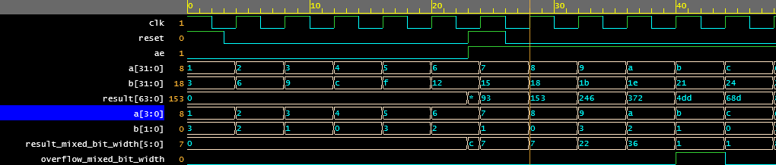

**Figure 1:** Screenshot of resulting waveform. Bottom half is using module with mixed bit-width inputs where a is 4 bits wide and b is 2 bits wide.

**Contribution:**

Scott: Worked on code/process implementation with Ankush as a pair.

Ankush: Worked on code/process implementation with Scott as a pair.

Asad: Worked on debugging, waveform development and the writeup (was not available for code implementation due to a death in the family)