“Kickstarter is one of those platforms that gives you space to work with people who know you, love, and support you.”

--De La Soul

According to Kickstarter they have accumulated.

Kickstarter campaigns have accumulated over 5.9 Billion  with over 20 million backers, 6.7 million of which are repeat backers. Over 73 million total pledges overall. Over 450 projects have broken through the $1 million mark, and over 6,400 campaigns raised over $100,000.

Of Kickstarter’s 15 categories, the most popular are:

* Games – $1.14 billion successfully raised with a 40.63% success rate
* Design – $1 billion successfully raised with a 38.12% success rate
* Technology – $801.73 million successfully raised with a 20.66% success rate

The data we reviewed contained just over four thousand individual campaigns over less than ten years of data.

* + The most popular categories were: Theatre, Music, and Film & Video
  + Small projects had a higher success rate
  + Del La Soul was wrong, with nearly half of the projects failing to succeed to their goal.

Recent data paints an even more challenging picture for Kickstarter campaigns with a success rate, as of today, it’s less than 39%. 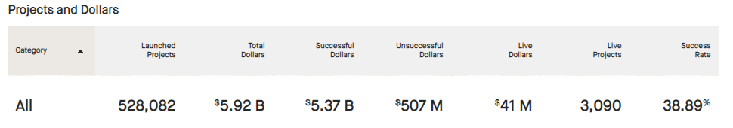

Source: https://www.kickstarter.com/help/stats , June, 26, 2021

The main limitation of the data set was the lack of information in regard to the campaign backers. The crosstab data would be extremely helpful here. Without it were left to make major assumptions about the campaigns and their successes and failures. What are some other possible tables and/or graphs that we could create?

Other visualizations that would be interesting would be a year over year comparison of campaign success. Or comparisons with other funding sites such as Gofundme.com.