l— output: word_document: default html_document: default —

# Questions - this chunk just holds all the questions for my reading  
  
# 1. How many breweries are present in each state?  
  
# 2. Merge beer data with the breweries data. Print the first 6 observations and the last six observations to check the merged file. (RMD only, this does not need to be included in the presentation or the deck.)  
  
# 3. Address the missing values in each column.  
  
# 4. Compute the median alcohol content and international bitterness unit for each state. Plot a bar chart to compare.  
  
# 5. Which state has the maximum alcoholic (ABV) beer? Which state has the most bitter (IBU) beer?  
  
# 6. Comment on the summary statistics and distribution of the ABV variable.  
  
# 7. Is there an apparent relationship between the bitterness of the beer and its alcoholic content? Draw a scatter plot. Make your best judgment of a relationship and EXPLAIN your answer.  
  
# 8. Budweiser would also like to investigate the difference with respect to IBU and ABV between IPAs (India Pale Ales) and other types of Ale (any beer with “Ale” in its name other than IPA). You decide to use KNN classification to investigate this relationship. Provide statistical evidence one way or the other. You can of course assume your audience is comfortable with percentages … KNN is very easy to understand conceptually.  
  
# In addition, while you have decided to use KNN to investigate this relationship (KNN is required) you may also feel free to supplement your response to this question with any other methods or techniques you have learned. Creativity and alternative solutions are always encouraged.   
  
# 9. Knock their socks off! Find one other useful inference from the data that you feel Budweiser may be able to find value in. You must convince them why it is important and back up your conviction with appropriate statistical evidence  
  
  
library(tidyverse)

## -- Attaching packages --------------------------------------- tidyverse 1.3.0 --

## v ggplot2 3.3.3 v purrr 0.3.4  
## v tibble 3.0.4 v dplyr 1.0.4  
## v tidyr 1.1.2 v stringr 1.4.0  
## v readr 1.4.0 v forcats 0.5.1

## Warning: package 'dplyr' was built under R version 4.0.4

## Warning: package 'forcats' was built under R version 4.0.4

## -- Conflicts ------------------------------------------ tidyverse_conflicts() --  
## x dplyr::filter() masks stats::filter()  
## x dplyr::lag() masks stats::lag()

library(maps)

##   
## Attaching package: 'maps'

## The following object is masked from 'package:purrr':  
##   
## map

library(mapproj)  
library(usmap)  
library(curl)

##   
## Attaching package: 'curl'

## The following object is masked from 'package:readr':  
##   
## parse_date

library(class)  
library(e1071)  
library(caret)

## Loading required package: lattice

##   
## Attaching package: 'caret'

## The following object is masked from 'package:purrr':  
##   
## lift

library(plotly)

##   
## Attaching package: 'plotly'

## The following object is masked from 'package:ggplot2':  
##   
## last_plot

## The following object is masked from 'package:stats':  
##   
## filter

## The following object is masked from 'package:graphics':  
##   
## layout

library(fuzzyjoin)  
library(RCurl)

##   
## Attaching package: 'RCurl'

## The following object is masked from 'package:tidyr':  
##   
## complete

Answering question 1 by creating a heat map: How many breweries are there for each state? Answer: top 5 are Colorado, California, Michigan, Oregon, Texas

# write up of the code  
  
# Bringing in the brewery data  
brew_data <- read.csv('https://raw.githubusercontent.com/scottdyl/MSDS6306_CastStudy1/main/data/Breweries.csv')  
  
# Counting each brewery by each state and renaming the count column to count  
brewery_count = count(brew_data,State)  
  
#trimming the extra spaces off of state  
brewery_count$State = str_trim(brewery_count$State)  
  
#getting the fips for each state for my map  
brewery_count$fips = fips(brewery_count$State)  
  
#renaming the 'n' column to count   
colnames(brewery_count)[2] = 'Count'  
  
# creating the heat map  
plot_usmap(data=brewery_count, values="Count", color = "black") + scale_fill_gradient(name = "Count of Breweries", low = "white", high = "red") + labs(title="Brewery Count by State") + theme(legend.position = "top")

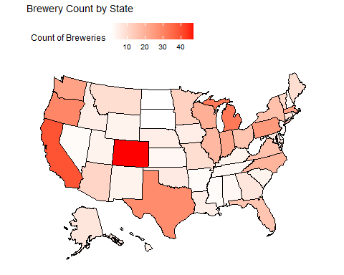

# getting the top 3 states by brewery for presentation  
brewery_count$State[order(brewery_count$Count,decreasing = T)[1:5]]

## [1] "CO" "CA" "MI" "OR" "TX"

Merging the two datasets from github and printing the first and last 6.

brew_data <- read.csv('https://raw.githubusercontent.com/scottdyl/MSDS6306_CastStudy1/main/data/Breweries.csv')  
beer_data <- read.csv('https://raw.githubusercontent.com/scottdyl/MSDS6306_CastStudy1/main/data/Beers.csv')  
  
# changed the ID column name to match in each dataset and did a full join  
colnames(beer_data)[5] = 'Brew_ID'  
bud_data <- full_join(brew_data,beer_data,'Brew_ID')  
  
head(bud_data,6)

## Brew_ID Name.x City State Name.y Beer_ID ABV IBU  
## 1 1 NorthGate Brewing Minneapolis MN Get Together 2692 0.045 50  
## 2 1 NorthGate Brewing Minneapolis MN Maggie's Leap 2691 0.049 26  
## 3 1 NorthGate Brewing Minneapolis MN Wall's End 2690 0.048 19  
## 4 1 NorthGate Brewing Minneapolis MN Pumpion 2689 0.060 38  
## 5 1 NorthGate Brewing Minneapolis MN Stronghold 2688 0.060 25  
## 6 1 NorthGate Brewing Minneapolis MN Parapet ESB 2687 0.056 47  
## Style Ounces  
## 1 American IPA 16  
## 2 Milk / Sweet Stout 16  
## 3 English Brown Ale 16  
## 4 Pumpkin Ale 16  
## 5 American Porter 16  
## 6 Extra Special / Strong Bitter (ESB) 16

tail(bud_data,6)

## Brew_ID Name.x City State  
## 2405 556 Ukiah Brewing Company Ukiah CA  
## 2406 557 Butternuts Beer and Ale Garrattsville NY  
## 2407 557 Butternuts Beer and Ale Garrattsville NY  
## 2408 557 Butternuts Beer and Ale Garrattsville NY  
## 2409 557 Butternuts Beer and Ale Garrattsville NY  
## 2410 558 Sleeping Lady Brewing Company Anchorage AK  
## Name.y Beer_ID ABV IBU Style Ounces  
## 2405 Pilsner Ukiah 98 0.055 NA German Pilsener 12  
## 2406 Heinnieweisse Weissebier 52 0.049 NA Hefeweizen 12  
## 2407 Snapperhead IPA 51 0.068 NA American IPA 12  
## 2408 Moo Thunder Stout 50 0.049 NA Milk / Sweet Stout 12  
## 2409 Porkslap Pale Ale 49 0.043 NA American Pale Ale (APA) 12  
## 2410 Urban Wilderness Pale Ale 30 0.049 NA English Pale Ale 12

Address the missing values in each column we removed 1005 beers due to missing values

# is it best to just filter out the missing data?  
# how else would I fill it in?   
#unclean data count  
dim(bud_data)

## [1] 2410 10

#summing possible missing values to see how much data we will lose  
sum(is.na(bud_data$ABV))

## [1] 62

sum(is.na(bud_data$IBU))

## [1] 1005

#filtering out the missing values and leaving the full data in new dataframe  
bud_data_clean<- filter(bud_data,!is.na(bud_data$ABV)&!is.na(bud_data$IBU)&!is.na(bud_data$Style))  
colnames(bud_data_clean)[2] = "Brew Name"  
colnames(bud_data_clean)[5] = "Beer Name"  
#clean data count  
dim(bud_data_clean)

## [1] 1405 10

we would like to find the median alcohol content and IBU for each state this will be presented in a bar chart ggplot used to show the median ABV and IBU for each state using the clean data

# I pipe in the data and group by state then summarize by median abv giving me median abv by state  
bud_data_clean %>%   
 group_by(State) %>%  
 summarise(median_ABV = median(ABV)) %>%  
 #I use ggplot bar to plot the data  
 ggplot(aes(State,median_ABV,fill = median_ABV)) +  
 geom_bar(stat = 'identity',width = .75,color = 'black')+  
 scale_fill_gradient(low = 'white', high = 'black') +  
 labs(title="Median ABV by State", x="State", y="Median ABV")+  
 theme(axis.text.x = element_text(angle = 90, vjust = .3))

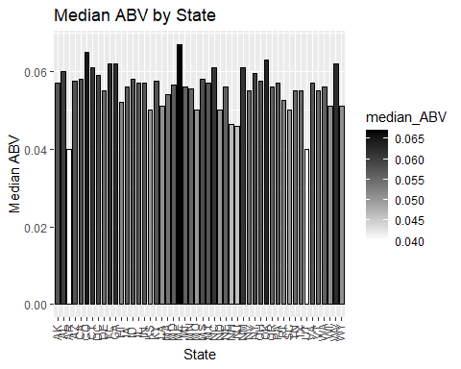

# This code does the same as the ABV but by IBU  
bud_data_clean %>%   
 group_by(State) %>%  
 summarise(median_IBU = median(IBU)) %>%  
 #I use ggplot bar to plot the data  
 ggplot(aes(State,median_IBU,fill = median_IBU)) +  
 geom_bar(stat = 'identity',width = .75,color = 'black')+  
 scale_fill_gradient(low = 'white', high = 'black') +  
 labs(title="Median IBU by State", x="State", y="Median IBU")+  
 theme(axis.text.x = element_text(angle = 90, vjust = .3))

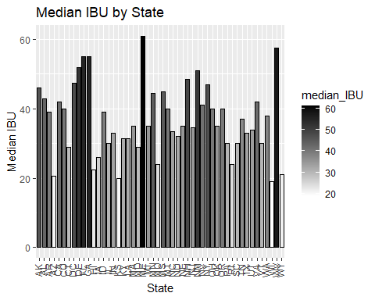

we will calculate which state has highest ABV and IBU beer finding the max and selecting the row

# use grep to find the max value then select the columns from the data to show which city, state, name of the beer and name of the brewery  
bud_data_clean[grep(max(bud_data_clean$ABV),bud_data_clean$ABV),] %>% select(City, State, `Beer Name`, `Brew Name`, ABV, Style)

## City State Beer Name Brew Name ABV  
## 8 Louisville KY London Balling Against the Grain Brewery 0.125  
## Style  
## 8 English Barleywine

bud_data_clean[grep(max(bud_data_clean$IBU),bud_data_clean$IBU),] %>% select(City, State, `Beer Name`, `Brew Name`, IBU, Style)

## City State Beer Name Brew Name IBU  
## 1134 Astoria OR Bitter Bitch Imperial IPA Astoria Brewing Company 138  
## Style  
## 1134 American Double / Imperial IPA

#finding the industry average for ABV and IBU  
bud_data_clean[grep(median(bud_data_clean$ABV),bud_data_clean$ABV),] %>% select(City, State, `Beer Name`, `Brew Name`, ABV, Style)

## City State Beer Name  
## 162 Chicago IL Oktoberfest Revolution  
## 219 Roseville MN Nordic Blonde  
## 343 Cincinnati OH Hustle  
## 366 Anchorage AK King Street Hefeweizen  
## 371 Lone Tree CO Peach Pale Ale  
## 373 Columbus OH Brass Knuckle Pale Ale  
## 423 Durango CO Steam Engine Lager  
## 426 Cheboygan MI IPA #11  
## 427 Cheboygan MI Blood Orange Honey  
## 474 Stevens Point WI Point Oktoberfest  
## 479 Stevens Point WI Point Oktoberfest  
## 500 Dillon CO Over the Rail Pale Ale  
## 538 Raleigh NC Peacemaker Pale Ale  
## 567 Lewisburg WV Wild Trail Pale Ale  
## 593 Aurora IN Cherry Ale  
## 596 Aurora IN Aurora Lager  
## 599 Aurora IN Great Crescent Oktoberfest Lager  
## 601 Aurora IN Cherry Ale (1)  
## 602 Aurora IN Aurora Lager (2011)  
## 608 Aurora IN Great Crescent Dark Lager  
## 637 Boonville CA Barney Flats Oatmeal Stout  
## 641 Boonville CA Barney Flats Oatmeal Stout  
## 645 Boonville CA Barney Flats Oatmeal Stout (2012)  
## 658 Nellysford VA Wild Wolf Wee Heavy Scottish Style Ale  
## 684 Seattle WA Persnickety Pale  
## 758 Bozeman MT Plum St. Porter  
## 774 Anchorage AK Sockeye Red IPA  
## 865 Durango CO ESB Special Ale  
## 912 Dallas TX Block Party Robust Porter  
## 945 York PA American Hero  
## 1004 Black Mountain NC Pisgah Pale Ale  
## 1012 Bronx NY Bronx Black Pale Ale  
## 1035 Papillion NE Cardinal Pale Ale  
## 1038 Brooklyn NY KelSo Nut Brown Lager  
## 1056 Westfield MA Westfield Octoberfest  
## 1133 Astoria OR Trolley Stop Stout  
## 1143 Lahaina HI CoCoNut Porter  
## 1212 Boulder CO Hoopla Pale Ale  
## 1299 Spirit Lake IA Winter Games Select #32 Stout  
## Brew Name ABV  
## 162 Revolution Brewing Company 0.057  
## 219 Bent Brewstillery 0.057  
## 343 Rhinegeist Brewery 0.057  
## 366 King Street Brewing Company 0.057  
## 371 Lone Tree Brewing Company 0.057  
## 373 Four String Brewing Company 0.057  
## 423 Steamworks Brewing Company 0.057  
## 426 Cheboygan Brewing Company 0.057  
## 427 Cheboygan Brewing Company 0.057  
## 474 Stevens Point Brewery 0.057  
## 479 Stevens Point Brewery 0.057  
## 500 Pug Ryan's Brewery 0.057  
## 538 Lonerider Brewing Company 0.057  
## 567 Greenbrier Valley Brewing Company 0.057  
## 593 Great Crescent Brewery 0.057  
## 596 Great Crescent Brewery 0.057  
## 599 Great Crescent Brewery 0.057  
## 601 Great Crescent Brewery 0.057  
## 602 Great Crescent Brewery 0.057  
## 608 Great Crescent Brewery 0.057  
## 637 Anderson Valley Brewing Company 0.057  
## 641 Anderson Valley Brewing Company 0.057  
## 645 Anderson Valley Brewing Company 0.057  
## 658 Wild Wolf Brewing Company 0.057  
## 684 Two Beers Brewing Company 0.057  
## 758 Bozeman Brewing Company 0.057  
## 774 Midnight Sun Brewing Company 0.057  
## 865 Ska Brewing Company 0.057  
## 912 Four Corners Brewing Company 0.057  
## 945 Liquid Hero Brewery 0.057  
## 1004 Pisgah Brewing Company 0.057  
## 1012 The Bronx Brewery 0.057  
## 1035 Nebraska Brewing Company 0.057  
## 1038 KelSo Beer Company 0.057  
## 1056 Westfield River Brewing Company 0.057  
## 1133 Astoria Brewing Company 0.057  
## 1143 Maui Brewing Company 0.057  
## 1212 Boulder Beer Company 0.057  
## 1299 Okoboji Brewing Company 0.057  
## Style  
## 162 MÃ¤rzen / Oktoberfest  
## 219 American Blonde Ale  
## 343 American Amber / Red Ale  
## 366 Hefeweizen  
## 371 American Pale Ale (APA)  
## 373 American Pale Ale (APA)  
## 423 American Amber / Red Lager  
## 426 American IPA  
## 427 Fruit / Vegetable Beer  
## 474 MÃ¤rzen / Oktoberfest  
## 479 MÃ¤rzen / Oktoberfest  
## 500 American Pale Ale (APA)  
## 538 American Pale Ale (APA)  
## 567 American Pale Ale (APA)  
## 593 Fruit / Vegetable Beer  
## 596 Dortmunder / Export Lager  
## 599 MÃ¤rzen / Oktoberfest  
## 601 Fruit / Vegetable Beer  
## 602 Dortmunder / Export Lager  
## 608 Euro Dark Lager  
## 637 Oatmeal Stout  
## 641 Oatmeal Stout  
## 645 Oatmeal Stout  
## 658 Scotch Ale / Wee Heavy  
## 684 American Pale Ale (APA)  
## 758 American Porter  
## 774 American IPA  
## 865 Extra Special / Strong Bitter (ESB)  
## 912 American Porter  
## 945 American Amber / Red Ale  
## 1004 American Pale Ale (APA)  
## 1012 American Black Ale  
## 1035 American Pale Ale (APA)  
## 1038 Euro Dark Lager  
## 1056 MÃ¤rzen / Oktoberfest  
## 1133 American Stout  
## 1143 American Porter  
## 1212 American Pale Ale (APA)  
## 1299 American Stout

bud_data_clean[grep(median(bud_data_clean$IBU),bud_data_clean$IBU),] %>% select(City, State, `Beer Name`, `Brew Name`, IBU, Style)

## City State Beer Name  
## 35 Bridgman MI Peck's Porter  
## 48 Comstock Park MI Grapefruit IPA  
## 62 Evansville IN Circuit Bohemian Pilsner  
## 119 Seven Points TX Scruffy's Smoked Alt  
## 138 Torrance CA Surfrider  
## 168 Manhattan KS Zombie Monkie  
## 197 Brooklyn NY Harbinger  
## 208 Atlanta GA Take Two Pils  
## 285 San Francisco CA Baby Daddy Session IPA  
## 302 Portland OR Survival Stout  
## 346 Cincinnati OH Panther  
## 395 Temecula CA Blackmarket Rye IPA  
## 399 Norfolk VA Murphy's Law  
## 434 Birmingham MI Grand Trunk Bohemian Pils  
## 436 Birmingham MI Grind Line  
## 527 Providence RI Narragansett Bohemian Pilsner  
## 546 Baton Rouge LA Parade Ground Coffee Porter  
## 587 Fort Worth TX Rubberneck Red  
## 612 Longmont CO Pinner Throwback IPA  
## 615 Longmont CO Mama's Little Yella Pils  
## 627 Longmont CO Mama's Little Yella Pils  
## 629 Longmont CO Old Chub  
## 662 Oklahoma City OK Native Amber  
## 664 Oklahoma City OK Native Amber (2013)  
## 673 Austin TX Luchesa Lager  
## 674 Austin TX Slow Ride  
## 744 Farmers Branch TX Lakefire Rye Pale Ale  
## 748 Richmond TX First Stand  
## 769 Atlantic Highlands NJ Boat Beer  
## 790 Gloucester MA Fisherman's Pils  
## 813 Newburgh NY Cream Ale  
## 817 Los Angeles CA Saison Pamplemousse  
## 839 Greenville SC Golden Fleece  
## 870 Hyannis MA Cape Cod Red  
## 922 Lewiston ME Amber Road  
## 967 Garden City ID Rodeo Rye Pale Ale  
## 969 Garden City ID Payette Pale Ale  
## 1009 Saint Louis MO Golden Pilsner  
## 1022 Missoula MT Montana Trout Slayer Ale  
## 1026 Missoula MT Montana Trout Slayer Ale (2012)  
## 1029 Missoula MT Montana Trout Slayer Ale (2009)  
## 1044 Abingdon VA Troopers Alley IPA  
## 1100 Kent WA Maylani's Coconut Stout  
## 1101 Kent WA Oatmeal PSA  
## 1117 San Francisco CA Monk's Blood  
## 1135 Astoria OR Poop Deck Porter  
## 1136 Astoria OR Old Red Beard Amber Ale  
## 1156 Lincoln NE 834 Happy As Ale  
## 1174 Brevard NC Old Chub  
## 1189 Sacramento CA 1881 California Red  
## 1193 Sacramento CA 1881 California Red Ale  
## 1211 Boulder CO Hazed & Infused  
## 1212 Boulder CO Hoopla Pale Ale  
## 1213 Boulder CO Hazed & Infused (2010)  
## 1256 Vadnais Heights MN Morning Wood  
## 1260 Gainesville FL Stump Knocker Pale Ale  
## 1284 Seattle WA Harvest Ale  
## 1350 Lyons CO Old Chub (2008)  
## 1351 Lyons CO Old Chub (2004)  
## 1352 Lyons CO Old Chub (2003)  
## 1389 Reno NV Original Orange Blossom Ale (Current)  
## Brew Name IBU Style  
## 35 Tapistry Brewing 35 American Porter  
## 48 Perrin Brewing Company 35 American IPA  
## 62 Tin Man Brewing Company 35 Czech Pilsener  
## 119 Cedar Creek Brewery 35 Smoked Beer  
## 138 The Dudes' Brewing Company 35 American Pale Ale (APA)  
## 168 Tallgrass Brewing Company 35 American Porter  
## 197 Sixpoint Craft Ales 35 Saison / Farmhouse Ale  
## 208 SweetWater Brewing Company 35 German Pilsener  
## 285 Speakasy Ales & Lagers 35 American IPA  
## 302 Hopworks Urban Brewery 35 American Stout  
## 346 Rhinegeist Brewery 35 American Porter  
## 395 Black Market Brewing Company 35 American IPA  
## 399 Smartmouth Brewing Company 35 American Amber / Red Ale  
## 434 Griffin Claw Brewing Company 35 Czech Pilsener  
## 436 Griffin Claw Brewing Company 35 American Pale Ale (APA)  
## 527 Narragansett Brewing Company 35 German Pilsener  
## 546 Tin Roof Brewing Company 35 American Porter  
## 587 Martin House Brewing Company 35 American Amber / Red Ale  
## 612 Oskar Blues Brewery 35 American IPA  
## 615 Oskar Blues Brewery 35 Czech Pilsener  
## 627 Oskar Blues Brewery 35 Czech Pilsener  
## 629 Oskar Blues Brewery 35 Scottish Ale  
## 662 COOP Ale Works 35 American Amber / Red Ale  
## 664 COOP Ale Works 35 American Amber / Red Ale  
## 673 Oasis Texas Brewing Company 35 Keller Bier / Zwickel Bier  
## 674 Oasis Texas Brewing Company 35 American Pale Ale (APA)  
## 744 Grapevine Craft Brewery 35 American Pale Ale (APA)  
## 748 Texian Brewing Co. 35 Saison / Farmhouse Ale  
## 769 Carton Brewing Company 35 American IPA  
## 790 Cape Ann Brewing Company 35 German Pilsener  
## 813 Newburgh Brewing Company 35 Cream Ale  
## 817 Golden Road Brewing 35 Saison / Farmhouse Ale  
## 839 Quest Brewing Company 35 Belgian Pale Ale  
## 870 Cape Cod Beer 35 American Amber / Red Ale  
## 922 Baxter Brewing Company 35 American Amber / Red Ale  
## 967 Payette Brewing Company 35 American Pale Ale (APA)  
## 969 Payette Brewing Company 35 American Pale Ale (APA)  
## 1009 Morgan Street Brewery 35 German Pilsener  
## 1022 Big Sky Brewing Company 35 American Pale Wheat Ale  
## 1026 Big Sky Brewing Company 35 American Pale Wheat Ale  
## 1029 Big Sky Brewing Company 35 American Pale Wheat Ale  
## 1044 Wolf Hills Brewing Company 135 American IPA  
## 1100 Airways Brewing Company 35 American Stout  
## 1101 Airways Brewing Company 35 American Pale Ale (APA)  
## 1117 21st Amendment Brewery 35 Belgian Dark Ale  
## 1135 Astoria Brewing Company 35 American Porter  
## 1136 Astoria Brewing Company 35 American Amber / Red Ale  
## 1156 Blue Blood Brewing Company 35 American Pale Ale (APA)  
## 1174 Oskar Blues Brewery (North Carol... 35 Scottish Ale  
## 1189 Ruhstaller Beer Company 35 American Amber / Red Ale  
## 1193 Ruhstaller Beer Company 35 American Amber / Red Ale  
## 1211 Boulder Beer Company 35 American Pale Ale (APA)  
## 1212 Boulder Beer Company 35 American Pale Ale (APA)  
## 1213 Boulder Beer Company 35 American Pale Ale (APA)  
## 1256 Big Wood Brewery 35 Oatmeal Stout  
## 1260 Swamp Head Brewery 35 American Pale Ale (APA)  
## 1284 Fremont Brewing Company 35 Saison / Farmhouse Ale  
## 1350 Oskar Blues Brewery 35 Scottish Ale  
## 1351 Oskar Blues Brewery 35 Scottish Ale  
## 1352 Oskar Blues Brewery 35 Scottish Ale  
## 1389 Buckbean Brewing Company 35 Herbed / Spiced Beer

Comment on the summary statistics and distribution of the ABV variable. for this I will be using a histogram to show the distribution we showed how the distribution of ABV was by using a histogram

# here I pipe the budwiser data into a ggplot using the variable ABV and create a histogram  
bud_data_clean %>%  
 ggplot(aes(ABV)) +  
 geom_histogram(fill ='black', binwidth = .0025, color = 'white') +  
 labs(title="Distribution of ABV")

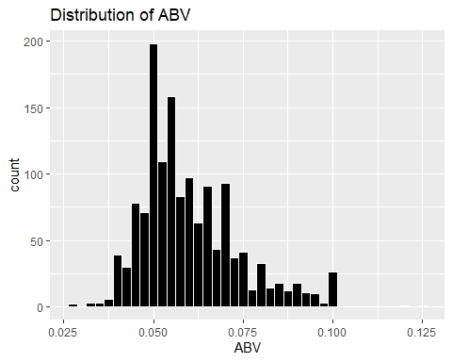

summary(bud_data_clean$ABV)

## Min. 1st Qu. Median Mean 3rd Qu. Max.   
## 0.02700 0.05000 0.05700 0.05991 0.06800 0.12500

#summarize the data by min, max, mean, median, and standard deviation  
summarise(bud_data_clean,  
 max=max(ABV),  
 min=min(ABV),  
 mean = mean(ABV),  
 median = median(ABV),  
 sd=sd(ABV))

## max min mean median sd  
## 1 0.125 0.027 0.05991388 0.057 0.01357633

Is there an apparent relationship between the bitterness of the beer and its alcoholic content? Draw a scatter plot. Make your best judgment of a relationship and EXPLAIN your answer.

Answer: their appears to be a direct correlation between ABV and IBU. this is presented in the graph below with a strong positive relationship.

bud_data_clean %>%  
 ggplot(aes(ABV, IBU)) +  
 geom_jitter(width = .01) +  
 geom_smooth(method = 'lm', se = F, color = 'red')+  
 labs(title="Bitterness vs Alcohol", x="Alcohol Content by Volume", y="IBU")

## `geom_smooth()` using formula 'y ~ x'

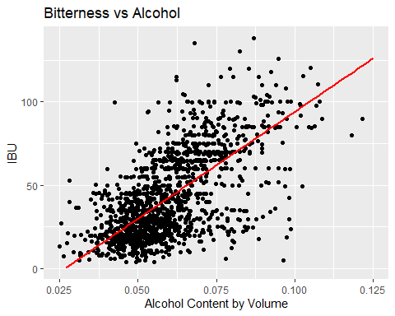 # 8. Budweiser would also like to investigate the difference with respect to IBU and ABV between IPAs (India Pale Ales) and other types of Ale (any beer with “Ale” in its name other than IPA). You decide to use KNN classification to investigate this relationship. Provide statistical evidence one way or the other. You can of course assume your audience is comfortable with percentages … KNN is very easy to understand conceptually.

Answer: IBU is a better variable to tell IPA from an Ale over ABV. Overall this model was 86% accurate. IBU was a better descriptor than ABV shown by the clustering of the two beers

# include IPA into one category and ales into another but exclude "india pale ale" from the ale section  
# test example is "english india pale ale (IPA)"  
# how to do this? filter out all the IPAs first to ensure you don't get them put into the ale section - filter out the ales and merge with IPA data  
  
IPA_Brew <- bud_data_clean %>% filter(grepl("IPA",Style) | grepl("India Pale Ale", Style))  
IPA_Brew$General_Style<-"IPA"  
  
Ale_Brew <- bud_data_clean[grepl("Ale",bud_data_clean$Style) & !grepl("India Pale Ale",bud_data_clean$Style) & !grepl("IPA", bud_data_clean$Style),]  
Ale_Brew$General_Style<-"Ale"  
  
Beer_train<- rbind(IPA_Brew,Ale_Brew)  
  
Beer_train %>% ggplot(aes(ABV, IBU, color = General_Style)) + geom_jitter(width=.01) + labs(title="Scatterplot Bitterness vs Alcohol of IPAs and Ales", x="Alcohol Content (ABV)", y="Bitterness (IBU)")

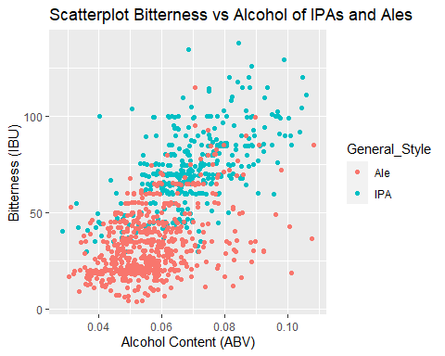

#KNN train where we set seed to 99 and do a 70/30 split of the data  
set.seed(99)  
split_data = .70  
train_split = sample(1:dim(Beer_train)[1],round(split_data * dim(Beer_train)[1]))  
train = Beer_train[train_split,]  
test = Beer_train[-train_split,]  
  
  
#setting up the data frame to find the most accurate K value  
accs = data.frame(accuracy = numeric(75), k = numeric(75))  
  
# for loop that runs 75 times over upping the k value by 1 each time k=1:75  
for(i in 1:75)  
{  
 classifications = knn(train[,c(7,8)],test[,c(7,8)],train$General_Style, prob = TRUE, k = i)  
 table(test$General_Style,classifications)  
 CM = confusionMatrix(table(test$General_Style,classifications))  
 accs$accuracy[i] = CM$overall[1]  
 accs$k[i] = i  
}  
# plotting k and accuracy to see visually how k performs over time  
plot(accs$k,accs$accuracy, type = "l", xlab = "k", ylab = "Accurcy by Percent")

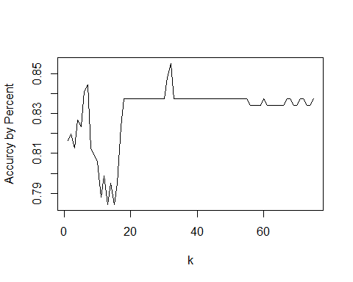

#filtering by the best accuracy value  
filter(accs, accuracy == max(accs$accuracy))

## accuracy k  
## 1 0.8551237 32

#we will use K = 32 here because that gave us the best results given seed 99  
classifications = knn(train[,c(7,8)],test[,c(7,8)],train$General_Style, prob = TRUE, k = 32)  
table(test$General_Style,classifications)

## classifications  
## Ale IPA  
## Ale 137 20  
## IPA 21 105

confusionMatrix(table(test$General_Style,classifications))

## Confusion Matrix and Statistics  
##   
## classifications  
## Ale IPA  
## Ale 137 20  
## IPA 21 105  
##   
## Accuracy : 0.8551   
## 95% CI : (0.8086, 0.894)  
## No Information Rate : 0.5583   
## P-Value [Acc > NIR] : <2e-16   
##   
## Kappa : 0.7065   
##   
## Mcnemar's Test P-Value : 1   
##   
## Sensitivity : 0.8671   
## Specificity : 0.8400   
## Pos Pred Value : 0.8726   
## Neg Pred Value : 0.8333   
## Prevalence : 0.5583   
## Detection Rate : 0.4841   
## Detection Prevalence : 0.5548   
## Balanced Accuracy : 0.8535   
##   
## 'Positive' Class : Ale   
##

# This is the code Dylan used to answer qustion 9

# 9. Knock their socks off! Find one other useful inference from the data that you feel Budweiser may be able to find value in. You must convince them why it is important and back up your conviction with appropriate statistical evidence

# is one state more likly to purchase local? Where is there a gap in that states beer?

# This is using data from another study which can be found on the github and is cited in the slides

Overall Maine had the best chance for a successful booze stout by having a high ABV average but a middle of the road ABV max

# we want to plot the max and median ABV by state and eliminate a state if their regulations are too high  
# next we will find a gap in the market by showing number of stouts/porters by states and give reccomondations  
  
#filter the data to stout and get a summary to see what the max abv is  
stout_porter <- bud_data_clean %>% filter(grepl("Stout",Style) | grepl("Porter", Style))  
summary(stout_porter$ABV)

## Min. 1st Qu. Median Mean 3rd Qu. Max.   
## 0.03700 0.05500 0.06000 0.06572 0.07100 0.12000

#getting the max and median abv by state by using aggregate  
state_abv = aggregate(ABV~State,data = bud_data_clean,max)  
avg_abv = aggregate(ABV~State,data = bud_data_clean,median)  
  
#trimming off those empty spaces of state from the data *cleaning*  
state_abv$State = str_trim(state_abv$State)  
avg_abv$State = str_trim(avg_abv$State)  
  
#getting the fips for each state for my map  
state_abv$fips = fips(state_abv$State)  
avg_abv$fips = fips(avg_abv$State)  
  
#renaming the 'n' column to count   
colnames(state_abv)[2] = 'abv'  
colnames(avg_abv)[2] = 'abv'  
  
# creating the heat map  
plot_usmap(data=state_abv, values="abv", color = "black") +   
 scale_fill_gradient(name = "ABV Scale", low = "white", high = "red") +   
 labs(title="Highest ABV by State") + theme(legend.position = "top")

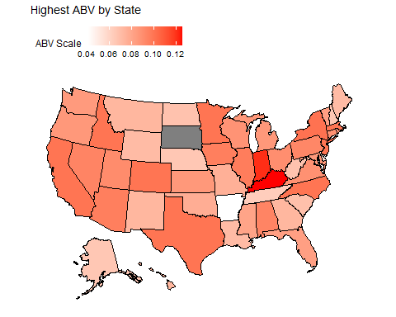

plot_usmap(data=avg_abv, values="abv", color = "black") +   
 scale_fill_gradient(name = "ABV Scale", low = "white", high = "red") +   
 labs(title="Median ABV by State") + theme(legend.position = "top")

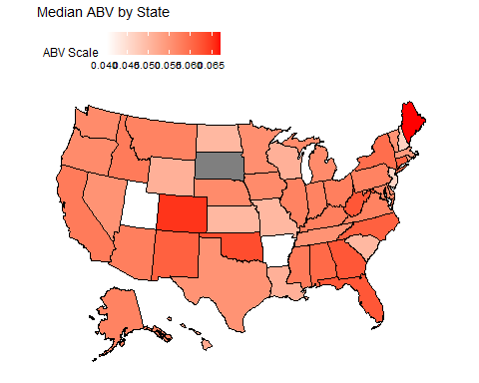

#counting stouts and porters by state  
stout_count = count(stout_porter,State)  
#changing the column name from n to count  
colnames(stout_count)[2] = 'Count'  
#creating a bar graph by state to show number of stouts  
stout_count %>%  
 ggplot(aes(State,Count,fill = Count)) +  
 geom_bar(stat = 'identity',width = .75,color = 'black')+  
 scale_fill_gradient(low = 'white', high = 'black') +  
 labs(title="Number of Stouts or Porters by State", x="State", y="Count of Stouts or Porters")+  
 theme(axis.text.x = element_text(angle = 90, vjust = .3))

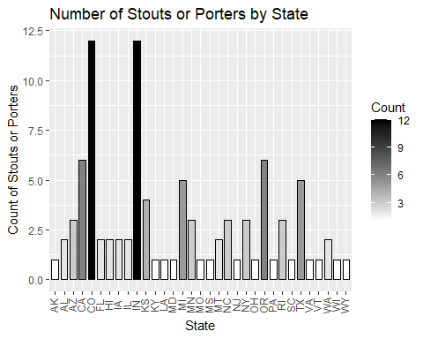

# This is how Sadik answered number 9

ggplot(data = bud_data_clean, aes(x = Style, color = State,)) +  
 stat_count(width = 0.5,) +  
 labs(title="Style by State")

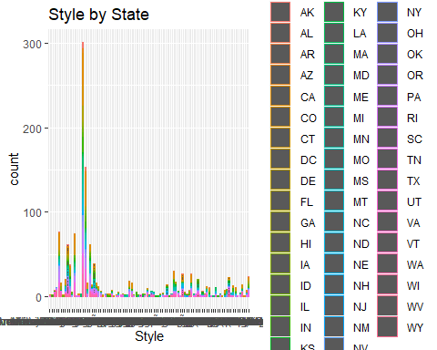

#Conclusion:  
# From the study we can see that There are various kind of Brew in different states.One Brew may be popular in one states, may not be poplar in another. This study will help companies to increase their production in states where the brand is famous. This also help to balance demand and supply curve and improve production capacity.