**Boogie Battle Mobile App**

Table of Contents

Introduction 1

Design 2

Start Screen 2

Organizer Role 3

Judging Screen 4

Dancer Registration 5

Score Display 6

Summary 7

## Introduction

The Boogie Battle App was developed as the final project for the Spring 2019 Grand Circus Front-End Programming Bootcamp in Detroit, Michigan. The team was comprised of Steven Ly, Jonathan Bernstein, and myself. It is a single page app developed using the Angular 2+ framework, socket.io, Express server, and Postgres database. The goal of the project was to create a mobile app that allows on-the-fly dance competitions and pushing score data in real-time to end users. Our team came together to work through challenges, leverage each member’s strengths, and deliver a working product for demo day. I served as the team lead in project management, design, and architecture.

## Design

We drew some of our design inspiration from a dance show broadcasted in Detroit in the 80’s and 90’s. The bright color palette was chosen to create a sense of fun, whimsy, and excitement, which provided a sharp contrast against the white backdrop.

## Start Screen

The start screen design provides a clear list of actions a user can take within the app. The main menu along the bottom lists the two main options a user would take to participate in a battle. Most users would typically only choose one option, so we opted to keep the main menu clean and uncluttered.

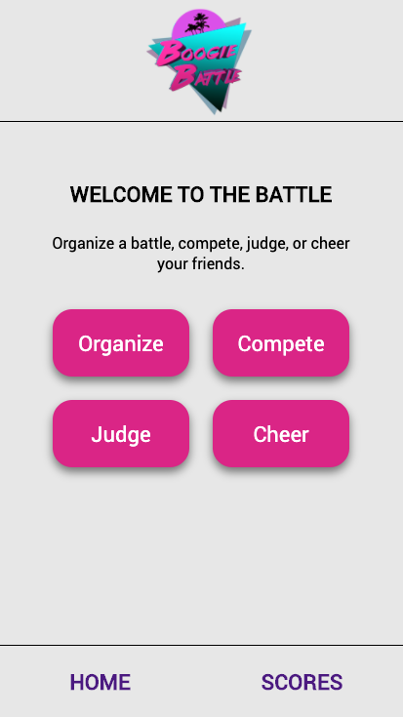

## Organizer Role

When someone selects the Organize option, they essentially become the administrator of the battle. The Start button commences the battle. The competitors’ avatars slide into view showing who is now dancing and who is on deck. The rest of the app is updated simultaneously for judging and cheering. The Next Player button brings the On Deck player into Live status. Judges can start scoring the next player

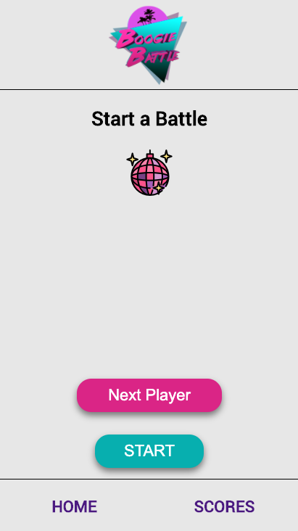

while the Cheer page displays live score updates.

**Note:** More development time would have added a placeholder in the center and disabled the Next Player button until the game is started.

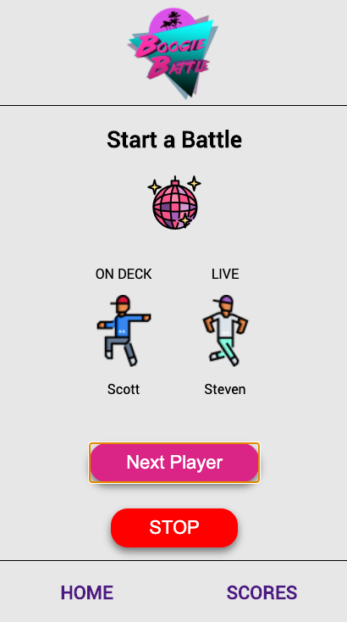

## Judging Screen

We used Material Design by Google for the scoring. It provided a clean and easy-to-use interface.

The current competitor name is updated in the top left of the screen.

Once the score has been submitted the interface is updated with the message “Please stand by for next dancer” in order to provide clear feedback to the judge. When the organizer advances to the next player the scoring interface is displayed and the process repeats.

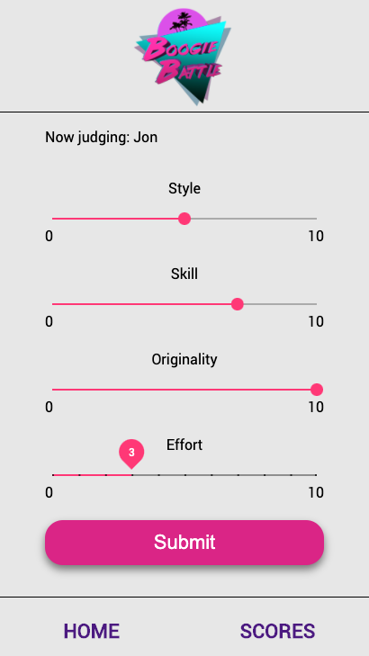

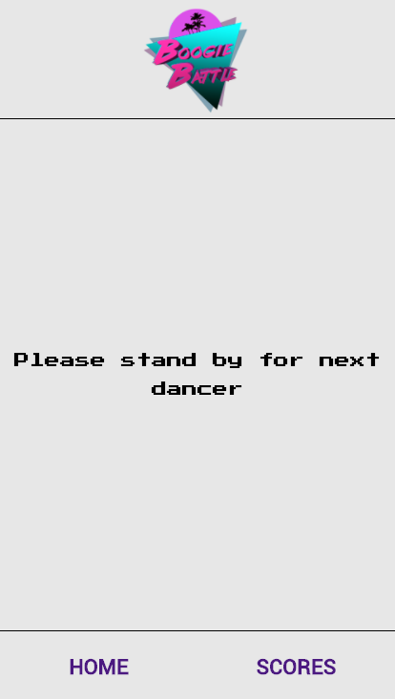

## Dancer Registration

A simple interface allows competitors to register for a battle with their name and an avatar. While it was fun to select avatars, in the real world it might be more practical to have them take selfies so the judges can identify them better. It also depends whether the app would be used amongst friends, in which case a name and avatar might work fine. Future user research could help better define the needs of this interface.

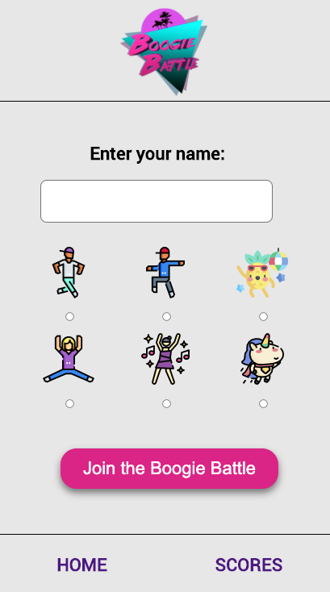

## Score Display

Spectators can view live scores by selecting Cheer on the home screen. This was one of the most fun, yet challenging, pieces of the project. As the scores come in from the judges, the chart and overall average is updated as well. While we had the data, creating a live chart was difficult. My teammate wrangled with Google Charts for several days without success. The course TA also assisted without luck. Coming down to the wire, I came up with an idea. It involved using a good old-fashioned table. With the magic of Angular we used structural directives to modify the CSS classes of the table cells. I threw together a basic prototype. It still had the padding on each cell. When I showed it to the team they both said it looks cool like that. They were right! And it played perfectly into the retro design. The live updates make the chart look like an equalizer from the 1980’s. It is the moments of accidental creativity like this that makes teamwork fun and satisfying.

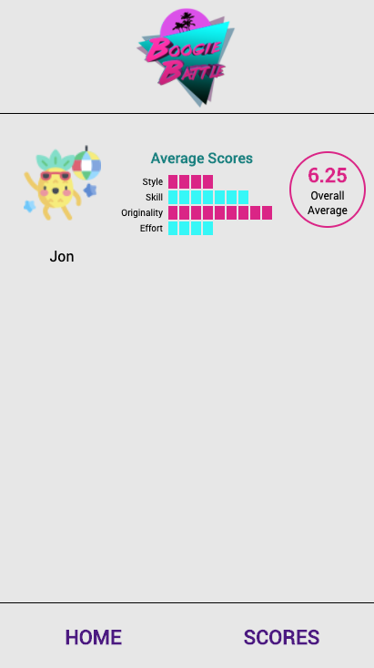

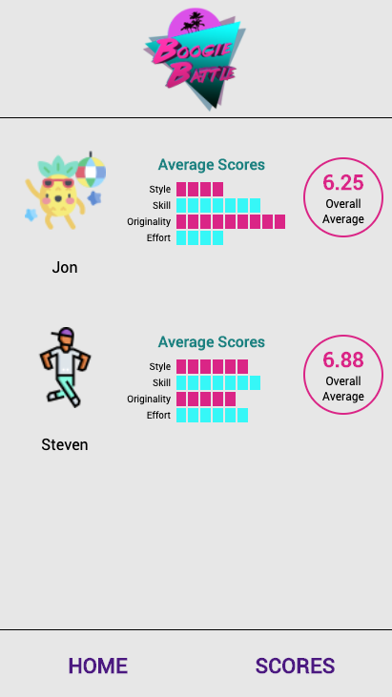

## Summary

We completed the project in time for two days of demoing to employers and friends and family. We received a lot of positive feedback. It was a challenge to demo the complete project because it involves multiple users. And since it was still a prototype it was missing many of the safeguards a production app would have. We were able to work together to run full demos to interested attendees. The app was my idea and I am glad to have had a team that was willing to take a big risk with this project.