Scott Enriquez
Los Angeles, CA
https://scottie.is | scottie@enriquez.io | https://github.com/scottenriquez

Executive Summary

Currently serving as Director, Cloud FinOps at SiriusXM and pursuing a Master of Science in Applied Data Science from the University of Southern California part-time. Results-driven engineer, architect, and technical leader with over 13 years of professional experience spanning cloud solutions architecture, DevOps, FinOps, and software development. Experience in consulting, technical sales, and corporate IT. Combines deep technical knowledge with strong leadership and communication abilities. Executed dozens of successful technical projects, advised C-suite executives on enterprise technology strategy, and presented at major industry conferences.

Core Competencies

- Architecting and deploying cloud solutions on AWS, GCP, and Azure
- Infrastructure as code using AWS CloudFormation, AWS Cloud Development Kit (CDK), Azure Resource Manager (ARM), and Terraform
- CI/CD using Azure DevOps, AWS Code Suite, GitLab, and GitHub Actions
- FinOps, cloud financial management, and commitment purchasing strategies
- Full-stack software engineering using Python, Node.js, .NET, Go, and React
- Containerization and orchestration using Docker and Kubernetes
- Delivering machine learning and data analytics solutions using Amazon SageMaker

Work Experience

SiriusXM | Director, Cloud FinOps
June 2025 – present | Los Angeles, California
- Designing and executing a comprehensive FinOps roadmap to support corporate-wide cost optimization initiatives and advance cloud financial management maturity
- Delivering cloud efficiency recommendations and strategy to engineers, leaders, and executives as a FinOps subject matter expert
- Architecting a public cloud cost and usage data lake in Databricks to centralize multi-cloud consumption data and enable advanced analytics for engineers and leaders
- Establishing advanced metrics and KPIs to streamline savings calculations, forecasting, and spend efficiency scoring
- Implementing Tableau dashboards, building automation using Python, and managing team infrastructure using CDK and TypeScript

Amazon Web Services | Senior Solutions Architect
July 2024 – April 2025 | Los Angeles, California
- Architected and implemented prototypes leveraging machine learning, generative AI, spatial computing, and other cutting-edge technologies on the Prototyping and Customer Engineering (PACE) team
- Served as technical lead on six-week, customer-facing engagements from discovery to handoff, resulting in millions in influenced revenue for AWS by proving the viability of novel use cases
- Delivered infrastructure and built reusable constructs with AWS Cloud Development Kit (CDK)
- Developed software in Python, TypeScript, and Go
- Reduced the team’s internal costs by 36% by establishing FinOps best practices

Amazon Web Services | Solutions Architect
December 2021 – July 2024 | Los Angeles, California
- Served as a specialist solutions architect focusing on FinOps and cloud efficiency for AWS’s Strategic Accounts on the Optimization Intelligence for Cloud Systems (OPTICS) team
- Performed financial modeling and technical analysis to support strategic enterprise contracts, resulting in the successful acquisition of billions in revenue for AWS
- Conducted technical deep dives and workshops for services such as Amazon EC2, Amazon EBS, Amazon S3, Amazon DynamoDB, Amazon RDS, and AWS Lambda resulting in over $100MM of realized savings across over 40 customers
- Analyzed complex telemetry, cost, and usage datasets using Python, SQL, and Amazon QuickSight to identify savings opportunities to present to customers
- Presented at re:Invent and other major conference events

Slalom | Consultant
January 2021 – December 2021 | Houston, Texas
- Served as a solutions architect, software engineer, and DevOps engineer on customer-facing engagements as a member of the Cloud, DevOps, and Security (CDS) practice
- Executed billable engagements and provided pre-sales support across various industries, resulting in over $1MM in total revenue
- Advised customer C-suite leadership on enterprise cloud adoption and governance, resulting in earned trust and additional billable opportunities

ConocoPhillips | Solutions Architect
November 2019 – January 2021 | Houston, Texas
- Architected and oversaw the implementation of cloud-native solutions in AWS, Azure, and Mendix
- Facilitated adoption of DevOps and AWS best practices across an enterprise environment as a member of the Cloud Business Office
- Developed standardized infrastructure as code templates using Terraform and AWS Cloud Development Kit (CDK) for company-wide reuse

ConocoPhillips | Software Engineer and Technical Team Lead
January 2014 – November 2019 | Houston, Texas; Bartlesville, Oklahoma; Anchorage, Alaska
- Designed and implemented 15 greenfield software solutions using web, cloud, and desktop technologies, including .NET, React, and Azure
- Maintained a portfolio of over 50 full-stack applications across several domains supporting critical business processes, including royalty distribution, financial planning, and safety reporting
- Built CI/CD pipelines using Azure DevOps, resulting in fast, reliable, and secure deployments
- Prioritized and managed project intake and workload for a team of over 20 developers
- Oversaw roadmap for the enterprise implementation of the low-code development platform Mendix, resulting in dozens of citizen developers adopting the tool across the world
- Performed code reviews and mentored other developers

Education

University of Southern California | Master of Science | Applied Data Science
August 2025 – present | Los Angeles, California

University of Texas at Austin | Bachelor of Arts | Computer Science and Asian Studies
August 2008 – December 2013 | Austin, Texas

Active Certifications

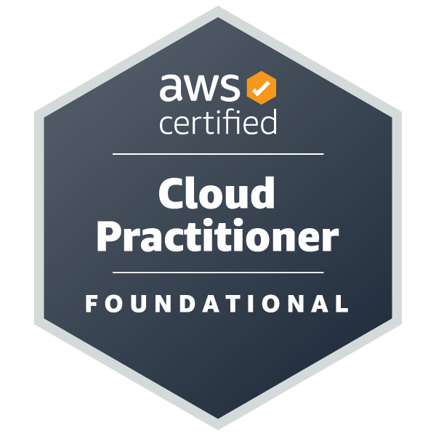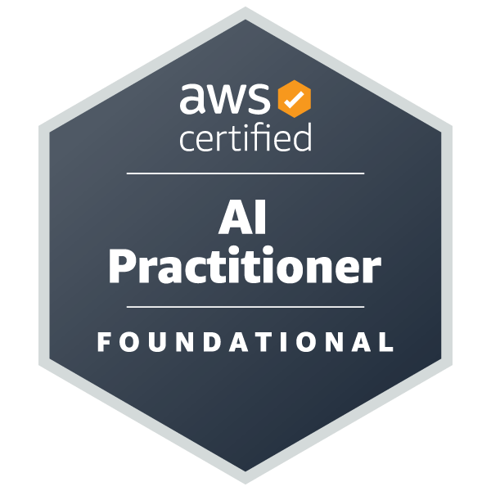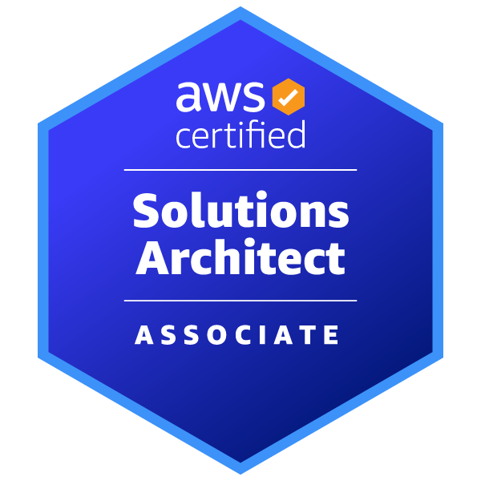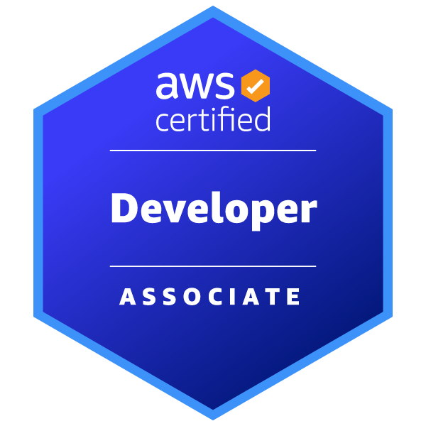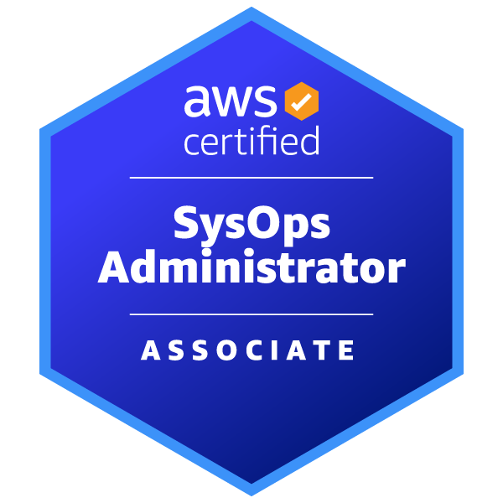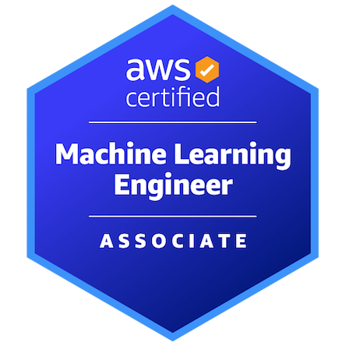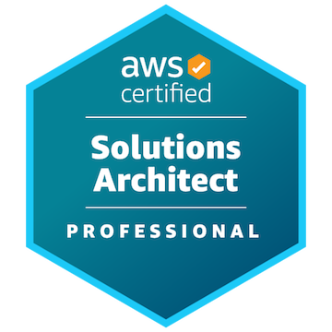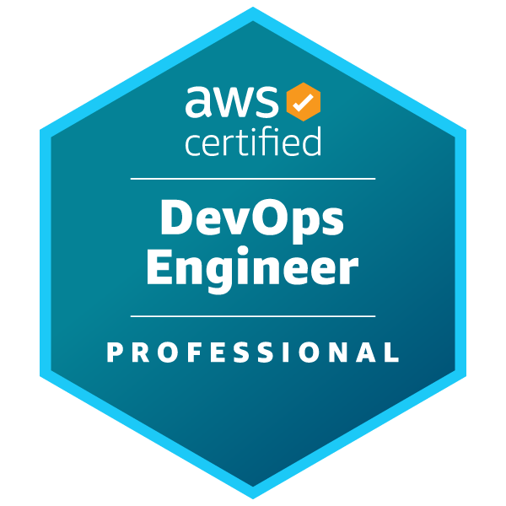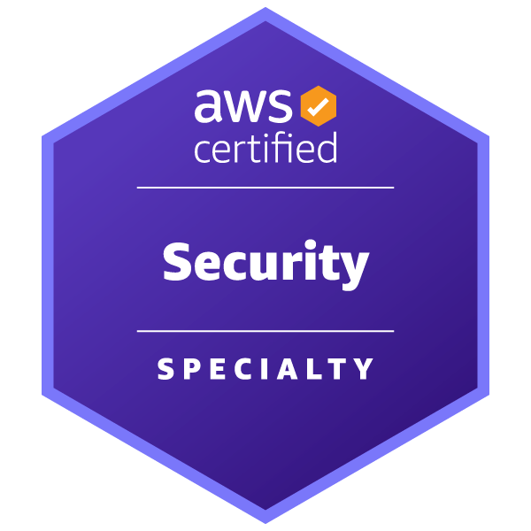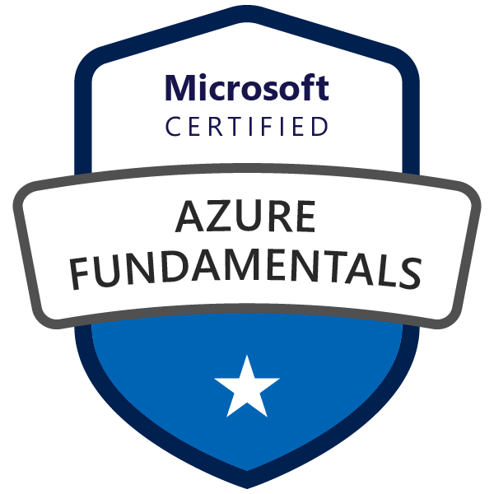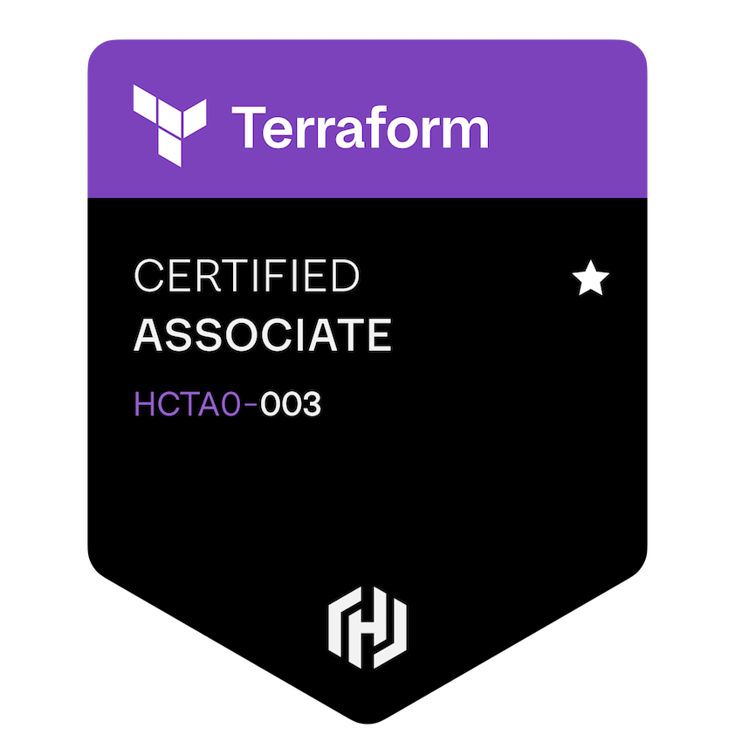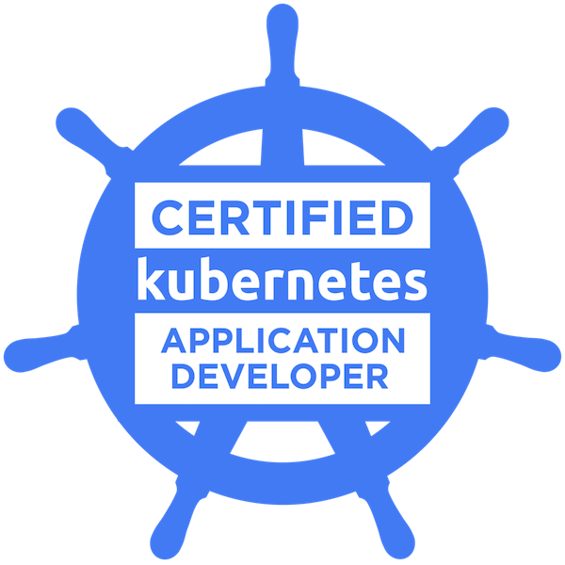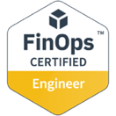

Volunteering Experience

Microsoft TEALS | Volunteer Advanced Placement Computer Science Teaching Assistant
June 2018 – March 2022 | Houston, Texas
- Trained in computer science teaching pedagogy
- Co-taught Java and Python at Heights High School and Yates High School utilizing tools like Repl.it
- Coordinated guest lectures from a variety of tech professionals to showcase careers for students

