Scott Enriquez
https://scottie.is | scottie@enriquez.io | https://github.com/scottenriquez

Education at the University of Texas at Austin

Bachelor of Arts | Computer Science and Asian Studies
August 2008 – December 2013 | Austin, Texas

Active Certifications

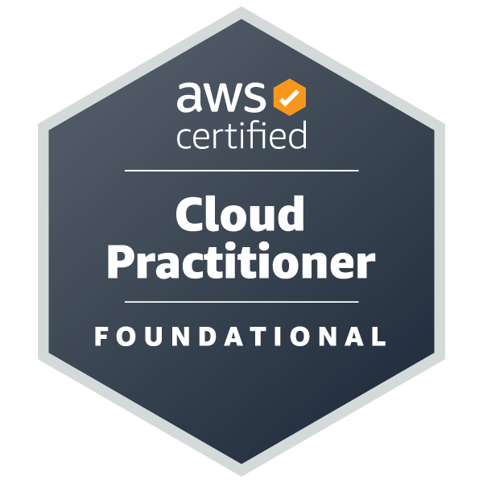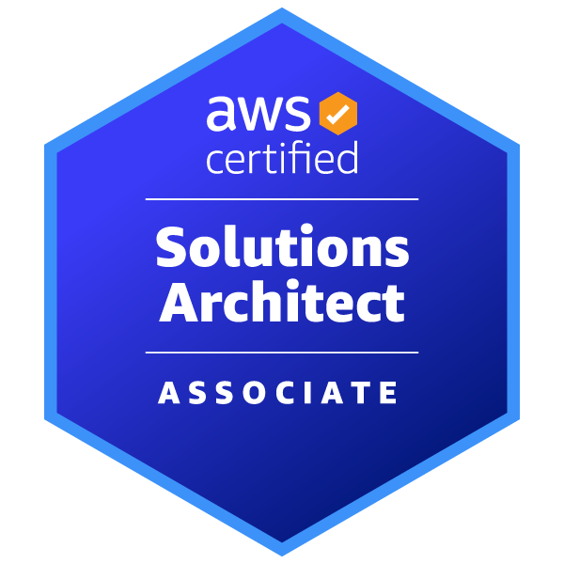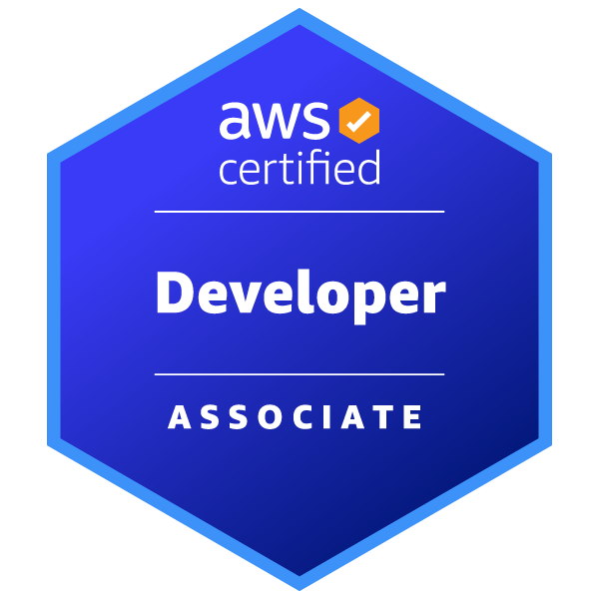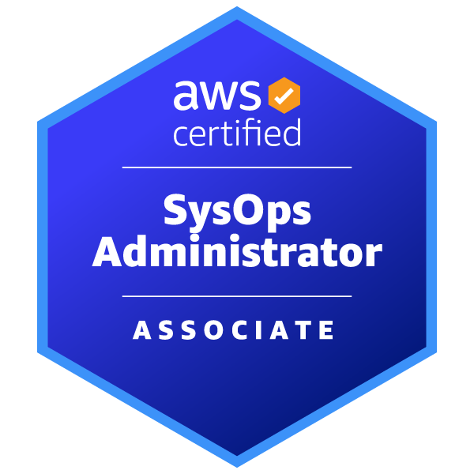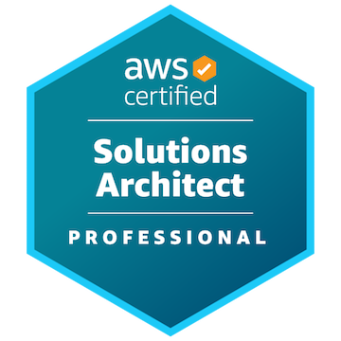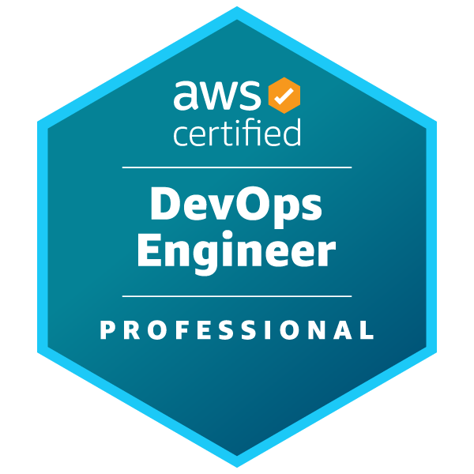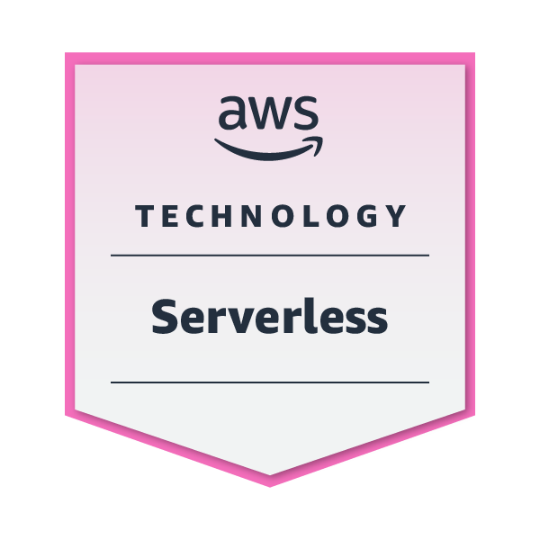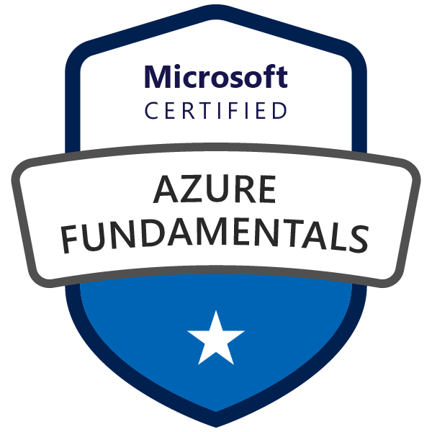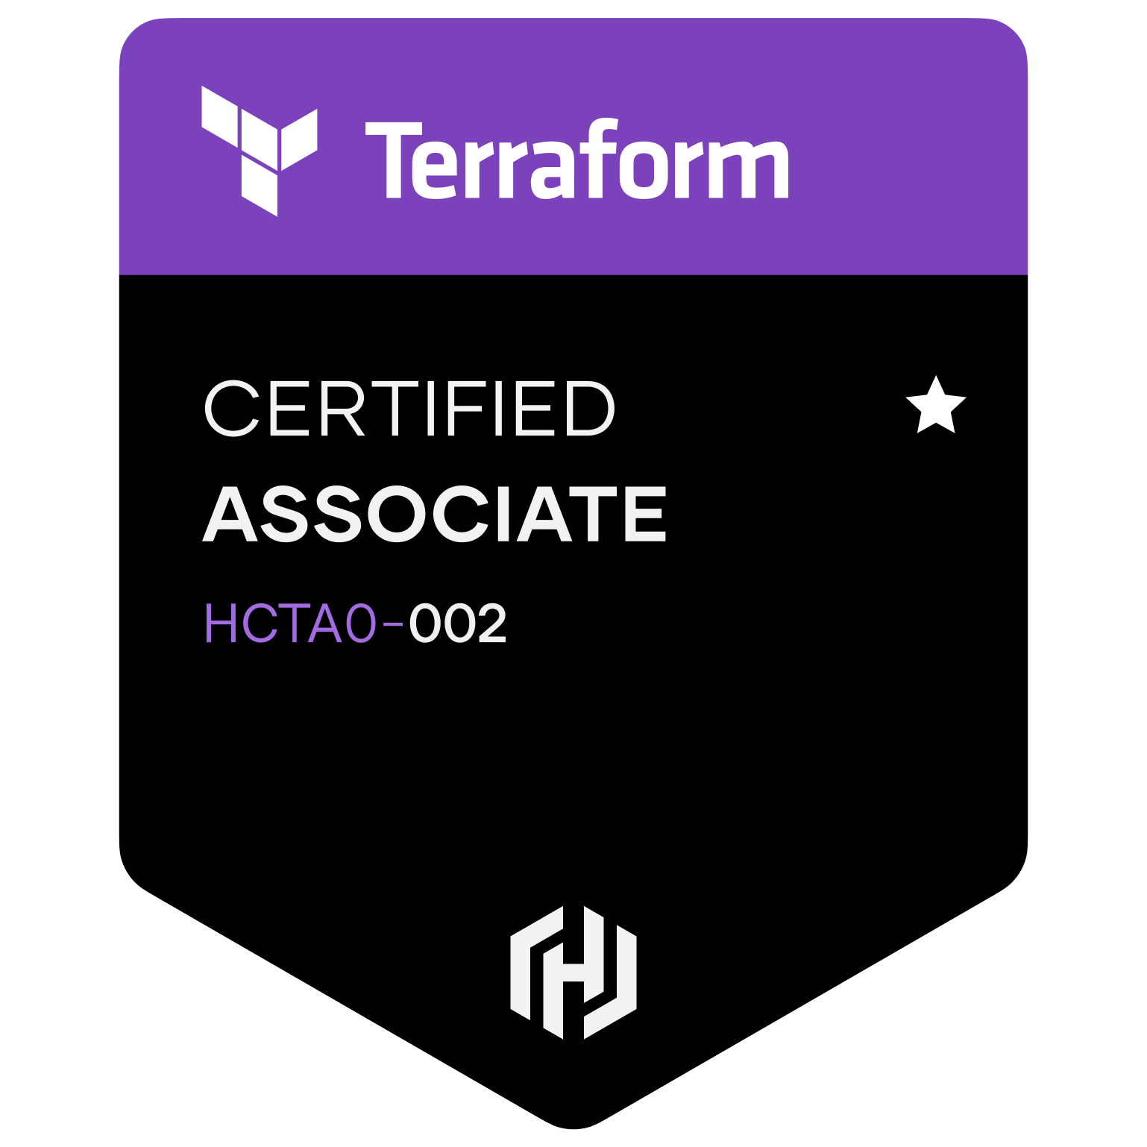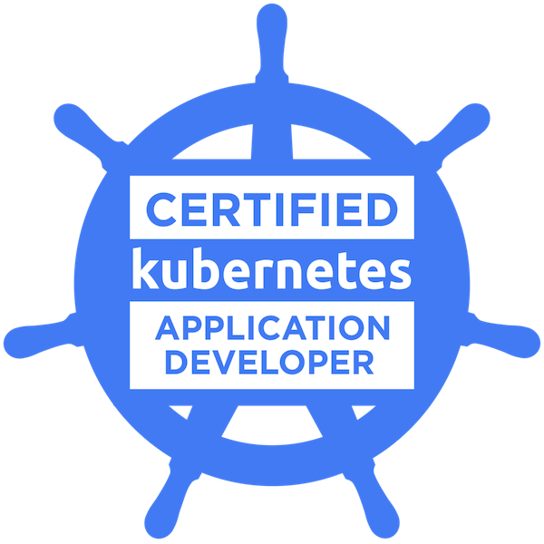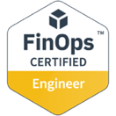

Skills

- Architecting cloud solutions on AWS and Azure
- Infrastructure as code using AWS CloudFormation, AWS Cloud Development Kit (CDK), Azure Resource Manager (ARM), and Terraform
- CI/CD using Azure DevOps, AWS Code Suite, GitLab, and GitHub Actions
- FinOps, commitment purchasing strategies, cloud efficiency, and cloud cost optimization
- Full-stack software engineering using .NET, Node.js, Python, Go, and React
- Containerization using Docker and Kubernetes
- Machine learning and data analytics using Amazon SageMaker

Work Experience

Amazon Web Services | Senior Solutions Developer
July 2024 – present | Los Angeles, California
- Architecting and implementing customer-facing prototypes on AWS leveraging machine learning, generative AI, computer vision, and other cutting-edge technologies
- Delivering infrastructure and building reusable constructs with AWS CDK
- Writing software in Python, Node.js, and Go

Amazon Web Services | Solutions Architect
December 2021 – July 2024 | Los Angeles, California
- Served as a specialist solutions architect focusing on FinOps and cloud efficiency for AWS’s Strategic Accounts on the Optimization Intelligence for Cloud Systems (OPTICS) team
- Performed financial modeling and technical analysis to support strategic enterprise contracts, resulting in the successful acquisition of billions in revenue for AWS
- Conducted technical deep dives and workshops for services such as EC2, EBS, S3, DynamoDB, RDS, Graviton, and Spot, resulting in tens of millions of dollars saved for customers
- Analyzed complex telemetry, cost, and usage datasets using Python, SQL, and QuickSight to identify savings opportunities for customers

Slalom | Consultant | Cloud, DevOps, and Security
January 2021 – December 2021 | Houston, Texas
- Served as a solutions architect, software engineer, and DevOps engineer on billable engagements across various industries
- Advised customer C-suite leadership on enterprise cloud adoption and governance, resulting in earned trust and additional billable opportunities

ConocoPhillips | Solutions Architect
November 2019 – January 2021 | Houston, Texas
- Architected and oversaw the implementation of cloud-native solutions in AWS, Azure, and Mendix
- Facilitated adoption of DevOps and AWS best practices across an enterprise environment as a member of the Cloud Business Office
- Developed standardized infrastructure as code templates using Terraform and AWS CDK for company-wide reuse

ConocoPhillips | Software Engineer and Technical Team Lead
January 2014 – November 2019 | Houston, Texas; Bartlesville, Oklahoma
- Designed and implemented greenfield software solutions using technology such as .NET and React
- Maintained a portfolio of over 50 full-stack applications across several business domains
- Built CI/CD pipelines using Azure DevOps, resulting in fast, reliable, and secure deployments
- Prioritized and managed project intake and workload for a team of over 20 developers
- Oversaw roadmap for the enterprise implementation of the low-code development platform Mendix, resulting in dozens of citizen developers adopting the tool across the world
- Performed code reviews and mentored other developers

Volunteering Experience

Microsoft TEALS | Volunteer Advanced Placement Computer Science Teaching Assistant
June 2018 – March 2022 | Houston, Texas
- Trained in computer science teaching pedagogy and the course curriculum
- Co-taught Java and Python at Heights High School and Yates High School utilizing tools like Repl.it and Newrow
- Coordinated guest lectures from a variety of tech professionals to showcase careers for students

