

[https://scottie.is](https://scottie.is/) | [scottie@enriquez.io](mailto:scottie@enriquez.io) | <https://github.com/scottenriquez>

**Education at the University of Texas at Austin**

**Bachelor of Arts | Computer Science and Asian Studies**

August 2008 – December 2013 | Austin, Texas

**Skills**

* Architecting cloud solutions in AWS and Azure
* Relational and non-relational database design using DynamoDB, Amazon RDS, and Azure managed database services
* Infrastructure as code using AWS CloudFormation, AWS CDK, and Terraform
* CI/CD using Azure DevOps, AWS Code Suite, and GitHub Actions
* FinOps and cloud cost optimization
* Serverless development using AWS Lambda and Azure Functions
* Backend software development using .NET, Node.js, and Python
* Frontend software development using React, Svelte, and Angular

**Active Certifications**

[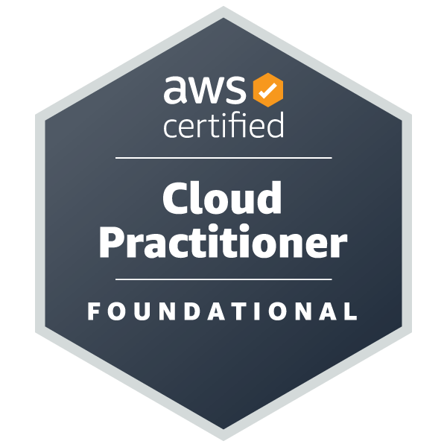](https://www.credly.com/badges/a7e6b0f7-ce2a-431d-8f9f-17bad4a0cb4d/public_url)[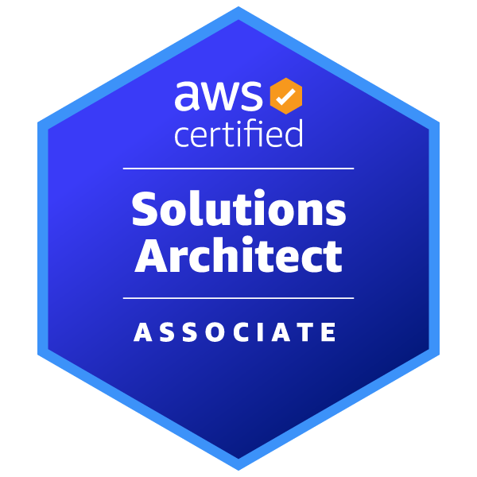](https://www.credly.com/badges/69072f5b-4bee-4f4b-995c-40fb05767755/public_url)[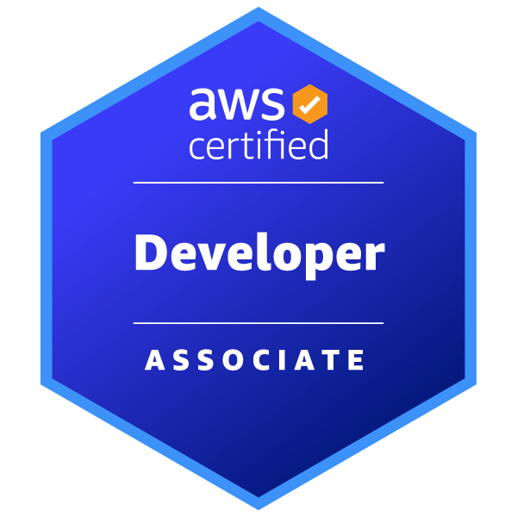](https://www.credly.com/badges/a8d84cc5-1f7e-4583-9253-03c27de4ce4b/public_url)[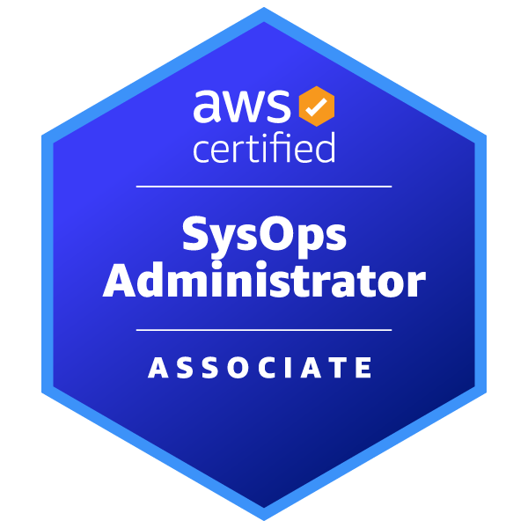](https://www.credly.com/badges/b129d101-d04d-4a18-a2d1-57c68e309380/public_url)[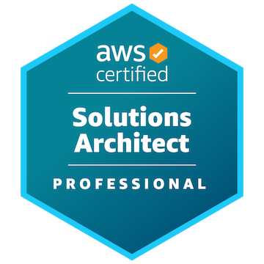](https://www.credly.com/badges/d3007461-ab00-48f1-b6a6-514c9fd496e2/public_url)[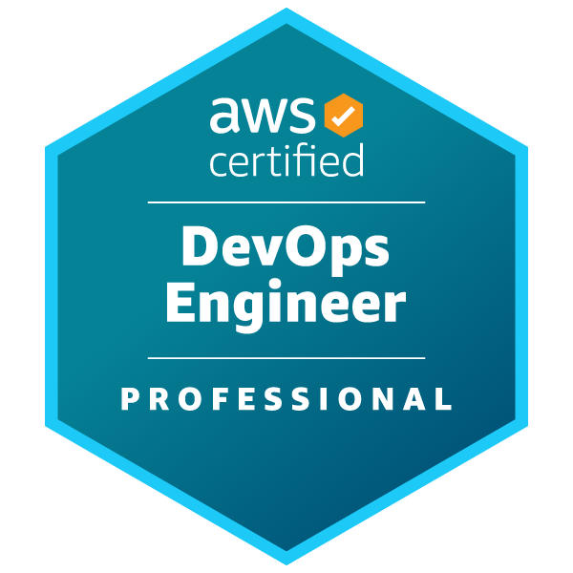](https://www.credly.com/badges/b2c78c78-6553-4d7b-a86a-1eab958ee914/public_url)[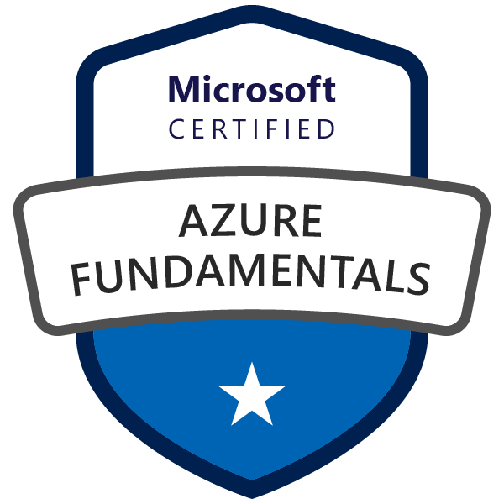](https://www.credly.com/badges/33179129-1e02-4f47-8a2a-013fe9b5c6b2/public_url)

**Work Experience**

**Amazon Web Services | Solutions Architect**

February 2023 – present | Los Angeles, California

* Serving as a specialist solutions architect focused on cost and sustainability optimization for four Strategic Accounts on the Optimization Intelligence for Cloud Systems (OPTICS) team
* Architecting internal tooling to streamline analysis of complex cost, usage, and telemetry datasets using SQL, QuickSight, and Python
* Conducting technical deep dives and workshops for customers for AWS offerings, including EC2, EBS, S3, DynamoDB, RDS, Graviton, and Spot resulting in millions of dollars saved for customers
* Partnering with customer FinOps programs to drive technical roadmaps and organization-wide optimization strategies
* Performing financial modeling and technical analysis to strategically support enterprise contracts, resulting in the successful acquisition of billions in revenue

**Amazon Web Services | FinOps Commercial Architect**

December 2021 – February 2023 | Los Angeles, California

* Supported six Strategic Accounts with cost and sustainability optimization on the OPTICS team
* Helped customers build and maintain successful cloud financial management programs and FinOps practices
* Analyzed complex cost and usage datasets, including CUR, to identify and facilitate the implementation of cost-saving opportunities resulting in millions of dollars saved for customers
* Conducted technical deep dives into spend and optimization opportunities to help customers make data-driven decisions
* Assisted customers with developing complex purchasing strategies involving Savings Plans, Reserved Instances, and Spot
* Developed queries, visualizations, and scripts for data analysis using SQL, QuickSight, and Python

**Slalom | Consultant | Cloud, DevOps, and Security**

January 2021 – December 2021 | Houston, Texas

* Served as a solutions architect, application architect, cloud engineer, and DevOps engineer on engagements across various industries and companies
* Provided expertise to clients in the areas of cloud-native solution design using AWS, infrastructure as code, and software engineering

**ConocoPhillips | Cloud Enablement Architect**

September 2020 – January 2021 | Houston, Texas

* Facilitated adoption of DevOps and cloud-native solution design in an enterprise environment with solution engineering teams across the globe
* Provided best practices and troubleshooting support for solutions comprised of services such as EC2, Elastic Beanstalk, RDS, ECS, and Lambda
* Developed standardized infrastructure as code templates using Terraform, AWS CloudFormation, and AWS CDK
* Assisted engineers with implementing CI/CD automation using Azure DevOps and AWS Code Suite
* Reviewed service control policies and security remediation logic for new services to be sanctioned in the AWS Organization

**ConocoPhillips | Solutions Architect**

November 2019 – September 2020 | Houston, Texas

* Architected cloud-native solutions in AWS, Azure, and Mendix
* Designed and implemented full-stack applications using .NET, Node.js, React, and relational databases
* Built CI/CD pipelines using Azure DevOps
* Implemented rules, configuration, and integration for SonarQube to perform static code analysis and WhiteSource to execute vulnerability scanning
* Facilitated SAFe adoption and worked on two Agile teams
* Performed code reviews and mentored other developers

**ConocoPhillips | Software Development Technical Team Lead**

January 2019 – November 2019 | Houston, Texas

* Prioritized and managed project intake and team workload
* Oversaw roadmap for enterprise implementation of the low-code development platform Mendix
* Performed code reviews and mentored other developers

**ConocoPhillips | Full-Stack Software Developer**

August 2014 – January 2019 | Houston, Texas; Bartlesville, Oklahoma

* Provided software development and IT support for business units across the world, including Alaska, United Kingdom, and Norway and corporate functions like finance and HR
* Implemented, enhanced, and supported full-stack and desktop enterprise solutions using .NET, Angular, and relational databases
* Maintained customer relations and assumed business analyst responsibilities when needed

**ConocoPhillips | Data Integration Analyst**

January 2014 – August 2014 | Anchorage, Alaska

* Created a visualization of the business unit’s data universe
* Used Informatica Cloud to implement various data integration jobs to replace Perl scripts

**ConocoPhillips | Operations Analyst Intern**

May 2013 – August 2013 | Anchorage, Alaska

* Handled general IT responsibilities for day-to-day operations in the business unit
* Led a project to select, install, and configure video camera management software
* Worked on numerous coding projects using C#, Visual Basic, Python, Perl, and SQL

**ConocoPhillips | Network Operations Intern**

May 2012 – August 2012 | Bartlesville, Oklahoma

* Managed a networking project to streamline device purchase, configuration, and onsite setup
* Automated data entry via Python scripts
* Enhanced the team portal site using .NET, HTML, and CSS

**Valero Energy Corporation | Software Developer Intern**

May 2011 – August 2011 | San Antonio, Texas

* Implemented software using ABAP for security controls for Sarbanes-Oxley compliance
* Met with clients regularly to gather requirements and for user acceptance testing
* Identified complex relationships within data models and role-based access controls

**The University of Texas at Austin | Computer Science Tutor and First-Year Student Mentor**

March 2009 – December 2010 | Austin, Texas

* Tutored programming and logic courses on a group and individual basis
* Mentored a group of first-year computer science students and taught teambuilding, networking, and effective study habits
* Participated in frequent mentor and tutor training

**Volunteering Experience**

**Microsoft TEALS | Volunteer Advanced Placement Computer Science Teaching Assistant**

June 2018 – March 2022 | Houston, Texas

* Trained in computer science teaching pedagogy and the course curriculum
* Co-teaching Java at Heights High School utilizing tools like Repl.it and Newrow
* Coordinating guest lectures from a variety of tech professionals to showcase careers for students