How to Run First Step of iCAPs TA

REPLACE FILES
From the zipped folder contains one folder: functions
- please replace the functions files that you downloaded from the original iCAP on github. This removes the need for some files and adds the mion convolution filter!

RUNNING TA
I will list out steps you need to run the TA step. This first involves putting the data in the correct format and secondly editing the files to make sure paths and variables are correct.

- Preprocessing
  - How to structure folders
    - Each participant should have their own folder in their own condition with the monkey’s name
      - Example: baseline/Jade or post_stim_2ma/Khali
    - Inside that there will be a folder of the run for it
      - Example: baseline/Jade/run12_20210908
    - Inside that folder will be two folders. A) a folder containing the fMRI data B) a folder containing the grey matter mask
      - Example: baseline/Jade/run12_20210908/fmri
        - This will contain the 4D bold file
        - IMPORTANT: this file must be separated by volume. The 4D file has 110 volumes so there should be 110 .nii files in this fmri folder. There are plenty of linux commands to do this and if you need help let me know
        - IMPORTANT: these files must be named baseline_0001, baseline_0002, baseline_0003, baseline_0004 and so on. The numbers must be preceded by 0s (the baseline part is arbitrary and can be whatever you want)
      - Example: baseline/Jade/run12_20210908/gm
        - Inside this folder will be a .nii file of the segmentation of the gray matter mask. It should be a binary image. Please use a common gray matter mask that will be applied to all the monkeys in the study

- Path and variables
  - There are three files you have to edit to run the first step. Please make sure these files are in the correct paths of main and input folders of the iCAP folders
  - main_TA
    - File Naming
      - This is the file you run when starting each run of TA for each subject
      - I suggest naming it main_TA_MONKEYNAME_RUNNUMBER_DATE ex: main_TA_Jade_run28_20121109
    - Inside the file
      - 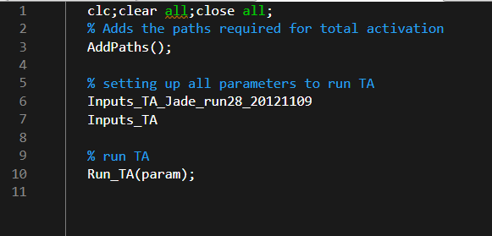
      - There is one line to focus on and that is Inputs_TA_Jade_run28_20121109. This is the convention of the same name of this file but for another file which I will go over soon. This is all this file function needs
  - Inputs_TA_Jade_run28_20121109
    - I will list each line that needs to be changed here
      - param.PathData = “path to the folder that you named for this subject. Based on step a.i.1 in the previous section ../awake/jade the beginning of this path can be whatever you want
      - param.TR = 2.2 (whatever the TR of the data is
      - param.Subjects = {'/ run28_20121109}; #based on a.ii.1 in previous section
      - param.title = “cm_mion_baseline” # this can be whatever you want but must be the same for all monkeys in the same experiment pipeline
      - param.Folder_functional = {“fmri”} #based on step a.iii.1
      - param.TA_func_prefix = {“baseline”} # based on the prefix of each file you have there in a.iii.1.c
      - param.Folder_GM = {“gm”} # based on a.iii.2
      - param.TA_gm_prefix = {“common_mask”} # based on a.iii.2.a
      - param.skipped_scans = X # please set this to what you need to discard for equilibration effects of the bold scans (ex, 5)
      - The rest of the parts can be seen in the image below 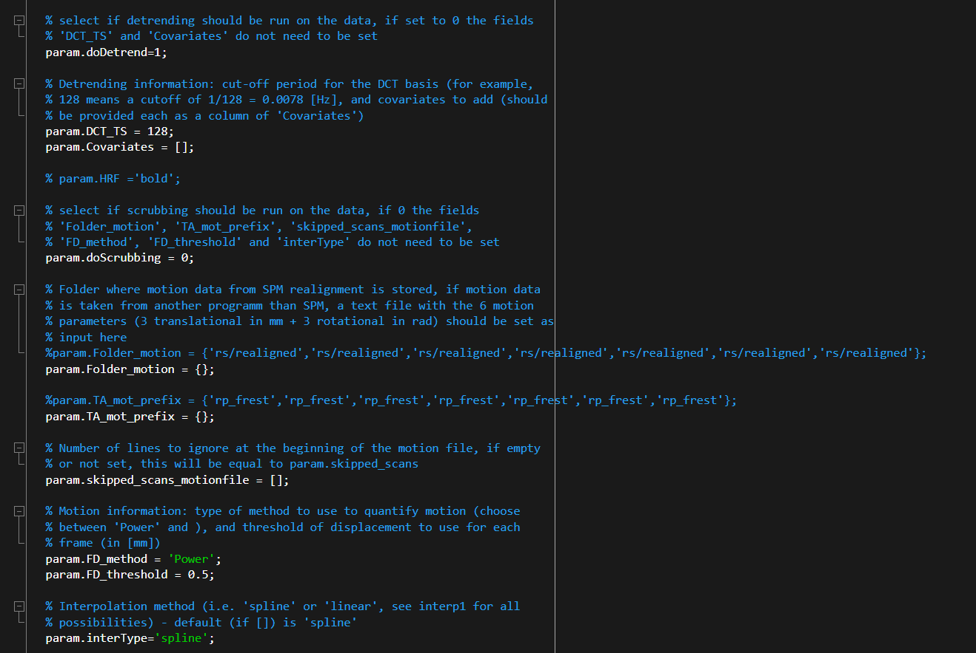
  - Inputs_TA
    - Below is an image of this code
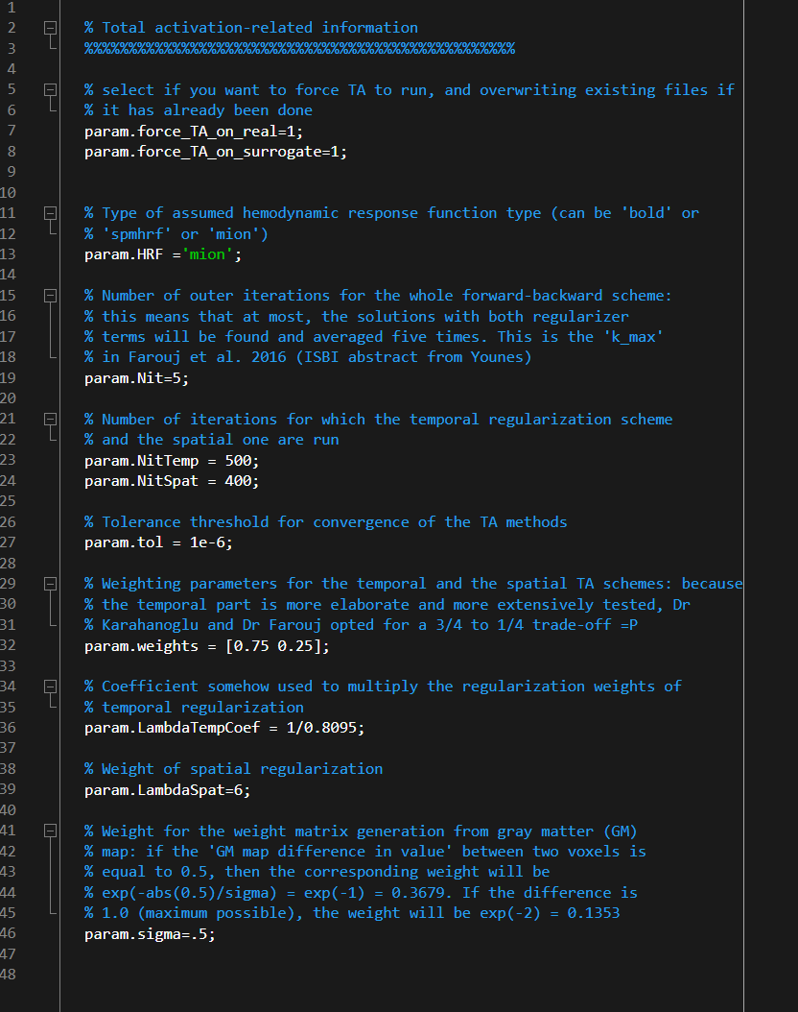

And you are done!

Unfortunately, this has to be done for each participant of each experiment. Each main_TA has to be run separately for each subject. So there will be a main_TA and an inputs_TA each named main_TA_Jade_run28_20121109 and Inputs_TA_Jade_run28_20121109 but for every subject you want to run this with.

Please let me know if you have any questions!

