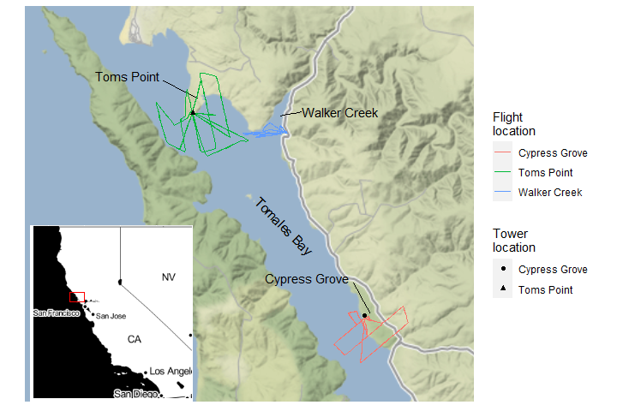

Table 1.

|  | Flight characteristics | | |  | Cypress Grove antennae | | | |  | Toms Point antennae | | | |
| --- | --- | --- | --- | --- | --- | --- | --- | --- | --- | --- | --- | --- | --- |
| Date | Duration (min) | Location | Type |  | 31.3 | 112.3 | 196.3 | 305.3 |  | 34.3 | 111.3 | 192.3 | 285.3 |
| 9-14 | 47.2 | Cypress Grove | P |  | 189 (175; 14) | 189 (175; 14) | 189 (175; 14) | 189 (174; 15) |  | 184 (47; 137) | 186 (110; 76) | 182 (13; 169) | 184 (29; 155) |
| 9-14 | 18.3 | Cypress Grove | M |  | 77 (75; 2) | 77 (77; 0) | 77 (76; 1) | 77 (76; 1) |  | 74 (1; 73) | 76 (23; 53) | 75 (0; 75) | 75 (0; 75) |
| 9-14 | 35.2 | Walker Creek | M |  | 143 (10; 133) | 144 (0; 144) | 144 (0; 144) | 143 (32; 111) |  | 147 (111; 36) | 146 (118; 28) | 143 (35; 108) | 146 (73; 73) |
| 9-15 | 72.5 | Toms Point | P |  | 289 (229; 60) | 289 (176; 113) | 289 (141; 148) | 289 (279; 10) |  | 289 (284; 5) | 289 (285; 4) | 289 (267; 22) | 289 (288; 1) |

Figure 2.

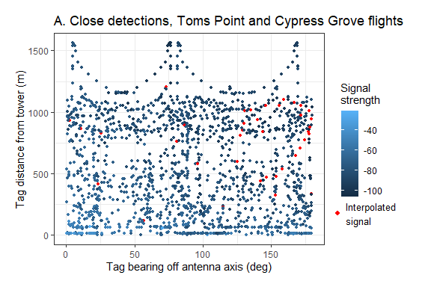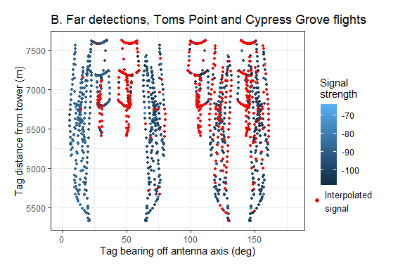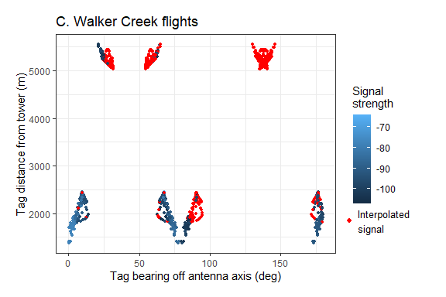

Table 2.

|  | | | 95% Confidence Interval | |
| --- | --- | --- | --- | --- |
| Data subset | Coefficient | Estimate | lower | upper |
| Signal strength, close | Distance | -60.78 | -63.72 | -57.84 |
|  | Bearing | -5.26 | -5.67 | -4.86 |
| Signal strength, far | Distance | -3.28 | -4.78 | -1.78 |
|  | Bearing | -3.16 | -3.43 | -2.88 |
| Detection probability, close | Distance | 2.33 | 0.71 | 4.05 |
|  | Bearing | -0.36 | -0.59 | -0.15 |
| Detection probability, far | Distance | -3.68 | -4.36 | -3.03 |
|  | Bearing | -0.60 | -0.71 | -0.50 |

Figure 3.

