Tomales Bay waterbird foraging guild summary

Number of surveys per year

| Year | Number of surveys | Year | Number of surveys | Year | Number of surveys | Year | Number of surveys |
| --- | --- | --- | --- | --- | --- | --- | --- |
| 1989 | 4 | 1997 | 4 | 2005 | 4 | 2013 | 4 |
| 1990 | 1 | 1998 | 4 | 2006 | 4 | 2014 | 4 |
| 1991 | 4 | 1999 | 2 | 2007 | 4 | 2015 | 4 |
| 1992 | 4 | 2000 | 3 | 2008 | 4 | 2016 | 4 |
| 1993 | 4 | 2001 | 4 | 2009 | 3 | 2017 | 4 |
| 1994 | 4 | 2002 | 4 | 2010 | 4 | 2018 | 2 |
| 1995 | 2 | 2003 | 4 | 2011 | 4 | 2019 | 3 |
| 1996 | 4 | 2004 | 3 | 2012 | 4 | NA | NA |

Foraging guild membership of wintering waterbirds on Tomales Bay.

| Piscivore | Diving benthivore | Planktivore | Omnivore | Herbivore |
| --- | --- | --- | --- | --- |
| Western Grebe | Horned Grebe | Cassin's Auklet | Mallard | Gadwall |
| Clark's Grebe | Horned/Eared Grebe | Red Phalarope | Green-winged Teal | Eurasian Wigeon |
| Western/Clark's Grebe | Eared Grebe |  | Unidentified Teal | American Wigeon |
| Red-necked Grebe | Pied-billed Grebe |  | Cinnamon Teal | Northern Pintail |
| Common Loon | Redhead |  | Northern Shoveler | Wood Duck |
| Loon | Canvasback |  |  | Ross's Goose |
| Red-throated/Pacific Loon | Greater Scaup |  |  | Greater White-fronted Goose |
| Pacific/Common Loon | Scaup |  |  | Canada Goose |
| Yellow-billed Loon | Lesser Scaup |  |  | Black Brant |
| Pacific Loon | Ring-necked Duck |  |  | Mute Swan |
| Red-throated Loon | Common Goldeneye |  |  | Common Gallinule |
| Rhinoceros Auklet | Barrow's Goldeneye |  |  | American Coot |
| Common Murre | Bufflehead |  |  |  |
| Bonaparte's Gull | Long-tailed Duck |  |  |  |
| Caspian Tern | Harlequin Duck |  |  |  |
| Forster's Tern | King Eider |  |  |  |
| Cormorant | Black Scoter |  |  |  |
| Double-crested Cormorant | Scoter |  |  |  |
| Brandt's Cormorant | White-winged Scoter |  |  |  |
| Pelagic Cormorant | Surf Scoter |  |  |  |
| American White Pelican | Ruddy Duck |  |  |  |
| Brown Pelican |  |  |  |  |
| Common Merganser |  |  |  |  |
| Merganser |  |  |  |  |
| Red-breasted Merganser |  |  |  |  |
| Hooded Merganser |  |  |  |  |
| Great Blue Heron |  |  |  |  |
| Great Egret |  |  |  |  |
| Snowy Egret |  |  |  |  |
| Black-crowned Night-Heron |  |  |  |  |

There is relatively little variance in abundance between surveys, so the mean of those values is a good representation of the number of waterbirds on the bay.

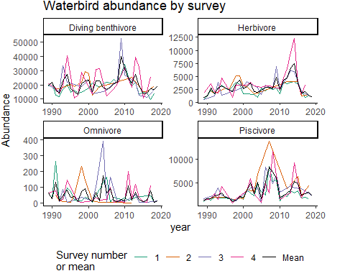

Now looking at just the mean value, waterbird abundance has not changed dramatically (like shorebirds), but there may be decreasing abundance in the last 10 or so years. There are very noticable cyclical patterns in abundance for some guilds. 