2022-07-28

For Great Egret (Table XXX), the largest percent increase was observed in San Pablo Bay where abundance went from 4 (2-6) nests in 1995 to 110 (82-148) nests in 2019. The largest absolute increase was observed in Suisun Bay where abundance increased by 146 nests. The largest percent decrease in Great Egret nest abundance was in Central San Francisco Bay where nesting abundance decreased from 150 (77-293) nests in 1995 to 11 (6-19) nests in 2019. The largest absolute decrease was observed in Central San Francisco Bay where abundance dropped by 139 nests.

**Table** : Changes in number of observed Great Egret nests by subregion in the San Francisco Bay area, 1995-2019. Shown for each subregion are the first and last years a species was observed nesting, the estimated nest abundance and 95% Confidence interval, and the percent change from the first to final year.

|  | First year observed | |  | Final year observed | |  |
| --- | --- | --- | --- | --- | --- | --- |
| Subregion | Year | Estimate (95% CI) |  | Year | Estimate (95% CI) | % change |
| Entire study area | 1995 | 607 (454-812) |  | 2019 | 837 (678-1034) | 37.9 |
| Outer Pacific Coast, North | 1995 | 122 (87-171) |  | 2019 | 105 (82-133) | -13.9 |
| Outer Pacific Coast, South* |  |  |  |  |  |  |
| Russian River, Laguna de Santa Rosa | 1995 | 35 (23-56) |  | 2019 | 53 (38-74) | 51.4 |
| Northern Napa County* |  |  |  |  |  |  |
| San Pablo Bay | 1995 | 4 (2-6) |  | 2019 | 110 (82-148) | 2,650.0 |
| Central San Francisco Bay | 1995 | 150 (77-293) |  | 2019 | 11 (6-19) | -92.7 |
| Suisun Bay | 1995 | 262 (171-403) |  | 2019 | 408 (296-564) | 55.7 |
| Interior East Bay | 1996 | 3 (1-8) |  | 2019 | 10 (4-22) | 233.3 |
| South San Francisco Bay | 1995 | 70 (44-111) |  | 2019 | 87 (64-119) | 24.3 |
| Santa Clara Valley | 1999 | 2 (1-4) |  | 2019 | 14 (9-21) | 600.0 |

For Great Blue Heron (Table XXX), the largest percent increase was observed in Outer Pacific Coast, South where abundance went from 3 (2-7) nests in 1995 to 26 (19-36) nests in 2019. The largest absolute increase was observed in Interior East Bay where abundance increased by 42 nests. The largest percent decrease in Great Blue Heron nest abundance was in Russian River, Laguna de Santa Rosa where nesting abundance decreased from 68 (51-90) nests in 1995 to 33 (26-42) nests in 2019. The largest absolute decrease was observed in South San Francisco Bay where abundance dropped by 42 nests.

**Table** : Changes in number of observed Great Blue Heron nests by subregion in the San Francisco Bay area, 1995-2019. Shown for each subregion are the first and last years a species was observed nesting, the estimated nest abundance and 95% Confidence interval, and the percent change from the first to final year.

|  | First year observed | |  | Final year observed | |  |
| --- | --- | --- | --- | --- | --- | --- |
| Subregion | Year | Estimate (95% CI) |  | Year | Estimate (95% CI) | % change |
| Entire study area | 1995 | 414 (335-510) |  | 2019 | 446 (383-520) | 7.7 |
| Outer Pacific Coast, North | 1995 | 64 (46-88) |  | 2019 | 61 (48-77) | -4.7 |
| Outer Pacific Coast, South | 1995 | 3 (2-7) |  | 2019 | 26 (19-36) | 766.7 |
| Russian River, Laguna de Santa Rosa | 1995 | 68 (51-90) |  | 2019 | 33 (26-42) | -51.5 |
| Northern Napa County | 1995 | 22 (15-32) |  | 2019 | 32 (24-42) | 45.5 |
| San Pablo Bay | 1995 | 47 (32-70) |  | 2019 | 59 (44-79) | 25.5 |
| Central San Francisco Bay | 1995 | 16 (10-24) |  | 2019 | 33 (24-45) | 106.2 |
| Suisun Bay | 1995 | 75 (43-131) |  | 2019 | 68 (44-104) | -9.3 |
| Interior East Bay | 1995 | 33 (22-50) |  | 2019 | 75 (55-102) | 127.3 |
| South San Francisco Bay | 1995 | 82 (49-135) |  | 2019 | 40 (28-56) | -51.2 |
| Santa Clara Valley | 1995 | 30 (18-48) |  | 2019 | 21 (15-29) | -30.0 |

For Snowy Egret (Table XXX), the largest percent increase was observed in Suisun Bay where abundance went from 3 (0-54) nests in 2002 to 83 (6-1232) nests in 2019. The largest absolute increase was observed in Suisun Bay where abundance increased by 80 nests. The largest percent decrease in Snowy Egret nest abundance was in San Pablo Bay where nesting abundance decreased from 52 (20-134) nests in 1995 to 2 (1-5) nests in 2019. The largest absolute decrease was observed in South San Francisco Bay where abundance dropped by 74 nests.

**Table** : Changes in number of observed Snowy Egret nests by subregion in the San Francisco Bay area, 1995-2019. Shown for each subregion are the first and last years a species was observed nesting, the estimated nest abundance and 95% Confidence interval, and the percent change from the first to final year.

|  | First year observed | |  | Final year observed | |  |
| --- | --- | --- | --- | --- | --- | --- |
| Subregion | Year | Estimate (95% CI) |  | Year | Estimate (95% CI) | % change |
| Entire study area | 1995 | 460 (257-824) |  | 2019 | 413 (270-632) | -10.2 |
| Outer Pacific Coast, North | 1995 | 4 (1-22) |  | 2011 | 1 (0-3) | -75.0 |
| Outer Pacific Coast, South* |  |  |  |  |  |  |
| Russian River, Laguna de Santa Rosa | 1995 | 20 (11-39) |  | 2019 | 56 (35-90) | 180.0 |
| Northern Napa County* |  |  |  |  |  |  |
| San Pablo Bay | 1995 | 52 (20-134) |  | 2019 | 2 (1-5) | -96.2 |
| Central San Francisco Bay | 1995 | 155 (75-320) |  | 2019 | 146 (84-255) | -5.8 |
| Suisun Bay | 2002 | 3 (0-54) |  | 2019 | 83 (6-1232) | 2,666.7 |
| Interior East Bay* |  |  |  |  |  |  |
| South San Francisco Bay | 1995 | 286 (122-670) |  | 2019 | 212 (121-374) | -25.9 |
| Santa Clara Valley | 1997 | 5 (2-13) |  | 2019 | 11 (6-20) | 120.0 |

For Black-crowned Night-Heron (Table XXX), the largest percent increase was observed in Santa Clara Valley where abundance went from 3 (1-9) nests in 1995 to 12 (6-26) nests in 2019. The largest absolute increase was observed in Russian River, Laguna de Santa Rosa where abundance increased by 146 nests. The largest percent decrease in Black-crowned Night-Heron nest abundance was in San Pablo Bay where nesting abundance decreased from 138 (66-288) nests in 1995 to 4 (2-8) nests in 2019. The largest absolute decrease was observed in Central San Francisco Bay where abundance dropped by 430 nests.

**Table** : Changes in number of observed Black-crowned Night-Heron nests by subregion in the San Francisco Bay area, 1995-2019. Shown for each subregion are the first and last years a species was observed nesting, the estimated nest abundance and 95% Confidence interval, and the percent change from the first to final year.

|  | First year observed | |  | Final year observed | |  |
| --- | --- | --- | --- | --- | --- | --- |
| Subregion | Year | Estimate (95% CI) |  | Year | Estimate (95% CI) | % change |
| Entire study area | 1995 | 687 (424-1114) |  | 2019 | 500 (352-712) | -27.2 |
| Outer Pacific Coast, North | 2000 | 2 (0-7) |  | 2012 | 2 (1-8) | 0.0 |
| Outer Pacific Coast, South* |  |  |  |  |  |  |
| Russian River, Laguna de Santa Rosa | 1995 | 61 (26-144) |  | 2019 | 207 (109-390) | 239.3 |
| Northern Napa County* |  |  |  |  |  |  |
| San Pablo Bay | 1995 | 138 (66-288) |  | 2019 | 4 (2-8) | -97.1 |
| Central San Francisco Bay | 1995 | 548 (331-908) |  | 2019 | 118 (80-176) | -78.5 |
| Suisun Bay | 2008 | 0 (0-2) |  | 2019 | 9 (2-44) | Inf |
| Interior East Bay* |  |  |  |  |  |  |
| South San Francisco Bay | 1995 | 68 (16-283) |  | 2019 | 146 (57-374) | 114.7 |
| Santa Clara Valley | 1995 | 3 (1-9) |  | 2019 | 12 (6-26) | 300.0 |

Figures

Great Egret 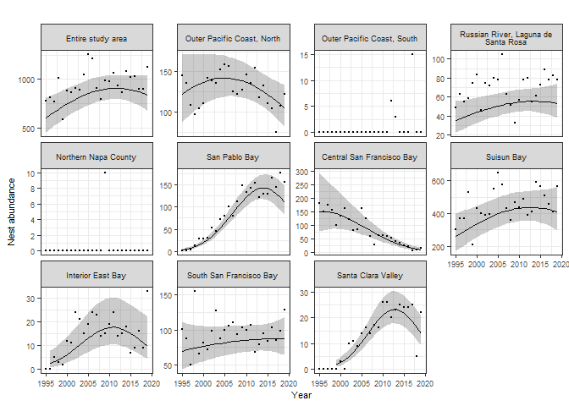

Great Blue Heron 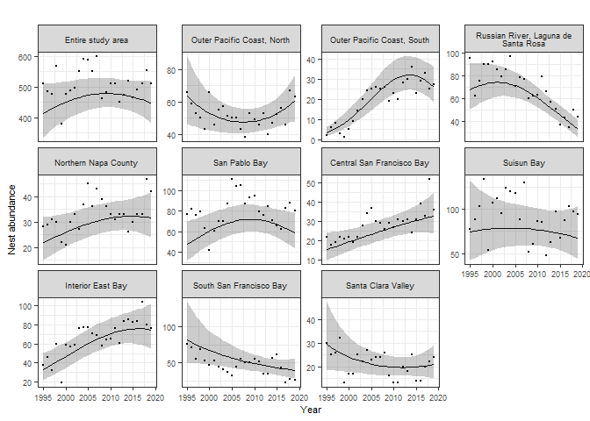

Snowy Egret 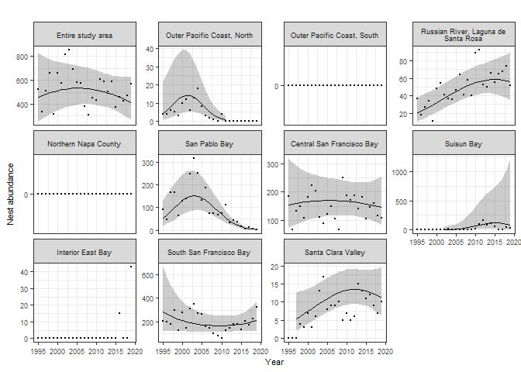

Black-crowned Hight-Heron 