2022-08-02

For Great Egret (Table XXX), the largest percent increase was observed in San Pablo Bay where abundance went from 4 (2-6) nests in 1995 to 110 (82-148) nests in 2019. The largest absolute increase was observed in Suisun Bay where abundance increased by 146 nests. The largest percent decrease in Great Egret nest abundance was in Central San Francisco Bay where nesting abundance decreased from 150 (77-293) nests in 1995 to 11 (6-19) nests in 2019. The largest absolute decrease was observed in Central San Francisco Bay where abundance dropped by 139 nests.

**Table** : Changes in number of observed Great Egret nests by subregion in the San Francisco Bay area, 1995-2019. Shown for each subregion are the first and last years a species was observed nesting, the estimated nest abundance and 95% Confidence interval, and the percent change from the first to final year.

|  | First year observed | |  | Final year observed | |  |
| --- | --- | --- | --- | --- | --- | --- |
| Subregion | Year | Estimate (95% CI) |  | Year | Estimate (95% CI) | % change |
| Entire study area | 1995 | 607 (454-812) |  | 2019 | 837 (678-1034) | 37.9 |
| Outer Pacific Coast, North | 1995 | 122 (87-171) |  | 2019 | 105 (82-133) | -13.9 |
| Outer Pacific Coast, South* |  |  |  |  |  |  |
| Russian River, Laguna de Santa Rosa | 1995 | 35 (23-56) |  | 2019 | 53 (38-74) | 51.4 |
| Northern Napa County* |  |  |  |  |  |  |
| San Pablo Bay | 1995 | 4 (2-6) |  | 2019 | 110 (82-148) | 2,650.0 |
| Central San Francisco Bay | 1995 | 150 (77-293) |  | 2019 | 11 (6-19) | -92.7 |
| Suisun Bay | 1995 | 262 (171-403) |  | 2019 | 408 (296-564) | 55.7 |
| Interior East Bay | 1996 | 3 (1-8) |  | 2019 | 10 (4-22) | 233.3 |
| South San Francisco Bay | 1995 | 70 (44-111) |  | 2019 | 87 (64-119) | 24.3 |
| Santa Clara Valley | 1999 | 2 (1-4) |  | 2019 | 14 (9-21) | 600.0 |

For Great Blue Heron (Table XXX), the largest percent increase was observed in Outer Pacific Coast, South where abundance went from 3 (2-7) nests in 1995 to 26 (19-36) nests in 2019. The largest absolute increase was observed in Interior East Bay where abundance increased by 42 nests. The largest percent decrease in Great Blue Heron nest abundance was in Russian River, Laguna de Santa Rosa where nesting abundance decreased from 68 (51-90) nests in 1995 to 33 (26-42) nests in 2019. The largest absolute decrease was observed in South San Francisco Bay where abundance dropped by 42 nests.

**Table** : Changes in number of observed Great Blue Heron nests by subregion in the San Francisco Bay area, 1995-2019. Shown for each subregion are the first and last years a species was observed nesting, the estimated nest abundance and 95% Confidence interval, and the percent change from the first to final year.

|  | First year observed | |  | Final year observed | |  |
| --- | --- | --- | --- | --- | --- | --- |
| Subregion | Year | Estimate (95% CI) |  | Year | Estimate (95% CI) | % change |
| Entire study area | 1995 | 414 (335-510) |  | 2019 | 446 (383-520) | 7.7 |
| Outer Pacific Coast, North | 1995 | 64 (46-88) |  | 2019 | 61 (48-77) | -4.7 |
| Outer Pacific Coast, South | 1995 | 3 (2-7) |  | 2019 | 26 (19-36) | 766.7 |
| Russian River, Laguna de Santa Rosa | 1995 | 68 (51-90) |  | 2019 | 33 (26-42) | -51.5 |
| Northern Napa County | 1995 | 22 (15-32) |  | 2019 | 32 (24-42) | 45.5 |
| San Pablo Bay | 1995 | 47 (32-70) |  | 2019 | 59 (44-79) | 25.5 |
| Central San Francisco Bay | 1995 | 16 (10-24) |  | 2019 | 33 (24-45) | 106.2 |
| Suisun Bay | 1995 | 75 (43-131) |  | 2019 | 68 (44-104) | -9.3 |
| Interior East Bay | 1995 | 33 (22-50) |  | 2019 | 75 (55-102) | 127.3 |
| South San Francisco Bay | 1995 | 82 (49-135) |  | 2019 | 40 (28-56) | -51.2 |
| Santa Clara Valley | 1995 | 30 (18-48) |  | 2019 | 21 (15-29) | -30.0 |

For Snowy Egret (Table XXX), the largest percent increase was observed in Suisun Bay where abundance went from 3 (0-54) nests in 2002 to 83 (6-1232) nests in 2019. The largest absolute increase was observed in Suisun Bay where abundance increased by 80 nests. The largest percent decrease in Snowy Egret nest abundance was in San Pablo Bay where nesting abundance decreased from 52 (20-134) nests in 1995 to 2 (1-5) nests in 2019. The largest absolute decrease was observed in South San Francisco Bay where abundance dropped by 74 nests.

**Table** : Changes in number of observed Snowy Egret nests by subregion in the San Francisco Bay area, 1995-2019. Shown for each subregion are the first and last years a species was observed nesting, the estimated nest abundance and 95% Confidence interval, and the percent change from the first to final year.

|  | First year observed | |  | Final year observed | |  |
| --- | --- | --- | --- | --- | --- | --- |
| Subregion | Year | Estimate (95% CI) |  | Year | Estimate (95% CI) | % change |
| Entire study area | 1995 | 460 (257-824) |  | 2019 | 413 (270-632) | -10.2 |
| Outer Pacific Coast, North | 1995 | 4 (1-22) |  | 2011 | 1 (0-3) | -75.0 |
| Outer Pacific Coast, South* |  |  |  |  |  |  |
| Russian River, Laguna de Santa Rosa | 1995 | 20 (11-39) |  | 2019 | 56 (35-90) | 180.0 |
| Northern Napa County* |  |  |  |  |  |  |
| San Pablo Bay | 1995 | 52 (20-134) |  | 2019 | 2 (1-5) | -96.2 |
| Central San Francisco Bay | 1995 | 155 (75-320) |  | 2019 | 146 (84-255) | -5.8 |
| Suisun Bay | 2002 | 3 (0-54) |  | 2019 | 83 (6-1232) | 2,666.7 |
| Interior East Bay* |  |  |  |  |  |  |
| South San Francisco Bay | 1995 | 286 (122-670) |  | 2019 | 212 (121-374) | -25.9 |
| Santa Clara Valley | 1997 | 5 (2-13) |  | 2019 | 11 (6-20) | 120.0 |

For Black-crowned Night-Heron (Table XXX), the largest percent increase was observed in Santa Clara Valley where abundance went from 3 (1-9) nests in 1995 to 12 (6-26) nests in 2019. The largest absolute increase was observed in Russian River, Laguna de Santa Rosa where abundance increased by 146 nests. The largest percent decrease in Black-crowned Night-Heron nest abundance was in San Pablo Bay where nesting abundance decreased from 138 (66-288) nests in 1995 to 4 (2-8) nests in 2019. The largest absolute decrease was observed in Central San Francisco Bay where abundance dropped by 430 nests.

**Table** : Changes in number of observed Black-crowned Night-Heron nests by subregion in the San Francisco Bay area, 1995-2019. Shown for each subregion are the first and last years a species was observed nesting, the estimated nest abundance and 95% Confidence interval, and the percent change from the first to final year.

|  | First year observed | |  | Final year observed | |  |
| --- | --- | --- | --- | --- | --- | --- |
| Subregion | Year | Estimate (95% CI) |  | Year | Estimate (95% CI) | % change |
| Entire study area | 1995 | 687 (424-1114) |  | 2019 | 500 (352-712) | -27.2 |
| Outer Pacific Coast, North | 2000 | 2 (0-7) |  | 2012 | 2 (1-8) | 0.0 |
| Outer Pacific Coast, South* |  |  |  |  |  |  |
| Russian River, Laguna de Santa Rosa | 1995 | 61 (26-144) |  | 2019 | 207 (109-390) | 239.3 |
| Northern Napa County* |  |  |  |  |  |  |
| San Pablo Bay | 1995 | 138 (66-288) |  | 2019 | 4 (2-8) | -97.1 |
| Central San Francisco Bay | 1995 | 548 (331-908) |  | 2019 | 118 (80-176) | -78.5 |
| Suisun Bay | 2008 | 0 (0-2) |  | 2019 | 9 (2-44) | Inf |
| Interior East Bay* |  |  |  |  |  |  |
| South San Francisco Bay | 1995 | 68 (16-283) |  | 2019 | 146 (57-374) | 114.7 |
| Santa Clara Valley | 1995 | 3 (1-9) |  | 2019 | 12 (6-26) | 300.0 |

Figures

Figure XXX. Number of active (≥1 nest) heron and egret colonies monitored in each subregion in the San Francisco Bay Area, 1995-2019. 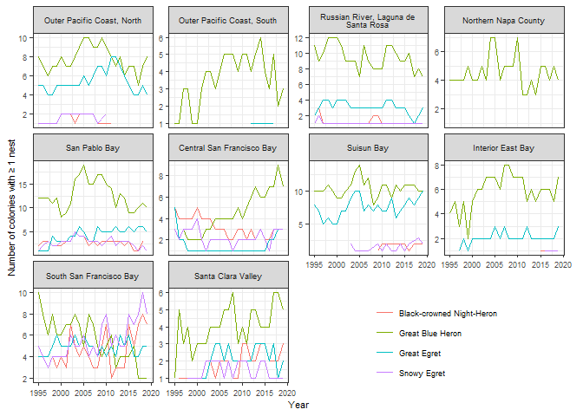

Figure XXX. Changes in nest abundance of Great Egret by subregion in the San Francisco Bay Area, 1995-2019. Shown are the estimated mean abundance (line) and 95% Confidence interval (gray ribbon) from a generalize linear model and the raw data (dots) the models were fitted to.

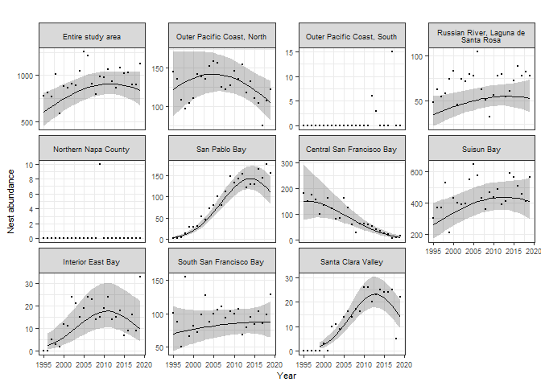

Figure XXX. Changes in nest abundance of Great Blue Heron by subregion in the San Francisco Bay Area, 1995-2019. Shown are the estimated mean abundance (line) and 95% Confidence interval (gray ribbon) from a generalize linear model and the raw data (dots) the models were fitted to.

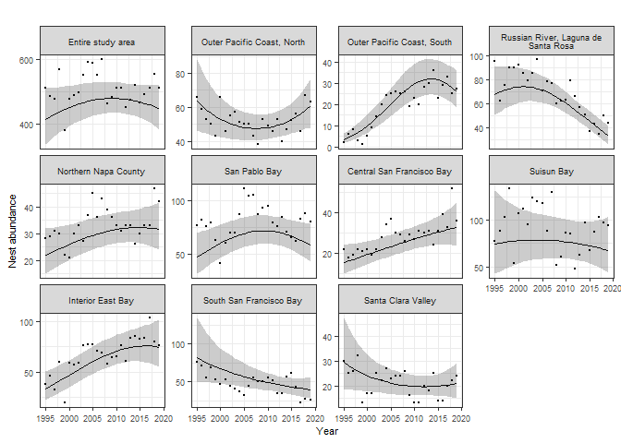

Figure XXX. Changes in nest abundance of Snowy Egret by subregion in the San Francisco Bay Area, 1995-2019. Shown are the estimated mean abundance (line) and 95% Confidence interval (gray ribbon) from a generalize linear model and the raw data (dots) the models were fitted to. 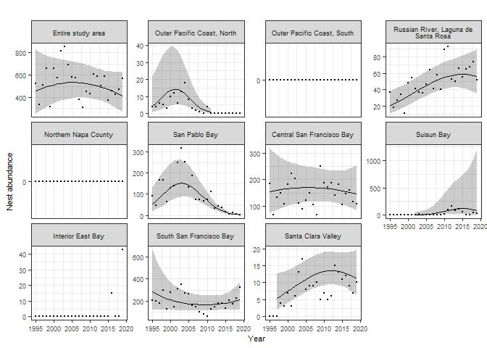

Figure XXX. Changes in nest abundance of Black-crowned Night-Heron by subregion in the San Francisco Bay Area, 1995-2019. Shown are the estimated mean abundance (line) and 95% Confidence interval (gray ribbon) from a generalize linear model and the raw data (dots) the models were fitted to. 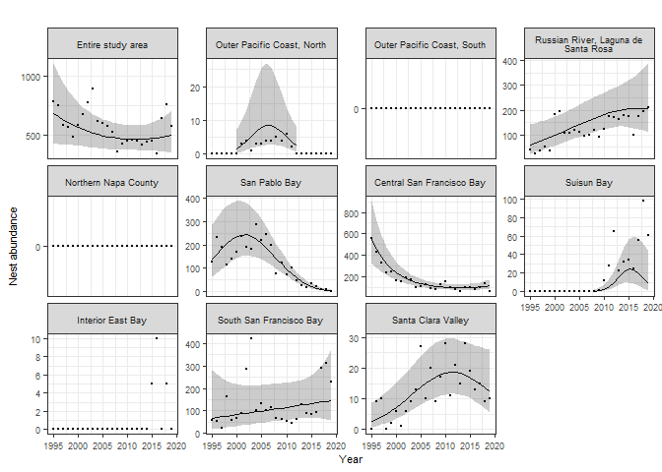

Figure XXX. Absolute and percent changes in the number of observed heron and egret nests by subregion in the San Francisco Bay area, 1995-2019. Shown for each subregion are the change from the first to last years a species was observed nesting. All estimates are extracted from the fit of a genralized linear model. 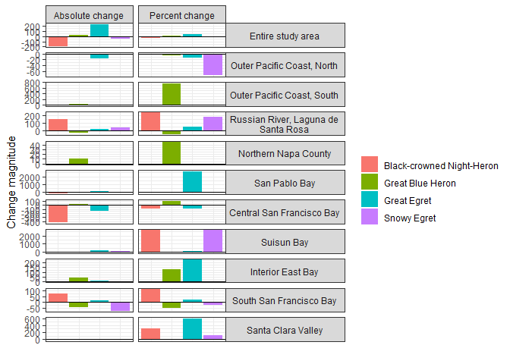

**Table** : Changes in absolute number of observed heron and egret nests by subregion in the San Francisco Bay area, 1995-2019. Shown for each subregion are the change in number of nests from the first to last years a species was observed nesting, and in parentheses the values in the first and last years. All estimates are extracted from the fit of a genralized linear model.

|  | Great Egret | Great Blue Heron | Snowy Egret | Black-crowned Night-Heron |
| --- | --- | --- | --- | --- |
| Entire study area | 230 (607, 837) | 32 (414, 446) | -47 (460, 413) | -187 (687, 500) |
| Outer Pacific Coast, North | -17 (122, 105) | -3 (64, 61) | -3 (4, 1) | 0 (2, 2) |
| Outer Pacific Coast, South |  | 23 (3, 26) |  |  |
| Russian River, Laguna de Santa Rosa | 18 (35, 53) | -35 (68, 33) | 36 (20, 56) | 146 (61, 207) |
| Northern Napa County |  | 10 (22, 32) |  |  |
| San Pablo Bay | 106 (4, 110) | 12 (47, 59) | -50 (52, 2) | -134 (138, 4) |
| Central San Francisco Bay | -139 (150, 11) | 17 (16, 33) | -9 (155, 146) | -430 (548, 118) |
| Suisun Bay | 146 (262, 408) | -7 (75, 68) | 80 (3, 83) | 9 (0, 9) |
| Interior East Bay | 7 (3, 10) | 42 (33, 75) |  |  |
| South San Francisco Bay | 17 (70, 87) | -42 (82, 40) | -74 (286, 212) | 78 (68, 146) |
| Santa Clara Valley | 12 (2, 14) | -9 (30, 21) | 6 (5, 11) | 9 (3, 12) |

**Table** : Changes in number of observed heron and egret nests by subregion in the San Francisco Bay area, 1995-2019. Shown for each subregion are the percent change in number of nests from the first to last years a species was observed nesting, and in parentheses the values in the first and last years. All estimates are extracted from the fit of a genralized linear model.

|  | Great Egret | Great Blue Heron | Snowy Egret | Black-crowned Night-Heron |
| --- | --- | --- | --- | --- |
| Entire study area | 37.9 (607, 837) | 7.7 (414, 446) | -10.2 (460, 413) | -27.2 (687, 500) |
| Outer Pacific Coast, North | -13.9 (122, 105) | -4.7 (64, 61) | -75 (4, 1) | 0 (2, 2) |
| Outer Pacific Coast, South |  | 766.7 (3, 26) |  |  |
| Russian River, Laguna de Santa Rosa | 51.4 (35, 53) | -51.5 (68, 33) | 180 (20, 56) | 239.3 (61, 207) |
| Northern Napa County |  | 45.5 (22, 32) |  |  |
| San Pablo Bay | 2650 (4, 110) | 25.5 (47, 59) | -96.2 (52, 2) | -97.1 (138, 4) |
| Central San Francisco Bay | -92.7 (150, 11) | 106.2 (16, 33) | -5.8 (155, 146) | -78.5 (548, 118) |
| Suisun Bay | 55.7 (262, 408) | -9.3 (75, 68) | 2666.7 (3, 83) | Inf (0, 9) |
| Interior East Bay | 233.3 (3, 10) | 127.3 (33, 75) |  |  |
| South San Francisco Bay | 24.3 (70, 87) | -51.2 (82, 40) | -25.9 (286, 212) | 114.7 (68, 146) |
| Santa Clara Valley | 600 (2, 14) | -30 (30, 21) | 120 (5, 11) | 300 (3, 12) |

Figure xxx. Effect of rainfall (previous 3 years cumulative) on number of observed heron and egret nests in each subregion in the San Francisco Bay Area, 1995-2019. 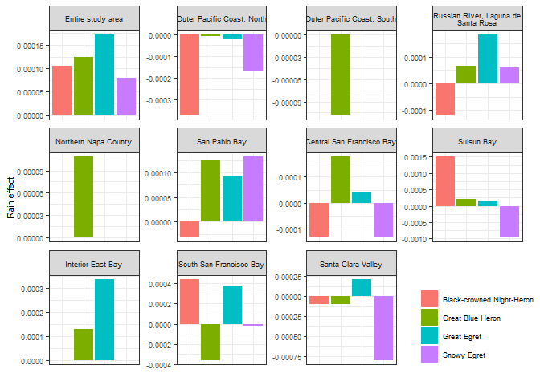

Results of sensitivity analysis

Figure XXX. Results of analysis testing sensitivity of estimates of Great Egret nesting abundance to missing data, by subregion in the San Francisco Bay Area, 1995-2019. The analysis consisted of randomly removing 5% of the annual colony-level observations, refitting the model used in the main analysis, and extracting model predictions as in the main analysis. This process was repeated 1000 times, and 95% confidence intervals for the bootstrapped model predictions were generated. These 95% CI are shown in gray, and the main analysis model predictions (using all the data) are shown by the black line. 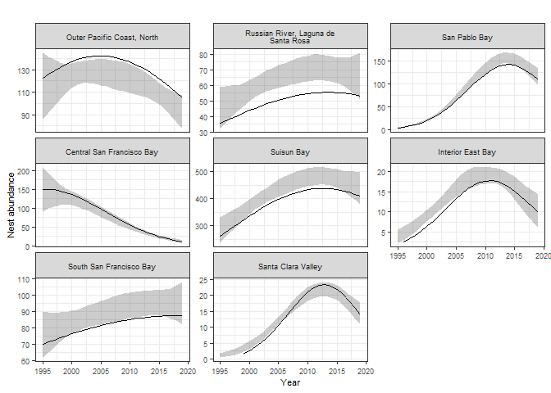

Figure XXX. Results of analysis testing sensitivity of estimates of Great Blue Heron nesting abundance to missing data, by subregion in the San Francisco Bay Area, 1995-2019. The analysis consisted of randomly removing 5% of the annual colony-level observations, refitting the model used in the main analysis, and extracting model predictions as in the main analysis. This process was repeated 1000 times, and 95% confidence intervals for the bootstrapped model predictions were generated. These 95% CI are shown in gray, and the main analysis model predictions (using all the data) are shown by the black line. 