Can we get good estimates of the most abundant species by only counting some sections?

Considering the species that were among the top 5 most abundant in at least 1 year, is there any section of the bay where the count of that section best represents the count of the entire bay?

For Scaup, section 2 appears most important. 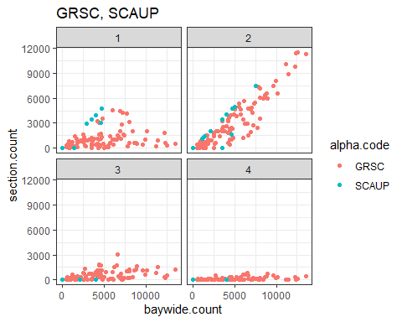

For Double-crested and Brandt’s Cormorant, section 2 seems most important.

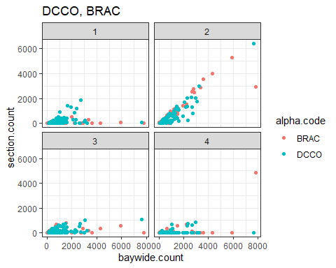

For Bufflehead, section 3 appears most important.

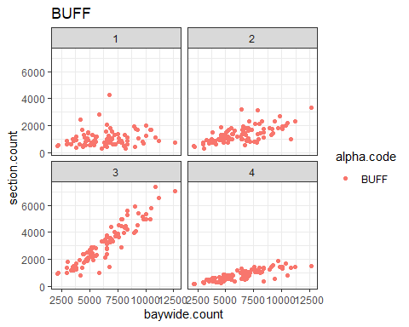

For Surf Scoter, section 2 appears most important.

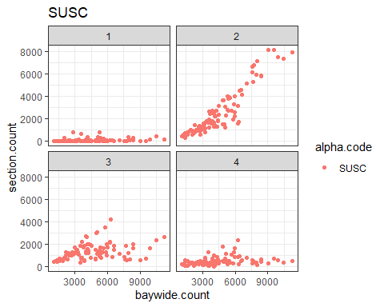

For Ruddy Duck, sections 1 and 3 appear most important, but there are some instances where the counts in these sections poorly match the baywide count. 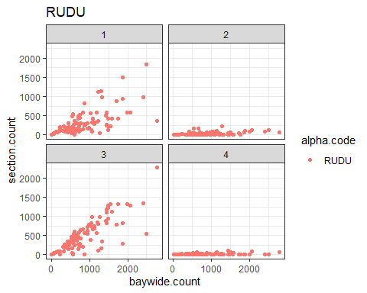

For small grebes, section 2 appears most important. 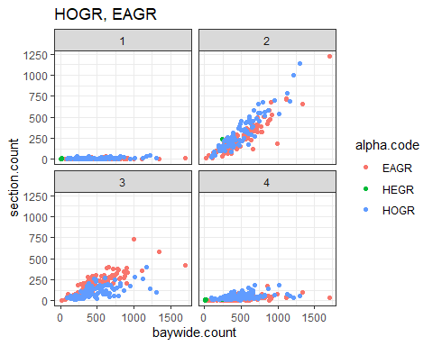

For Black Brant, sections 3 and 4 appear most important.Should count both sections for this spp. 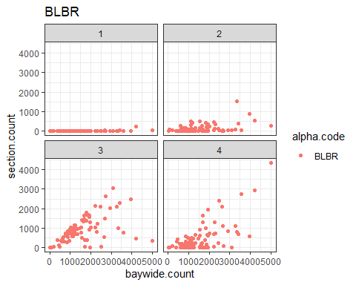

For coots, sections 1 and 3 appear most important, but there are several instances where the counts in these sections did not match the baywide count.

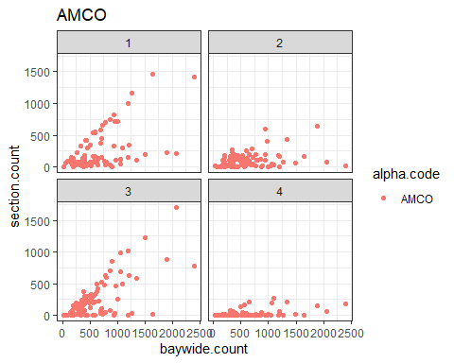

For Western Grebe, section 2 appears most important.

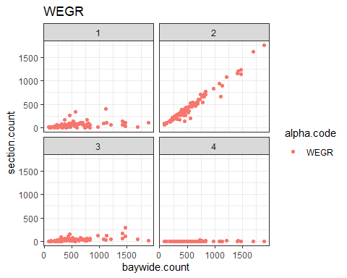

For Widgeon, section 1 appears most important.

