Tomales Bay waterbird species detections and proportions

Scott Jennings

2020-11-04

How many species are detected during ACR Tomales Bay Waterbird surveys, how frequently is each species detected, and what proportion of the total waterbirds does each species represent?

###  
library(tidyverse)  
library(officer)  
library(officedown)  
options(scipen = 999)  
  
  
source("C:/Users/scott.jennings/Documents/Projects/water_birds/code/utility/waterbird_utility_functions.r")  
source("C:/Users/scott.jennings/Documents/Projects/R_general/utility_functions/bird_utility_functions.r")  
  
# read cleaned data  
wbirds4analysis <- readRDS("C:/Users/scott.jennings/Documents/Projects/water_birds/data_files/working_rds/wbirds4analysis") %>%   
 wbird_add_study_day() # from waterbird_utility_functions.R

A note on grouped species. Some “species” exist in the database to represent lumped birds that could not be identified to species level. Some of these groupings are useful and are regularly used:

useful_groupies <- c("LOON", "RTPALO", "CORM", "HEGR", "WCGR", "PCLO")

while some have only been used once or are not particularly informative or useful

useless_groupies <- c("AMCOGRSCLESCBUFF", "COMERBME", "GOOSE", "MERG", "MURRELET", "SWAN", "UNTE", "DUCK", "SCOTER")

Additionally, Greater and Lesser Scaup may not always be reliably distinguished, and a SCAUP group is used even more often than the useful groupies. Thus all Greater and Lesser Scaup are changed to “SCAUP”.

wbirds4analysis <- wbirds4analysis %>%   
 mutate(alpha.code = ifelse(alpha.code == "GRSC" | alpha.code == "LESC", "SCAUP", alpha.code))

Code to calculate Species proportions.

# sum baywide abundance for each species on each survey date, calculate proportion of all birds counted each day composed by each species  
  
baywide_abund_spp_date<- wbirds4analysis %>%   
 # first calculate number of birds of each species each date  
 group_by(study.year, date, alpha.code) %>%   
 summarise(baywide.count = sum(section.final)) %>%   
 ungroup() %>%   
 # then calculate the total number of birds each date   
 group_by(study.year, date) %>%   
 mutate(baywide.total.birds = sum(baywide.count)) %>%   
 ungroup() %>%   
 # next the proportion of all birds comprised by each species  
 mutate(date.spp.proportion.all = baywide.count / baywide.total.birds) %>%   
 # and finally rank species by proportional abundance   
 arrange(date, -date.spp.proportion.all) %>%   
 group_by(study.year, date) %>%   
 mutate(abund.rank = row_number()) %>%   
 ungroup()  
   
  
# calculate the average proportion of the total waterbirds made up by each species each year  
# classify each species each year as being more or less abundandant at a 5% of total cutoff  
ave_proportion_each_year <- baywide_abund_spp_date %>%   
 group_by(study.year, alpha.code) %>%   
 summarise(mean.proportion = mean(date.spp.proportion.all)) %>%   
 ungroup() %>%   
 mutate(prop.group = cut(mean.proportion, breaks = c(-Inf, 0.05, Inf), labels = c("less", "more")))  
  
# calculate the average proportion of the total waterbirds made up by each species across all years  
# classify each species each year as being more or less abundandant at a 5% of total cutoff  
ave_proportion_all_years <- ave_proportion_each_year %>%   
 group_by(alpha.code) %>%   
 summarise(mean.proportion = mean(mean.proportion)) %>%   
 ungroup() %>%   
 mutate(prop.group = cut(mean.proportion, breaks = c(-Inf, 0.05, Inf), labels = c("less", "more")))  
  
saveRDS(ave_proportion_each_year, "C:/Users/scott.jennings/Documents/Projects/water_birds/data_files/working_rds/ave_proportion_each_year")  
saveRDS(ave_proportion_all_years, "C:/Users/scott.jennings/Documents/Projects/water_birds/data_files/working_rds/ave_proportion_all_years")

How many years was each species detected on at least one survey date?

num_years_detected <- ave_proportion_each_year %>%   
 group_by(alpha.code) %>%   
 summarise(num.year.detected = n()) %>%   
 bird_taxa_filter(join_taxa = c("alpha.code", "alpha.code")) %>%   
 mutate(abund.group = cut(num.year.detected, breaks=c(-Inf, 10, 20, Inf), labels=c("low","middle","high")))  
  
saveRDS(num_years_detected, "C:/Users/scott.jennings/Documents/Projects/water_birds/data_files/working_rds/num_years_detected")  
  
num_years_detected %>%   
 filter(!alpha.code %in% useless_groupies, !alpha.code %in% useful_groupies) %>%   
 ggplot() +  
 geom_col(aes(x = reorder(common.name, num.year.detected), y = num.year.detected, fill = abund.group)) +  
 coord_flip() +  
 xlab("") +  
 ylab("Number of years detected at least once") +  
 theme_classic() +  
 theme(legend.position = "none")

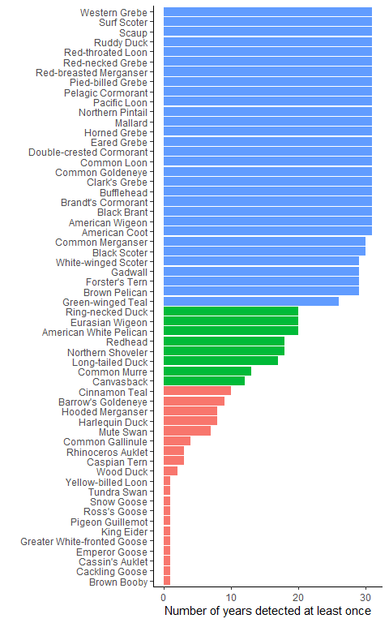

ggsave("C:/Users/scott.jennings/Documents/Projects/water_birds/figures_output/raw_data_plots/number_years_detected.png", width = 6, height = 10)

Of the 34 species detected on at least one date in at least 20 years, only a small number comprise the majority of waterbird abundance.

ave_proportion_all_years %>%   
 filter(alpha.code %in% filter(num_years_detected, abund.group == "high")$alpha.code, !alpha.code %in% useful_groupies) %>%   
 bird_taxa_filter(join_taxa = c("alpha.code", "alpha.code")) %>%   
 ggplot() +  
 geom_col(aes(reorder(common.name, mean.proportion), y = mean.proportion * 100, fill = prop.group))+  
 coord_flip() +  
 xlab("") +  
 ylab("Average percent of all birds counted") +  
 theme_classic() +  
 theme(legend.position = "none") +  
 ylim(0, 30)

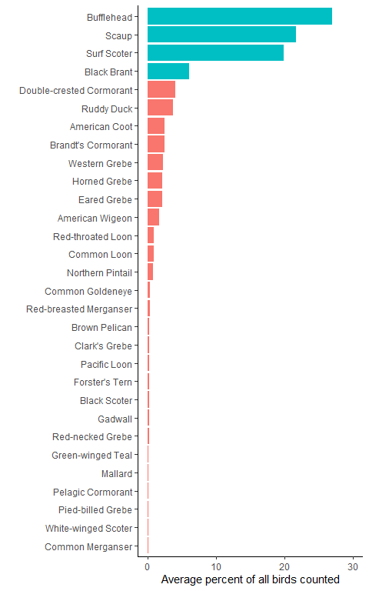

ggsave("C:/Users/scott.jennings/Documents/Projects/water_birds/figures_output/raw_data_plots/ave_percent_all_detected.png", width = 6, height = 10)

Of the 4 species that on average comprise at least 5% of the total waterbird abundance on Tomales Bay, the relative proportions of each have remained fairly stable throughout the monitoring project.

ave_proportion_each_year %>%   
 filter(alpha.code %in% filter(ave_proportion_all_years, prop.group == "more")$alpha.code, !alpha.code %in% useless_groupies) %>%   
 bird_taxa_filter(join_taxa = c("alpha.code", "alpha.code")) %>%   
 ggplot() +  
 geom_col(aes(x = study.year, y = mean.proportion * 100, fill = common.name)) +  
 theme_classic() +  
 theme(legend.title = element_blank()) +  
 xlab("Year") +  
 ylab("Percent of all waterbirds detected")

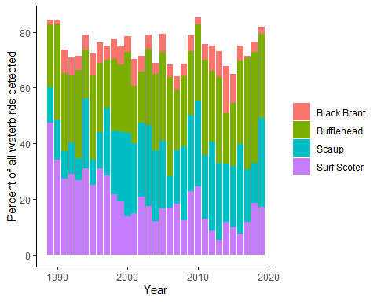

ggsave("C:/Users/scott.jennings/Documents/Projects/water_birds/figures_output/raw_data_plots/four_most_abund_proportion_total.png", width = 10, height = 8)

Lumped species are assigned to species in that group based on proportions of positively IDed species, but if there were more grouped than positively IDed species, then those birds remain grouped. In most years, the number of birds that remain unclassified to species, and that fit into species classifications that we might consider meaningful and useful, generally comprise less than 1% of the total waterbirds.

ave_proportion_each_year %>%   
 filter(alpha.code %in% useful_groupies) %>%   
 bird_taxa_filter(join_taxa = c("alpha.code", "alpha.code")) %>%   
 ggplot() +  
 geom_col(aes(x = study.year, y = mean.proportion * 100, fill = common.name)) +  
 theme_classic() +  
 theme(legend.title = element_blank()) +  
 xlab("Year") +  
 ylab("Percent of all waterbirds detected")

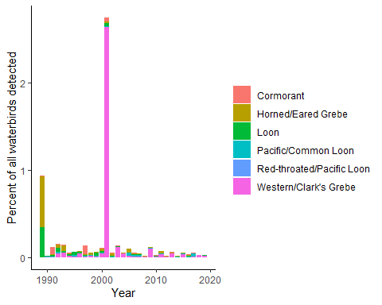

ggsave("C:/Users/scott.jennings/Documents/Projects/water_birds/figures_output/raw_data_plots/useful_groupies_proportion_total.png", width = 10, height = 8)

Similarly, the number of birds that remain unclassified to species but that fit into vague (not useful) species classifications were also a very small percentage of the total waterbirds. Most of these involve isolated instances of (apparently) a single group of birds being unidentified.

ave_proportion_each_year %>%   
 filter(alpha.code %in% useless_groupies) %>%   
 bird_taxa_filter(join_taxa = c("alpha.code", "alpha.code")) %>%   
 ggplot() +  
 geom_col(aes(x = study.year, y = mean.proportion * 100, fill = common.name)) +  
 theme_classic() +  
 theme(legend.title = element_blank()) +  
 xlab("Year") +  
 ylab("Percent of all waterbirds detected")

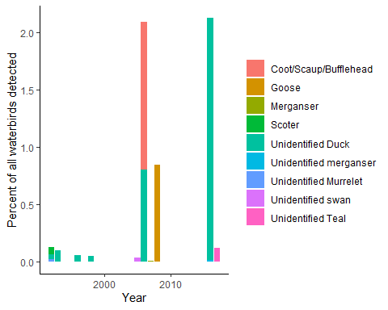

ggsave("C:/Users/scott.jennings/Documents/Projects/water_birds/figures_output/raw_data_plots/useful_groupies_proportion_total.png", width = 10, height = 8)