2025 Revenue Mix
Full Year (January – December 2025) | All Locations | Source: Citrin Cooperman
Total 2025 Revenue
$17,754,712
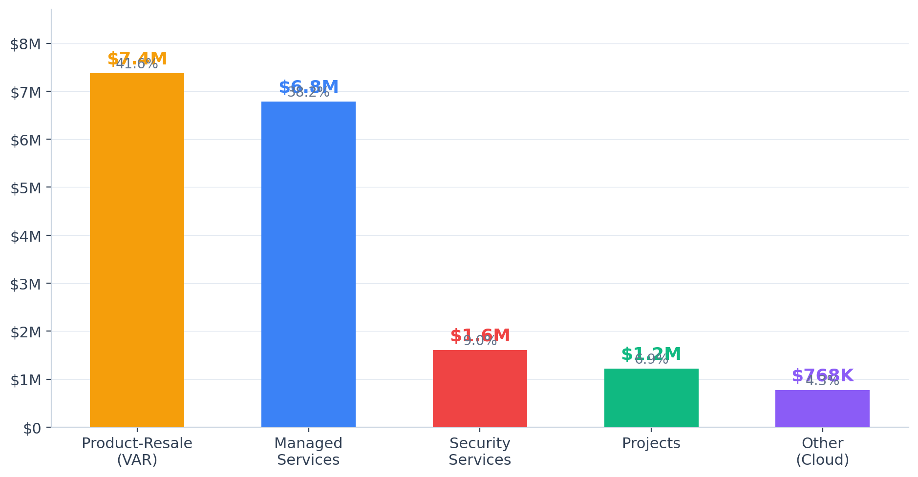

Revenue Breakdown by Category
Category | Revenue | % of Total | Rank
Product-Resale (VAR) | $7,377,601 | 41.6% | #1
Managed Services | $6,785,882 | 38.2% | #2
Security Services | $1,605,619 | 9.0% | #3
Projects | $1,217,477 | 6.9% | #4
Other (Cloud & Hosting) | $768,133 | 4.3% | #5
TOTAL | $17,754,712 | 100.0%

Key Observations
Product-Resale (VAR) dominates at 41.6% — $7.4M in hardware, software licensing (M365), and product sales. This is the largest revenue segment but carries the lowest margins (~13–16%). High dependency on lumpy product deals creates revenue volatility.
Managed Services is the recurring core at 38.2% — $6.8M in managed IT, voice, backup, and E-Rate. This is the high-margin (88–93%) predictable revenue that drives premium MSP valuations. Target: grow to 50%+ of total revenue.
Security Services growing at 9.0% — $1.6M in managed security and security resale. High-growth opportunity (industry growing 25–30% annually). Acquirers pay 1.5–2x higher multiples for strong security practices.
Projects at 6.9% — $1.2M in project services and subcontracted work. Lumpy but important for client onboarding and migrations. 25% of project labor supports managed services operations.
Cloud & Hosting is smallest at 4.3% — $768K in public/private cloud and SaaS. Growth opportunity as clients migrate from on-prem. Target 20%+ of revenue within 18 months through cloud management bundling.

