**Project 1**

**By: Lizzy Sterling and Scott Herford**

Table of Contents

Introduction 1

Data Description 1

Exploratory Analysis 2

Analysis Question 1 2

The Problem 2

The Model 2

Analysis Question 2 2

The Problem 2

The Model & Assumptions 2

Comparing Competing Models 2

Conclusion 2

Appendix 2

# Introduction

“Ask a home buyer to describe their dream house, and they probably won't begin with the height of the basement ceiling or the proximity to an east-west railroad. But this Kaggle competition's dataset proves that much more influences price negotiations than the number of bedrooms or a white-picket fence.” This project, investigates factors that influence sale prices of houses in Ames, Iowa. We will conduct two analyses for this project to examine the influence that neighborhood and square footage have on sale prices of homes as well as other factors that may be significant on the sale price of homes. This project could benefit realators and homebuyers in Ames that may want to know what the most influential factors are on home prices.

# Data Description

This data is from the Kaggle competition “House Prices: Advanced Regression Techniques” (see more at <https://www.kaggle.com/c/house-prices-advanced-regression-techniques>). The data consists of 79 explanatory variables that describe elements of homes in Ames, Iowa. The training data set consists of 1460 homes with the test data set providing 1459 more observations, a total of 2919 homes.

***Note: All figures and graphs have been placed in the appendix for readability and space conservation purposes. Please refer to the*** ***appendix*** ***to see figures referenced in this project.***

# Exploratory Analysis

To begin this analysis, we first needed to check all of the variables to make sure that all of the data was entered in correctly. We found that LotFrontage was saved in the data as a character rather than a numeric, so we needed to fix that in order to run a proper analysis.

Next we need to consider 3 main assumptions: **Normality**, **Equality of Variance**, and **Independence**. We started to look at this by comparing our results variable, SalePrice, side-by-side with every other quantifiable variable. Looking at figure 1, the data seems to be very skewed and non-linear, so we tried logging SalePrice, the results of which can be found in figure 2. We are going to keep this variable logged for the remainder of our analysis.

Once we decided to log our response variable, we decided to look at how all of the explanatory variables interact with logSalePrice. We found that there were a few variables that appeared to be skewed due to outliers and some that did not have a very linear relationship, so we decided to look into transformations. We found that the variables GrLivArea, LowQualFinSF, TotalBsmtSF, PoolArea, and MiscVal all had major issues with equality of variances, so we decided to log them and rerun the individual analysis with logSalePrice. We found that GrLivArea performed a lot better when logged as well as PoolArea and MiscVal. With the latter two variables we kept them logged, but keep in mind that both of these have very few data points so they might not meet other assumptions. Although we saw these improvements, we are not going to dwell too much here since logging the explanatory variables will not have too large of an effect on our models due to the fact that we are fitting so many variables into a linear model.

Because each model is unique, we are going to conduct further analysis as we create new models.

# Analysis Question 1

## The Problem

We want to create a model that will help buyers, real estate agents, and contractors to gain insight into what factors influence housing prices in Ames, Iowa. By doing this, we are going to perform three basic methods of model selection: **Forward**, **Backward**, and **Stepwise** selection.

## Forward Model

We began our model by including all qualitative and quantitative variables into a glmselect procedure. After running the forward selection procedure a few times, we ended up deciding that this model (figure 3) was the best fit. To ensure that we do not have collinearity, we checked the VIFs and found that although Yearbuilt, logGrLivArea and OverallQual have a higher VIF than the rest, they are still pretty low with values around 2, so we kept both of these parameters in our model. Now we are going to check the assumptions on this model in particular:

**Normality:** Looking at the histogram (figure 4) the data appears to be normal, although the QQ-plot shows a slight curvature pattern. We are going to assume normality due the large number of data points and even if the data is not normal, we can assume that the central limit theorem will kick in.

**Equality of Variance:** Looking at the residual plot (figure 5) , there still seems to be a few outliers, but looking at the cook’s D and leverage, these points don’t seem to be anything to worry about, so we are going to assume equality of variance.

**Independence:** For the sake of this analysis, we are going to assume independent data.

Since all of our assumptions are met, we are going to look into the statistics of the model, which can be found in the table. For information on the estimates, look to figure 6.

## Backward Model – I need to come back to this once we figure out the logging of miscval

We began our model by including all qualitative and quantitative variables into a glmselect procedure. After running the backward selection procedure a few times, we ended up deciding that this model (figure 7) was the best fit. To account for collinearity, we checked variance inflation and found that non of the variables are collinear. Now we are going to check the assumptions on this model in particular:

**Normality:** From the histogram (figure 8) we can say that data appear to be relatively normal. Even though the QQ-plot shows evidence of a slight pattern, the sample size is large enough that we would assume the central limit theorem to kick in. For these reasons we are going to assume normality.

**Equality of Variance:** the residual plot (figure 9) does not look great – there are a few points in the bottom right that seem to be skewing the data. This is most likely due to the MiscVal variables, which we noted earlier were very few data points, so we are going to try logging MiscVal, which makes the residual plot more of a random cluster (figure 10), but when we try to fit the model again with the logged variable, it becomes more trouble than it’s worth because of the huge number of zeros. Therefore we are going to keep MiscVal in the model even though it skews the variance. Because we are looking at one particular outlier, we are going to assume equality of variance.

**Independence:** For the sake of analysis, we are going to assume the data to be independent.

Since all of our assumptions are met, we are going to look into the statistics of the model, which can be found in the table. For information on the estimates, look to figure 10.

## Stepwise Model

We began our model by including all qualitative and quantitative variables into a glmselect procedure. After running the forward selection procedure a few times, we ended up deciding that this model (figure 11) was the best fit. Now we are going to check the assumptions on this model in particular:

**Normality:**

**Equality of Variance:**

**Independence:**

## Table:

|  |  |  |  |  |
| --- | --- | --- | --- | --- |
| Models | Adjusted R2 | AIC | CVPress | Kaggle Score |
| Forward | .8631 | -3166.34605 | 26.67304 | .17533 |
| Backward | .8701 | -3210.84885 | 25.83838 | 1.24987 |
| Stepwise |  |  |  |  |

# Analysis Question 2

## The Problem

We would like to build the most predictive model for sale prices of homes in all of Ames, Iowa. We will use four model selection techniques to analyze the influential factors on sale prices of homes in Ames.

## The Model & Assumptions

## Comparing Competing Models

|  |  |  |  |  |
| --- | --- | --- | --- | --- |
| Kaggle Competition Models | Adjusted R2 | AIC | ASE | Kaggle Score |
|  |  |  |  |  |
|  |  |  |  |  |
|  |  |  |  |  |

# Conclusion

## Appendix

### Exploratory Analysis

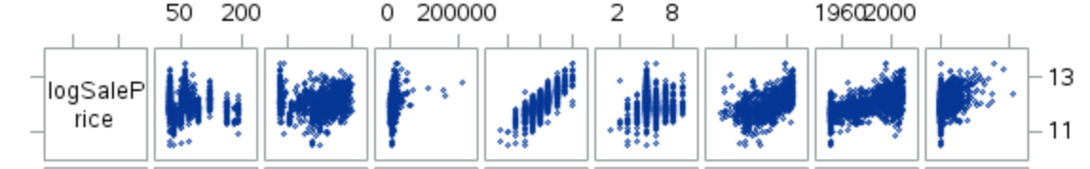*Figure 1 Figure 2*

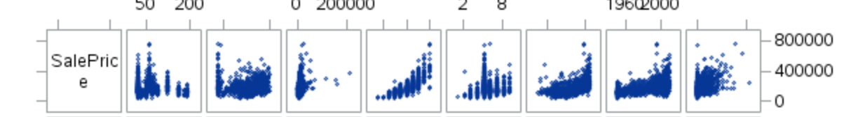

### Analysis 1

#### Forward Selection

*Figure 3 Figure 4 Figure 5*

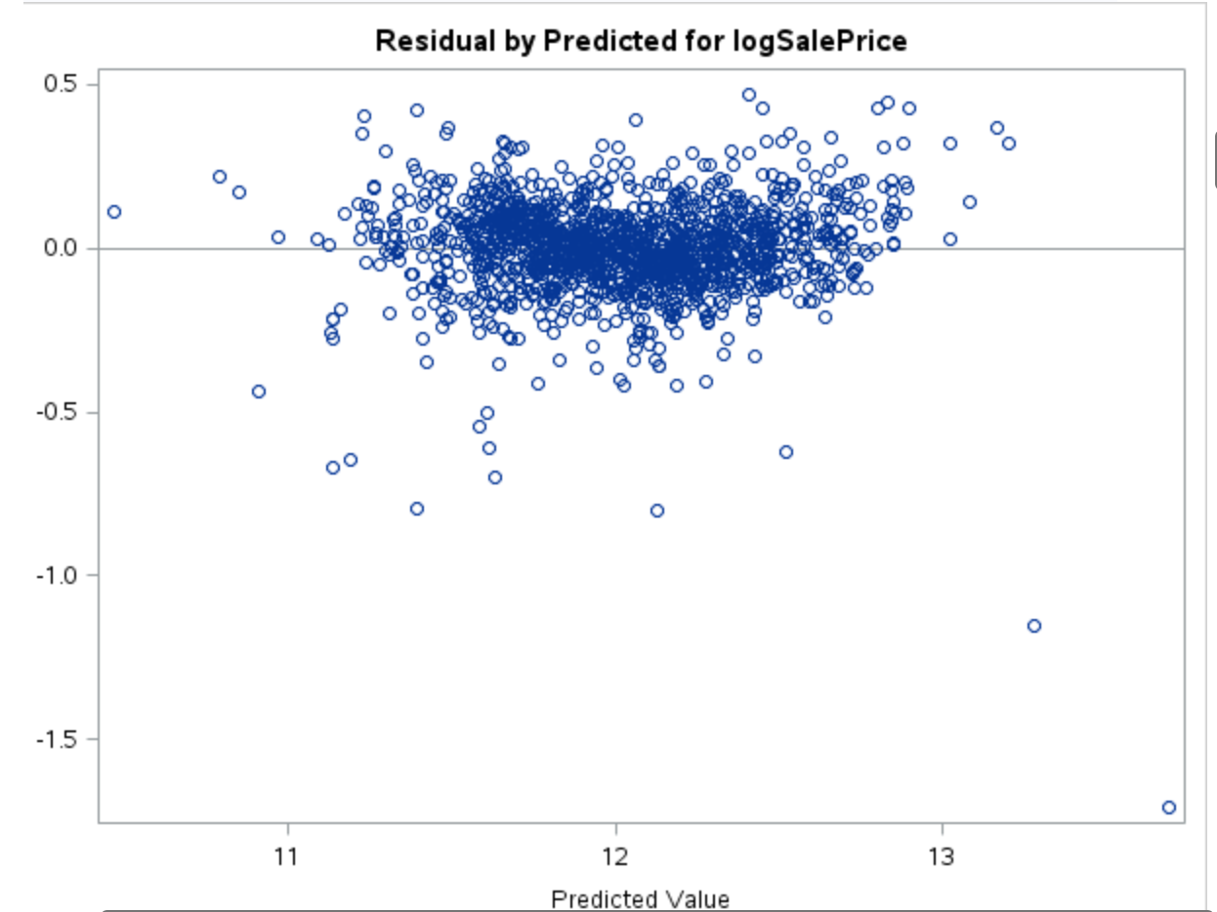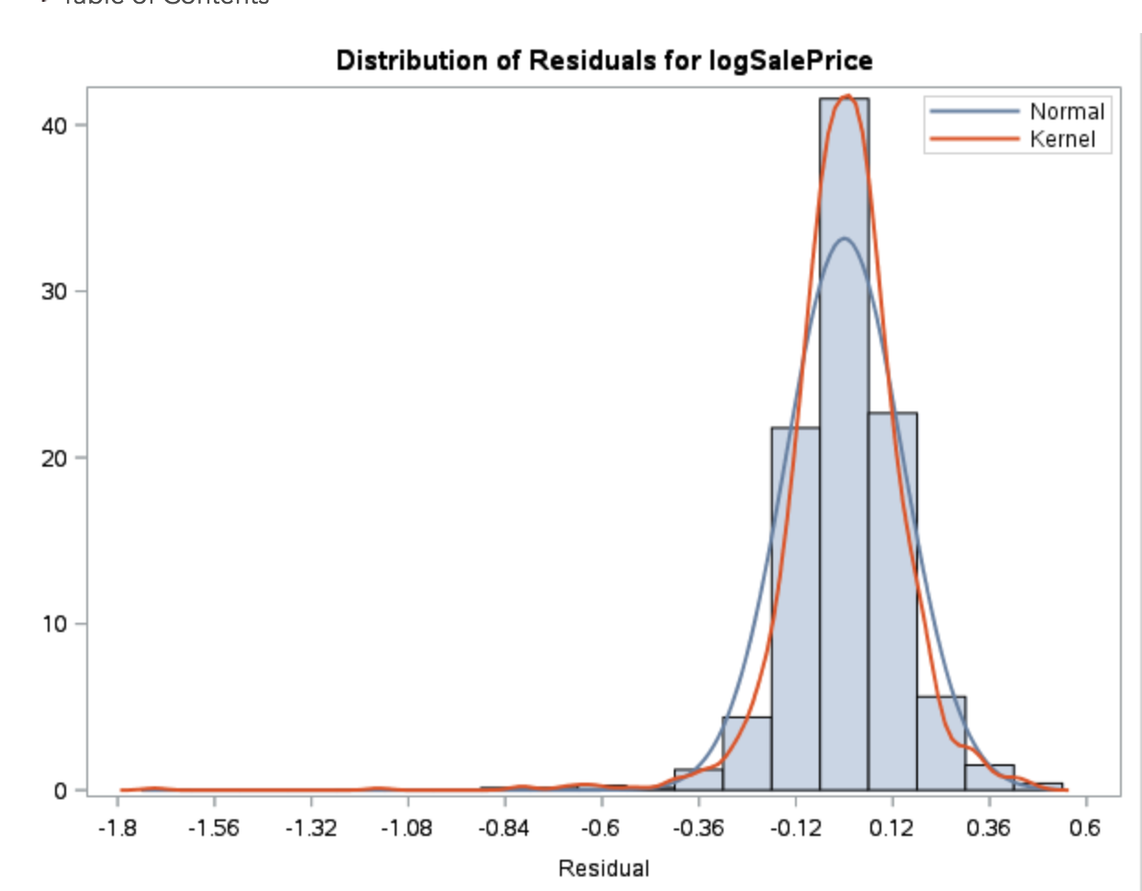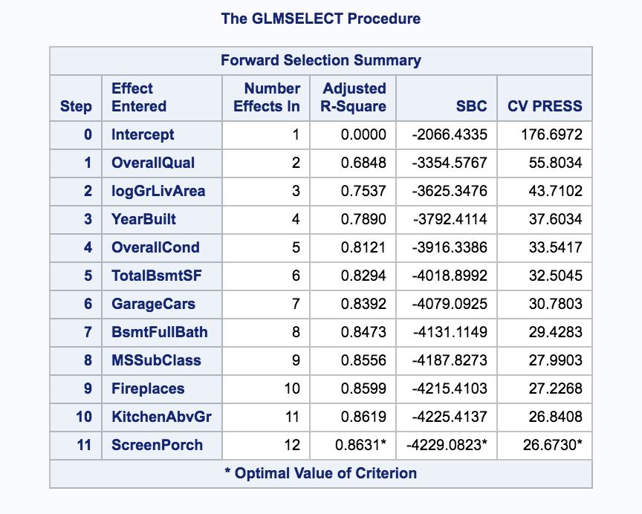

*Figure 6*

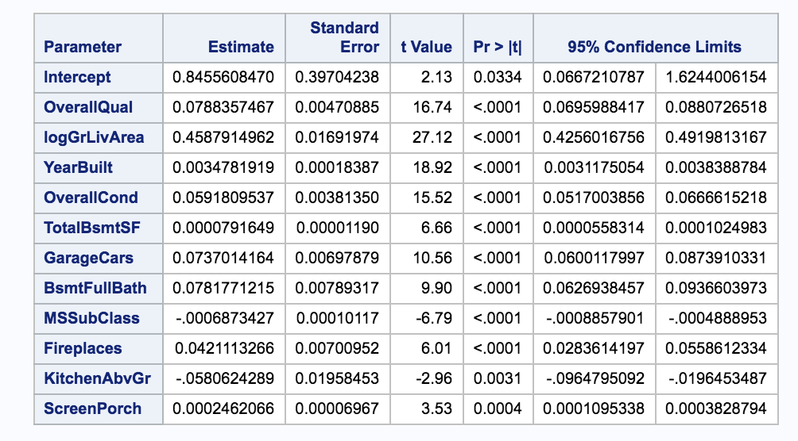

#### Backward Selection

#### Stepwise Selection

***General Notes from Class – not going to be included in final document, just for reference:***

Scatterplots: LotArea, LotFrontage, BsmtFinSF1, BsmtFinSF2, LowQualFinSF, TotalBsmtSF

Outliers: LotArea, LotFrontage, BsmtFinSF1, GrLivArea, LowQualFinSF, TotalBsmtSF, PoolArea, MiscVal

Normality:

High Leverage: LotArea, LogSalePrice, BsmtFinSF1, GrLivArea, TotalBsmtSF

Cooks D: LotArea, TotalBsmtSF

Constant Variance: GrLivArea, LowQualFinSF, TotalBsmtSF, PoolArea, MiscVal