KD4SIR’s Technician Simple Study (forever free)

For exams starting July 1, 2022

2022-2026 Technician Class Pool – updated 15Apr2024

Dedicated to the Tri-State Amateur Radio Club, Evansville IN (w9og.net)

Directions: print this, don’t memorize – just read at least thrice, practice exam then exam. 73!!

Which of the following is a safety hazard of a 12-volt storage battery?

Shorting the terminals can cause burns, fire, or an explosion

What health hazard is presented by electrical current flowing through the body?

It may cause injury by heating tissue

It may disrupt the electrical functions of cells

It may cause involuntary muscle contractions

All these choices are correct

In the United States, what circuit does black wire insulation indicate in a three-wire 120 V cable?

Hot

What is the purpose of a fuse in an electrical circuit?

To remove power in case of overload

Why should a 5-ampere fuse never be replaced with a 20-ampere fuse?

Excessive current could cause a fire

What is a good way to guard against electrical shock at your station?

Use three-wire cords and plugs for all AC powered equipment

Connect all AC powered station equipment to a common safety ground

Install mechanical interlocks in high-voltage circuits

All these choices are correct

Where should a lightning arrester be installed in a coaxial feed line?

On a grounded panel near where feed lines enter the building

Where should a fuse or circuit breaker be installed in a 120V AC power circuit?

In series with the hot conductor only

What should be done to all external ground rods or earth connections?

Bond them together with heavy wire or conductive strap

What hazard is caused by charging or discharging a battery too quickly?

Overheating or out-gassing

What hazard exists in a power supply immediately after turning it off?

Charge stored in filter capacitors

Which of the following precautions should be taken when measuring high voltages with a voltmeter?

Ensure that the voltmeter and leads are rated for use at the voltages to be measured

Which of the following is good practice when installing ground wires on a tower for lightning protection?

Ensure that connections are short and direct

What is required when climbing an antenna tower?

Have sufficient training on safe tower climbing techniques

Use appropriate tie-off to the tower at all times

Always wear an approved climbing harness

All these choices are correct

Under what circumstances is it safe to climb a tower without a helper or observer?

Never

Which of the following is an important safety precaution to observe when putting up an antenna tower?

Look for and stay clear of any overhead electrical wires

What is the purpose of a safety wire through a turnbuckle used to tension guy lines?

Prevent loosening of the turnbuckle from vibration

What is the minimum safe distance from a power line to allow when installing an antenna?

Enough so that if the antenna falls, no part of it can come closer than 10 feet to the power wires

Which of the following is an important safety rule to remember when using a crank-up tower?

This type of tower must not be climbed unless it is retracted, or mechanical safety locking devices have been installed

Which is a proper grounding method for a tower?

Separate eight-foot ground rods for each tower leg, bonded to the tower and each other

Why should you avoid attaching an antenna to a utility pole?

The antenna could contact high-voltage power lines

Which of the following is true when installing grounding conductors used for lightning protection?

Sharp bends must be avoided

Which of the following establishes grounding requirements for an amateur radio tower or antenna?

Local electrical codes

What type of radiation are radio signals?

Non-ionizing radiation

At which of the following frequencies does maximum permissible exposure have the lowest value?

50 MHz

How does the allowable power density for RF safety change if duty cycle changes from 100 percent to 50 percent?

It increases by a factor of 2

What factors affect the RF exposure of people near an amateur station antenna?

Frequency and power level of the RF field

Distance from the antenna to a person

Radiation pattern of the antenna

All these choices are correct

Why do exposure limits vary with frequency?

The human body absorbs more RF energy at some frequencies than at others

Which of the following is an acceptable method to determine whether your station complies with FCC RF exposure regulations?

By calculation based on FCC OET Bulletin 65

By calculation based on computer modeling

By measurement of field strength using calibrated equipment

All these choices are correct

What hazard is created by touching an antenna during a transmission?

RF burn to skin

Which of the following actions can reduce exposure to RF radiation?

Relocate antennas

How can you make sure your station stays in compliance with RF safety regulations?

By re-evaluating the station whenever an item in the transmitter or antenna system is changed

Why is duty cycle one of the factors used to determine safe RF radiation exposure levels?

It affects the average exposure to radiation

What is the definition of duty cycle during the averaging time for RF exposure?

The percentage of time that a transmitter is transmitting

How does RF radiation differ from ionizing radiation (radioactivity)?

RF radiation does not have sufficient energy to cause chemical changes in cells and damage DNA

Who is responsible for ensuring that no person is exposed to RF energy above the FCC exposure limits?

The station licensee

Which of the following is part of the Basis and Purpose of the Amateur Radio Service?

Advancing skills in the technical and communication phases of the radio art

Which agency regulates and enforces the rules for the Amateur Radio Service in the United States?

The FCC

What do the FCC rules state regarding the use of a phonetic alphabet for station identification in the Amateur Radio Service?

It is encouraged

How many operator/primary station license grants may be held by any one person?

One

What proves that the FCC has issued an operator/primary license grant?

The license appears in the FCC ULS database

What is the FCC Part 97 definition of a beacon?

An amateur station transmitting communications for the purposes of observing propagation or related experimental activities

What is the FCC Part 97 definition of a space station?

An amateur station located more than 50 km above Earth's surface

Which of the following entities recommends transmit/receive channels and other parameters for auxiliary and repeater stations?

Volunteer Frequency Coordinator recognized by local amateurs

Who selects a Frequency Coordinator?

Amateur operators in a local or regional area whose stations are eligible to be repeater or auxiliary stations

What is the Radio Amateur Civil Emergency Service (RACES)?

A radio service using amateur frequencies for emergency management or civil defense communications

A radio service using amateur stations for emergency management or civil defense communications

An emergency service using amateur operators certified by a civil defense organization as being enrolled in that organization

All these choices are correct

When is willful interference to other amateur radio stations permitted?

At no time

Which of the following frequency ranges are available for phone operation by Technician licensees?

28.300 MHz to 28.500 MHz

Which amateurs may contact the International Space Station (ISS) on VHF bands?

Any amateur holding a Technician class or higher license

Which frequency is in the 6 meter amateur band?

52.525 MHz

Which amateur band includes 146.52 MHz?

2 meters

How may amateurs use the 219 to 220 MHz segment of 1.25 meter band?

Fixed digital message forwarding systems only

On which HF bands does a Technician class operator have phone privileges?

10 meter band only

Which of the following VHF/UHF band segments are limited to CW only?

50.0 MHz to 50.1 MHz and 144.0 MHz to 144.1 MHz

How are US amateurs restricted in segments of bands where the Amateur Radio Service is secondary?

U.S. amateurs may find non-amateur stations in those segments, and must avoid interfering with them

Why should you not set your transmit frequency to be exactly at the edge of an amateur band or sub-band?

To allow for calibration error in the transmitter frequency display

So that modulation sidebands do not extend beyond the band edge

To allow for transmitter frequency drift

All these choices are correct

Where may SSB phone be used in amateur bands above 50 MHz?

In at least some segment of all these bands

What is the maximum peak envelope power output for Technician class operators in their HF band segments?

200 watts

Except for some specific restrictions, what is the maximum peak envelope power output for Technician class operators using frequencies above 30 MHz?

1500 watts

For which license classes are new licenses currently available from the FCC?

Technician, General, Amateur Extra

Who may select a desired call sign under the vanity call sign rules?

Any licensed amateur

What types of international communications are an FCC-licensed amateur radio station permitted to make?

Communications incidental to the purposes of the Amateur Radio Service and remarks of a personal character

What may happen if the FCC is unable to reach you by email?

Revocation of the station license or suspension of the operator license

Which of the following is a valid Technician class call sign format?

KF1XXX

From which of the following locations may an FCC-licensed amateur station transmit?

From any vessel or craft located in international waters and documented or registered in the United States

Which of the following can result in revocation of the station license or suspension of the operator license?

Failure to provide and maintain a correct email address with the FCC

What is the normal term for an FCC-issued amateur radio license?

Ten years

What is the grace period for renewal if an amateur license expires?

Two years

How soon after passing the examination for your first amateur radio license may you transmit on the amateur radio bands?

As soon as your operator/station license grant appears in the FCC's license database

If your license has expired and is still within the allowable grace period, may you continue to transmit on the amateur radio bands?

No, you must wait until the license has been renewed

With which countries are FCC-licensed amateur radio stations prohibited from exchanging communications?

Any country whose administration has notified the International Telecommunication Union (ITU) that it objects to such communications

Under which of the following circumstances are one-way transmissions by an amateur station prohibited?

Broadcasting

When is it permissible to transmit messages encoded to obscure their meaning?

Only when transmitting control commands to space stations or radio control craft

Under what conditions is an amateur station authorized to transmit music using a phone emission?

When incidental to an authorized retransmission of manned spacecraft communications

When may amateur radio operators use their stations to notify other amateurs of the availability of equipment for sale or trade?

When selling amateur radio equipment and not on a regular basis

What, if any, are the restrictions concerning transmission of language that may be considered indecent or obscene?

Any such language is prohibited

What types of amateur stations can automatically retransmit the signals of other amateur stations?

Repeater, auxiliary, or space stations

In which of the following circumstances may the control operator of an amateur station receive compensation for operating that station?

When the communication is incidental to classroom instruction at an educational institution

When may amateur stations transmit information in support of broadcasting, program production, or news gathering, assuming no other means is available?

When such communications are directly related to the immediate safety of human life or protection of property

How does the FCC define broadcasting for the Amateur Radio Service?

Transmissions intended for reception by the general public

When may an amateur station transmit without identifying on the air?

When transmitting signals to control model craft

When may an amateur station transmit without a control operator?

Never

Who may be the control operator of a station communicating through an amateur satellite or space station?

Any amateur allowed to transmit on the satellite uplink frequency

Who must designate the station control operator?

The station licensee

What determines the transmitting frequency privileges of an amateur station?

The class of operator license held by the control operator

What is an amateur station's control point?

The location at which the control operator function is performed

When, under normal circumstances, may a Technician class licensee be the control operator of a station operating in an Amateur Extra Class band segment?

At no time

When the control operator is not the station licensee, who is responsible for the proper operation of the station?

The control operator and the station licensee

Which of the following is an example of automatic control?

Repeater operation

Which of the following are required for remote control operation?

The control operator must be at the control point

A control operator is required at all times

The control operator must indirectly manipulate the controls

All these choices are correct

Which of the following is an example of remote control as defined in Part 97?

Operating the station over the internet

Who does the FCC presume to be the control operator of an amateur station, unless documentation to the contrary is in the station records?

The station licensee

When must the station and its records be available for FCC inspection?

At any time upon request by an FCC representative

How often must you identify with your FCC-assigned call sign when using tactical call signs such as "Race Headquarters"?

At the end of each communication and every ten minutes during a communication

When are you required to transmit your assigned call sign?

At least every 10 minutes during and at the end of a communication

What language may you use for identification when operating in a phone sub-band?

English

What method of call sign identification is required for a station transmitting phone signals?

Send the call sign using a CW or phone emission

Which of the following self-assigned indicators are acceptable when using a phone transmission?

KL7CC stroke W3

KL7CC slant W3

KL7CC slash W3

All these choices are correct

Which of the following restrictions apply when a non-licensed person is allowed to speak to a foreign station using a station under the control of a licensed amateur operator?

The foreign station must be in a country with which the U.S. has a third party agreement

What is the definition of third party communications?

A message from a control operator to another amateur station control operator on behalf of another person

What type of amateur station simultaneously retransmits the signal of another amateur station on a different channel or channels?

Repeater station

Who is accountable if a repeater inadvertently retransmits communications that violate the FCC rules?

The control operator of the originating station

Which of the following is a requirement for the issuance of a club station license grant?

The club must have at least four members

Subelement T2 - Operating Procedures

What is a common repeater frequency offset in the 2 meter band?

Plus or minus 600 kHz

What is the national calling frequency for FM simplex operations in the 2 meter band?

146.520 MHz

What is a common repeater frequency offset in the 70 cm band?

Plus or minus 5 MHz

What is an appropriate way to call another station on a repeater if you know the other station's call sign?

Say the station's call sign, then identify with your call sign

How should you respond to a station calling CQ?

Transmit the other station's call sign followed by your call sign

Which of the following is required when making on-the-air test transmissions?

Identify the transmitting station

What is meant by "repeater offset"?

The difference between a repeater's transmit and receive frequencies

What is the meaning of the procedural signal "CQ"?

Calling any station

Which of the following indicates that a station is listening on a repeater and looking for a contact?

The station's call sign followed by the word "monitoring"

What is a band plan, beyond the privileges established by the FCC?

A voluntary guideline for using different modes or activities within an amateur band

What term describes an amateur station that is transmitting and receiving on the same frequency?

Simplex

What should you do before calling CQ?

Listen first to be sure that no one else is using the frequency

Ask if the frequency is in use

Make sure you are authorized to use that frequency

All these choices are correct

How is a VHF/UHF transceiver's "reverse" function used?

To listen on a repeater's input frequency

What term describes the use of a sub-audible tone transmitted along with normal voice audio to open the squelch of a receiver?

CTCSS

Which of the following describes a linked repeater network?

A network of repeaters in which signals received by one repeater are transmitted by all the repeaters in the network

Which of the following could be the reason you are unable to access a repeater whose output you can hear?

Improper transceiver offset

You are using the wrong CTCSS tone

You are using the wrong DCS code

All these choices are correct

What would cause your FM transmission audio to be distorted on voice peaks?

You are talking too loudly

What type of signaling uses pairs of audio tones?

DTMF

How can you join a digital repeater's "talkgroup"?

Program your radio with the group's ID or code

Which of the following applies when two stations transmitting on the same frequency interfere with each other?

The stations should negotiate continued use of the frequency

Why are simplex channels designated in the VHF/UHF band plans?

So stations within range of each other can communicate without tying up a repeater

Which Q signal indicates that you are receiving interference from other stations?

QRM

Which Q signal indicates that you are changing frequency?

QSY

What is the purpose of the color code used on DMR repeater systems?

Must match the repeater color code for access

What is the purpose of a squelch function?

Mute the receiver audio when a signal is not present

When do FCC rules NOT apply to the operation of an amateur station?

FCC rules always apply

Which of the following are typical duties of a Net Control Station?

Call the net to order and direct communications between stations checking in

What technique is used to ensure that voice messages containing unusual words are received correctly?

Spell the words using a standard phonetic alphabet

What is RACES?

An FCC part 97 amateur radio service for civil defense communications during national emergencies

What does the term "traffic" refer to in net operation?

Messages exchanged by net stations

What is the Amateur Radio Emergency Service (ARES)?

A group of licensed amateurs who have voluntarily registered their qualifications and equipment for communications duty in the public service

Which of the following is standard practice when you participate in a net?

Unless you are reporting an emergency, transmit only when directed by the net control station

Which of the following is a characteristic of good traffic handling?

Passing messages exactly as received

Are amateur station control operators ever permitted to operate outside the frequency privileges of their license class?

Yes, but only in situations involving the immediate safety of human life or protection of property

What information is contained in the preamble of a formal traffic message?

Information needed to track the message

What is meant by "check" in a radiogram header?

The number of words or word equivalents in the text portion of the message

Why do VHF signal strengths sometimes vary greatly when the antenna is moved only a few feet?

Multipath propagation cancels or reinforces signals

What is the effect of vegetation on UHF and microwave signals?

Absorption

What antenna polarization is normally used for long-distance CW and SSB contacts on the VHF and UHF bands?

Horizontal

What happens when antennas at opposite ends of a VHF or UHF line of sight radio link are not using the same polarization?

Received signal strength is reduced

When using a directional antenna, how might your station be able to communicate with a distant repeater if buildings or obstructions are blocking the direct line of sight path?

Try to find a path that reflects signals to the repeater

What is the meaning of the term "picket fencing"?

Rapid flutter on mobile signals due to multipath propagation

What weather condition might decrease range at microwave frequencies?

Precipitation

What is a likely cause of irregular fading of signals propagated by the ionosphere?

Random combining of signals arriving via different paths

Which of the following results from the fact that signals propagated by the ionosphere are elliptically polarized?

Either vertically or horizontally polarized antennas may be used for transmission or reception

What effect does multi-path propagation have on data transmissions?

Error rates are likely to increase

Which region of the atmosphere can refract or bend HF and VHF radio waves?

The ionosphere

What is the effect of fog and rain on signals in the 10 meter and 6 meter bands?

There is little effect

What is the relationship between the electric and magnetic fields of an electromagnetic wave?

They are at right angles

What property of a radio wave defines its polarization?

The orientation of the electric field

What are the two components of a radio wave?

Electric and magnetic fields

What is the velocity of a radio wave traveling through free space?

Speed of light

What is the relationship between wavelength and frequency?

Wavelength gets shorter as frequency increases

What is the formula for converting frequency to approximate wavelength in meters?

Wavelength in meters equals 300 divided by frequency in megahertz

In addition to frequency, which of the following is used to identify amateur radio bands?

The approximate wavelength in meters

What frequency range is referred to as VHF?

30 MHz to 300 MHz

What frequency range is referred to as UHF?

300 to 3000 MHz

What frequency range is referred to as HF?

3 to 30 MHz

What is the approximate velocity of a radio wave in free space?

300,000,000 meters per second

Why are simplex UHF signals rarely heard beyond their radio horizon?

UHF signals are usually not propagated by the ionosphere

What is a characteristic of HF communication compared with communications on VHF and higher frequencies?

Long-distance ionospheric propagation is far more common on HF

What is a characteristic of VHF signals received via auroral backscatter?

They are distorted and signal strength varies considerably

Which of the following types of propagation is most commonly associated with occasional strong signals on the 10, 6, and 2 meter bands from beyond the radio horizon?

Sporadic E

Which of the following effects may allow radio signals to travel beyond obstructions between the transmitting and receiving stations?

Knife-edge diffraction

What type of propagation is responsible for allowing over-the-horizon VHF and UHF communications to ranges of approximately 300 miles on a regular basis?

Tropospheric ducting

What band is best suited for communicating via meteor scatter?

6 meters

What causes tropospheric ducting?

Temperature inversions in the atmosphere

What is generally the best time for long-distance 10 meter band propagation via the F region?

From dawn to shortly after sunset during periods of high sunspot activity

Which of the following bands may provide long-distance communications via the ionosphere's F region during the peak of the sunspot cycle?

6 and 10 meters

Why is the radio horizon for VHF and UHF signals more distant than the visual horizon?

The atmosphere refracts radio waves slightly

Which of the following is an appropriate power supply rating for a typical 50 watt output mobile FM transceiver?

13.8 volts at 12 amperes

Which of the following should be considered when selecting an accessory SWR meter?

The frequency and power level at which the measurements will be made

Why are short, heavy-gauge wires used for a transceiver's DC power connection?

To minimize voltage drop when transmitting

How are the transceiver audio input and output connected in a station configured to operate using FT8?

To the audio input and output of a computer running WSJT-X software

Where should an RF power meter be installed?

In the feed line, between the transmitter and antenna

What signals are used in a computer-radio interface for digital mode operation?

Receive audio, transmit audio, and transmitter keying

Which of the following connections is made between a computer and a transceiver to use computer software when operating digital modes?

Computer "line in" to transceiver speaker connector

Which of the following conductors is preferred for bonding at RF?

Flat copper strap

How can you determine the length of time that equipment can be powered from a battery?

Divide the battery ampere-hour rating by the average current draw of the equipment

What function is performed with a transceiver and a digital mode hot spot?

Communication using digital voice or data systems via the internet

Where should the negative power return of a mobile transceiver be connected in a vehicle?

At the 12 volt battery chassis ground

What is an electronic keyer?

A device that assists in manual sending of Morse code

What is the effect of excessive microphone gain on SSB transmissions?

Distorted transmitted audio

Which of the following can be used to enter a transceiver's operating frequency?

The keypad or VFO knob

How is squelch adjusted so that a weak FM signal can be heard?

Set the squelch threshold so that receiver output audio is on all the time

What is a way to enable quick access to a favorite frequency or channel on your transceiver?

Store it in a memory channel

What does the scanning function of an FM transceiver do?

Tunes through a range of frequencies to check for activity

Which of the following controls could be used if the voice pitch of a single-sideband signal returning to your CQ call seems too high or low?

The RIT or Clarifier

What does a DMR "code plug" contain?

Access information for repeaters and talkgroups

What is the advantage of having multiple receive bandwidth choices on a multimode transceiver?

Permits noise or interference reduction by selecting a bandwidth matching the mode

How is a specific group of stations selected on a digital voice transceiver?

By entering the group's identification code

Which of the following receiver filter bandwidths provides the best signal-to-noise ratio for SSB reception?

2400 Hz

Which of the following must be programmed into a D-STAR digital transceiver before transmitting?

Your call sign

What is the result of tuning an FM receiver above or below a signal's frequency?

Distortion of the signal's audio

Electrical current is measured in which of the following units?

Amperes

Electrical power is measured in which of the following units?

Watts

What is the name for the flow of electrons in an electric circuit?

Current

What are the units of electrical resistance?

Ohms

What is the electrical term for the force that causes electron flow?

Voltage

What is the unit of frequency?

Hertz

Why are metals generally good conductors of electricity?

They have many free electrons

Which of the following is a good electrical insulator?

Glass

Which of the following describes alternating current?

Current that alternates between positive and negative directions

Which term describes the rate at which electrical energy is used?

Power

What type of current flow is opposed by resistance?

Direct current

Alternating current

RF current

All these choices are correct

What describes the number of times per second that an alternating current makes a complete cycle?

Frequency

How many milliamperes is 1.5 amperes?

1500 milliamperes

Which is equal to 1,500,000 hertz?

1500 kHz

Which is equal to one kilovolt?

One thousand volts

Which is equal to one microvolt?

One one-millionth of a volt

Which is equal to 500 milliwatts?

0.5 watts

Which is equal to 3000 milliamperes?

3 amperes

Which is equal to 3.525 MHz?

3525 kHz

Which is equal to 1,000,000 picofarads?

1 microfarad

Which decibel value most closely represents a power increase from 5 watts to 10 watts?

3 dB

Which decibel value most closely represents a power decrease from 12 watts to 3 watts?

-6 dB

Which decibel value represents a power increase from 20 watts to 200 watts?

10 dB

Which is equal to 28400 kHz?

28.400 MHz

Which is equal to 2425 MHz?

2.425 GHz

What describes the ability to store energy in an electric field?

Capacitance

What is the unit of capacitance?

The farad

What describes the ability to store energy in a magnetic field?

Inductance

What is the unit of inductance?

The henry

What is the unit of impedance?

The ohm

What does the abbreviation "RF" mean?

Radio frequency signals of all types

What is the abbreviation for megahertz?

MHz

What is the formula used to calculate electrical power (P) in a DC circuit?

P = E \* I

How much power is delivered by a voltage of 13.8 volts DC and a current of 10 amperes?

138 watts

How much power is delivered by a voltage of 12 volts DC and a current of 2.5 amperes?

30 watts

How much current is required to deliver 120 watts at a voltage of 12 volts DC?

10 amperes

What is impedance?

The opposition to AC current flow

What is the abbreviation for kilohertz?

kHz

What formula is used to calculate current in a circuit?

I = E / R

What formula is used to calculate voltage in a circuit?

E= I x R

What formula is used to calculate resistance in a circuit?

R = E / I

What is the resistance of a circuit in which a current of 3 amperes flows when connected to 90 volts?

30 ohms

What is the resistance of a circuit for which the applied voltage is 12 volts and the current flow is 1.5 amperes?

8 ohms

What is the resistance of a circuit that draws 4 amperes from a 12-volt source?

3 ohms

What is the current in a circuit with an applied voltage of 120 volts and a resistance of 80 ohms?

1.5 amperes

What is the current through a 100-ohm resistor connected across 200 volts?

2 amperes

What is the current through a 24-ohm resistor connected across 240 volts?

10 amperes

What is the voltage across a 2-ohm resistor if a current of 0.5 amperes flows through it?

1 volt

What is the voltage across a 10-ohm resistor if a current of 1 ampere flows through it?

10 volts

What is the voltage across a 10-ohm resistor if a current of 2 amperes flows through it?

20 volts

In which type of circuit is DC current the same through all components?

Series

In which type of circuit is voltage the same across all components?

Parallel

What electrical component opposes the flow of current in a DC circuit?

Resistor

What type of component is often used as an adjustable volume control?

Potentiometer

What electrical parameter is controlled by a potentiometer?

Resistance

What electrical component stores energy in an electric field?

Capacitor

What type of electrical component consists of conductive surfaces separated by an insulator?

Capacitor

What type of electrical component stores energy in a magnetic field?

Inductor

What electrical component is typically constructed as a coil of wire?

Inductor

What is the function of an SPDT switch?

A single circuit is switched between one of two other circuits

What electrical component is used to protect other circuit components from current overloads?

Fuse

Which of the following battery chemistries is rechargeable?

Nickel-metal hydride

Lithium-ion

Lead-acid

All these choices are correct

Which of the following battery chemistries is not rechargeable?

Carbon-zinc

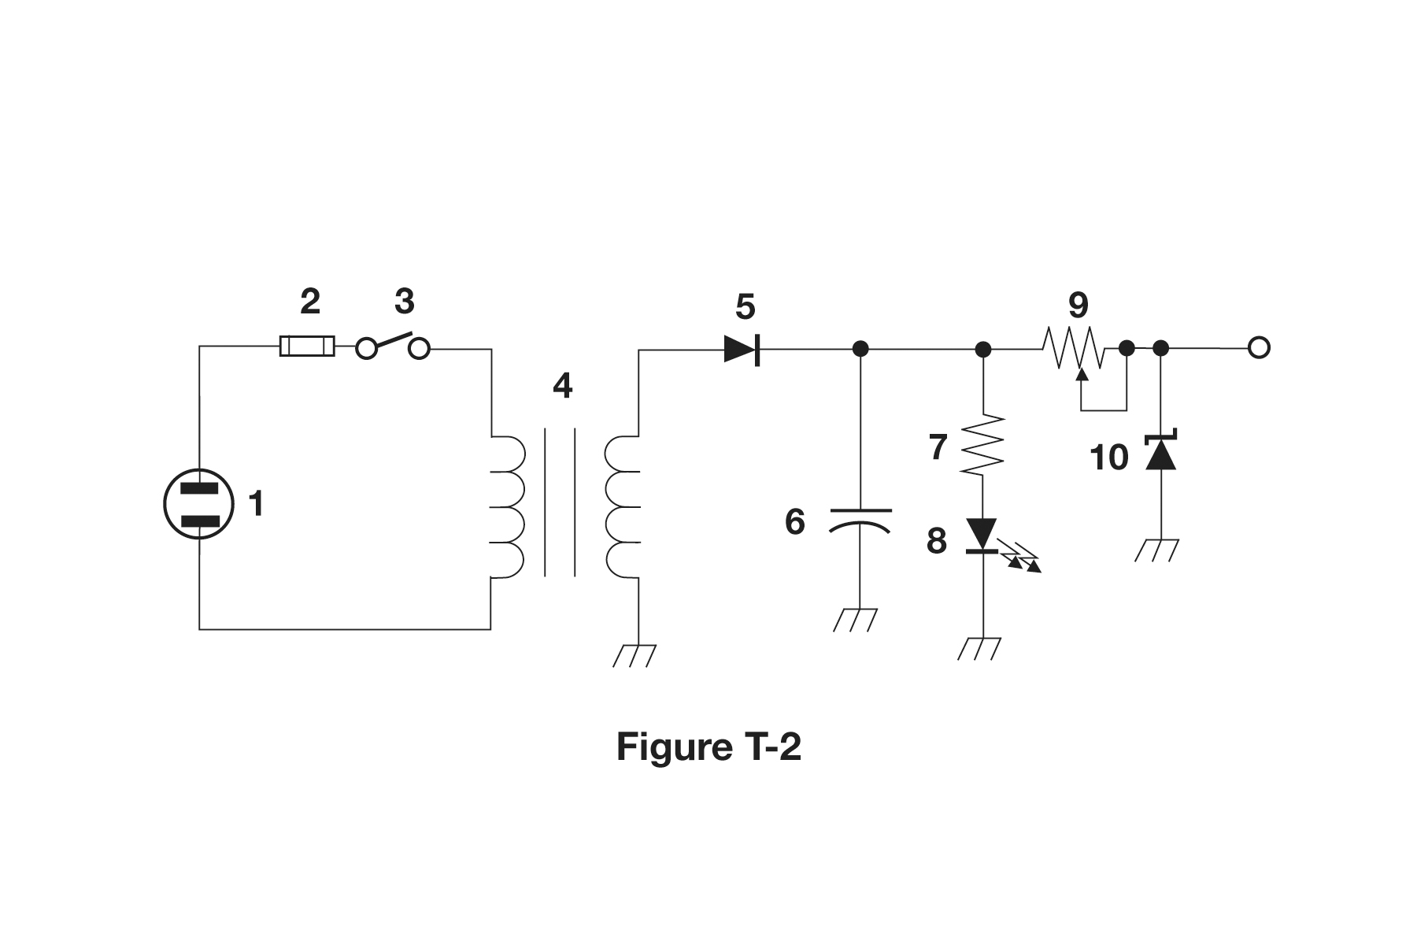

What type of switch is represented by component 3 in figure T-2?

Single-pole single-throw

What is component 6 in figure T-2?

Capacitor

What is component 8 in figure T-2?

Light emitting diode

What is component 9 in figure T-2?

Variable resistor

What is component 4 in figure T-2?

Transformer

Which is true about forward voltage drop in a diode?

It is lower in some diode types than in others

What electronic component allows current to flow in only one direction?

Diode

Which of these components can be used as an electronic switch?

Transistor

Which of the following components can consist of three regions of semiconductor material?

Transistor

What type of transistor has a gate, drain, and source?

Field-effect

How is the cathode lead of a semiconductor diode often marked on the package?

With a stripe

What causes a light-emitting diode (LED) to emit light?

Forward current

What does the abbreviation FET stand for?

Field Effect Transistor

What are the names for the electrodes of a diode?

Anode and cathode

Which of the following can provide power gain?

Transistor

What is the term that describes a device's ability to amplify a signal?

Gain

What are the names of the electrodes of a bipolar junction transistor?

Emitter, base, collector

What is the name of an electrical wiring diagram that uses standard component symbols?

Schematic

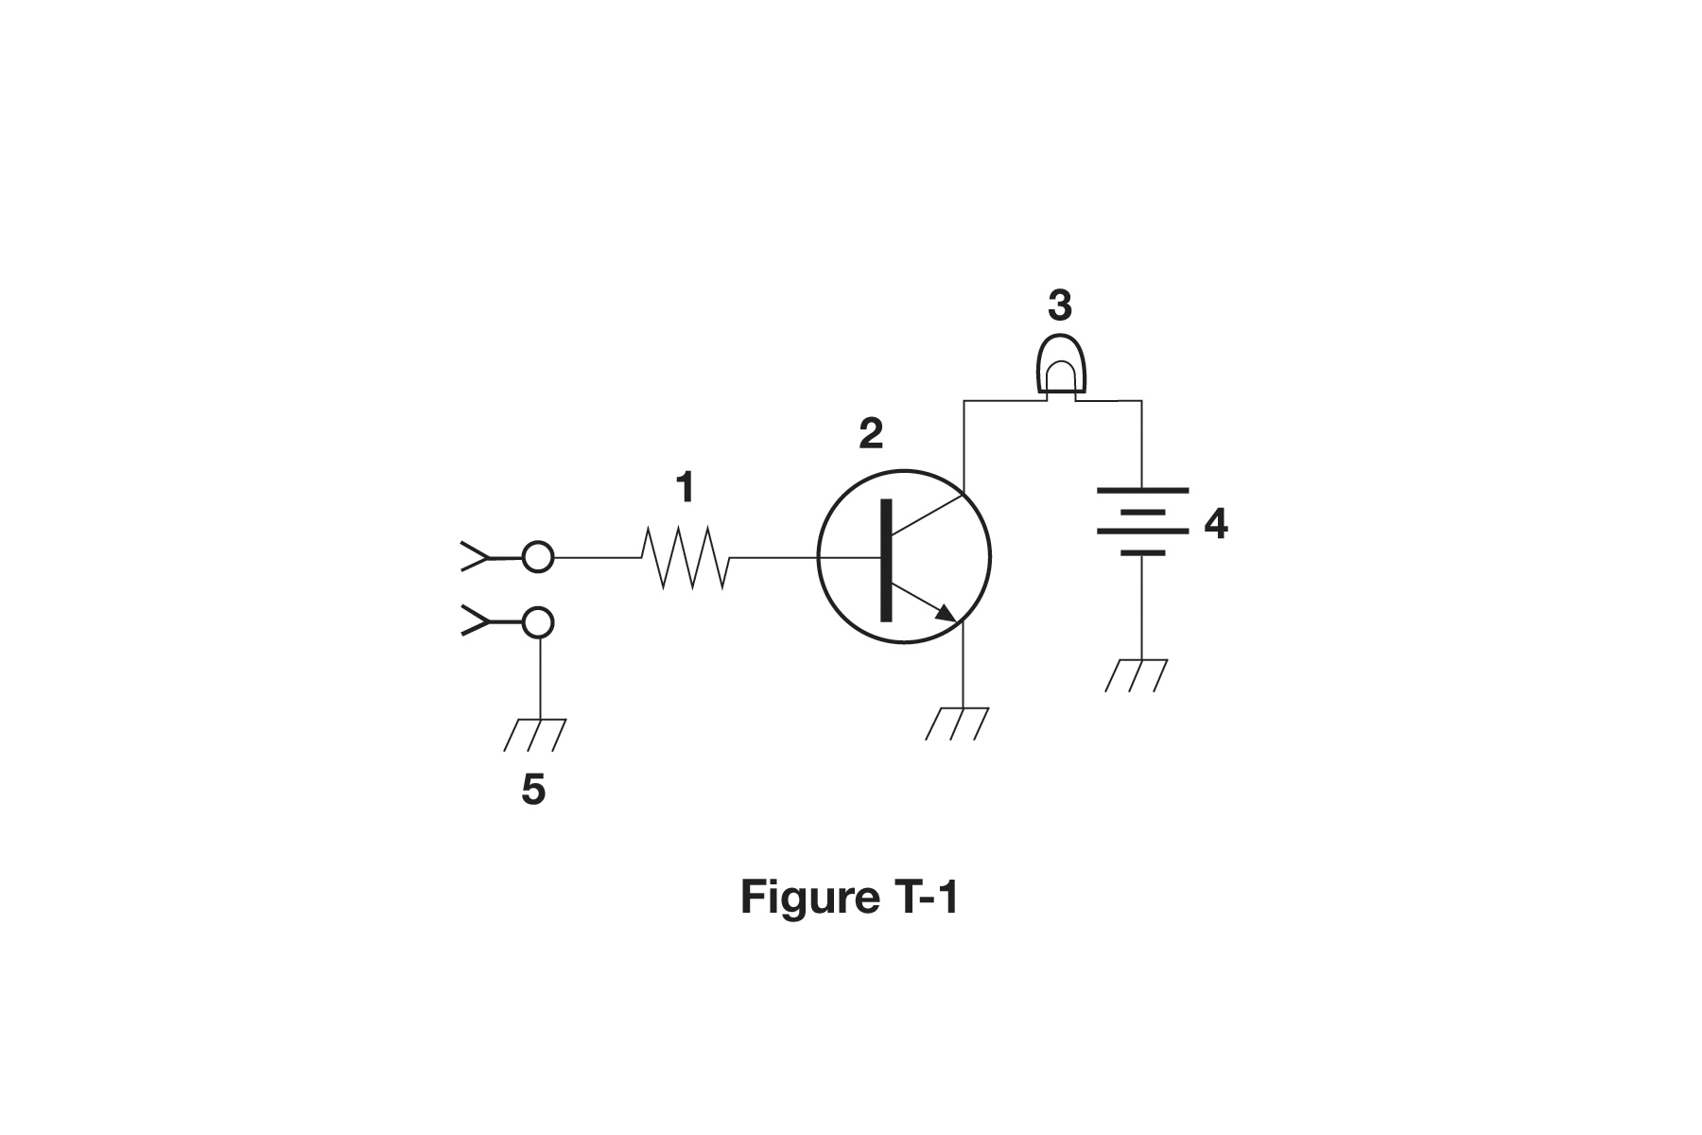

What is component 1 in figure T-1?

Resistor

What is component 2 in figure T-1?

Transistor

What is component 3 in figure T-1?

Lamp

What is component 4 in figure T-1?

Battery

What is the function of component 2 in figure T-1?

Control the flow of current

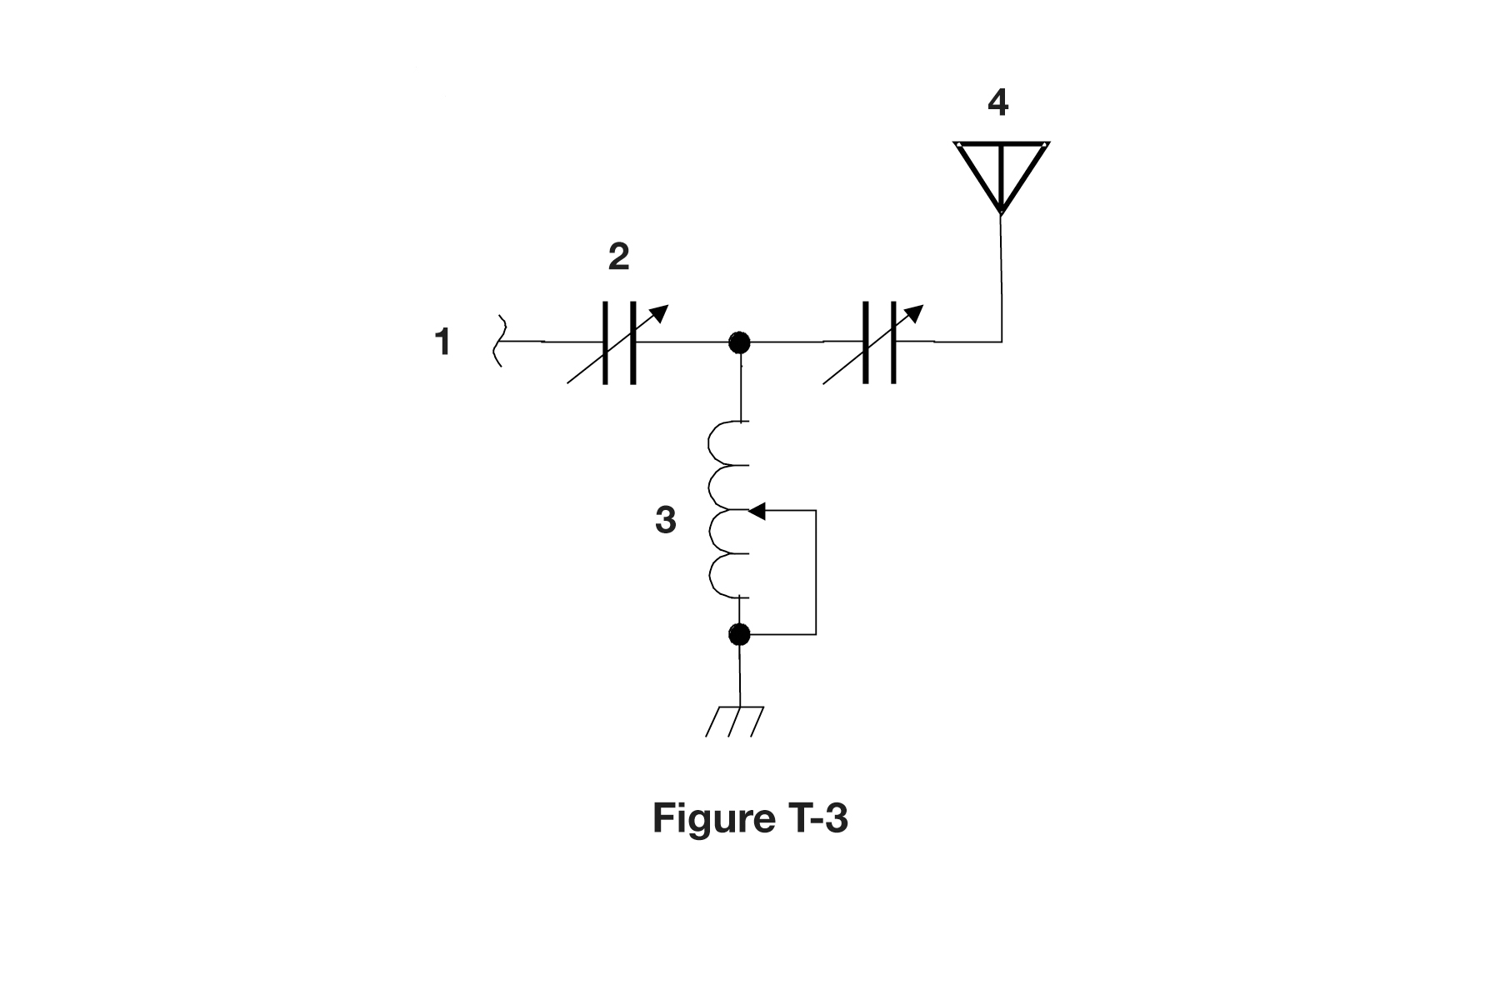What is component 3 in figure T-3?

Variable inductor

What is component 4 in figure T-3?

Antenna

Which of the following is accurately represented in electrical schematics?

Component connections

Which of the following devices or circuits changes an alternating current into a varying direct current signal?

Rectifier

What is a relay?

An electrically-controlled switch

Which of the following is a reason to use shielded wire?

To prevent coupling of unwanted signals to or from the wire

Which of the following displays an electrical quantity as a numeric value?

Meter

What type of circuit controls the amount of voltage from a power supply?

Regulator

What component changes 120 V AC power to a lower AC voltage for other uses?

Transformer

Which of the following is commonly used as a visual indicator?

LED

Which of the following is combined with an inductor to make a resonant circuit?

Capacitor

What is the name of a device that combines several semiconductors and other components into one package?

Integrated circuit

Which of the following is a resonant or tuned circuit?

An inductor and a capacitor in series or parallel

Which term describes the ability of a receiver to detect the presence of a signal?

Sensitivity

What is a transceiver?

A device that combines a receiver and transmitter

Which of the following is used to convert a signal from one frequency to another?

Mixer

Which term describes the ability of a receiver to discriminate between multiple signals?

Selectivity

What is the name of a circuit that generates a signal at a specific frequency?

Oscillator

What device converts the RF input and output of a transceiver to another band?

Transverter

What is the function of a transceiver's PTT input?

Switches transceiver from receive to transmit when grounded

Which of the following describes combining speech with an RF carrier signal?

Modulation

What is the function of the SSB/CW-FM switch on a VHF power amplifier?

Set the amplifier for proper operation in the selected mode

What device increases the transmitted output power from a transceiver?

An RF power amplifier

Where is an RF preamplifier installed?

Between the antenna and receiver

What can you do if you are told your FM handheld or mobile transceiver is over-deviating?

Talk farther away from the microphone

What would cause a broadcast AM or FM radio to receive an amateur radio transmission unintentionally?

The receiver is unable to reject strong signals outside the AM or FM band

Which of the following can cause radio frequency interference?

Fundamental overload

Harmonics

Spurious emissions

All these choices are correct

Which of the following could you use to cure distorted audio caused by RF current on the shield of a microphone cable?

Ferrite choke

How can fundamental overload of a non-amateur radio or TV receiver by an amateur signal be reduced or eliminated?

Block the amateur signal with a filter at the antenna input of the affected receiver

Which of the following actions should you take if a neighbor tells you that your station's transmissions are interfering with their radio or TV reception?

Make sure that your station is functioning properly and that it does not cause interference to your own radio or television when it is tuned to the same channel

Which of the following can reduce overload of a VHF transceiver by a nearby commercial FM station?

Installing a band-reject filter

What should you do if something in a neighbor's home is causing harmful interference to your amateur station?

Work with your neighbor to identify the offending device

Politely inform your neighbor that FCC rules prohibit the use of devices that cause interference

Make sure your station meets the standards of good amateur practice

All these choices are correct

What should be the first step to resolve non-fiber optic cable TV interference caused by your amateur radio transmission?

Be sure all TV feed line coaxial connectors are installed properly

What might be a problem if you receive a report that your audio signal through an FM repeater is distorted or unintelligible?

Your transmitter is slightly off frequency

Your batteries are running low

You are in a bad location

All these choices are correct

What is a symptom of RF feedback in a transmitter or transceiver?

Reports of garbled, distorted, or unintelligible voice transmissions

What is the primary purpose of a dummy load?

To prevent transmitting signals over the air when making tests

Which of the following is used to determine if an antenna is resonant at the desired operating frequency?

An antenna analyzer

What does a dummy load consist of?

A non-inductive resistor mounted on a heat sink

What reading on an SWR meter indicates a perfect impedance match between the antenna and the feed line?

1:1

Why do most solid-state transmitters reduce output power as SWR increases beyond a certain level?

To protect the output amplifier transistors

What does an SWR reading of 4:1 indicate?

Impedance mismatch

What happens to power lost in a feed line?

It is converted into heat

Which instrument can be used to determine SWR?

Directional wattmeter

Which of the following causes failure of coaxial cables?

Moisture contamination

Why should the outer jacket of coaxial cable be resistant to ultraviolet light?

Ultraviolet light can damage the jacket and allow water to enter the cable

What is a disadvantage of air core coaxial cable when compared to foam or solid dielectric types?

It requires special techniques to prevent moisture in the cable

Which instrument would you use to measure electric potential?

A voltmeter

How is a voltmeter connected to a component to measure applied voltage?

In parallel

When configured to measure current, how is a multimeter connected to a component?

In series

Which instrument is used to measure electric current?

An ammeter

Which of the following can damage a multimeter?

Attempting to measure voltage when using the resistance setting

Which of the following measurements are made using a multimeter?

Voltage and resistance

Which of the following types of solder should not be used for radio and electronic applications?

Acid-core solder

What is the characteristic appearance of a cold tin-lead solder joint?

A rough or lumpy surface

What reading indicates that an ohmmeter is connected across a large, discharged capacitor?

Increasing resistance with time

Which of the following precautions should be taken when measuring in-circuit resistance with an ohmmeter?

Ensure that the circuit is not powered

Which of the following is a form of amplitude modulation?

Single sideband

What type of modulation is commonly used for VHF packet radio transmissions?

FM or PM

Which type of voice mode is often used for long-distance (weak signal) contacts on the VHF and UHF bands?

SSB

Which type of modulation is commonly used for VHF and UHF voice repeaters?

FM or PM

Which of the following types of signal has the narrowest bandwidth?

CW

Which sideband is normally used for 10 meter HF, VHF, and UHF single-sideband communications?

Upper sideband

What is a characteristic of single sideband (SSB) compared to FM?

SSB signals have narrower bandwidth

What is the approximate bandwidth of a typical single sideband (SSB) voice signal?

3 kHz

What is the approximate bandwidth of a VHF repeater FM voice signal?

Between 10 and 15 kHz

What is the approximate bandwidth of AM fast-scan TV transmissions?

About 6 MHz

What is the approximate bandwidth required to transmit a CW signal?

150 Hz

Which of the following is a disadvantage of FM compared with single sideband?

Only one signal can be received at a time

What telemetry information is typically transmitted by satellite beacons?

Health and status of the satellite

What is the impact of using excessive effective radiated power on a satellite uplink?

Blocking access by other users

Which of the following are provided by satellite tracking programs?

Maps showing the real-time position of the satellite track over Earth

The time, azimuth, and elevation of the start, maximum altitude, and end of a pass

The apparent frequency of the satellite transmission, including effects of Doppler shift

All these choices are correct

What mode of transmission is commonly used by amateur radio satellites?

SSB

FM

CW/data

All these choices are correct

What is a satellite beacon?

A transmission from a satellite that contains status information

Which of the following are inputs to a satellite tracking program?

The Keplerian elements

What is Doppler shift in reference to satellite communications?

An observed change in signal frequency caused by relative motion between the satellite and Earth station

What is meant by the statement that a satellite is operating in U/V mode?

The satellite uplink is in the 70 centimeter band and the downlink is in the 2 meter band

What causes spin fading of satellite signals?

Rotation of the satellite and its antennas

What is a LEO satellite?

A satellite in low earth orbit

Who may receive telemetry from a space station?

Anyone

Which of the following is a way to determine whether your satellite uplink power is neither too low nor too high?

Your signal strength on the downlink should be about the same as the beacon

Which of the following methods is used to locate sources of noise interference or jamming?

Radio direction finding

Which of these items would be useful for a hidden transmitter hunt?

A directional antenna

What operating activity involves contacting as many stations as possible during a specified period?

Contesting

Which of the following is good procedure when contacting another station in a contest?

Send only the minimum information needed for proper identification and the contest exchange

What is a grid locator?

A letter-number designator assigned to a geographic location

How is over the air access to IRLP nodes accomplished?

By using DTMF signals

What is Voice Over Internet Protocol (VoIP)?

A method of delivering voice communications over the internet using digital techniques

What is the Internet Radio Linking Project (IRLP)?

A technique to connect amateur radio systems, such as repeaters, via the internet using Voice Over Internet Protocol (VoIP)

Which of the following protocols enables an amateur station to transmit through a repeater without using a radio to initiate the transmission?

EchoLink

What is required before using the EchoLink system?

Register your call sign and provide proof of license

What is an amateur radio station that connects other amateur stations to the internet?

A gateway

Which of the following is a digital communications mode?

Packet radio

IEEE 802.11

FT8

All these choices are correct

What is a "talkgroup" on a DMR repeater?

A way for groups of users to share a channel at different times without hearing other users on the channel

What kind of data can be transmitted by APRS?

GPS position data

Text messages

Weather data

All these choices are correct

What type of transmission is indicated by the term "NTSC?"

An analog fast-scan color TV signal

Which of the following is an application of APRS?

Providing real-time tactical digital communications in conjunction with a map showing the locations of stations

What does the abbreviation "PSK" mean?

Phase Shift Keying

Which of the following describes DMR?

A technique for time-multiplexing two digital voice signals on a single 12.5 kHz repeater channel

Which of the following is included in packet radio transmissions?

A check sum that permits error detection

A header that contains the call sign of the station to which the information is being sent

Automatic repeat request in case of error

All these choices are correct

What is CW?

Another name for a Morse code transmission

Which of the following operating activities is supported by digital mode software in the WSJT-X software suite?

Earth-Moon-Earth

Weak signal propagation beacons

Meteor scatter

All these choices are correct

What is an ARQ transmission system?

An error correction method in which the receiving station detects errors and sends a request for retransmission

Which of the following best describes an amateur radio mesh network?

An amateur-radio based data network using commercial Wi-Fi equipment with modified firmware

What is FT8?

A digital mode capable of low signal-to-noise operation

What is a beam antenna?

An antenna that concentrates signals in one direction

Which of the following describes a type of antenna loading?

Electrically lengthening by inserting inductors in radiating elements

Which of the following describes a simple dipole oriented parallel to Earth's surface?

A horizontally polarized antenna

What is a disadvantage of the short, flexible antenna supplied with most handheld radio transceivers, compared to a full-sized quarter-wave antenna?

It has low efficiency

Which of the following increases the resonant frequency of a dipole antenna?

Shortening it

Which of the following types of antenna offers the greatest gain?

Yagi

What is a disadvantage of using a handheld VHF transceiver with a flexible antenna inside a vehicle?

Signal strength is reduced due to the shielding effect of the vehicle

What is the approximate length, in inches, of a quarter-wavelength vertical antenna for 146 MHz?

19

What is the approximate length, in inches, of a half-wavelength 6 meter dipole antenna?

112

In which direction does a half-wave dipole antenna radiate the strongest signal?

Broadside to the antenna

What is antenna gain?

The increase in signal strength in a specified direction compared to a reference antenna

What is an advantage of a 5/8 wavelength whip antenna for VHF or UHF mobile service?

It has more gain than a 1/4-wavelength antenna

What is a benefit of low SWR?

Reduced signal loss

What is the most common impedance of coaxial cables used in amateur radio?

50 ohms

Why is coaxial cable the most common feed line for amateur radio antenna systems?

It is easy to use and requires few special installation considerations

What is the major function of an antenna tuner (antenna coupler)?

It matches the antenna system impedance to the transceiver's output impedance

What happens as the frequency of a signal in coaxial cable is increased?

The loss increases

Which of the following RF connector types is most suitable for frequencies above 400 MHz?

Type N

Which of the following is true of PL-259 type coax connectors?

They are commonly used at HF and VHF frequencies

Which of the following is a source of loss in coaxial feed line?

Water intrusion into coaxial connectors

High SWR

Multiple connectors in the line

All these choices are correct

What can cause erratic changes in SWR?

Loose connection in the antenna or feed line

What is the electrical difference between RG-58 and RG-213 coaxial cable?

RG-213 cable has less loss at a given frequency

Which of the following types of feed line has the lowest loss at VHF and UHF?

Air-insulated hardline

What is standing wave ratio (SWR)?

A measure of how well a load is matched to a transmission line