
Jordan Hample, Jake Hartigan, David Leonhardt, Calvin Martin, Faith Mauro and Ted StroheckeR



Features Overview
Team 3

Team 3

Office Layout Tool and Personnel Manager
- Simple user interface
- Cross platform
- Supports all major web browsers
- Secure logins to protect important information
- Multi-functional search helps find personnel and other information faster
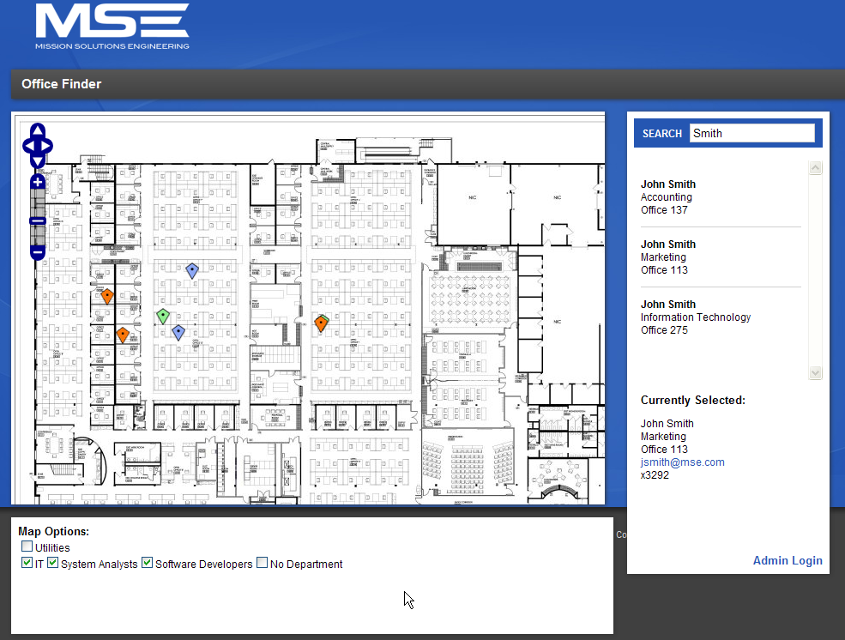

Features

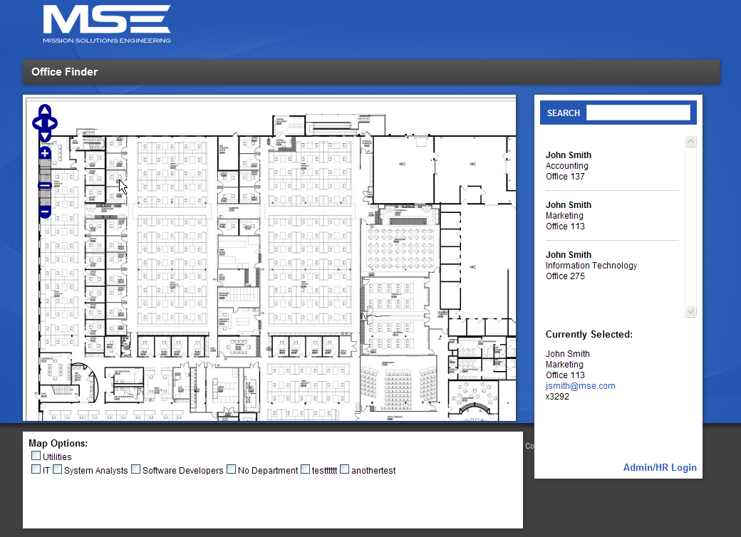

Overview
The Office Layout Tool and Personnel locater is a system designed for MSE to use when moving into a new building. This application will help get everyone acclimated with information regarding their new surroundings.

The application is web-based and consists of three major elements: A front end with Administrator, Human Resource and General user functions, a Search Engine, and Map Features.

Map View

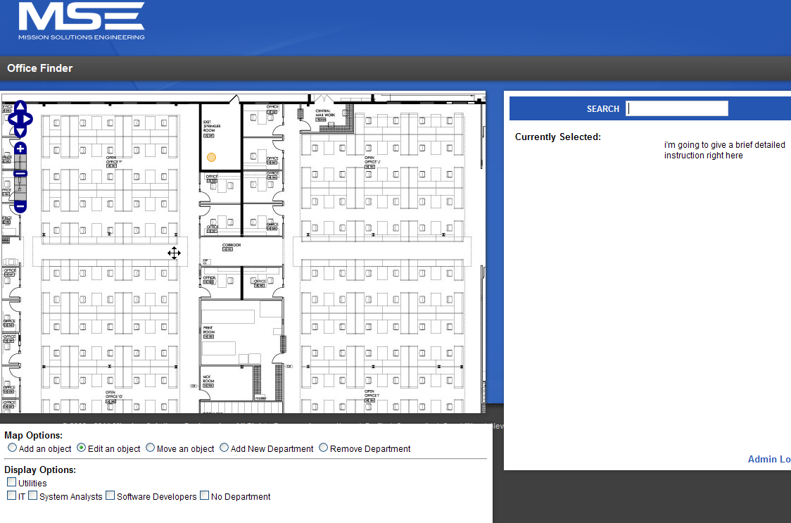
The map portion of the screen is the most important view. Users can view the layout of the building and overlay employee contact information, room numbers, utilities and more. The map is easily navigable using simple dragging controls or the on screen arrows and zoom.

Employee Search
Using the search bar users can locate employees and their information by searching for their name, phone number, room number, and other information. More details are then displayed and the employee’s location is shown on the map.

Administrator
Only the IT department will be able to edit the map or employee information. There is a separate password protected administrator page to ensure that only people with proper privileges are able to edit this information.

Human Resources
To aid the administrators, the HR department will have an option to send a request to IT to have information added, edited, or deleted. This will occur using the same login screen the administrators use.

