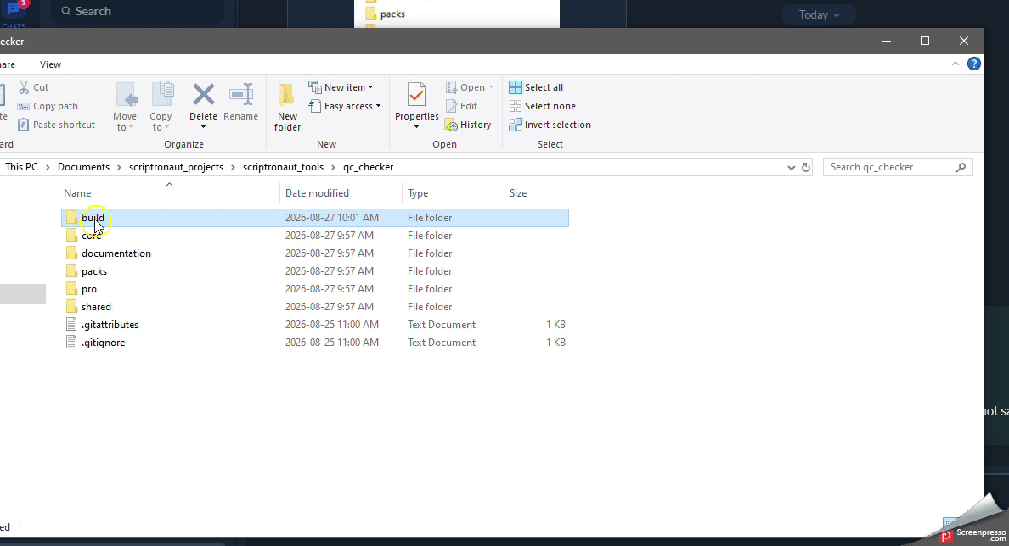
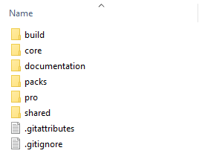
Build.Open.Test
Run the build_product.bat the build folder.
Type
1 for Core
or
2 for Pro
Type the version of your blender:
4.5
Enter
Repo Structure

