Repo
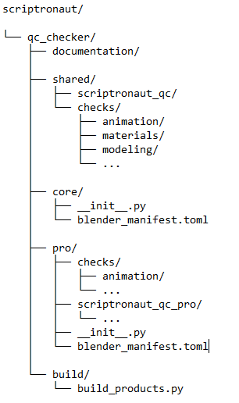
build_products.py
Core
shared framework
+ shared checks
+ Core manifest
Pro
shared framework
+ shared checks
+ Pro checks
+ Pro features
+ Pro manifest

