Having this project with my friend (started a "business of selling 3D digital tools), what would be the best approach? 1- "our project" incorporation? 2- "our project" registration or 3- me and him ARE at the moment already registered (in Quebec) as freelancers, so, staying like this, signing some sort of agreement and deal with each other revenues, like if "our project" was a contract that we each have? So of course here, I'm also referring to the expenses we gonna have, and the revenue we gonna share.

The best choice depends on whether you are testing the waters or ready to launch a long-term commercial business.
In Quebec, running a joint project as two separate freelancers is legally tricky, while jump straight into incorporating carries administrative overhead.

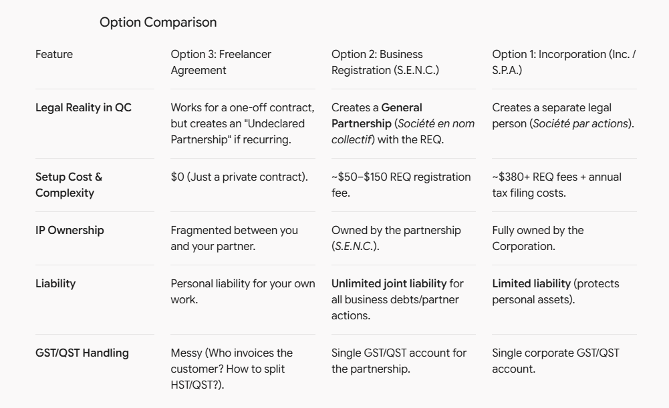

1. Option 3: Staying Freelancers + Private Agreement
- Best for: Testing a proof-of-concept for 1–3 months, or doing a single joint client contract.
- How it works: One of you acts as the main billing entity (or you bill clients 50/50), and you sign a Joint Venture / Subcontractor Agreement defining revenue share, expenses, and asset rights.
- The Quebec Catch: Under the Civil Code of Quebec, if two freelancers repeatedly carry on a business together, share profits, and present a unified brand, Revenue Quebec and the law view you as an Undeclared Partnership (Société créée de fait) anyway.
- IP Risk: Digital products (like scripts or 3D assets) need clean title. If you don't assign intellectual property correctly, selling items on platforms like BlenderMarket, Gumroad, or TurboSquid gets messy.

2. Option 2: Registering a General Partnership (S.E.N.C.)
- Best for: A serious low-budget launch where you want a shared brand name and unified accounting without corporate fees.
- How it works: You register a Société en nom collectif with the Registraire des entreprises du Québec (REQ). You get a single NEQ (Quebec Business Number) and open a joint business bank account.
Canada Incorporation Agency+ 1
- Crucial Step: You must sign a written Convention de société (Partnership Agreement) defining:
  - Expense deductions (e.g., server costs, software, marketing split 50/50).
  - Net profit distribution (flowed through to your personal tax returns on T5013/TP-600).
Canada Incorporation Agency
  - Who owns the code/3D IP if one person walks away.
- Liability Warning: Partners in an S.E.N.C. share unlimited personal liability. If your digital tool breaks a production pipeline and a customer sues, your personal assets are exposed.
Bankeo+ 1

3. Option 1: Incorporation (Inc. / S.P.A.)
- Best for: A commercial software/asset store aiming for scaling, significant revenue ($80k+ net profit), or high risk.
Bankeo
- How it works: You form a new provincial or federal corporation. The Inc. owns all IP, collects all sales, pays expenses, and distributes profits to you as salaries or dividends.
Bankeo
- Why digital tool makers choose this: Liability shield (limits risk to the company's assets), clean asset assignment, and tax benefits if you keep profits inside the business.
Incorp-Québec

Recommended Action Plan
- If you are just launching a few tools to see if anyone buys them:
  - Start with Option 3 for the first few weeks to validate demand.
  - Draft a basic written deal specifying: "We split tool sales 50/50 after store fees. Tool A IP belongs to [Name], Tool B IP belongs to [Name], but royalty is shared."
- If you are launching a dedicated store/brand name with active expenses (hosting, marketplace fees, marketing):
  - Move to Option 2 (S.E.N.C.). It costs under $100 to register with REQ, gives you a business bank account, and simplifies GST/QST collection.
- When net profits cross $80k–$100k or you release complex software:
  - Transition the S.E.N.C. into a full Corporation (Inc.) and execute a Shareholder Agreement (Convention d'actionnaires).

I want to rectify something: we are not working for clients. We want to create tools that we gonna sell on, for example, SuperHive (or our own website commerce later)

Selling mass-market digital tools (scripts, plugins, assets) directly to end-users on platforms like

SuperHive, Gumroad, or your own site changes the dynamic—specifically around intellectual property (IP) assignment, platform sales tax handling, and product liability.

Key Reality Check for Product vs. Service
When selling digital products instead of doing client work:
- Tax handling is simpler on marketplaces: Platforms like SuperHive or Gumroad often act as the "merchant of record" or handle sales tax/VAT remittance at checkout, meaning you primarily receive payout distributions rather than invoicing individual consumers for GST/QST.
- IP ownership is critical: Digital assets and code need clear ownership. If your friend writes half a script and leaves, your business cannot legally keep selling or updating that product unless the IP was explicitly assigned to the business or shared entity.
- Liability exists, but is lower than client work: While a broken plugin can corrupt a user's scene, marketplace Terms of Service usually include clear "as-is" disclaimers.

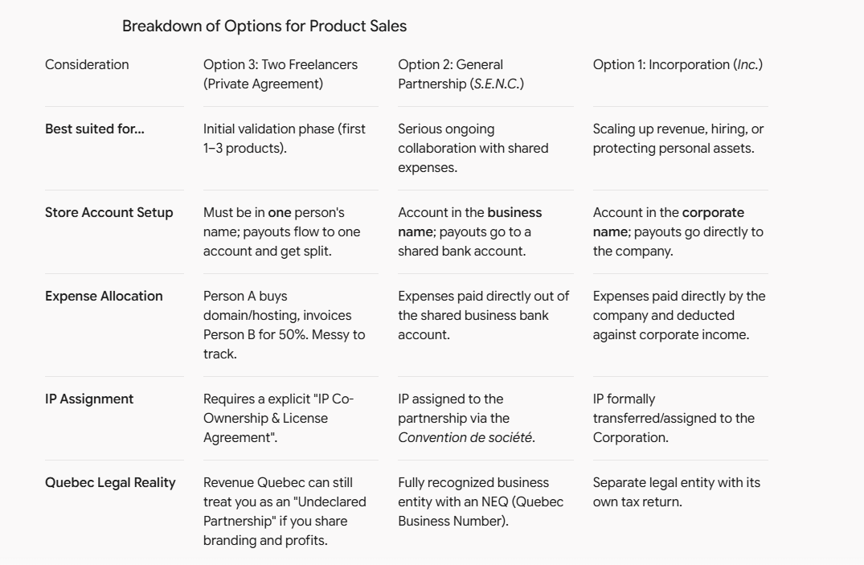

How to Handle Each Approach

Approach A: The "Testing the Waters" Setup (Option 3)
If you just want to put your first 1–2 tools online to see if anyone buys them before spending money on legal filings:
- Pick One Account Owner: The marketplace account (e.g., SuperHive) will sit under one partner's name or a personal tax ID.
- Execute a Private Agreement: Write a simple, signed contract covering:
  - Revenue Split: Payouts (after marketplace fees) are split 50/50.
  - Expense Reimbursement: Shared expenses (domain registration, web hosting, paid API keys) are deducted from total revenue before profit splits.
  - IP License: "Each contributor grants the project a non-exclusive, perpetual license to distribute and sell the authored scripts/tools."
  - Exit Terms: What happens to the product listings if one of you wants to stop working on the project.

Approach B: The Shared Entity Setup (Option 2 - S.E.N.C.)
If you are building a dedicated brand, building a library of tools, and operating a shared website:
- Register with the REQ: Register a Société en nom collectif (~$50–$100 fee) under your brand name.
- Open a Joint Business Bank Account: Direct all marketplace payouts and website payment gateways (Stripe/PayPal) into this single account.
- Pay Expenses Directly: Pay hosting, domain names, software licenses, and store fees straight from the joint account.
- Draft a Partnership Agreement (Convention de société): Document that all code, scripts, and asset files created for the brand belong to the partnership, and define how net profits are drawn by each partner.

Direct Recommendation
- For the first 30–90 days (Validation): Stay as freelancers, use Option 3, but write down a firm agreement covering expense deductions before profit splits and IP licensing rights.
- As soon as sales are consistent or you launch your own site: Move to Option 2 (S.E.N.C.). It establishes a single identity for tax reporting in Quebec, lets you open a unified bank account, and provides a clean container for your digital assets.



What does that mean?

An Undeclared Partnership (Société créée de fait under the Civil Code of Quebec) means that even if you haven't registered a business together or signed formal corporation papers, the tax authorities and the courts will legally consider you a general partnership based on your actions.
PNG
If you work together, share profits, and present yourselves under a unified brand name to customers, Quebec law decides you are acting as a partnership regardless of how you classify yourselves on paper.
PNG

Why This Happens
Under Quebec civil law, three conditions automatically trigger a legal partnership:
- Pecuniary Contributions: Both of you contribute something of value (code, 3D models, time, or cash for hosting/domain costs).
- Profit Sharing: You split the net profits or income from sales.
PNG
- Intent to Cooperate under a Brand: You operate under a common brand name ("our tool store") instead of acting as two completely separate contractors.
PNG

Why This Matters for Your Business
- Unlimited Joint Liability: Because an undeclared partnership functions like a General Partnership (S.E.N.C.), you become personally liable for business debts or legal claims incurred by your partner in the name of the project. If a user sues over a faulty script or bad asset, both of your personal assets are on the line.
- Tax Audit Complications: If Revenu Québec audits you, they can reclassify your individual freelancer tax filings. Instead of accepting separate freelancer income/expense claims, they may require partnership tax returns (Form TP-600), recalculate shared GST/QST obligations, or adjust how shared expenses were deducted.
- Intellectual Property Uncertainty: Without a formal written agreement or entity, ownership of the tools, code, and brand remains legally ambiguous if one partner decides to walk away.

How to Avoid the Trap
- Option A (Formalize it): Register an official S.E.N.C. with the REQ or incorporate (Inc.) so you have a recognized tax structure, clear rules, and a dedicated business bank account.
- Option B (Keep it truly independent): If remaining freelancers, one person must own the brand/store account entirely and pay the other as a subcontractor (issuing an invoice for work rendered) rather than splitting end profits under a joint commercial identity.

So we ABSOLUTELY have to at least be "registered" (S.E.N.C) or "incorporated" before we even start earning money (start the sells)?

No, you do NOT strictly have to form an S.E.N.C. or incorporate before earning your first dollar.
Thousands of developers launch side projects and test tools online before ever filing formal business entity paperwork. What you must do depends on how you structure the sales and payouts upfront.

Your 3 Real Options Before Launching
- Option 1: The "Lead Freelancer" Model (Zero upfront registration costs)
  - How it works: One of you puts their personal name or existing sole proprietorship/freelance profile on the marketplace account (SuperHive, Gumroad, etc.). All payouts go to that person's bank account.
  - Expenses & Splitting: That lead person pays the platform fees/hosting, keeps 50% of net profits, and pays the remaining 50% to the other partner.
  - Tax Handling: The second partner simply invoices the lead partner for "Software Development / Technical Consulting Services." The lead partner deducts that invoice as a business expense, and both report their respective halves as personal freelance income.
  - Requirement: No new business registration needed. You just need a signed private IP & Profit Sharing Agreement between the two of you.
- Option 2: Registering a General Partnership (S.E.N.C.)
  - How it works: You register a joint partnership with the Registraire des entreprises du Québec (REQ) for ~$60 before launching. You get a single NEQ (Quebec Business Number) and open a dedicated joint business bank account.
  - Tax Handling: Marketplaces pay the S.E.N.C. account directly. At tax time, net income flows 50/50 onto each of your personal tax returns via partnership schedules.
  - Requirement: Quick online registration with the REQ + a basic Partnership Agreement (Convention de société).
- Option 3: Incorporation (Inc.)
  - How it works: You form a new provincial or federal corporation before launching.
  - Requirement: Higher setup cost (~$350–$1,000+ including corporate tax filings). Usually unnecessary until you hit consistent, significant revenue ($50k–$80k+).

Government Rules to Keep in Mind
- GST/QST Tax Threshold ($30,000 Rule):
  - You do not need to register for GST/QST tax numbers on day one if your sales are under $30,000 CAD over 4 consecutive quarters.
  - Furthermore, platforms like Gumroad or SuperHive often act as the Merchant of Record, meaning they collect and remit sales taxes globally on your digital sales anyway.
- Operating Under a Shared Brand Name:
  - In Quebec, if you operate under a brand name other than your own legal names (e.g., calling your shop "Apex 3D Tools" instead of "John Doe & Jane Smith"), you are technically supposed to register that trade name with the REQ.
  - Doing this as a sole proprietorship or S.E.N.C. takes about 15 minutes online and costs under $60.

Recommended Game Plan
- For Tool #1 (The Soft Launch): Don't overcomplicate it. Use Option 1. Put the listing on SuperHive under one account, track sales in a simple spreadsheet, deduct host/server expenses, and have the account owner pay the other 50% as a sub-contractor.
- Once you hit ~$1,000 in sales or release a suite of tools: Take an afternoon to register an S.E.N.C. (Option 2) with the REQ so you can get a joint bank account and run everything cleanly under your brand name.

That's why Iask you if if ABSOLUTELY have to be at least registered before stating to sell: We already have setup our own "entity" (website) and intend to sell under the name of our "brand". So what I'm saying is: when we do launch, we will have a website with a brand name, we will have an account that will display to user "Brand Name" (example on Superhive) and would have, yes, been created by me, for example. So again: do we ABSOLUTELY have to at least be registered or incorporated before we start selling under the circumstances I've just described?

No, you do NOT strictly have to register or incorporate before making your first sale.
While Quebec law (Act respecting the legal publicity of enterprises) technically requires anyone doing business under a trade name other than their exact personal legal name to file a registration with the REQ, there is no technical or legal "hard lock" that blocks you from launching. Payment processors, marketplaces, and banks will let you collect money without an NEQ (Quebec Business Number).

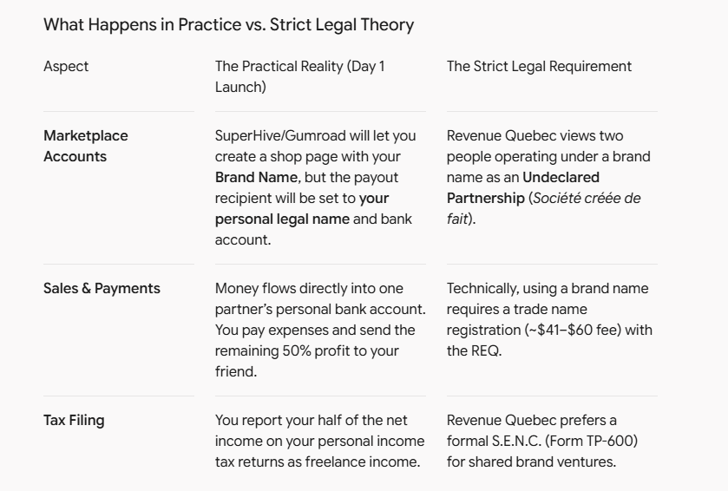

The Risk of Starting Without Registration
If you launch tomorrow under your brand name without registering:
- The Police/Government Won't Shut You Down: Nobody from Revenue Quebec inspects new SuperHive or Gumroad storefronts on launch day.
- The Main Risk is Internal: Because the account is in your personal name, you are legally 100% responsible for all revenues, refunds, and taxes on the gross payout. If your friend stops helping or you have a disagreement, you hold all the financial liability.
- Banking Limits: You cannot open a dedicated bank account under your Brand Name until you have an NEQ from the REQ. Payouts must go to a personal account.

Safe "Day One" Execution Strategy
If you want to validate demand without spending time or money on registration right now:
- Launch Under the Brand Name: Set up your website and SuperHive storefront using your brand name.
- Use One Personal Payout Account: Set up the payout/Stripe account under your (or your partner's) personal legal identity.
- Sign a Simple 1-Page Private Agreement: Write down: "Sales from Brand Name will be collected by [Partner A]. After platform and server costs, [Partner A] will pay [Partner B] 50% as a contractor fee."
- The $500 Threshold Rule of Thumb:
  - Under $500–$1,000 in total sales: Stay completely unregistered. Prove people actually want the tools.
  - Once you hit $1,000+ or steady monthly sales: Spend 15 minutes and ~$60 on the REQ website to register as an S.E.N.C. This gives you an official NEQ, allows you to open a business bank account in your brand name, and legalizes the partnership cleanly.

All good but, what happens if, let's say, I opened a SuperHive account, and I have the hosting service account, and we do registered? We sure could now have a business bank account after registration, to be used for expenses and revenues, but do I, stay the one who operates the SuperHive accounts and the Hosting account (under my name) or would we have to make a certain move about that, once we would be registered?

No, you do not have to close or re-create your SuperHive or web hosting accounts once you register the business.
You can simply keep using the existing accounts and transition their internal settings to point to your new business entity.

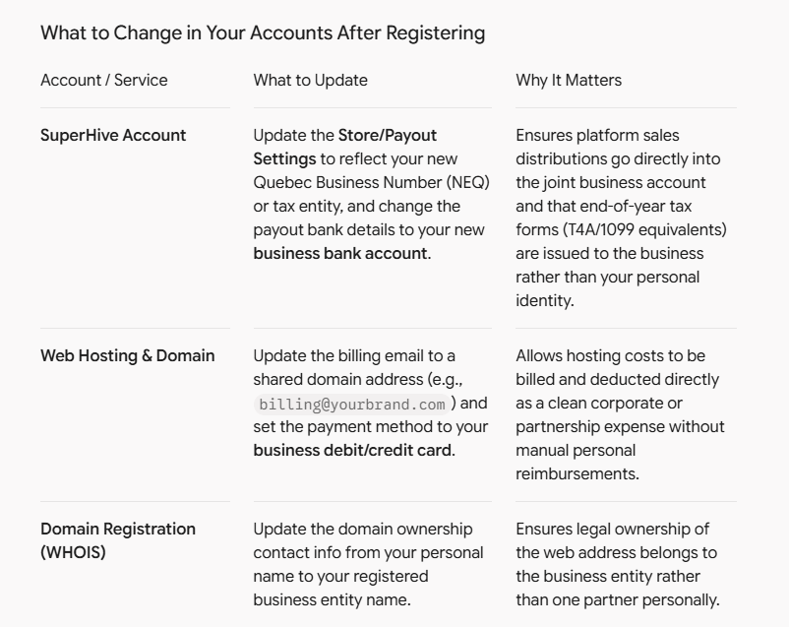

Handling Existing Assets & Accounts
- Keep the Logins Active: The actual account credentials (username, login email, developer profile) can stay exactly as they are. SuperHive and hosting providers care about where money flows and who legally owns the account, not who physically created the login.
- Execute an IP & Asset Transfer: To make sure everything is legally bulletproof between you and your partner, sign a simple one-page assignment document stating that the domain, hosting account, and SuperHive storefront assets belong to the registered partnership/entity.
- Store Access: Ensure both you and your partner have stored credentials (or administrative seat access) for the hosting and store platforms so that neither of you is a single point of failure if account access is needed.

Next Steps Once Registered
- Open your joint business bank account using your new NEQ (Quebec Business Number).
- Log into SuperHive and update your bank payout destination to the new business account.
- Switch your hosting and domain recurring payments to your business debit card.

So if the "project" is Registered, how does it work at the end of the year, for the income tax report? Let's say "project" is registered, expenses are made from the joint business bank account (we keep the receipts), revenues goes inside that account also. End of the year comes, let's suppose we made 100k, we split 50k each. Each of us must make our personal tax report? Is it considered like a "revenue" like if we had worked "for a business"?. Does "project" has to make a tax report to?

When you register a General Partnership (Société en nom collectif or S.E.N.C.) in Quebec, the business itself is not a tax-paying entity. It does not pay corporate income tax. Instead, it acts as a "pass-through" entity where all income and expenses flow through directly to you and your partner.
PNG+ 2

1. Does the "Project" (S.E.N.C.) File a Tax Report?
Yes, but it is an informational return, not a tax payment.
At fiscal year-end, the S.E.N.C. prepares and files annual partnership information returns:
- Federally (CRA): Form T5013 (Statement of Partnership Income).
- Provincially (Revenu Québec): Form TP-600-V (Partnership Information Return).

What goes into this report?
- Total gross revenues collected in the business bank account (e.g., $150,000).
- Total deductible business expenses paid from the account (e.g., $50,000 for hosting, domain fees, software licenses, SuperHive/store commissions).
- Net Partnership Income: $100,000.
- Partner Distribution (50/50): The S.E.N.C. issues an official tax slip to each of you (T5013 / RL-15 slip) showing your exact $50,000 share of net business income.

2. How Do You and Your Partner File Personal Income Taxes?
Each of you takes your individual T5013 / RL-15 slip and includes that $50,000 on your personal income tax returns (Form T1 federally and TP-1 in Quebec).

Is it considered "work for a business" (like a salary/employee)?
No, it is reported as Net Business / Partnership Self-Employment Income.
- No Tax Withholding: Unlike an employer who deducts income tax, QPP/CPP, and EI automatically from a paycheck, the S.E.N.C. transfers money to your personal bank account without deducting income taxes.
- QPP & QPIP Contributions: You will pay self-employed Quebec Pension Plan (QPP) and Quebec Parental Insurance Plan (QPIP) contributions when you file your personal tax return.
- Installment Payments (Acomptes provisionnels): After your first year filing a profit, Revenu Québec and CRA may ask you to pay quarterly tax installments for the upcoming year to avoid a large tax bill at year-end.

3. Step-by-Step Year-End Tax Flow Example
[Gross Sales on SuperHive & Website]
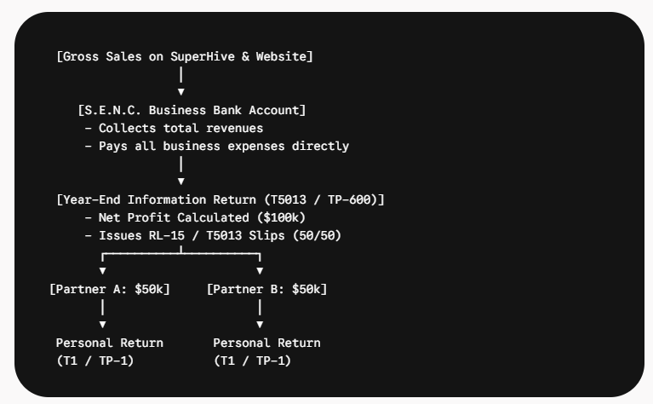
│
▼.N.C. Business Bank Account]
/ TP-1) (T1 / TP-1)
- All Year: SuperHive payouts enter your joint business bank account. Web hosting, domain renewals, marketing, and software tools are paid directly from this account using the business debit card.
- At Year-End: Your accountant (or tax software) tallies Total Revenue - Total Expenses = Net Income.
- The S.E.N.C. files Form TP-600/T5013 and generates two RL-15 slips for $50,000 each.
- You and your partner report the $50,000 on line 12200 (Net partnership income) of your personal returns. You pay personal income tax at your individual marginal tax rate on that $50,000.

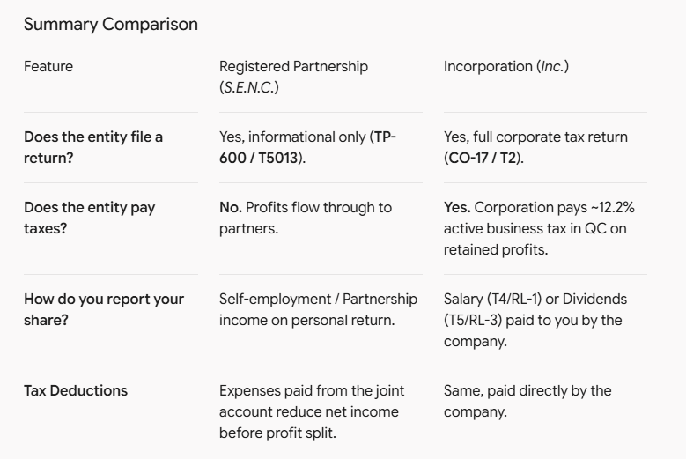

Right now, I'm a freelancer, I have my tax numbers, etc... So when I make a contract for a client, if I have expenses, I keep the receipts and I file a quarterly report (for taxes) and I either get deductions (because of my expenses) on that report, but also at the end of the year, on my income tax report. With this new "project" registered, what will be the dynamic from now on, for the expenses (the concept of "keeping receipts in order to have deductions on deductible expenses")?

The core rules of keeping receipts and deducting expenses stay exactly the same, but the mechanics of where and when those expenses are deducted change when you operate a registered S.E.N.C. (General Partnership).

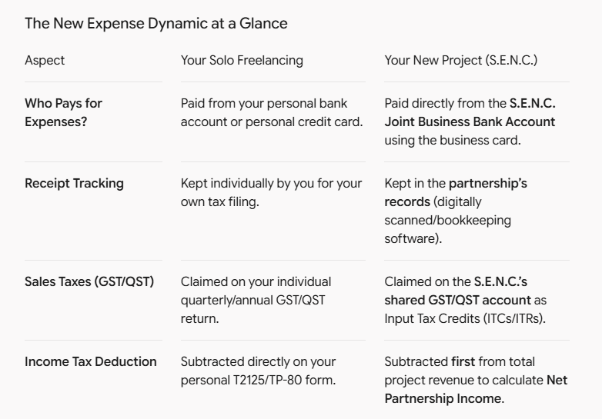

How Project Expenses Are Handled

1. Deductions Happen Before the 50/50 Split
Instead of each partner receiving gross sales and claiming separate expenses on personal tax returns, all business expenses are subtracted inside the S.E.N.C. first:
Gross Sales−Total Project Expenses=Net Project Income
- You sell $120,000 in 3D digital tools.
- The project incurs $20,000 in shared expenses (web hosting, domains, asset purchases, marketplace fees, marketing, plugins).
- Net Project Income is $100,000.
- The S.E.N.C. issues tax slips (T5013 / RL-15) allocating $50,000 net income to you and $50,000 net income to your partner.
- You report $50,000 on your personal tax return, meaning you already received the full tax benefit of that $20,000 in deductions without doing individual math.

2. Receipts & Proof of Purchase
- You must still keep all receipts and invoices for at least 6 years in case Revenu Québec or CRA audits the project.
- Rule of thumb: If an expense is bought for the project (e.g., website server, 3D render farm fees, store software), pay for it with the joint business card and upload the digital receipt to a shared folder or cloud accounting software (e.g., Wave, QuickBooks).

What About Sales Tax (GST/QST) Reports?
If the project registers for GST/QST (required once total project sales hit $30,000 over 4 consecutive quarters):
- The S.E.N.C. gets its own GST/QST numbers (separate from your individual freelancer tax numbers).
- Filing the GST/QST Report: When the S.E.N.C. files its report (quarterly or annually), it compares total GST/QST collected on sales against total GST/QST paid on business expenses (Input Tax Credits / Input Tax Refunds).
- You receive a refund or pay the difference directly through the joint business account. Your individual freelancer GST/QST filing remains completely separate for your personal client contracts.

What If You Pay for a Project Expense out of Your Personal Pocket?
If you personally pay for a domain renewal or tool license on your personal card before the business bank account is set up:
- Keep the receipt showing your personal name and the expense details.
- Reimburse yourself from the S.E.N.C. bank account as soon as funds are available.
- Record it in the bookkeeping as a Business Expense paid by Partner A, so it gets properly deducted from the overall project income before year-end taxes are calculated.

