LEARNING MANAGEMENT SYSTEM

Full Stack Final Project



By Scott Ziegler || .NET Developer

5/10/2019

About the Developer

My name is Scott Ziegler, and I began Centriq in January of 2019. Coding really stood out to me because it’s almost alchemical in nature; you can take a lot of fragments that seem unrelated and ultimately create something tangible. There is also a sense of intrigue, because the IT world is something that’s constantly changing and evolving. It’s exciting to me to know that what I’m working on or with now will most likely be completely different in a relatively short timeframe. In the future, I intend to further my development skills with a focus on mobile applications and game design, as well as graphic design.

Project Purpose/Outline

The scenario was to create a continued education and training application for employees of a company. The employees themselves can view the lesson videos and/or .PDF files, and automation on the application logs their lesson completions, and sends an email to the appropriate manager upon completion of a set amount of lessons in a course.

Other requirements on this project included:

* **Separation of concerns regarding users**
  + **Different functionality for Admins, Employees and Managers**
  + **CRUD functionality for Admins only**
* **Implementation of an HTML template, including JS functionality**
* **Integration of ASP.NET Identity**
* **Creation and usage of a connected database**
* **File upload and viewing functionality**
* **YouTube API consumption and customization**
* **Use and creation of metadata for custom validation**

Database Details

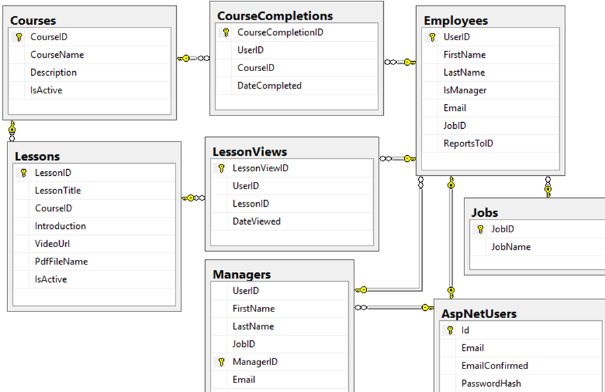

* As users register, their Asp Identity becomes their UserID for their role as employee or manager
* The admin creates the relationship between the employee ReportsToID and the ManagerID
* As Employees view Lessons, a Lesson View is generated
* After a set amount of Lesson Views are generated for the Course, a Course Completion is generated
* When the Course Completion is generated, an email is sent to the Manager who is tied to the Employee who finished the course
* Full CRUD functionality only resides with the Admin(s)

Use-Case Diagram

**Database**

Course Completions

Lessons

Admin

Lesson Views

Employees

Managers

Jobs

Courses

Custom Functionality Examples

Video Event & Course Completion Email

|  |  |  |  |
| --- | --- | --- | --- |
| **Scott Ziegler Jr**  314-974-4318 / [ziggish@att.net](mailto:ziggish@att.net) / scottieZ.com  [Image result for LINKEDIN LOGO](http://www.linkedin.com/in/scott-ziegler-03747214b) | | | |
|  |  |  |  |
| **FULL-STACK DEVELOPER** | | | |
|  |  |  |  |
| **qUALIFICATIONS**   * Solid foundational knowledge of designing and developing full-stack web applications using .NET framework. * Management experience; comprehensive understanding of time/cost relationships and teamwork fundamentals. * Extensive background in customer service and experience; unique problems need unique solutions. * Role-Orientated team player and self-motivated. * Familiar with multi-purpose team environments; individual, small and large group.   **TECHNICAL SKILLS**  **Front End:** HTML5, JavaScript, jQuery, jQueryUI, CSS3, Responsive/Mobile Web Development, Bootstrap  **Middle Tier:** Visual Studio, C#.NET, ASP.NET, LINQ, MVC, EF  **Back End:** ADO.NET, SQL, SQL Server, SSMSE jQuery  **Other:** Unity, ADB/APK, PHP  **Independent development projects**   * **Personal Site**: www.scottieZ.com * **U Store**: Created a secure application for managing product data. Application is built to simulate an online store front with a shopping cart. Administrators have the ability to manage product, category and vendor data. * **Final Project**: Created a secure data-driven ASP.NET MVC application from design through deployment for managing the tracking and organization of hardware and software within a company. Administrators have the ability to manage employee, department data and all details relating to assigned hardware and software.   **technical training**  **FULL-STACK WEB DEVELOPER PROGRAM** at CENTRIQ TRAINING  St. Louis, MO | January 28, 2019 – Present  *Core Competencies:*   * MVC Framework * Trouble Shooting & Debugging * Source Control * Agile/Scrum (Created Team Project) * Website Deployment * Pair Programming * Code Review * Professionalism, Teamwork, Problem Solving & Effective Communication   **HVAC/R Technician Program** at American Trade School  St. Louis MO | May 2011 – June 2012 | | | |

|  |
| --- |
| **Demolition/Remediation/Construction Laborer - 1099** **St. Louis, MO and outlying areas – March 2018 to April 2019**   * Hired under private contract based on multi-field experience to deconstruct and remediate an electroplating workshop as well as construction/demolition of associated estate properties. * Worked extensively under little supervision to complete phases of overall project. * Met all project deadlines within or under budget. * Acquired necessary training/certifications independently in accordance with laws/regulations.   Sous Chef/Kitchen Manager – Fandango’s Sports Bar and Grill  St. Louis, MO – 2012 to March 2018   * Promoted to kitchen manager in 2016, taking charge of all regulatory responsibilities, budgeting, and team management. * Interacted daily with customers to develop custom catering/ordering plans, and oversaw all operations related to food quality and production relevant. * Participated in and won awards in local charitable food competition 2 years in a row. * Gained comprehensive understanding of cost-to-profit margins, team cohesiveness and workplace standards for high stress and high pace environments.   HVAC Installation/Service Technician – Classic Aire Care  St. Louis, MO – 2011 to 2013   * Performed residential and assisted in light commercial HVAC installation and applications. * Daily customer interaction on both sales and regulations facets. * Cultivated the patience and respect to emphasize getting “the job done right the first time.” |