Scott Macioce
CSD430
Server-Side Scripting
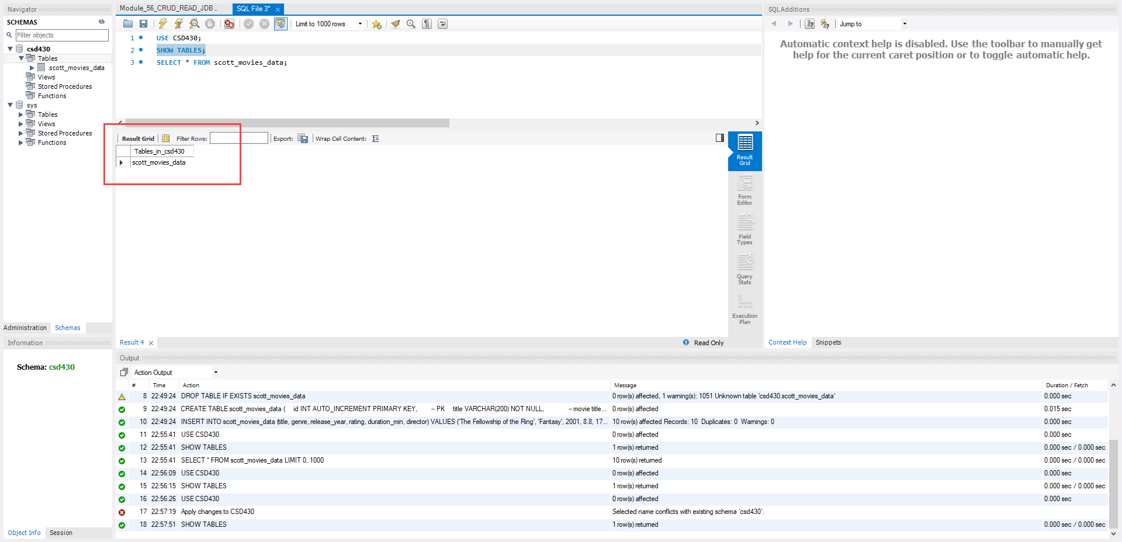
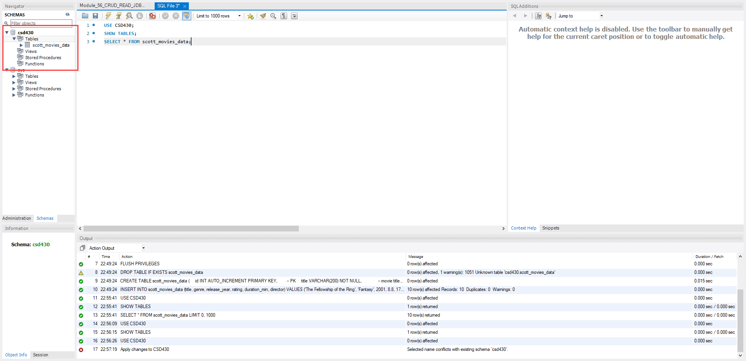
Module 5/6 – Working with CRUD-READ, JDBC, & JavaBeans

