Scott Macioce
01/15/2026
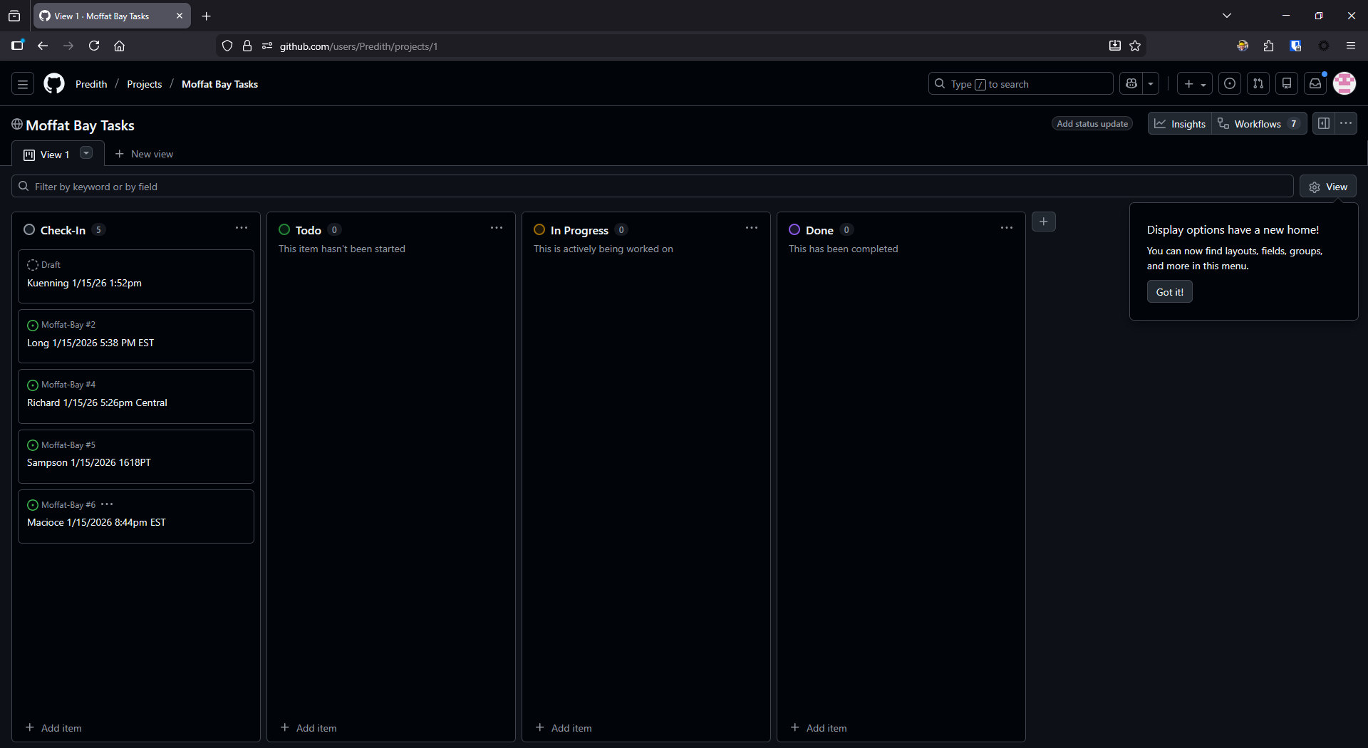
Module 1.1 Assignment

