Red Group

Dario Gomez, Juedeja Richard, Kristopher Kuenning, Scott Macioce

CSD-310

Case Study Project

Milestone #2

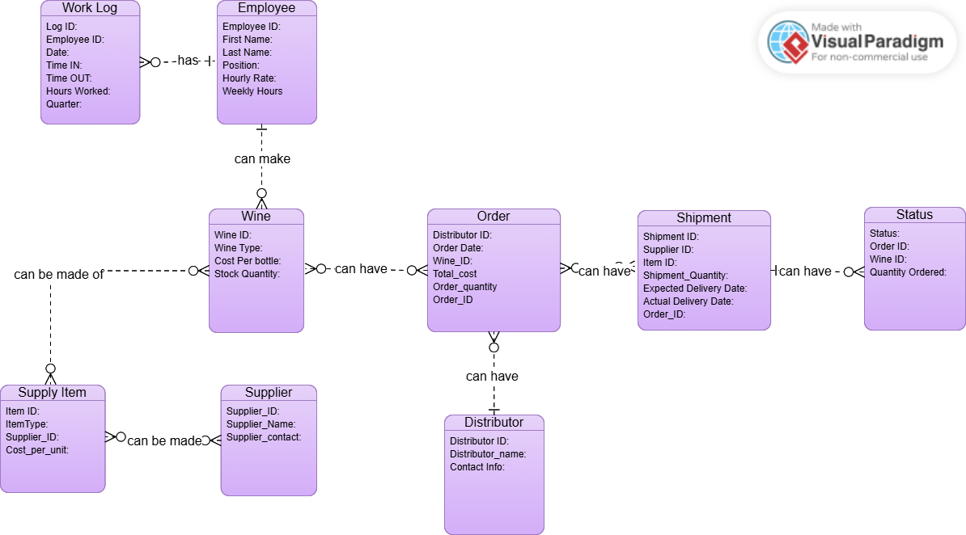**Revised ERD:**

**Screenshots of data:**

