Scott Macioce

Module 5.2

**SUBSTR()**

The SUBSTR() or SUBSTRING function allows you to extract a specified substring from a string, starting at any position. An example of this could be if you have multiple storage locations and only a few that begin with ‘CUBY’. You can put a substring around your storage location field for characters 1,4 where your storage location = ‘CUBY’ to show only ‘CUBY’ locations.

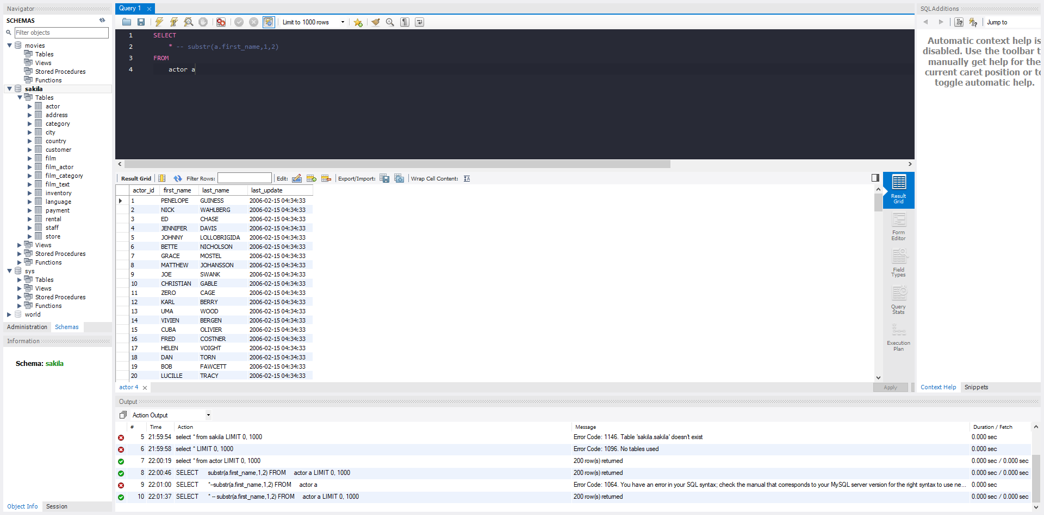In the example below, I looked at the Sakila database and looked at the actor table. I selected a substring around the actors first_name and aliased it with “Name”

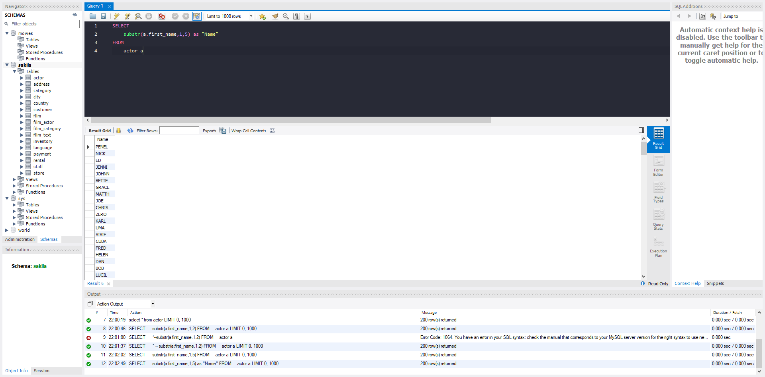

**COUNT()**

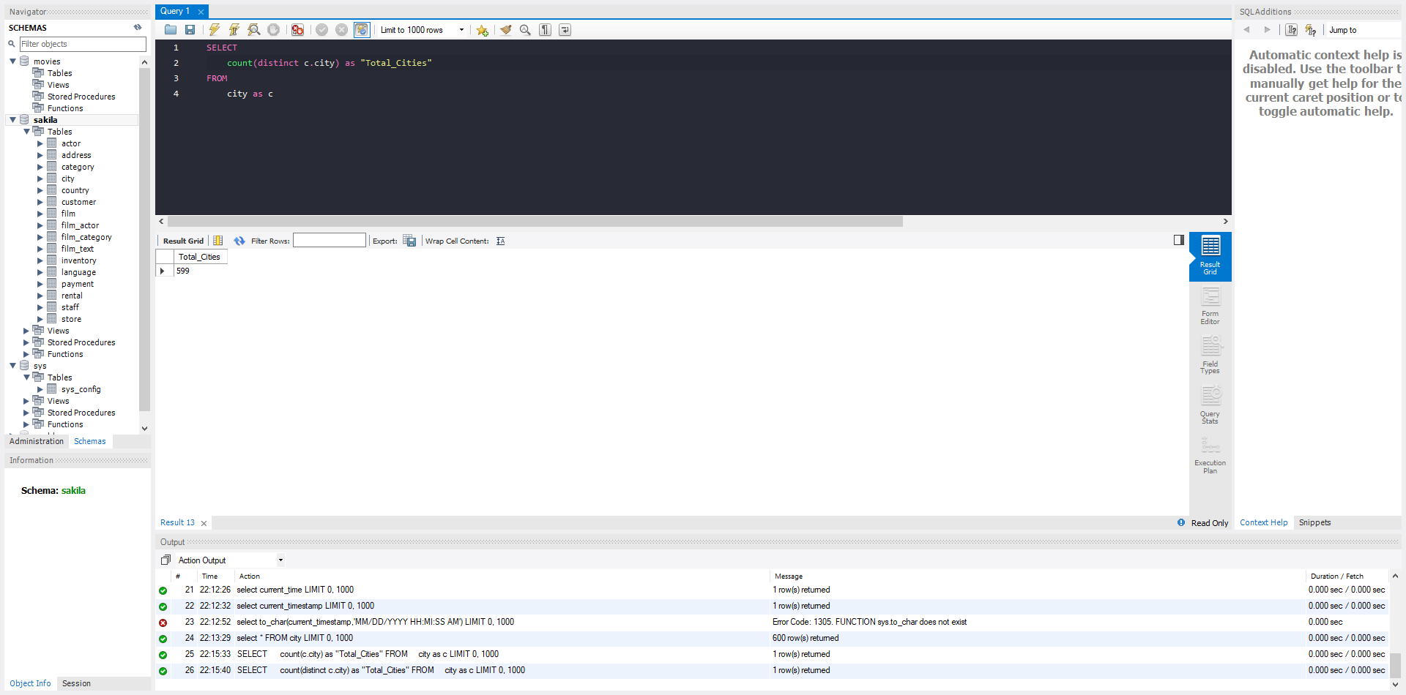The next function I used is COUNT(). The count function counts the total number of rows within a table. This function is useful when identifying the total number of records whether that be customers or orders within a table.In my example, I looked at the ‘city’ table and did a count(distinct) to pull the total number of unique cities in the table view.

**MIN()** & **MAX()**

The next functions I used where the MIN() and MAX() functions. These functions pull the minimum value and the maximum value in a set of values. In my example, I looked at the inventory table and pulled the min and max film ID. These functions are useful especially if you are looking at timestamps when you want to find the earliest event and the latest event.

