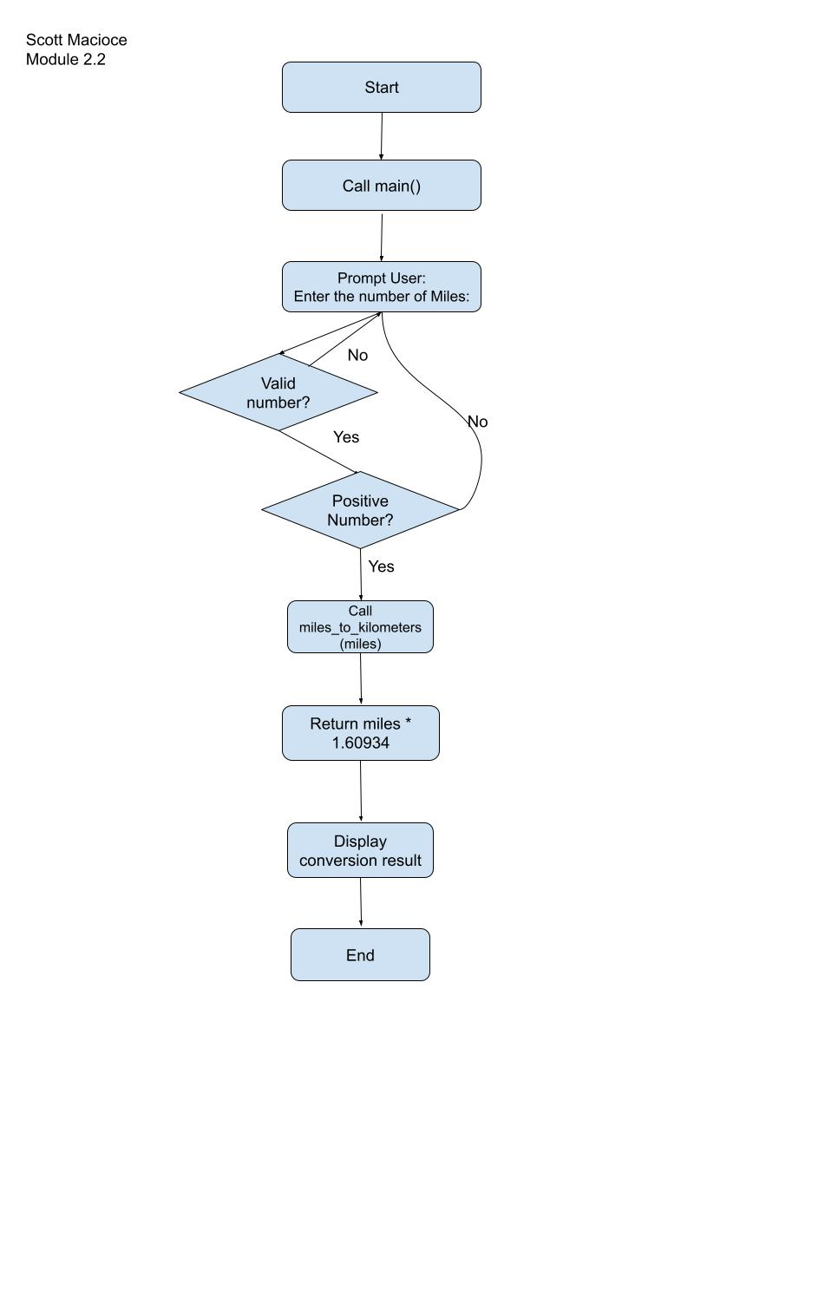Scott Macioce

Module 2.2

