Diween (Sopra Steria) suggested the following articles to me.

Spent 30 mins reading through, my take-aways/notes below.

Source: <https://geoffboeing.com/2020/11/off-grid-back-again/>

* How has the topology of the American street network changed over time?
  + Grid layout used to be popular, but sprawl embraced late 20th century, But Is the grid making a come back?
  + Streets are semi-permanent so can see how layouts change over a long time.
  + Sprawl is only suitable once car-ownership became popular
* Metrics:
  + Grid index is composed of the Geometric mean of 3 values (each between 0 and 1)
    - Straightness (Great Circle: length ratio)
    - % of nodes that are 4 way intersections
    - Orientation Order (entropy of directions)
  + Dead-end density
  + Average street length
  + Vehicles per household
* Tools:
  + Python OSMnx
  + OpenStreetMap data
* Why do we care?
  + Grid structure important for making cities less car dependent, more pedestrianised.
  + Also links to road safety.
  + Once streets built, they last. Retrofits not as effective as getting it ‘right’ the first time.

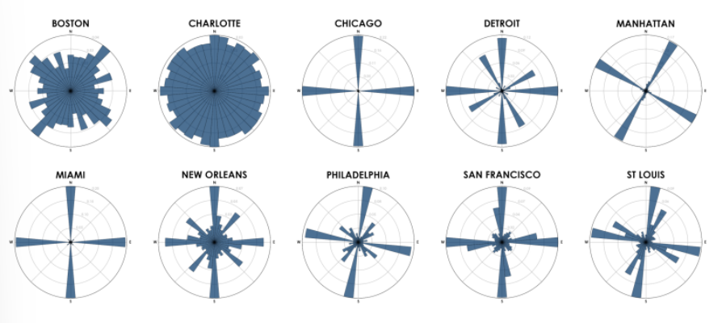

Above, the polar histogram bars’ directions represent compass bearings and bars’ lengths represent the proportion of city street segments with those bearings.

Question: Incorporation of green space? Health benefits the same if so rigidly gridded?

Other grid benefits:

* Navigation
* Organisation/memorability
* Efficient transportation (straights)
* Wind mitigation

Source: <https://geoffboeing.com/2019/09/urban-street-network-orientation/>

* Street orientations vary across the world
* Can cluster similar cities together – US is far more gridded than others

How to calculate Entropy:

**Challenge: Can I produce this chart for Dundee, Scotland?**

Source: <https://geoffboeing.com/2016/11/osmnx-python-street-networks/>

* Osmnx, python package. Visualise, analyse street networks from OpenStreetMap
  + <https://github.com/gboeing/osmnx>
  + Looks awesome!
  + Docs: <https://osmnx.readthedocs.io/en/stable/>

<https://openchargemap.org/site/country>

This API gives details about EV charging points across the world – data is public contributed, so may not be accurate?!

**Challenge: Can I confirm the Dundee charging infrastructure from this API?**