Requirements

<https://github.com/scottjohngibson/dissertation/issues>System Architecture

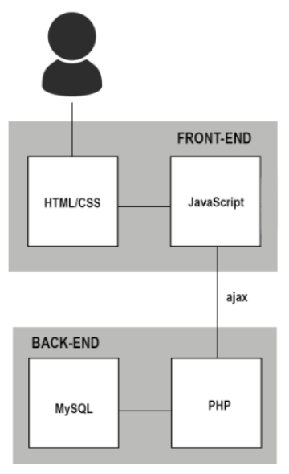

Class Diagram

