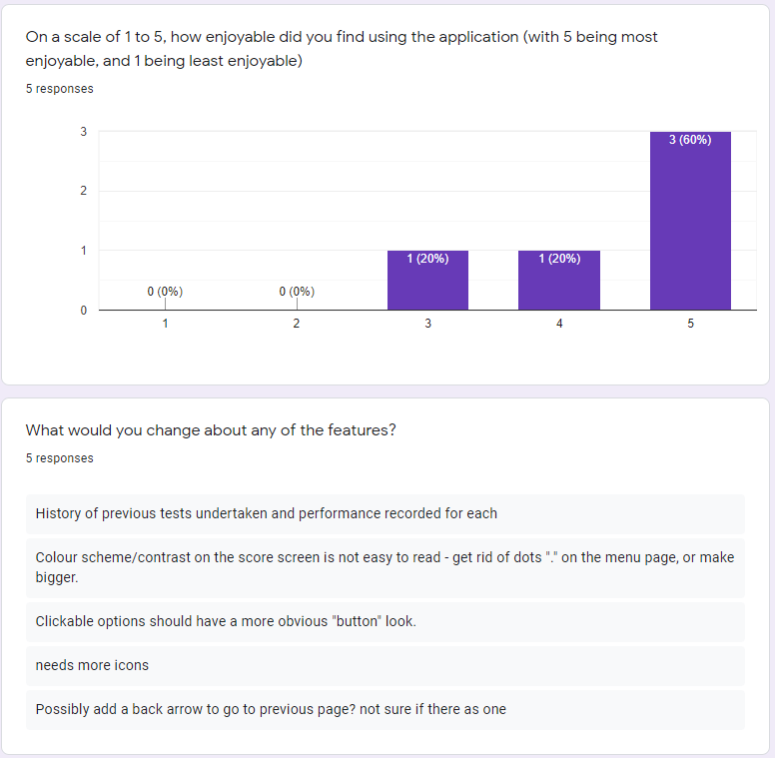

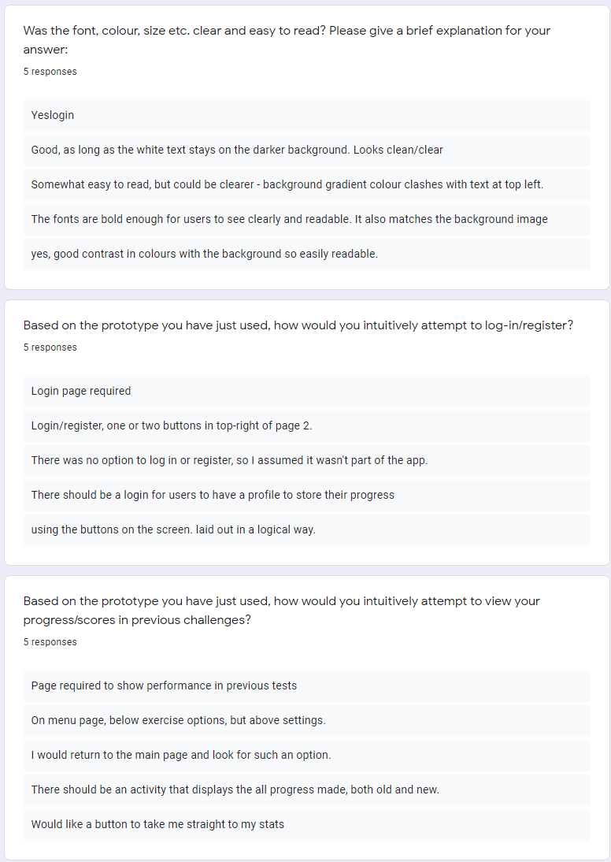

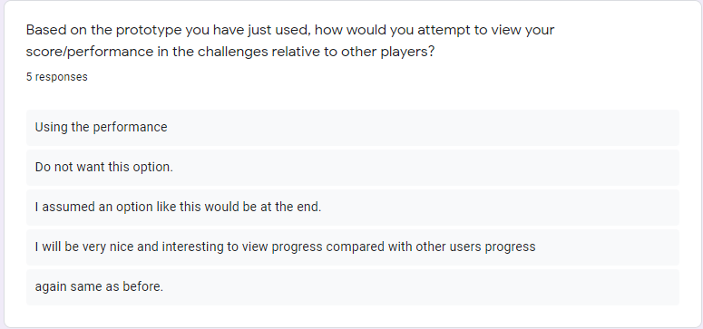

The majority of the users found the app to be a really enjoyable experience – when asked what they would change about the existing features most commented on visual elements and not on the functionality of the app itself. One person however did wish for “history of previous tests undertaken, and performance recorded for each”, and this was noted. Most users also found the text and background design to be agreeable and not distracting. One person noted that the use of a gradient made legibility less than desirable, however.

The existing sequence & placement of features was criticized. Majority of users wished that the system had a “login/register” feature displayed clearly – and not under the “settings” feature as it currently exists.

Likewise, users requested a separate means of accessing their progress/scores – as is, the app conveys this info upon completing the “maths game” – an additional feature will therefore be implemented

Finally, when asked how they would attempt to view their scores in comparison with other players – no users noticed this functionality existed via the “leader boards” link. Perhaps worthwhile reworking the wording of the question, or clarifying the meaning/placement of the leader boards link.

New Requirements:

* Non-functional requirement of UI design – revise existing look with accessibility in mind also.
* A new, separate link to “User Progress” from the home page