# 6.0 Hierarchy Chart

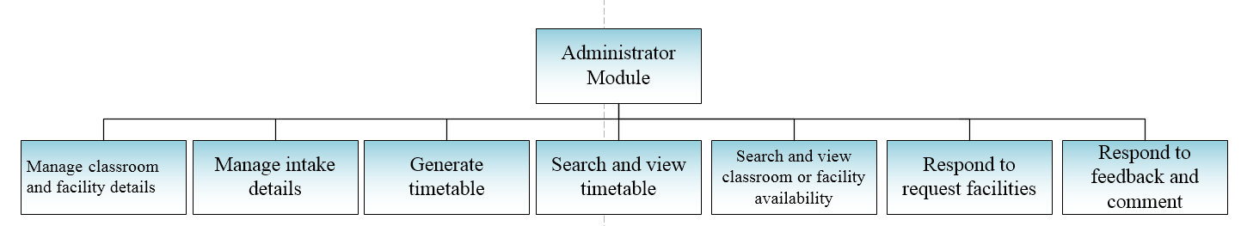

Figure 1. Administrator Hierarchy Chart.

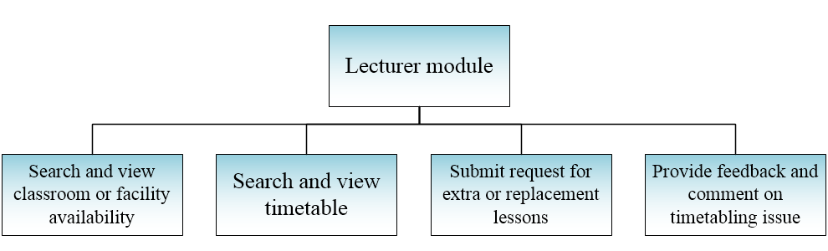

Figure 2. Lecturer Hierarchy Chart.

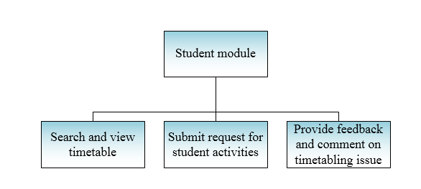

Figure 3. Student Hierarchy Chart.

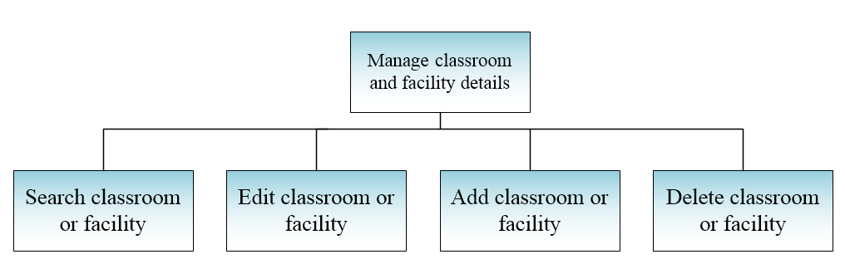

Figure 4. Manage Classroom and Facility Details Hierarchy Chart.

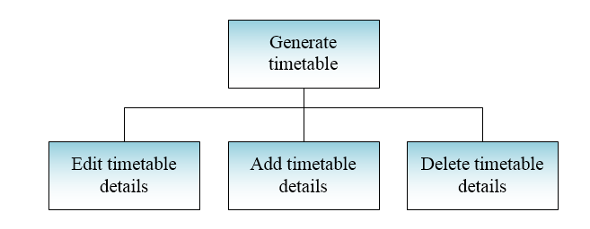

Figure 5. Generate Timetable Hierarchy Chart.

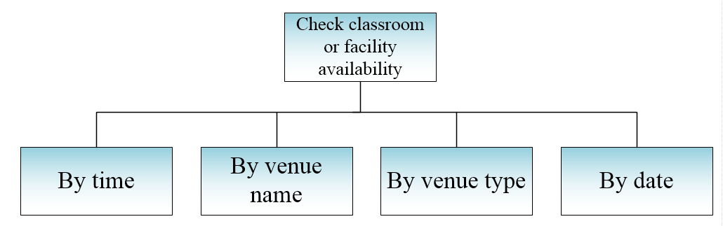

Figure 6. Check Classroom or Facility Availability Hierarchy Chart.

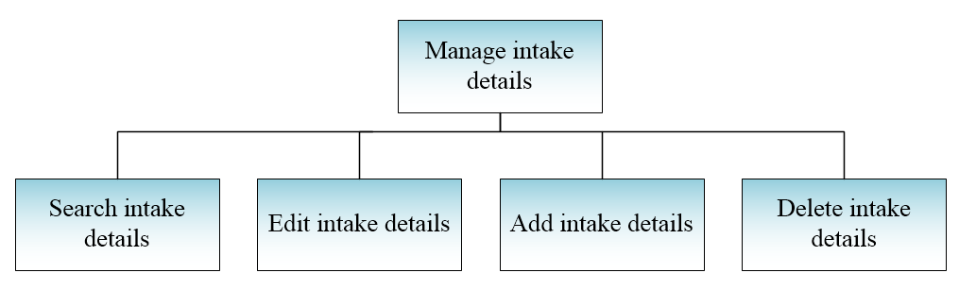

Figure 7. Manage Intake Details.

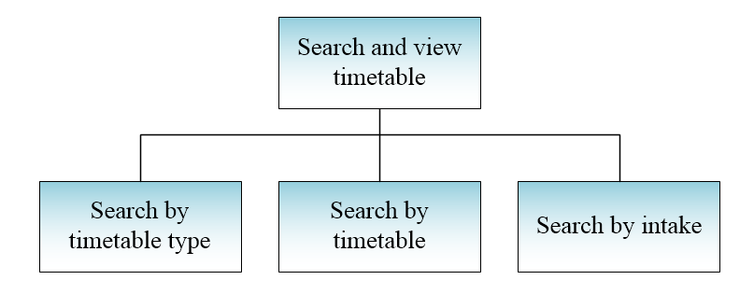

Figure 8. Search and View Timetable Hierarchy Chart.